SEM - VII - 2022-23
High Performance Computing Lab
Assignment – 10
2019BTECS00110 (Pavan Krishnat Shinde)
2019BTECS00101 (Aniket Sunil Kankekar)
2019BTECS00104 (Omkar Sharad Patil)
2019BTECS00109 (Lovish Trilok Agrawal)
Problem Statement 1:
Implement Matrix-matrix Multiplication using global memory in CUDA C. Analyze and tune the program for getting maximum speed up. Do Profiling and state what part of the code takes the huge amount of time to execute.

#include <stdio.h>
#define row1 20
#define col1 30
#define row2 30
#define col2 20
__global__ void matmul(int *l, int *m, int *n)
{
int x = threadIdx.x;
int y = threadIdx.y;
int k;
n[col2 * y + x] = 0;
for (k = 0; k < col1; k++)
{
n[col2 * y + x] = n[col2 * y + x] + l[col1 * y + k] * m[col2 * k + x];
}
}
int main()
{
int a[row1][col1];
int b[row2][col2];
int c[row1][col2];
int *d, *e, *f;
int i, j;
for (i = 0; i < row1; i++)
{
for (j = 0; j < col1; j++)
{
a[i][j] = 2;
}
}

for (i = 0; i < row2; i++)
{
for (j = 0; j < col2; j++)
{
b[i][j] = 3;
}
}
cudaMalloc((void **)&d, row1 * col1 * sizeof(int));
cudaMalloc((void **)&e, row2 * col2 * sizeof(int));
cudaMalloc((void **)&f, row1 * col2 * sizeof(int));
cudaMemcpy(d, a, row1 * col1 * sizeof(int), cudaMemcpyHostToDevice);
cudaMemcpy(e, b, row2 * col2 * sizeof(int), cudaMemcpyHostToDevice);
dim3 threadBlock(col2, row1);
matmul<<<1, threadBlock>>>(d, e, f);
cudaDeviceSynchronize();
cudaMemcpy(c, f, row1 * col2 * sizeof(int), cudaMemcpyDeviceToHost);
for (i = 0; i < row1; i++)
{
for (j = 0; j < col2; j++)
{
if (c[i][j] != 180)
{
printf("False\n");
return -1;
}
}
}
cudaFree(d);
cudaFree(e);
cudaFree(f);
printf("True\n");
return 0;
}

1.Time Required vs Problem Size

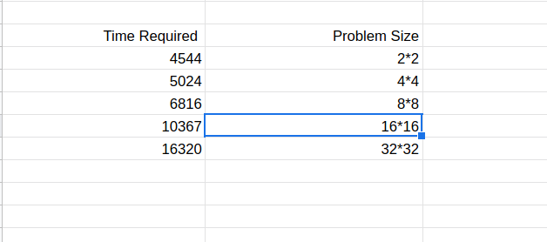

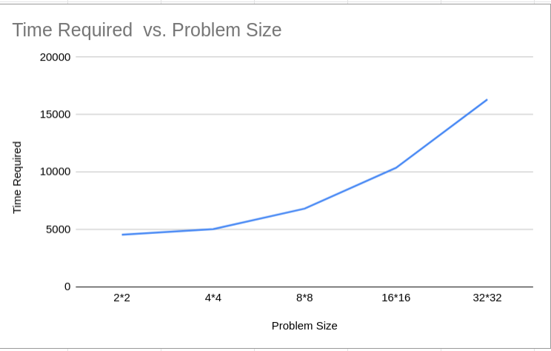
2.Time Required vs No. of threads per block (keeping no. of blocks constant)
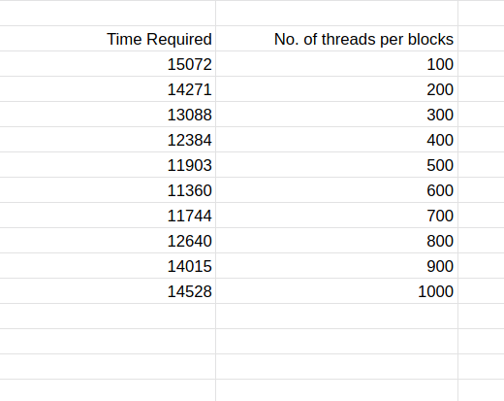

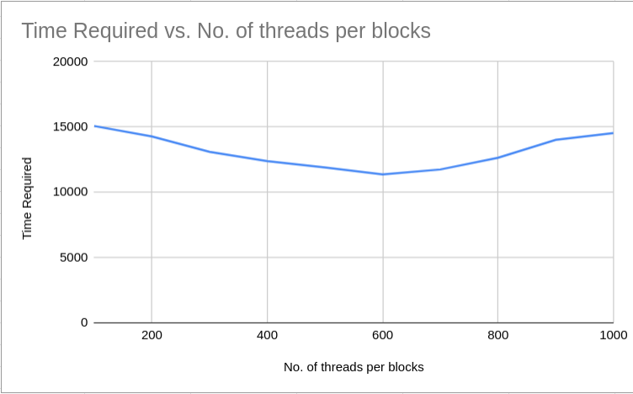
3.Time Required vs No. of block (keeping no. of threads per block constant)

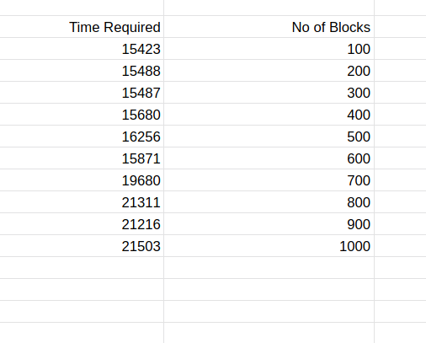

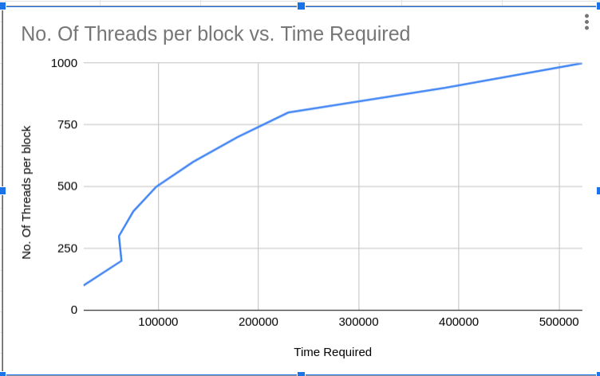

4.Time Required vs No. of block and No. of threads per block (Both increasing)

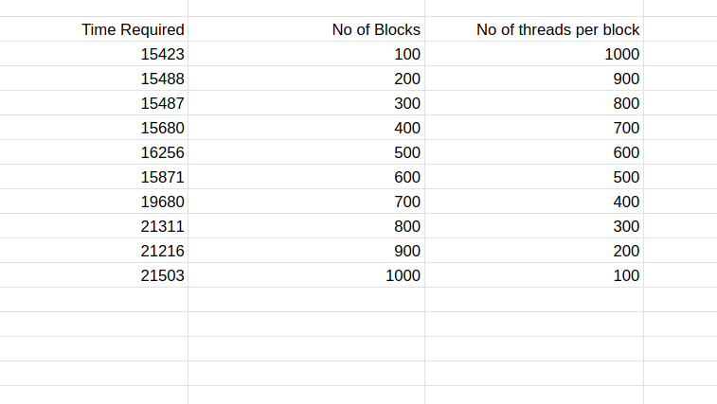
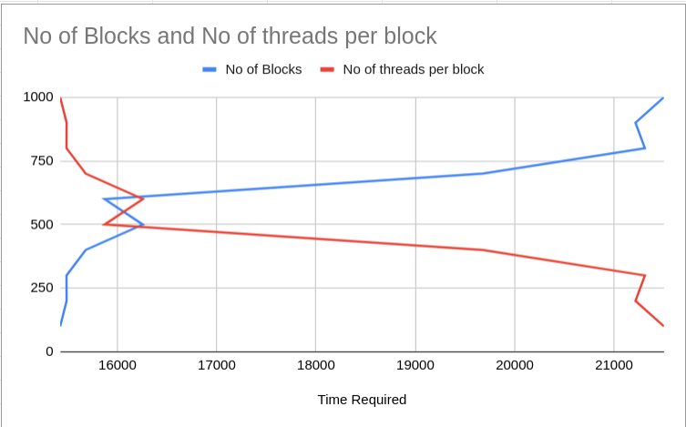

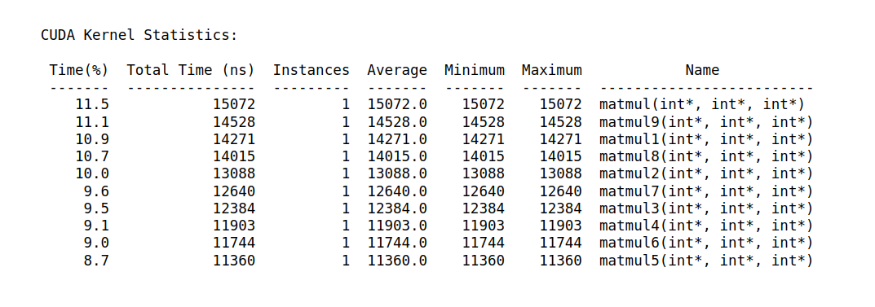
Problem Statement 2:
Implement Matrix-Matrix Multiplication using shared memory in CUDA C. Analyze and tune the program for getting maximum speed up. Do Profiling and state what part of the code takes the huge amount of time to execute.

#include <stdio.h>
#define row1 20
#define col1 30
#define row2 30
#define col2 20
__global__ void matproductsharedmemory(int *l, int *m, int *n)
{
int x = blockIdx.x;
int y = blockIdx.y;
__shared__ int p[col1];
int i;
int k = threadIdx.x;
n[col2 * y + x] = 0;
p[k] = l[col1 * y + k] * m[col2 * k + x];#include <stdio.h>
#define row1 20
#define col1 30
#define row2 30
#define col2 20
__global__ void matproductsharedmemory(int *l, int *m, int *n)
{
int x = blockIdx.x;
int y = blockIdx.y;
__shared__ int p[col1];
int i;
int k = threadIdx.x;
__syncthreads();
for (i = 0; i < col1; i++)
n[col2 * y + x] = n[col2 * y + x] + p[i];
}
int main()
{
int a[row1][col1];
int b[row2][co#include <stdio.h>
#define row1 20
#define col1 30
#define row2 30
#define col2 20
__global__ void matproductsharedmemory(int *l, int *m, int *n)
{
int x = blockIdx.x;
int y = blockIdx.y;
__shared__ int p[col1];
int i;
int k = threadIdx.x;
n[col2 * y + x] = 0;
p[k] = l[col1 * y + k] * m[col2 * k + x];#include <stdio.h>
#define row1 20
#define col1 30
#define row2 30
#define col2 20
__global__ void matproductsharedmemory(int *l, int *m, int *n)
{
int x = blockIdx.x;
int y = blockIdx.y;
__shared__ int p[col1];
int i;
int k = threadIdx.x;
__syncthreads();
for (i = 0; i < col1; i++)
n[col2 * y + x] = n[col2 * y + x] + p[i];
}
int main()
{
int a[row1][col1];
int b[row2][col2];
int c[row1][col2];
int *d, *e, *f;
int i, j;
for (i = 0; i < row1; i++)
{
for (j = 0; j < col1; j++)
{
a[i][j] = 2;
}
}
for (i = 0; i < row2; i++)
{
for (j = 0; j < col2; j++)
{
b[i][j] = 3;
}
}
cudaMalloc((void **)&d, row1 * col1 * sizeof(int));
cudaMalloc((void **)&e, row2 * col2 * sizeof(int));
cudaMalloc((void **)&f, row1 * col2 * sizeof(int));
cudaMemcpy(d, a, row1 * col1 * sizeof(int), cudaMemcpyHostToDevice);
cudaMemcpy(e, b, row2 * col2 * sizeof(int), cudaMemcpyHostToDevice);
dim3 grid(col2, row1);
matproductsharedmemory<<<grid, col1>>>(d, e, f);
cudaDeviceSynchronize();
cudaMemcpy(c, f, row1 * col2 * sizeof(int), cudaMemcpyDeviceToHost);
for (i = 0; i < row1; i++)
{
for (j = 0; j < col2; j++)
{
if (c[i][j] != 180)
{
printf("False\n");
return -1;
}
}
}
cudaFree(d);
cudaFree(e);
cudaFree(f);
printf("True\n");
return 0;
}

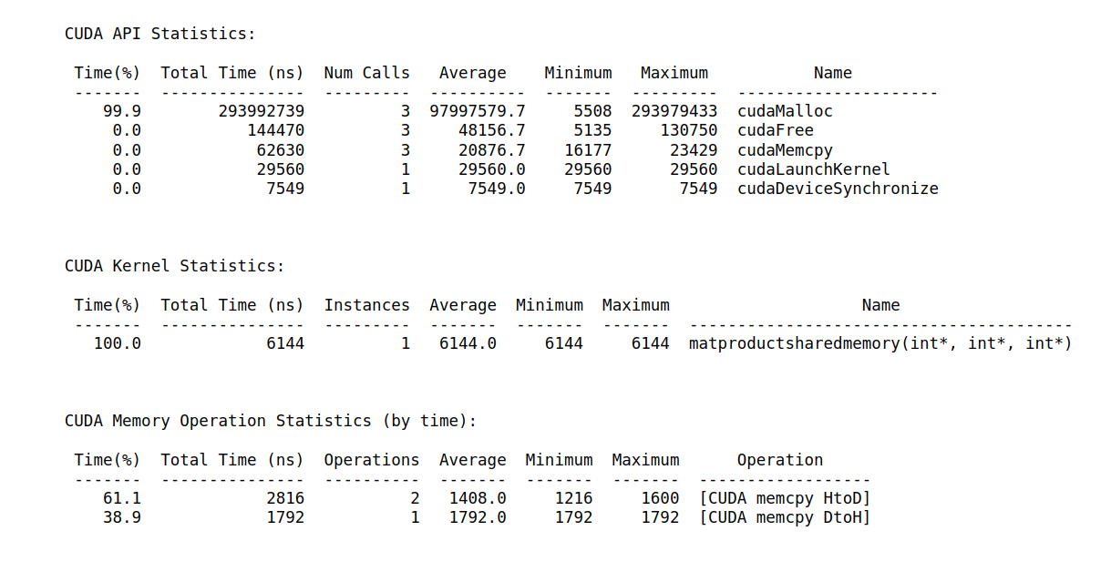
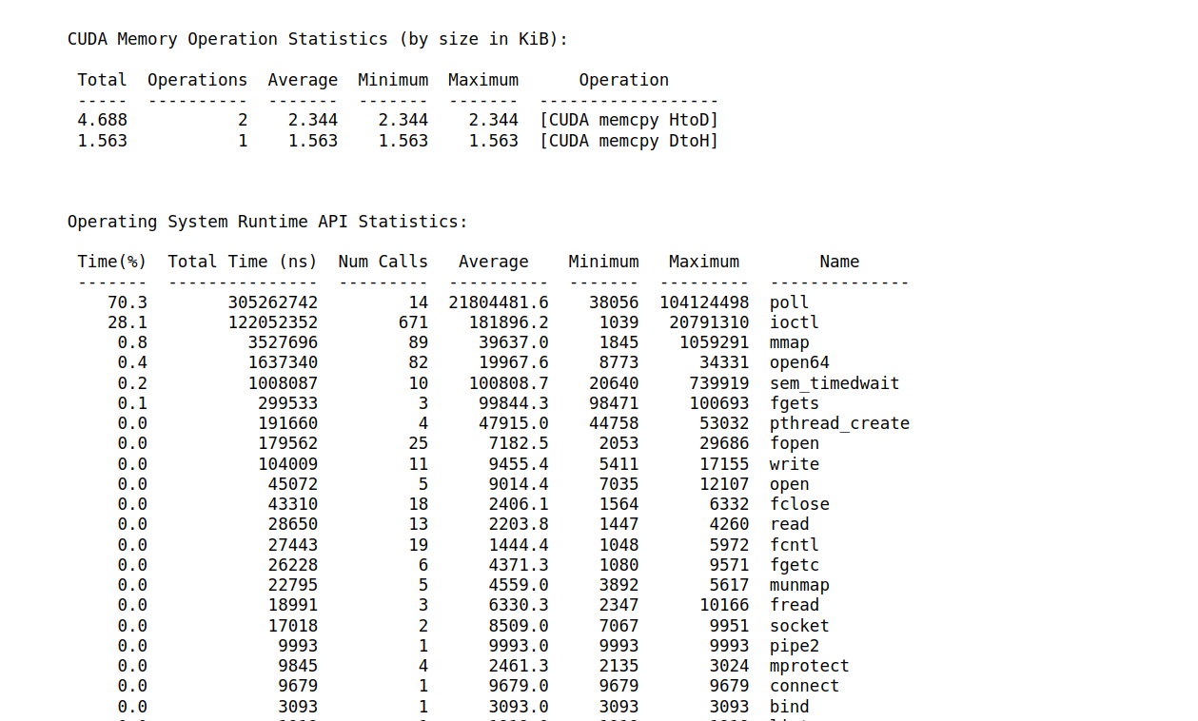

Problem Statement 3:
Implement Prefix sum using CUDA C. Analyze and tune the program for getting maximum speed up. Do Profiling and state what part of the code takes the huge amount of time to execute.

#include <stdio.h>
void initWith(float val, float *arr, int N)
{
for (int i = 0; i < N; i++)
{
arr[i] = val;
}
}

__global__
void prefixSum(float *arr, float *res, float *ptemp, float* ttemp, int N)
{
int threadId = blockIdx.x * blockDim.x + threadIdx.x;
int totalThreads = gridDim.x * blockDim.x;
int elementsPerThread = ceil(1.0 * N / totalThreads);

int start = threadId * elementsPerThread;
int count = 0;
float *sums = new float[elementsPerThread];
float sum = 0;

for (int i = start; i < N && count < elementsPerThread; i++, count++) {
sum += arr[i];
sums[count] = sum;
}

float localSum;
if (count)
localSum = sums[count - 1];
else
localSum = 0;
ptemp[threadId] = localSum;
ttemp[threadId] = localSum;

__syncthreads();

if (totalThreads == 1) {
for (int i = 0; i < N; i++)
res[i] = sums[i];
} else {
int d = 0; // log2(totalThreads)
int x = totalThreads;
while (x > 1) {
d++;
x = x >> 1;
}

x = 1;
for (int i = 0; i < 2*d; i++) {
int tsum = ttemp[threadId];

__syncthreads();

int newId = threadId / x;
if (newId % 2 == 0) {
int nextId = threadId + x;
ptemp[nextId] += tsum;
ttemp[nextId] += tsum;
} else {
int nextId = threadId - x;
ttemp[nextId] += tsum;
}

x = x << 1;
}

__syncthreads();

float diff = ptemp[threadId] - localSum;
for (int i = start, j = 0; i < N && j < count; i++, j++) {
res[i] = sums[j] + diff;
}
}
}

void checkRes(float *arr, float *res, int N, float *ptemp, float* ttemp)
{
float sum = 0;
for (int i = 0; i < N; i++)
{
sum += arr[i];
if (sum != res[i])
{
printf("FAIL: res[%d] - %0.0f does not equal %0.0f\n", i, res[i], sum);
exit(1);
}
}
printf("SUCCESS! All prefix sums added correctly.\n");
}

int main()
{
const int N = 1000000;
size_t size = N * sizeof(float);

float *arr;
float *res;

cudaMallocManaged(&arr, size);
cudaMallocManaged(&res, size);

initWith(2, arr, N);
initWith(0, res, N);

int blocks = 1;
int threadsPerBlock = 32;
int totalThreads = blocks * threadsPerBlock;

float *ptemp;
float *ttemp;
cudaMallocManaged(&ptemp, totalThreads * sizeof(float));
cudaMallocManaged(&ttemp, totalThreads * sizeof(float));

prefixSum<<<blocks, threadsPerBlock>>>(arr, res, ptemp, ttemp, N);
cudaDeviceSynchronize();

checkRes(arr, res, N, ptemp, ttemp);

cudaFree(arr);
cudaFree(res);
cudaFree(ttemp);
cudaFree(ptemp);
}

No of threads (1 block) | kernal time execution 1 | kernal time execution 2 | kernal time execution 3
16 | 29185007 | 28690201 | 29448042
32 | 24658464 | 23898575 | 24076521
64 | 20158082 | 19436169 | 20129785
128 | 18123523 | 17824168 | 17406672
256 | 14619018

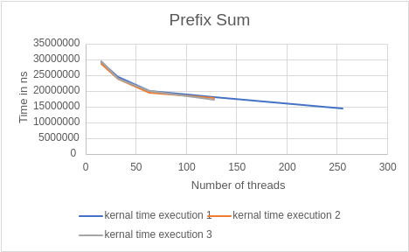

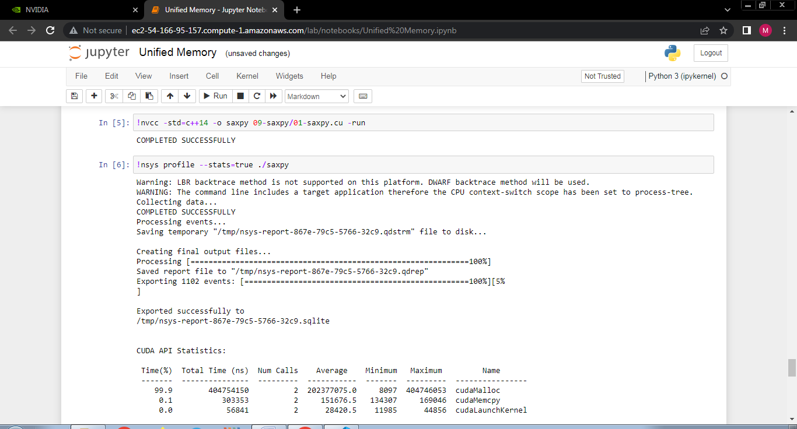

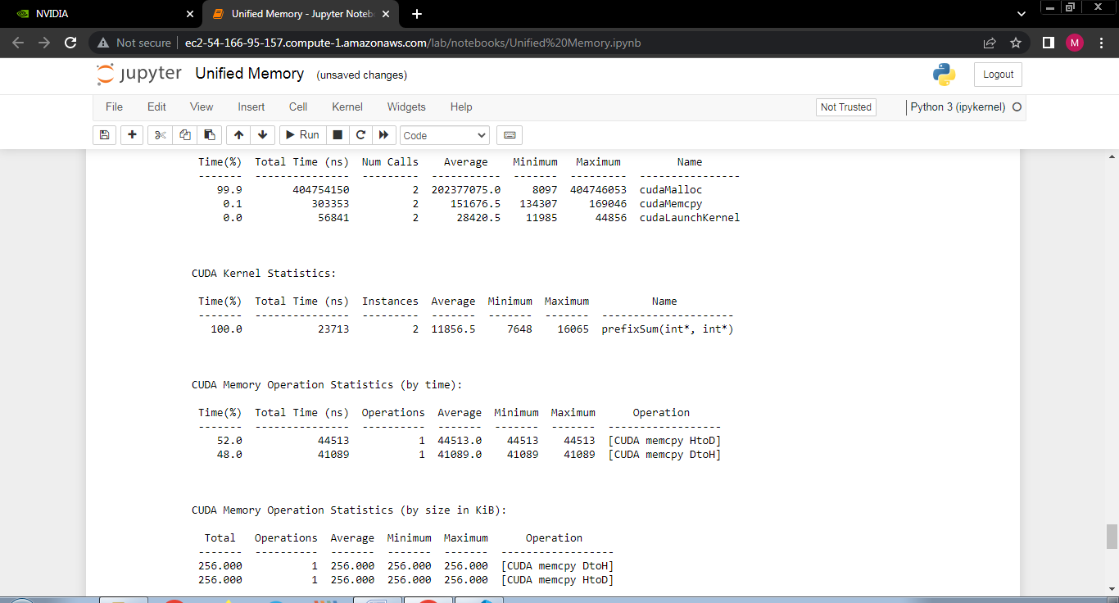

Conclusion:
As there is lack of synchronisation in blocks but there is synchronisation in threads, so for the prefix sum problem we consider only one block with varying number of threads. So by observing the above graph we have concluded that as the number of threads increases execution time is decreasing.

Problem Statement 4:
Implement 2D Convolution using shared memory using CUDA C. Analyze and tune the program for getting maximum speed up. Do Profiling and state what part of the code takes the huge amount of time to execute.
#include <stdio.h>

#define MASK_DIM 7

#define MASK_OFFSET (MASK_DIM / 2)

__constant__ int mask[7 * 7];

__global__ void convolution_2d(int *matrix, int *result, int N)
{
// Calculate the global thread positions
int row = blockIdx.y * blockDim.y + threadIdx.y;
int col = blockIdx.x * blockDim.x + threadIdx.x;

// Starting index for calculation
int start_r = row - MASK_OFFSET;
int start_c = col - MASK_OFFSET;

// Temp value for accumulating the result
int temp = 0;

// Iterate over all the rows
for (int i = 0; i < MASK_DIM; i++)
{
// Go over each column
for (int j = 0; j < MASK_DIM; j++)
{
// Range check for rows
if ((start_r + i) >= 0 && (start_r + i) < N)
{
// Range check for columns
if ((start_c + j) >= 0 && (start_c + j) < N)
{
// Accumulate result
temp += matrix[(start_r + i) * N + (start_c + j)] * mask[i * MASK_DIM + j];
}
}
}
}

// Write back the result
result[row * N + col] = temp;
}

void init_matrix(int *m, int n)
{
for (int i = 0; i < n; i++)
{
for (int j = 0; j < n; j++)
{
m[n * i + j] = rand() % 100;
}
}
}

void verify_result(int *m, int *mask, int *result, int N)
{

int temp;

int offset_r;
int offset_c;

// Go over each row
for (int i = 0; i < N; i++)
{
// Go over each column
for (int j = 0; j < N; j++)
{
// Reset the temp variable
temp = 0;

// Go over each mask row
for (int k = 0; k < MASK_DIM; k++)
{
// Update offset value for row
offset_r = i - MASK_OFFSET + k;

// Go over each mask column
for (int l = 0; l < MASK_DIM; l++)
{
// Update offset value for column
offset_c = j - MASK_OFFSET + l;

// Range checks if we are hanging off the matrix
if (offset_r >= 0 && offset_r < N)
{
if (offset_c >= 0 && offset_c < N)
{
// Accumulate partial results
temp += m[offset_r * N + offset_c] * mask[k * MASK_DIM + l];
}
}
}
}
// Fail if the results don't match
if (result[i * N + j] != temp)
{
printf("Check failed");
return;
}
}
}
}

int main()
{

int N = 1 << 10; // 2^10

size_t bytes_n = N * N * sizeof(int);
size_t bytes_m = MASK_DIM * MASK_DIM * sizeof(int);

int *matrix;
int *result;
int *h_mask;

cudaMallocManaged(&matrix, bytes_n);
cudaMallocManaged(&result, bytes_n);
cudaMallocManaged(&h_mask, bytes_m);

init_matrix(matrix, N);
init_matrix(mask, MASK_DIM);

cudaMemcpyToSymbol(mask, h_mask, bytes_m);

// Calculate grid dimensions
//int THREADS = 64;
//int BLOCKS = (N + THREADS - 1) / THREADS;

// Dimension launch arguments
//dim3 block_dim(THREADS, THREADS);
//dim3 grid_dim(BLOCKS, BLOCKS);

//printf("%d %d",grid_dim.y,block_dim.y);

convolution_2d<<<128, 1024>>>(matrix, result, N);

verify_result(matrix, h_mask, result, N);

printf("COMPLETED SUCCESSFULLY!");

cudaFree(matrix);
cudaFree(result);
cudaFree(h_mask);

return 0;
}

Blocks (thread constant 128) | kernal execution time
64 | 777744
128 | 720112
256 | 533781
512 | 582900
1024 | 448567

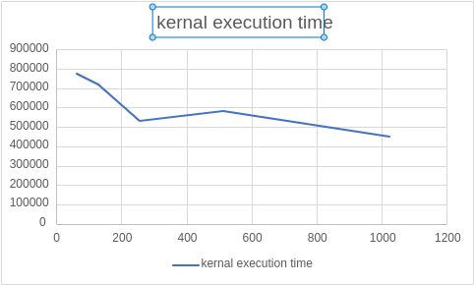

Threads(Block Constant 128) | kernal execution time
128 | 674482
256 | 539349
512 | 559860
1024 | 731410

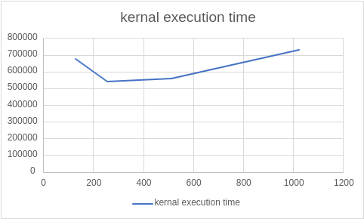

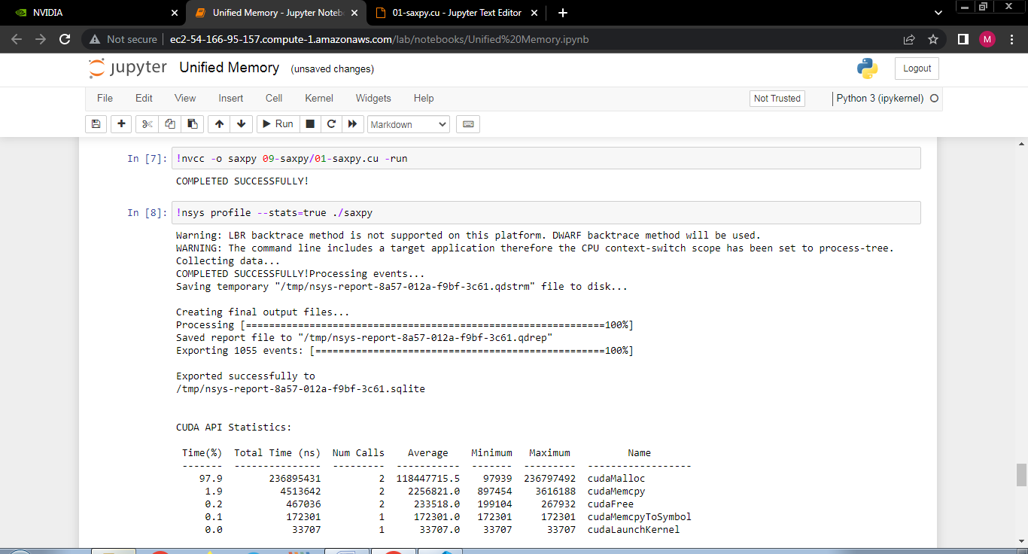

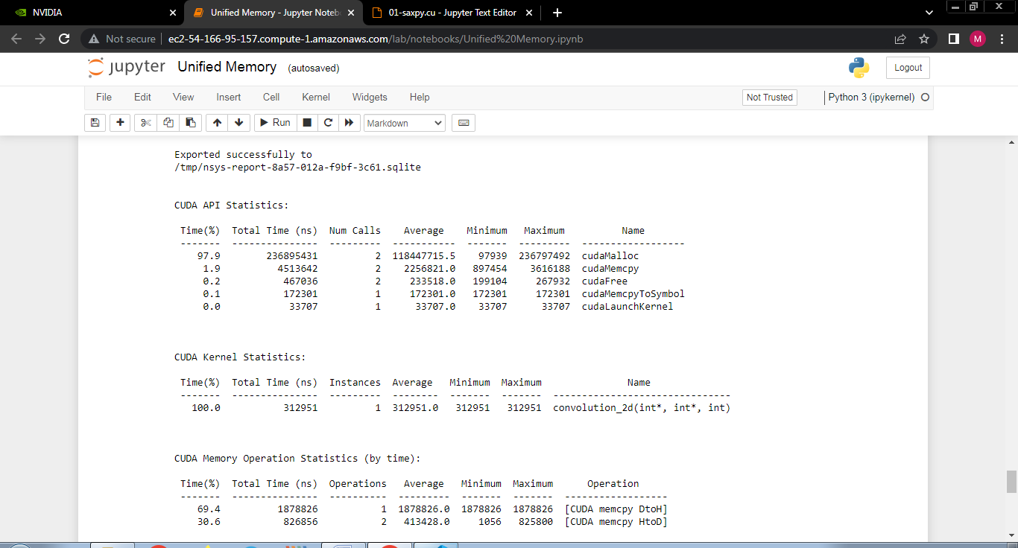

Github Link : https://github.com/pavanshinde7494/HPC-Assignment

