Class: Final Year (Computer Science and Engineering)
Year: 2022-23 Semester: 1
Course: High Performance Computing Lab

Practical No. 6
PRN No : 2019BTECS00110
Name :Pavan Krishnat Shinde

Q1: Implement a MPI program to give an example of Deadlock.
Code:
#include "mpi.h"
#include <math.h>
int main(int argc, char **argv)
{
MPI_Status status;
int num;

MPI_Init(&argc, &argv);
MPI_Comm_rank(MPI_COMM_WORLD, &num);

double d = 100.0;
int tag = 1;

if (num == 0)
{
//synchronous Send
MPI_Ssend(&d, 1, MPI_DOUBLE, 1, tag, MPI_COMM_WORLD);
MPI_Recv(&d, 1, MPI_DOUBLE, 1, tag, MPI_COMM_WORLD, &status);
}
else
{
//Synchronous Send
MPI_Ssend(&d, 1, MPI_DOUBLE, 1, tag, MPI_COMM_WORLD);
MPI_Recv(&d, 1, MPI_DOUBLE, 1, tag, MPI_COMM_WORLD, &status);
}

MPI_Finalize();
return 0;
}

Output: 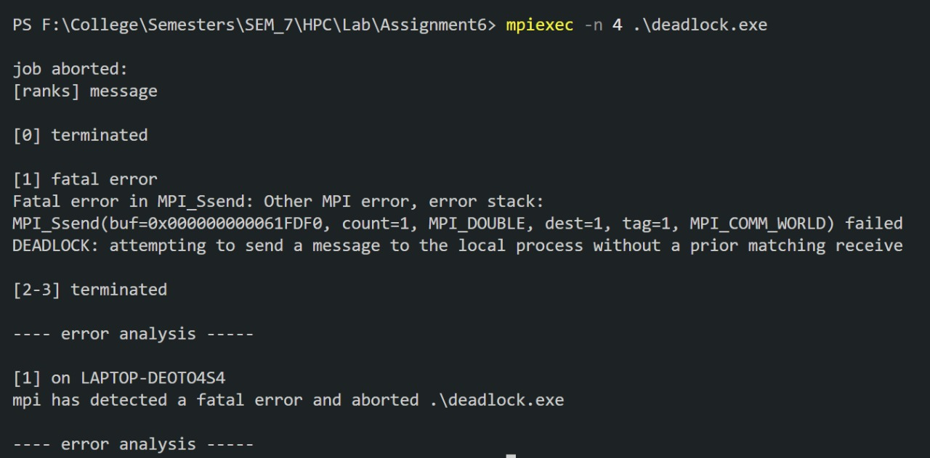

Q2. Implement blocking MPI send & receive to demonstrate Nearest neighbor exchange of data in a ring topology.
Code:
#include "mpi.h"
#include <stdio.h>

int main(int argc, char **argv)
{
int rank;
int num;

MPI_Init(&argc, &argv);

MPI_Comm_size(MPI_COMM_WORLD, &num);
MPI_Comm_rank(MPI_COMM_WORLD, &rank);

MPI_Status status;

double d = 483048.0;
int tag = 1;

//calculating next rank
int rank_next = (rank + 1) % num;
//prev process rank
int rank_prev = rank == 0 ? num - 1 : rank - 1;

if (num % 2 == 0)
{
printf("Rank %d: sending to %d\n", rank, rank_next);
MPI_Send(&d, 1, MPI_DOUBLE, rank_next, tag, MPI_COMM_WORLD);

printf("Rank %d: receiving from %d\n", rank, rank_prev);
MPI_Recv(&d, 1, MPI_DOUBLE, rank_prev, tag, MPI_COMM_WORLD, &status);
}
else
{
printf("Rank %d: receiving from %d\n", rank, rank_prev);
MPI_Recv(&d, 1, MPI_DOUBLE, rank_prev, tag, MPI_COMM_WORLD, &status);

printf("Rank %d: sending to %d\n", rank, rank_next);
MPI_Send(&d, 1, MPI_DOUBLE, rank_next, tag, MPI_COMM_WORLD);
}

MPI_Finalize();
return 0;
}

Output:
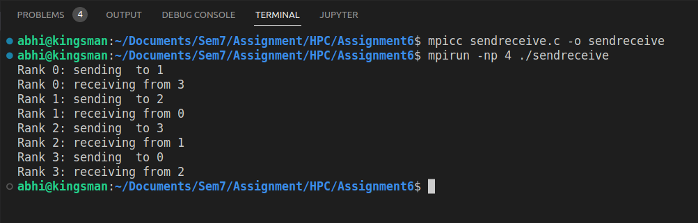

Q3. Write a MPI program to find the sum of all the elements of an array A of size n. Elements of an array can be divided into two equals groups. The first [n/2] elements are added by the first process, P0, and last [n/2] elements the by second process, P1. The two sums then are added to get the final result.

Code:
#include "mpi.h"
#include <stdio.h>

#define localSize 1000

int local[1000]; // to store the subarray data comming from process 0;

int main(int argc, char **argv)
{
int rank;
int num;

int n = 10;
int arr[10] = {1, 2, 3, 4, 5, 6, 7, 8, 9, 10};

int per_process, elements_received;

MPI_Init(&argc, &argv);

MPI_Comm_size(MPI_COMM_WORLD, &num);
MPI_Comm_rank(MPI_COMM_WORLD, &rank);

MPI_Status status;

// process with rank 0 will divide data among all processes and add partial sums to get final sum
if (rank == 0)
{
int index, i;

per_process = n / num;

if (num > 1) // if more than 1 processes available
{
//divide array data among processes
for (i = 1; i < num - 1; i++)
{
//calculating first index of subarray that need to be send to ith process
index = i * per_process;

//send no of elements and subarray of that lenght to each process
MPI_Send(&per_process, 1, MPI_INT, i, 0, MPI_COMM_WORLD);
MPI_Send(&arr[index], per_process, MPI_INT, i, 0, MPI_COMM_WORLD);
}

// for last process send all remaining elements
index = i * per_process;
int ele_left = n - index;

MPI_Send(&ele_left, 1, MPI_INT, i, 0, MPI_COMM_WORLD);
MPI_Send(&arr[index], ele_left, MPI_INT, i, 0, MPI_COMM_WORLD);
}

// add numbers on process with rank 0
int sum = 0;
for (int i = 0; i < per_process; i++)
{
sum += arr[i];
}

// add all partial sums from all processes
int tmp;
for (int i = 1; i < num; i++)
{
MPI_Recv(&tmp, 1, MPI_INT, MPI_ANY_SOURCE, 0, MPI_COMM_WORLD, &status);

int sender = status.MPI_SOURCE;

sum += tmp;
}

printf("Sum of array = %d\n", sum);
}
else // if rank of process is not 0, then receive elements and calculate partial sums
{
// receive no of elements and elements form process 0 and store them on local array
MPI_Recv(&elements_received, 1, MPI_INT, 0, 0, MPI_COMM_WORLD, &status);

MPI_Recv(&local, elements_received, MPI_INT, 0, 0, MPI_COMM_WORLD, &status);

// calculate partial local sum
int partial_sum = 0;
for (int i = 0; i < elements_received; i++)
{
partial_sum += local[i];
}

//send calculated partial sum to process with rank 0
MPI_Send(&partial_sum, 1, MPI_INT, 0, 0, MPI_COMM_WORLD);
}

MPI_Finalize();
return 0;
}

Output:
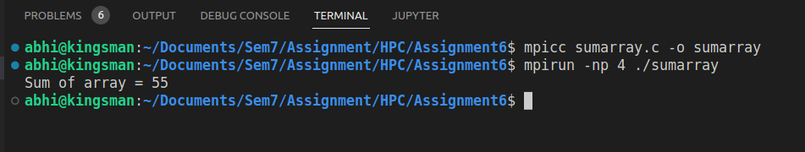

Github Link : https://github.com/pavanshinde7494/HPC-Assignment

