**ARDUINO BASED LASER BASED THEFT DETECTION SYSTEM**

**PRINCIPLE:**

There are three essential components to a laser security system: a laser, a detector and sensing circuit. The laser is a concentrated light source that puts out a straight line, 'pencil beam, of light of a single color. The detector is sensitive to light and puts out a voltage when the laser light hits it. The detector is connected to the sensing circuit. When the laser beam is interrupted and cannot reach the detector, its voltage output changes, and the circuit sense the change and put out a warning signal.

**WORKING :**

The basic sensing component of a modern laser security system is an infrared motion detector. The motion detector contains four parts: the laser, the mirrors, the detector and the sensing electronics. An infrared motion detector works by projecting a beam of light that shoots across a space into a series of mirrors and finally into a detector, which emits a particular voltage into the sensing electronics as long as the laser hits it. When the beam of light is broken, the detector changes its voltage output into the sensing electronics, which then trigger an alarm.

If infrared sensors are placed strategically, the beams of light will make it impossible for an intruder to come into the area without the sensor being alerted. The sensor, which is connected to the basic alarm unit through a wireless connection, then triggers the basic unit to alert the monitoring service through which the customer purchased the security plan. The monitoring service will contact the home and, if no response is received, will contact the police. In most models, the basic unit also sounds a loud alarm, though some systems use a silent alarm that contacts the police without notifying the suspected criminal.

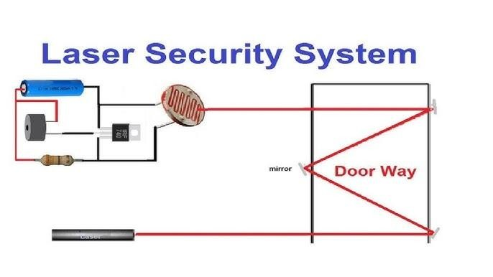

**CIRCUIT DIAGRAM:**

