**BLOCK DIAGRAM:**

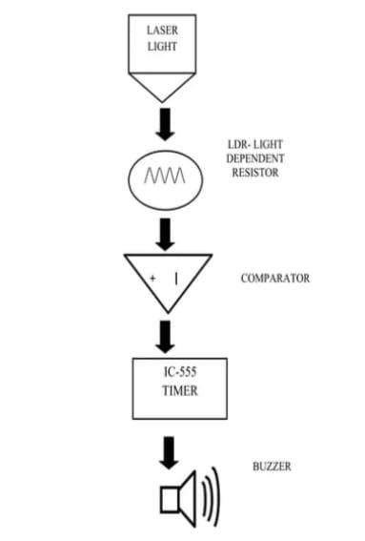

**COMPONENTS REQUIRED:**

Laser

LDR Light Sensor

Buzzer

Arduino

Battery

Connecting wires

Switch

**1.Laser**

A laser is a device that emits light through a process of optical amplification based on the stimulated emission of electromagnetic. radiation. The term "laser originated as an acronym for "light amplification by stimulated emission of radiation".

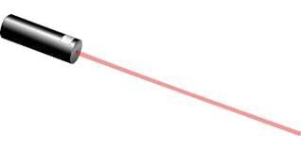

**2. LDR LIGHT SENSER (Light Dependent Resistor):**

A photo resistor or light-dependent resistor (LDR) or photocell is a light-controlled variable resistor. The resistance of a photo resistor decreases with increasing incident light intensity; in other words, it exhibits photoconductivity. A photo resistor can be applied in lightsensitive detector circuits, and light and dark-activated switching circuits.

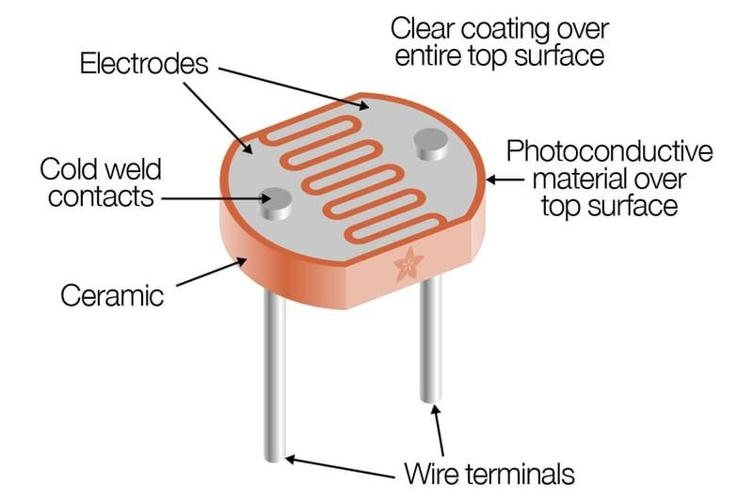

**3.BUZZER: -**

A buzzer or beeper is an audio signaling device, which may be mechanical, electromechanical, and piezoelectric. Typical uses of buzzers and beepers include alarm devices, timers and confirmation of user input such as a mouse click or keystroke.

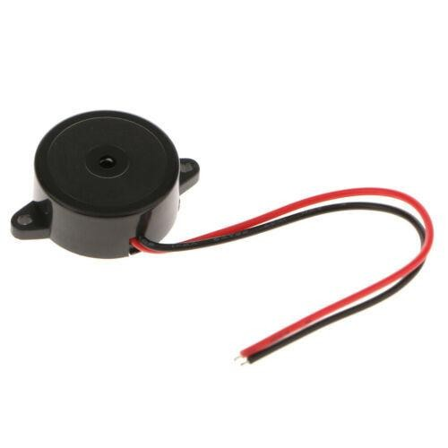

**4.Arduino**

Arduino is an open-source platform used for building electronics projects. your computer, used to write and upload computer code the physical board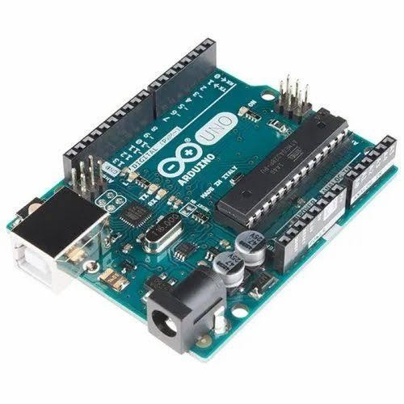

**BATTERY:**

An electric battery is a device consisting of two or more electrochemical cells that convert stored chemical energy into electrical energy. Each cell contains a positive terminal, or cathode, and a negative terminal, or anode**.**

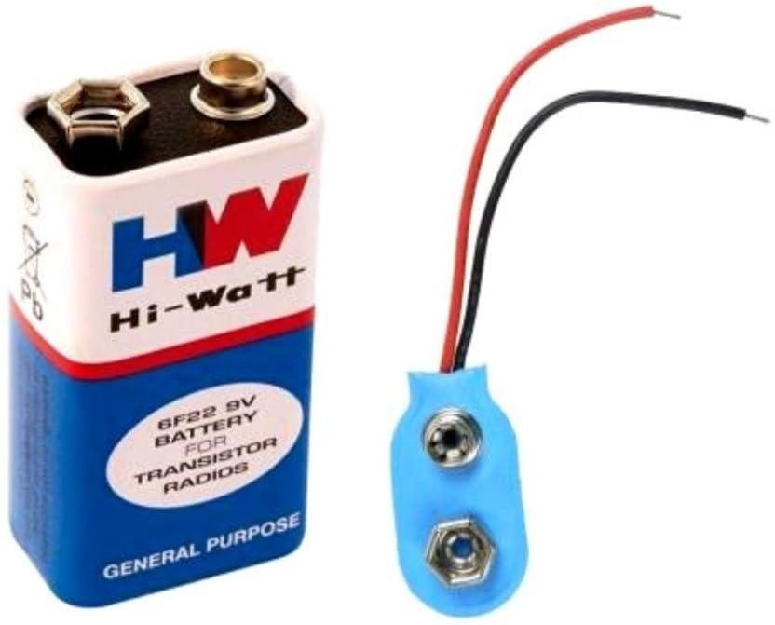

**Connecting wires:**

Connecting wires allows an electrical current to travel from one point on a circuit to another because electricity needs a medium through which it can move.

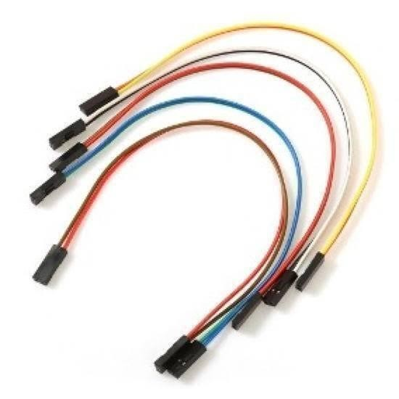

**7. SWITCH:**

Switch is an electronic device that is used to make or break an electrical circuit. The primary application of switch is to ON-OFF any circuit. The different types of switches which are widely used across industries such as Telecommunication, Industry control equipment, Commercial equipment, and Home appliances.

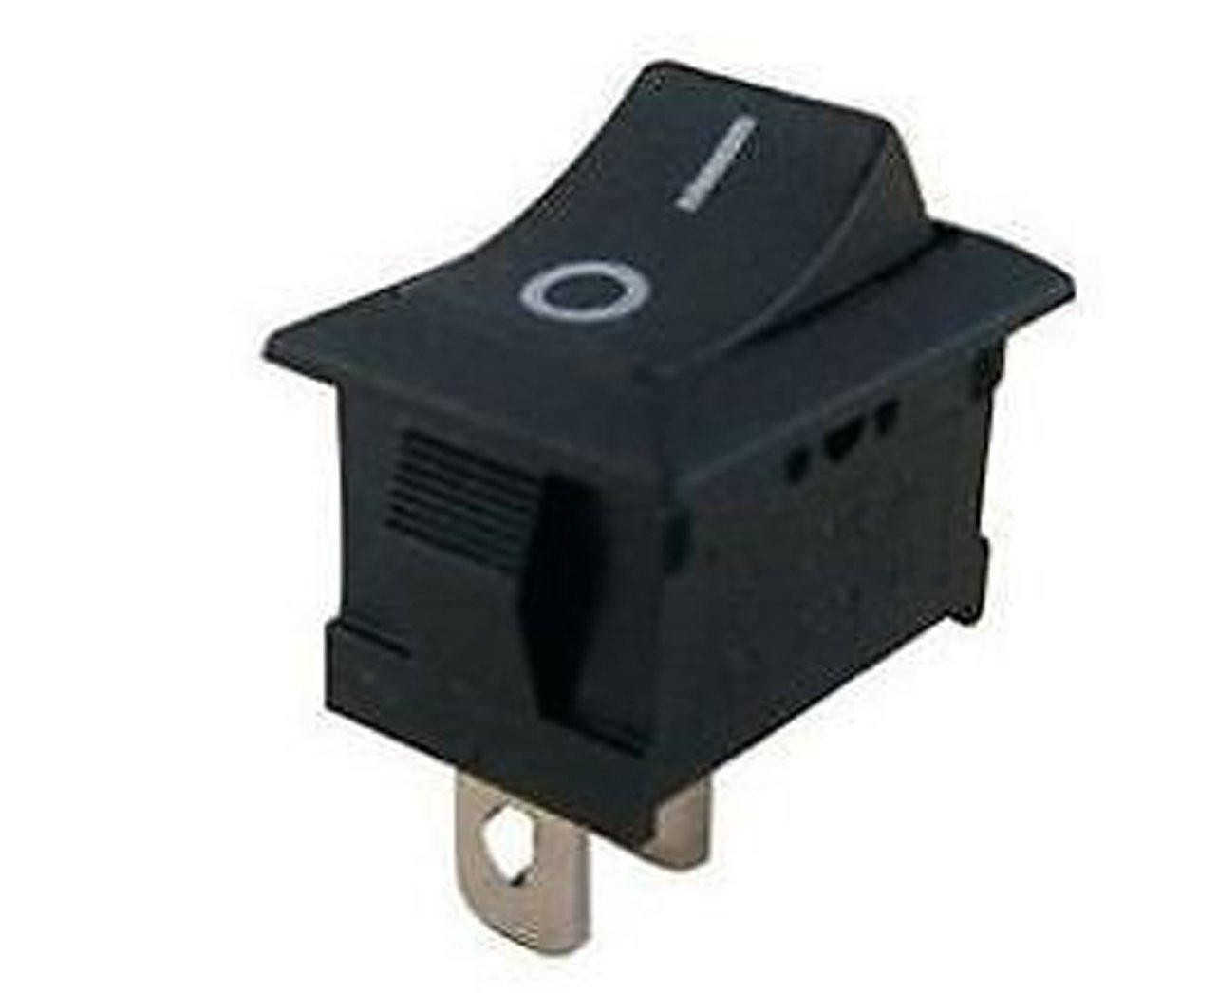

**APPLICATIONS:**

Laser Security System can be used in safety lockers in our homes, where even if the locker's code is hacked, it acts as an additional layer of security.

Apart from security systems, this laser-based setup can also be used to check if pets or babies crossed a certain boundary.

These are easy to install and work at both within as well as outside houses. These are very effective perimeter alarm systems around. properties. In indoor systems can utilize the normal power outlets and jacks making them inconspicuous. At outside these can be easily be hidden behind the bushes or plants without causing any damage. They consume less power when compared to the laser system as the whole, which is expensive.

These laser systems can be installed in homes either by self or by hiring a technical person. By technological innovations cost of the security systems has been cut to a large extent. So, making laser systems one among affordable security system options can be very safe.

Lasers are strong in beam width and can be focused on the perfect target. By using laser security system one can be safe in the case strong of harmful effects to the body. As the beam width used in the laser security systems are not beam widths.

The circuit, construction and setup for the Laser Security System are very simple. If used with a battery, the laser security system can work even when there is a power outage.

**ADVANTAGES:**

* **Cost-effective** and budget-friendly.
* **Customizable** and easy to modify.
* **Simple installation** with basic electronics knowledge.
* **Energy-efficient** for long-term use.
* **Real-time alerts** for immediate detection.

**DISADVANTAGES:**

* **Limited range** in larger areas.
* **Environmental factors** (dust, rain) may cause false alarms.
* Requires **basic technical skills**.
* **No remote monitoring** in basic setups.
* Lacks advanced features like video surveillance.

**APPLICATIONS:**

* **Home Security**: Protects homes from unauthorized entry by detecting intruders.
* **Business Security**: Secures small businesses or offices from theft during off-hours.
* **ATM Security**: Detects unauthorized access or tampering with ATMs.
* **Museum Protection**: Safeguards valuable artifacts in museums or galleries.
* **Warehouse Security**: Monitors entry points in warehouses to prevent unauthorized access.