**Docker Compose And Nagios**

**Docker Compose**

**1. Writing a Basic docker-compose.yml File**

**Step 1: Create a Folder**

Go to your desktop or any folder you prefer.

Right-click and select New Folder.

Name the folder my_docker_project.

**Step 2: Open a Text Editor**

Open Visual Studio Code, Notepad, or any other text editor.

Create a new file.

**Step 3: Write the YAML Configuration**

Here’s a simple example of a docker-compose.yml file for WordPress and MySQL:

version: '3.1'

services:

db:

2 RKR21 SOFTWARE ENGINEERING LAB CSE/IT/CSM/CSD III/I

image: mysql:5.7

container_name: mysql_container

environment:

MYSQL_ROOT_PASSWORD: rootpassword

MYSQL_DATABASE: wordpress_db

MYSQL_USER: wordpress_user

MYSQL_PASSWORD: wordpress_pass

volumes:

- db_data:/var/lib/mysql

wordpress:

depends_on:

- db

image: wordpress:latest

container_name: wordpress_container

ports:

- "8000:80"

environment:

WORDPRESS_DB_HOST: db:3306

WORDPRESS_DB_USER: wordpress_user

WORDPRESS_DB_PASSWORD: wordpress_pass

WORDPRESS_DB_NAME: wordpress_db

volumes:

- ./wordpress_data:/var/www/html

volumes:

3 RKR21 SOFTWARE ENGINEERING LAB CSE/IT/CSM/CSD III/I

db_data:

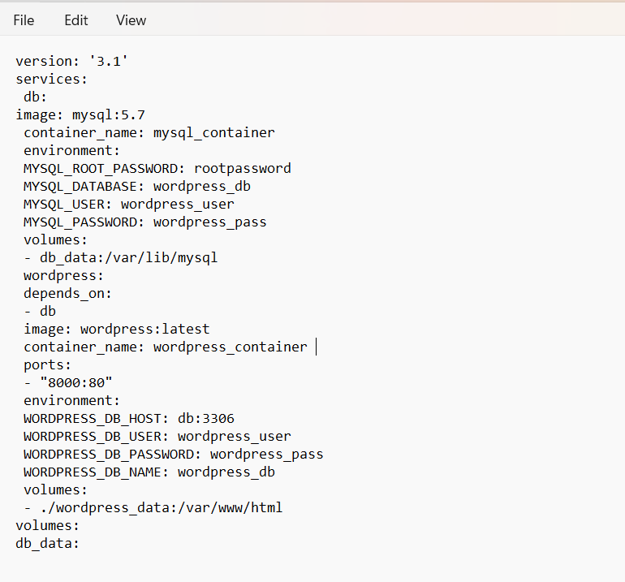

**2. Saving the File**

Save the file as docker-compose.yml.

Place it in the my_docker_project folder.

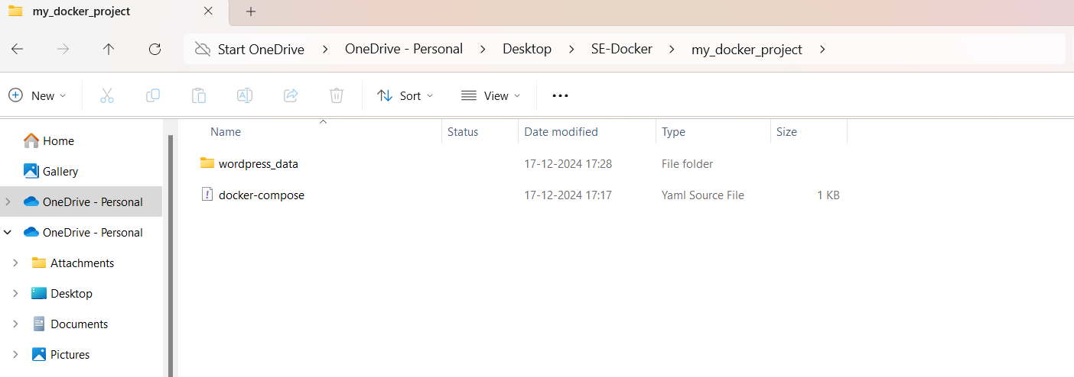

**3. Running the Setup**

**Step 1: Open Command Line**

Open PowerShell or Command Prompt.

Navigate to the my_docker_project folder:

cd path_to_my_docker_project

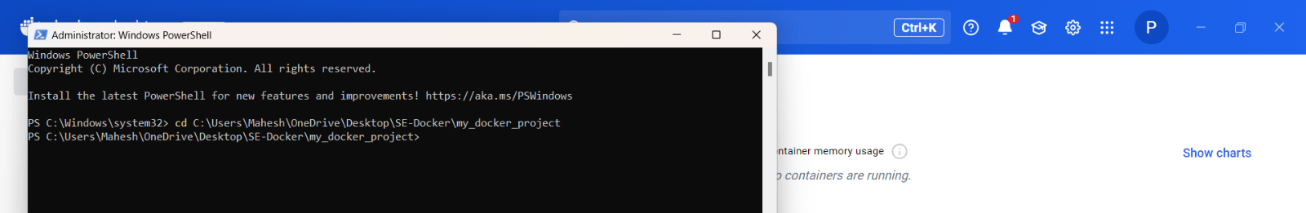

**Step 2: Start the Containers**

Run:

**docker-compose up -d**

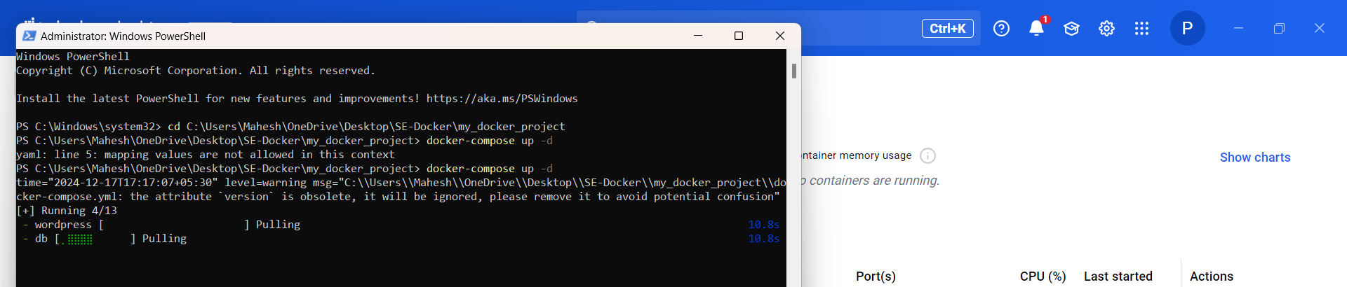

This command reads the docker-compose.yml file and creates both the WordPress and MySQL

containers.

-d runs the containers in the background.

**4. Accessing the Application**

Open your web browser.

Go to [**http://localhost:8000**](http://localhost:8000)

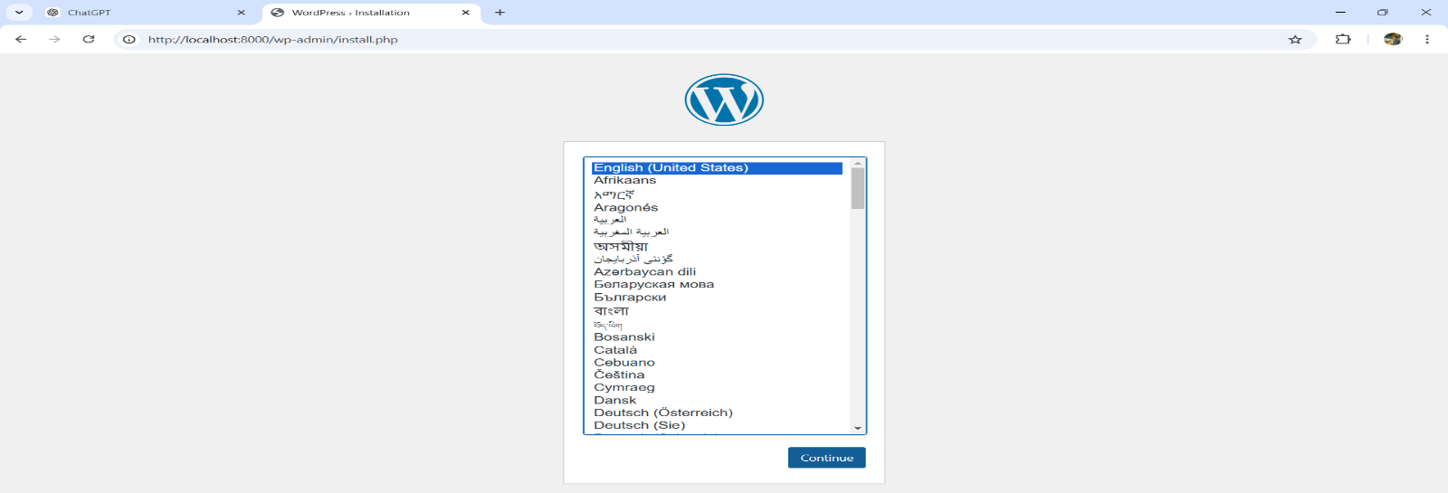

Follow the WordPress setup wizard to complete the installation:

Site Name.

Admin Username and Password.

Email Address.

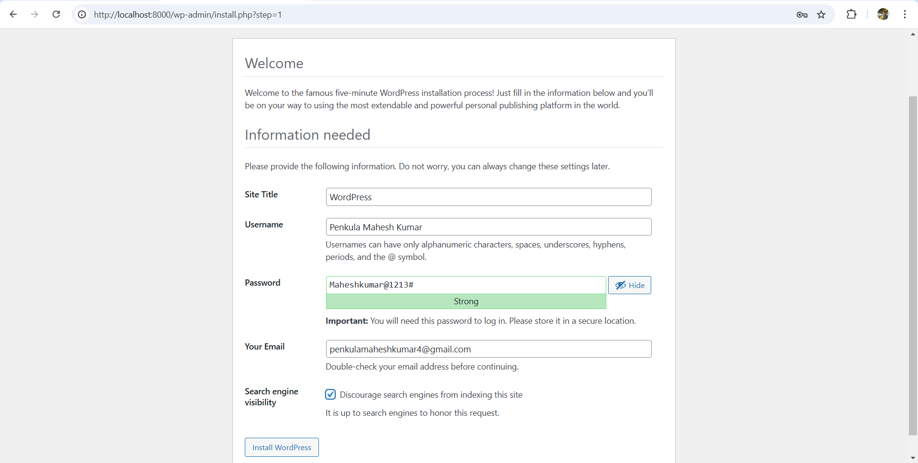

**8. Managing Containers**

Stop the Containers

To stop the containers without removing them:

**docker-compose stop**

Start Again

To restart the containers:

**docker-compose start**

Remove Containers

To stop and remove everything:

**docker-compose down**

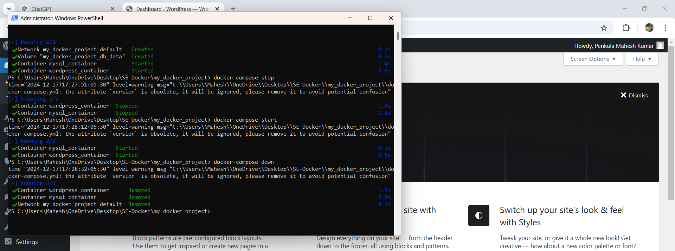

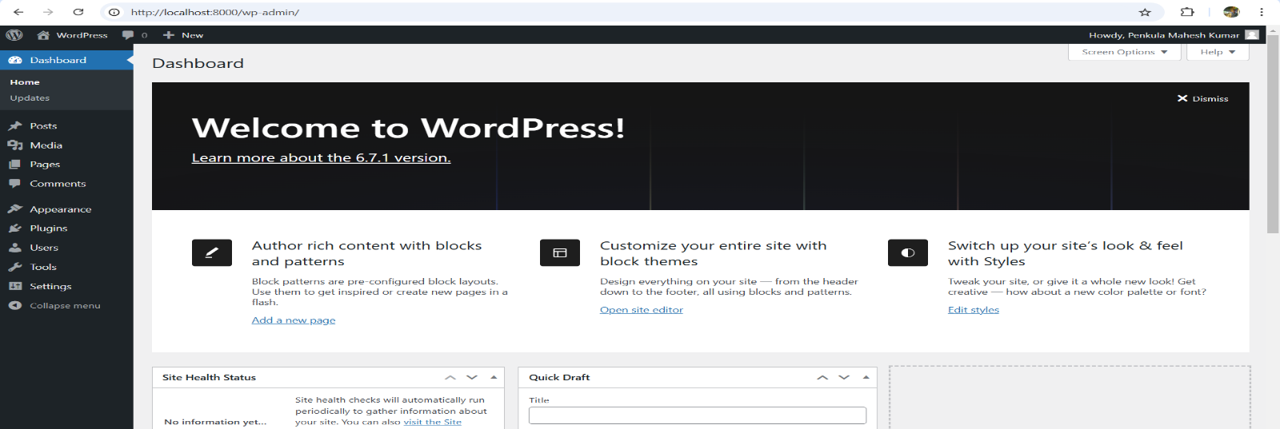

**Nagios**

1.Run Docker Desktop 2.Open PowerShell as administrator and type the following command **docker version** [to check that both client and dockere daemon are running] 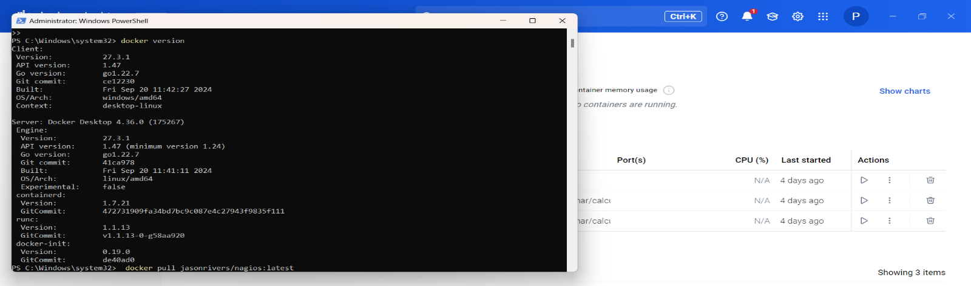

Pull the Nagios image from the Docker Hub with the following command

**docker pull jasonrivers/nagios:latest**

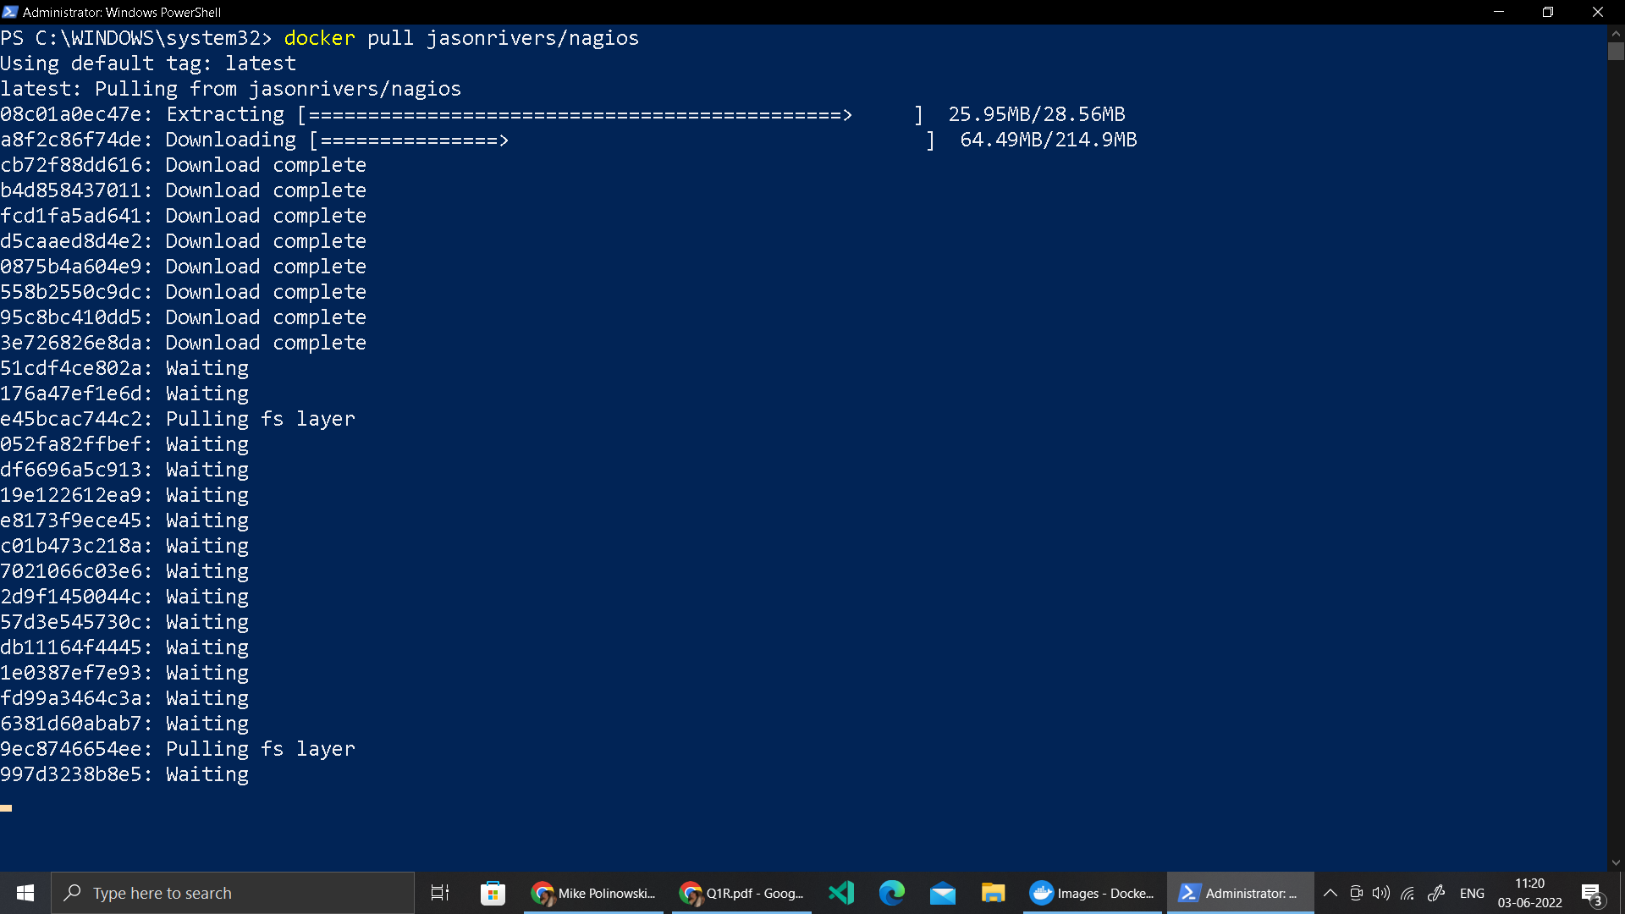

**docker run --name nagios4 -p 0.0.0.0:8888:80 jasonrivers/nagios:latest**

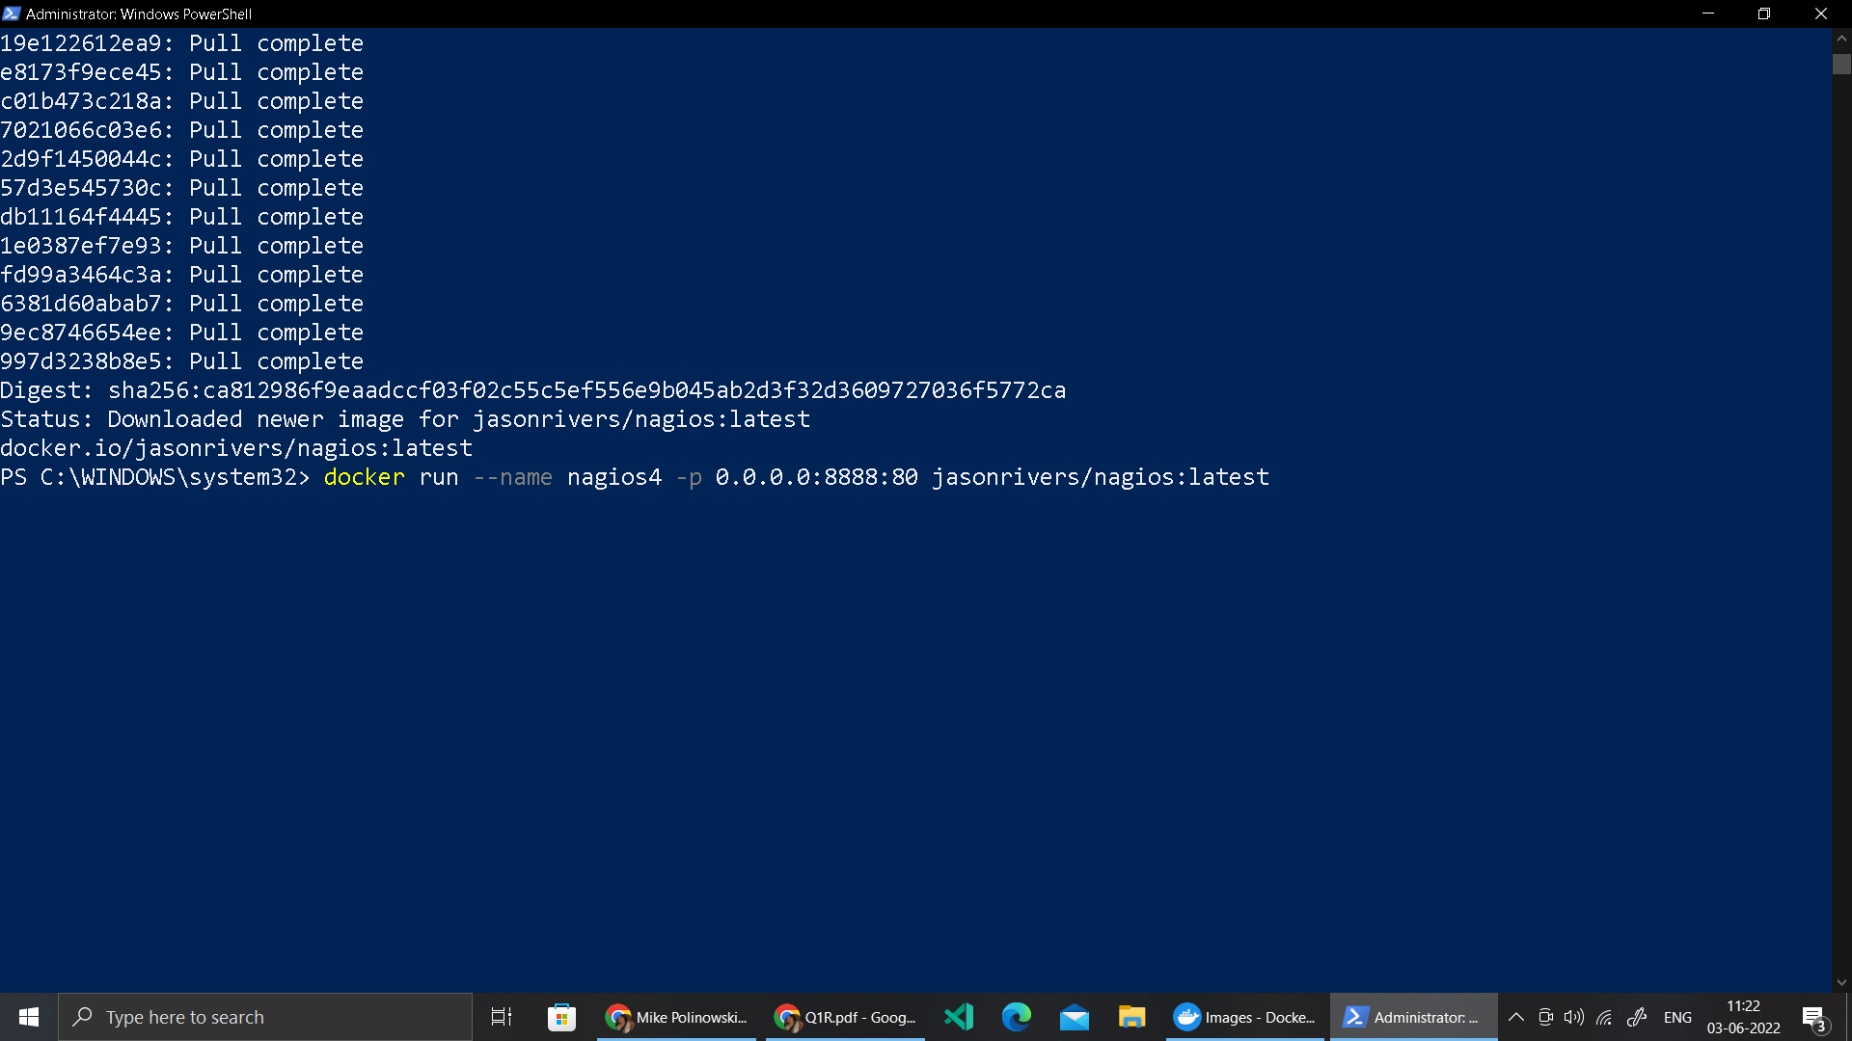

Nagios is successfully launched

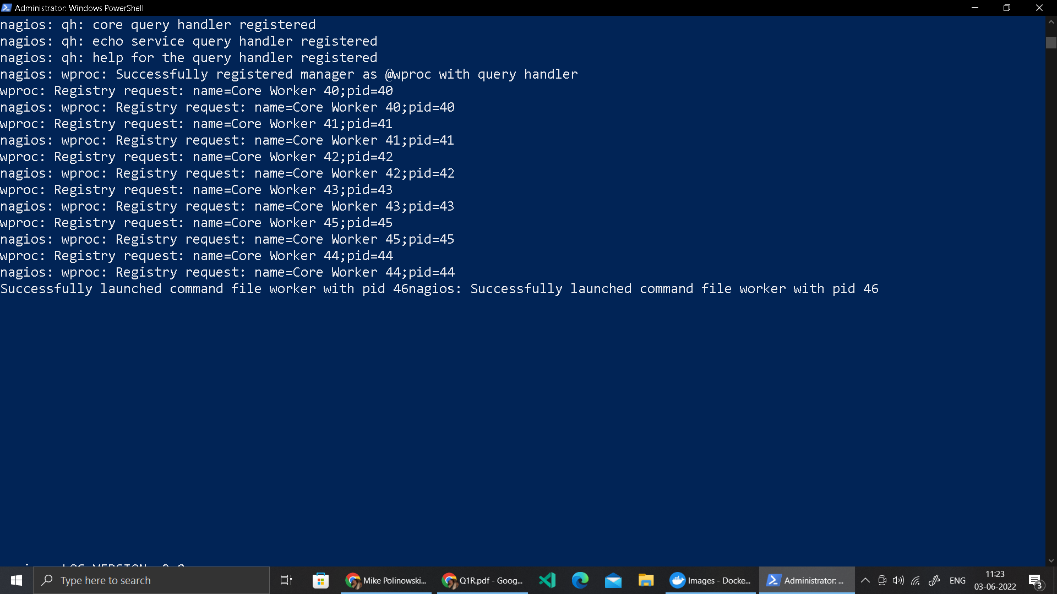

We can access Nagios at the browser at port **8888** [**localhost:8888**]The default credentials for the web interface is nagiosadmin / nagios



Nagios dashboard is the interface to monitor the services

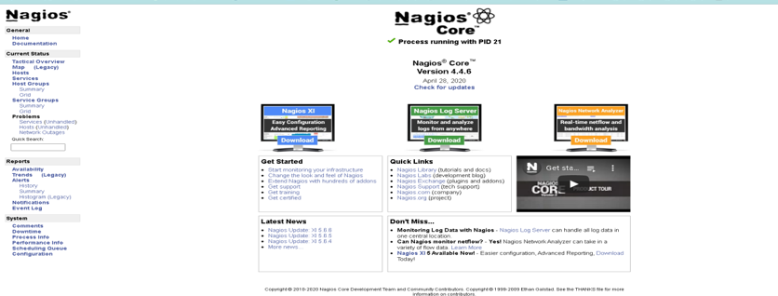

Host services [ left side pane can be used for selection.

Click on localhost to check the Host State information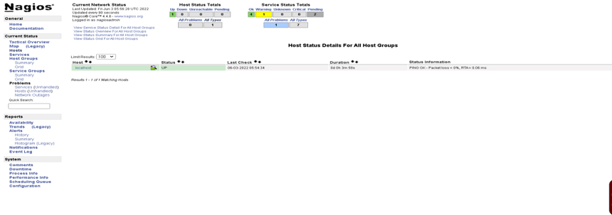

Click on localhost to check the Host State information

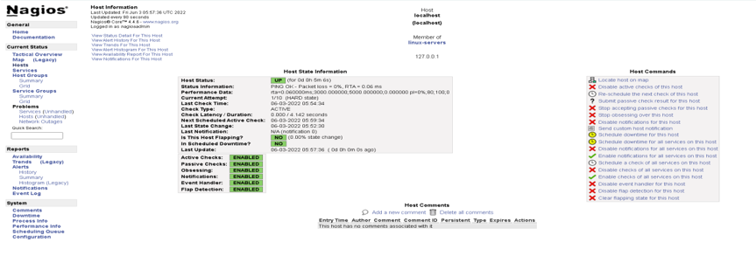

Click on services to check the various services running **CurrentLoad, Current User, HTTP, PING etc**

