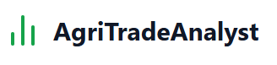

**A one-stop web platform empowering smallholder farmers with real-time finance tracking, predictive pricing, loan eligibility checks, and curated government schemes—all in their local language.**

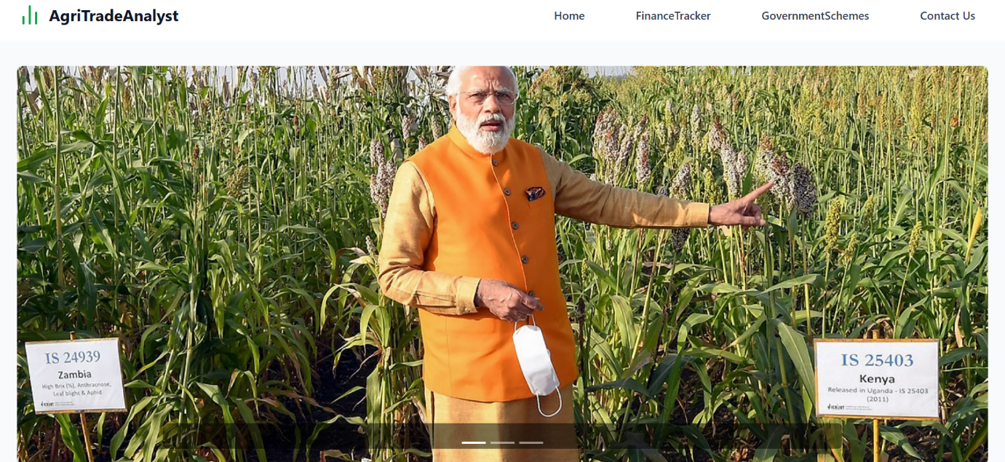

**1. Home Page:**

**Upon landing, users are greeted by a vibrant carousel showcasing key features—live finance charts, success stories, and the latest subsidy alerts. A sticky navigation bar ensures seamless movement between sections: Services, Finance Tracker, Data Insights, Loans, Subsidies & Schemes, Language Support, and Contact Us. The design uses clear icons, concise labels, and a responsive layout so farmers can quickly find what they need on any device.**

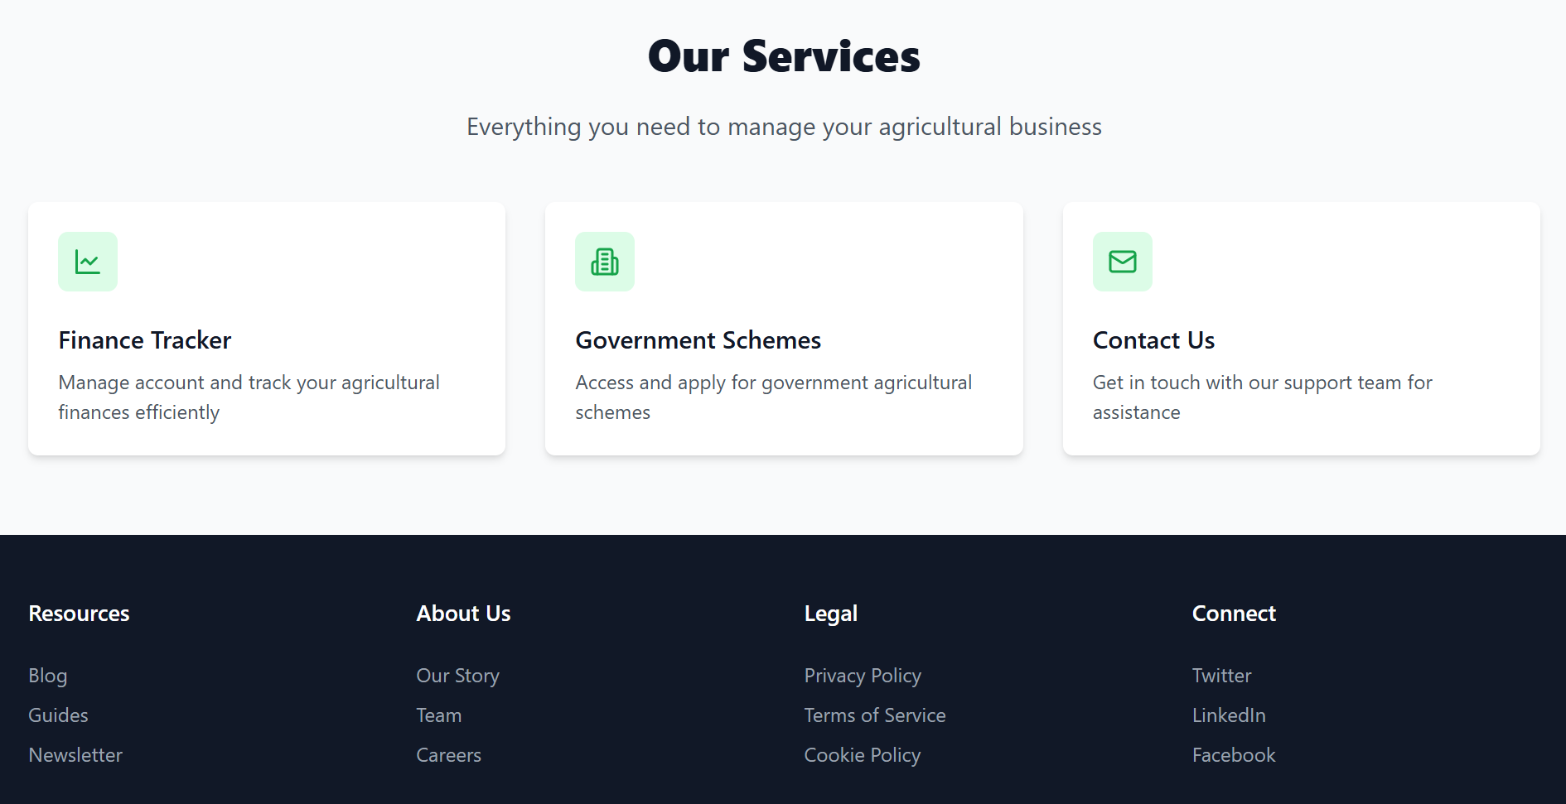

**2. Core Services:**

* **Finance Tracker:** Instant view of income, expenses, and net profit.
* **Price Forecasting:** 30-day ML crop-price predictions by district.
* **Expense Breakdown:** Per-acre cost details (seed, equipment, water, labor).
* **Loan Checker:** Auto-approve if profit margin > 50%; otherwise suggest alternatives.
* **Schemes Directory:** Filter and apply for subsidies by crop, region, and farm size.
* **Multilingual UI:** Switch to local languages with one click.

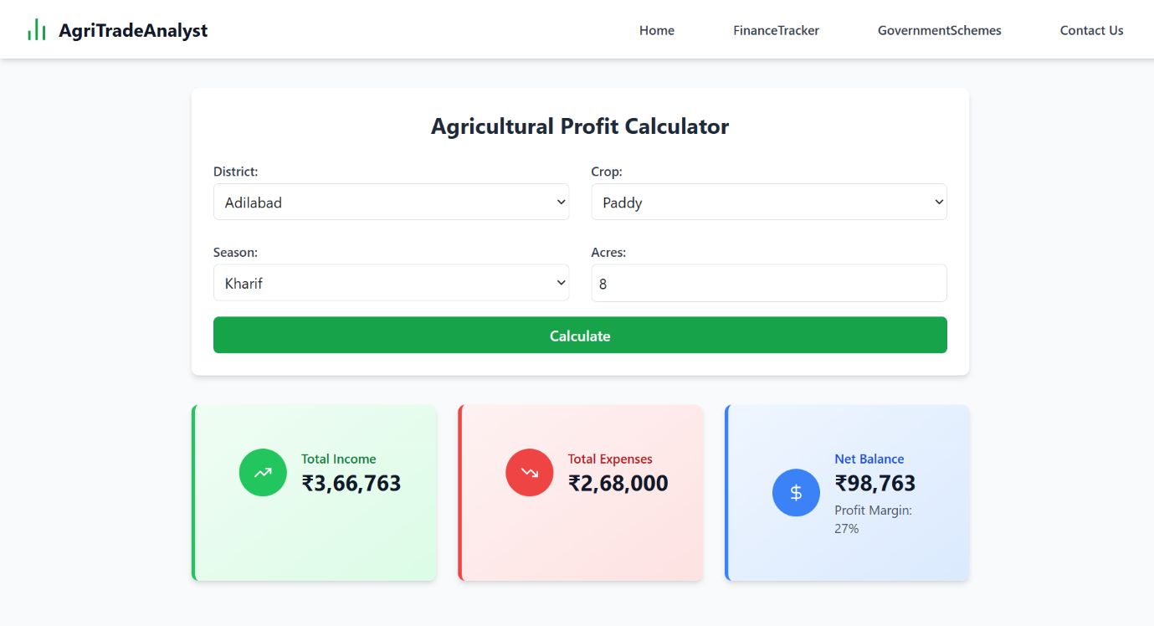

**3. Finance Tracker Module**

**This critical tool is split into three intuitive panels:**

* **Total Income: Aggregates forecasted crop revenues.**
* **Total Expenses: Summarizes per-acre costs across inputs.**
* **Net Balance: Calculates profit to inform budgeting and lending decisions.  
  Vibrant gauges and progress bars make financial health easy to interpret, while downloadable reports enable record-keeping and sharing with advisors or banking partners.**

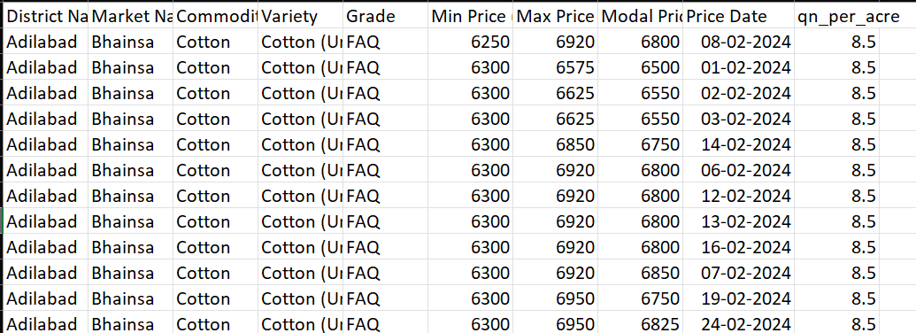

**4. District Dataset (District_Dataset.csv)**

**Our District Dataset contains historical and predicted market prices for key crops across regions. Fields include:**

* **District Name**
* **Crop Name**
* **Acres Cultivated**
* **30-Day Price Forecast (ML-derived)  
  This dataset fuels the Total Income calculator, ensuring location-specific accuracy and transparency.**

**5. Calculating Total Income**

**Farmers simply select:**

1. **District Name → narrows down regional price trends**
2. **Crop Name → pulls the relevant forecast data**
3. **No. of Acres → scales revenue estimates**

**Formula:**

**Total Income = (Average Forecasted Price per Quintal × Quintals per Acre) × Number of Acres**

**By automating this calculation, AgriTradeAnalyst removes guesswork and helps farmers plan sales and investments confidently.**

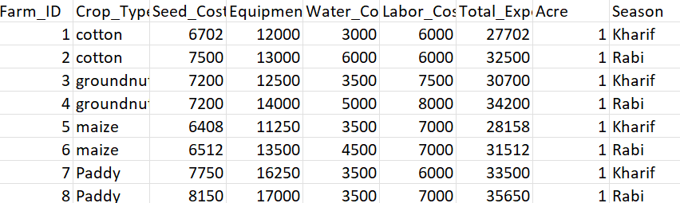

**6. Crop Cost Dataset (Cropcost.csv)**

**The Crop Cost Dataset itemizes seasonal expenses for each crop:**

* **Crop Type**
* **Season**
* **Seed Cost**
* **Equipment Cost**
* **Water Cost**
* **Labor Cost**

**These inputs combine to yield the per-acre Total Expense, ensuring farmers have a clear view of their outlays before planting.**

**7. Calculating Total Expenses**

**Through dropdown selections—Crop Type, Season, and No. of Acres—the system computes:**

**Total Expenses = (Total Expense per Acre) × Number of Acres**

**This breakdown helps identify cost-intensive stages and opportunities for savings or subsidy applications.**

**8. Net Balance Calculation**

**The Net Balance panel integrates both income and expense figures in real time:**

**Net Balance = Total Income – Total Expenses**

**A positive balance triggers colorful success alerts, while negative figures prompt actionable tips—like adjusting input levels or exploring higher-value crops.**

**9. Loan Approval Module**

**AgriTradeAnalyst streamlines loan decisions by evaluating:**

* **Profit Margin (Net Balance ÷ Total Expenses)**
* **Bank-Specific Interest Rates**

**If the profit margin exceeds 50%, the system flags the application as Approved; otherwise, it suggests alternative financing options or cost-reduction strategies.**

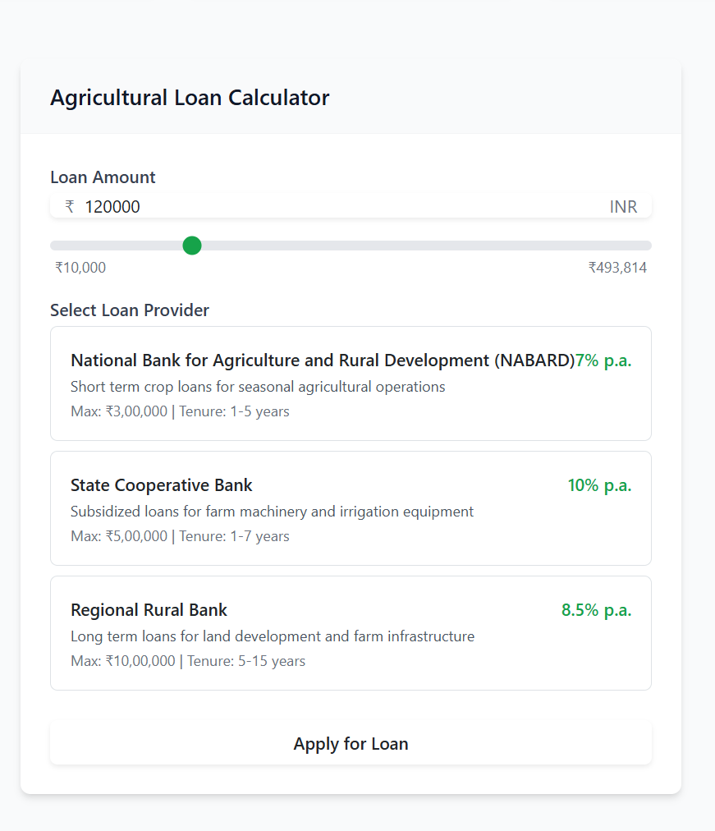

**10. Government Schemes & Subsidies**

**Our platform maintains an up-to-date catalogue of national and state agricultural programs. Farmers can:**

* **Filter by Crop, Region, Farm Size**
* **Check Eligibility Criteria**
* **Submit preliminary Applications online**

**This feature ensures maximum utilization of grants, insurance schemes, and input subsidies.**

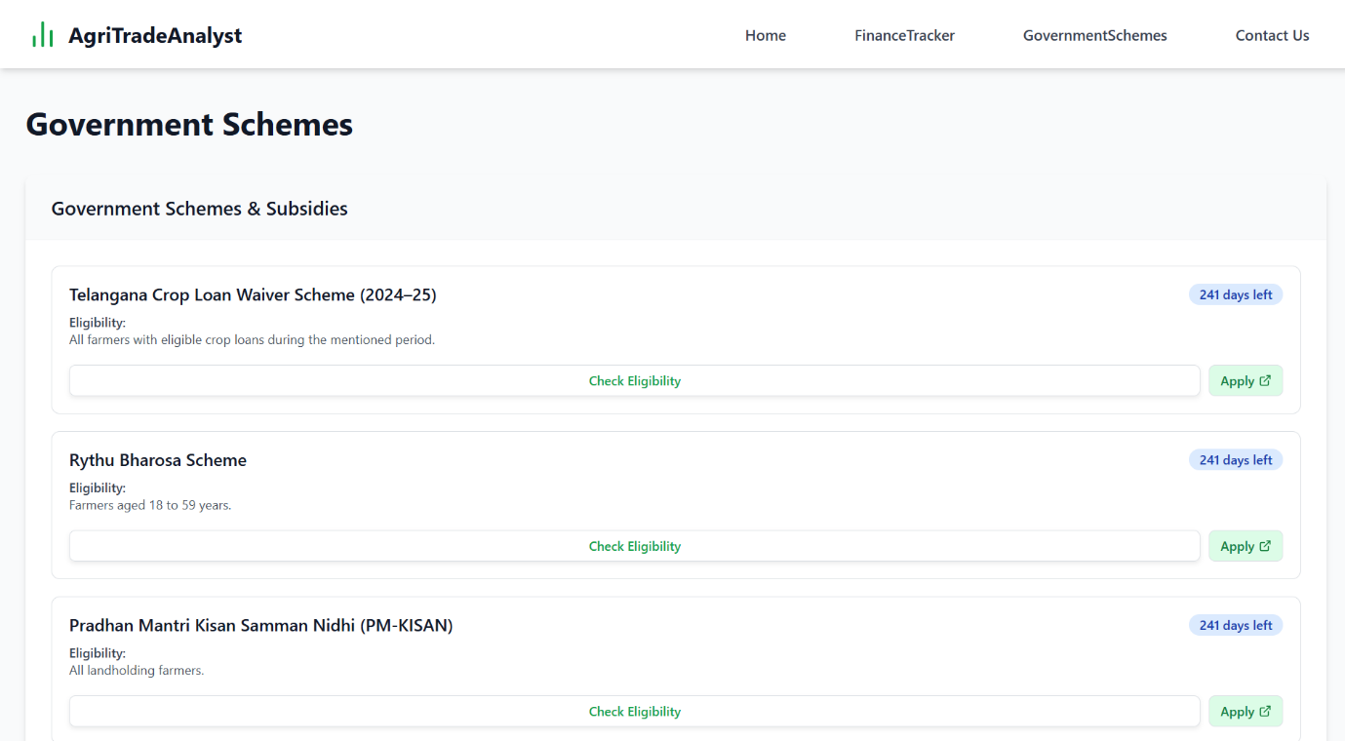

**11. Language Accessibility**

**To bridge literacy and language barriers, we’ve integrated Google Translate directly into the interface. Farmers can switch to their preferred local language instantly—ensuring no one is left behind due to script or dialect differences.**

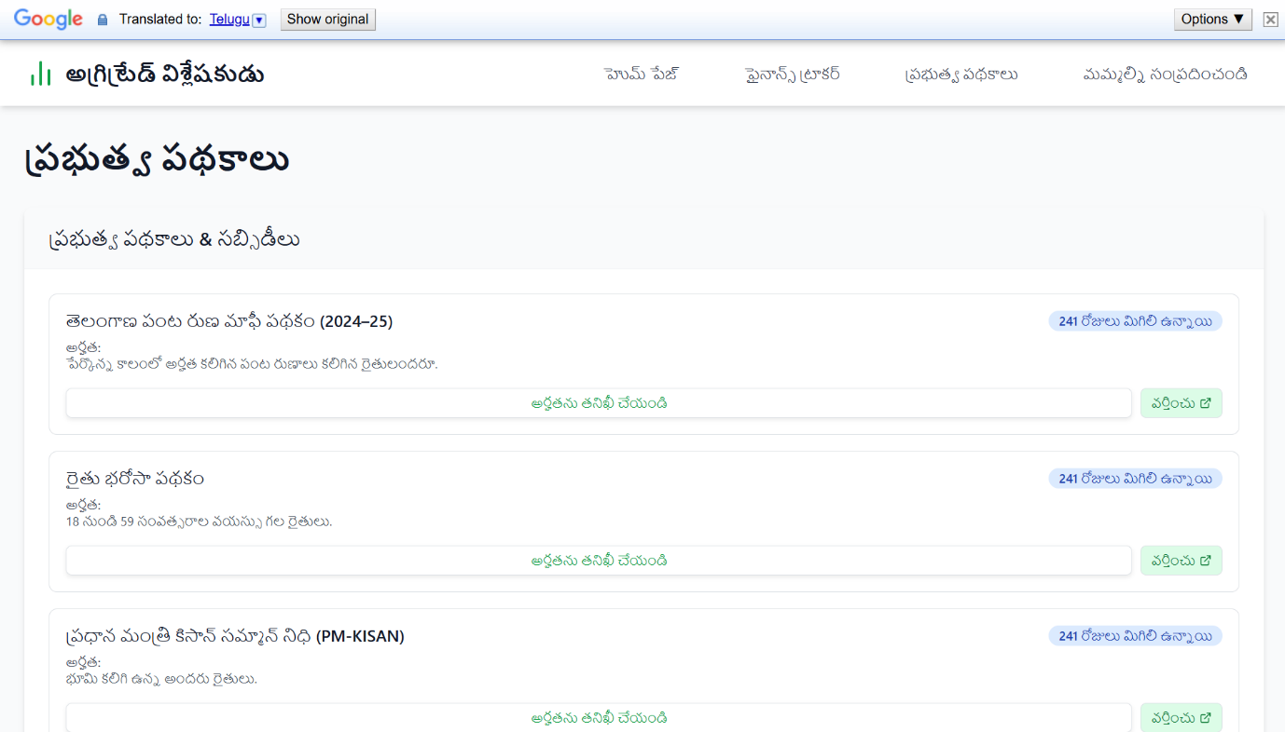

**12. Contact Us**

**A dedicated Contact Us section provides:**

* **Live Chat with AgriTradeAnalyst support agents**
* **Email & Phone for detailed inquiries**
* **Feedback Form to suggest new features or flag issues**

**Our goal is to maintain an open channel so farmers always have expert assistance at their fingertips.**

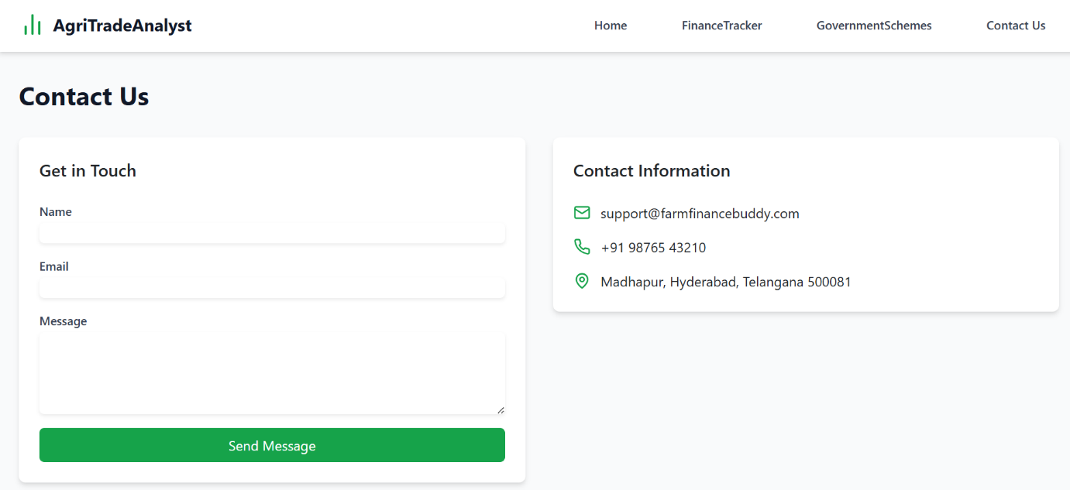

**TEAM JATHIRATNALU**

1. **PAVAN SINGI REDDY**
2. **VIJAY VARDHAN V**
3. **RAJKIRAN REDDY**
4. **SHASHANK KATTA**