KARNATAK LAW SOCIETY’S

GOGTE INSTITUTE OF TECHNOLOGY

UDYAMBAG, BELAGAVI-590008

(An Autonomous Institution under Visvesvaraya Technological University, Belagavi)

**(APPROVED BY AICTE, NEW DELHI)**

Department of Electronics and Communication Engineering



*Course Activity Report on*

**HOTEL MANAGEMENT SYSTEM**

**in**

***C/C++***

***Submitted by***

Punith Honnungar(2GI17EC088)

Pruthviraj Chavan(2GI17EC087)

Pavan Sogalad(2GI17EC070)

Rutik Budihal(2GI17EC102)

**Guide**

Prof. Maya.C

(Assistant Professor)

**2019-2020**

**OBJECTIVE:**

Implementation of hotel management system in C using structures,functions and looping constructs,with the following functionalities

* Adding Patient Info
* Viewing Patient Info
* Deleting Patient Info
* Exit

**CODE:**

#include<stdio.h>

#include<string.h>

struct ad

{

char name[30];

char disease[30];

int cabin,phone,age;

} x[100];

int n,i,j=0,a=0,sum=0,g,flag,num;

void add();

void view();

void del();

void read();

int main()

{

int c,i,q;

printf("GIT Hospital Management System\n");

int m,n;

//making out the pattern

for(m=1; m<=4; m++)

{

for(n=1; n<=5; n++)

printf(" ");

for(n=1; n<=m-1; n++)

{

printf(" ");

}

for(n=1; n<=4-m+1; n++)

{

if(n==4-m+1 || m==1 || m==4)

printf("*");

else

printf(" ");

}

for(n=1; n<=4-m+1; n++)

{

if(n==1 ||m==1 || m==4)

printf("*");

else

printf(" ");

}

printf("\n");

}

for(;;)

{

printf("**Enter your choice**\n\n1. Add Information\n2. View Information\n3. Delete Information\n4. Exit\n\nOption=");

scanf("%d",&c);//choice for option

fflush(stdin);//making it clear

switch(c){

case 1://add

add();

break;

case 2:

view();

break;

case 3:

del();

break;

case 4:

exit(0);

default:

printf("\n\nInvalid input , try again by using valid inputs");

printf("\n\n");

}

}

}

void add()

{

printf("\n\n");

printf("Number of entries present on the database =%d\n\n",num);//how many inputs

printf("How many entry do you want to add=\n");

scanf("%d",&n);

sum=n+num;

FILE *fp = fopen("patient.txt","a");

if(fp == NULL)

{

printf("Error");

exit(1);

}

for(i=num,j=0; i<sum; i++)

{

printf("\n");

//fflush(stdin);

printf("Enter patient's Name = ");

gets(x[i].name);

fprintf(fp, "Name = %s\n",x[i].name);

fflush(stdin);

printf("Enter disease = ");

gets(x[i].disease);

fprintf(fp, "Disease = %s\n",x[i].disease);

fflush(stdin);

printf("Enter the age = ");

scanf("%d",&x[i].age);

fprintf(fp, "Age = %d\n",x[i].age);

fflush(stdin);

printf("Enter cabin no = ");

scanf("%d",&x[i].cabin);

fprintf(fp, "Cabin = %d\n",x[i].cabin);

fflush(stdin);

printf("Enter phone number = ");

scanf("%d",&x[i].phone);

fprintf(fp, "Phone = %d\n",x[i].phone);

fflush(stdin);

printf("\n");

j++;

a++;

num++;

}

fwrite(x, sizeof(struct ad),num, fp);

fclose(fp);

}

void view()

{

FILE *fp = fopen("patient.txt","r");

if(fp == NULL)

{

//create empty file, so that we can open it

//in the next execution of this program

fp = fopen("patient.txt","w");

fclose(fp);

printf("File does not exist, I JUST CREATED IT, exiting...\n\n\n");

return 0;

}

for(i=0; i<num; i++)

{

printf("\n");

printf("Serial Number=%d\n",i);

printf("Name = ");

puts(x[i].name);

printf("Disease = ");

puts(x[i].disease);

printf("Cabin no = %d\nPhone number = 0%d\nAge=%d",x[i].cabin,x[i].phone,x[i].age);

printf("\n\n");

}

num = fread(x, sizeof(struct ad),100, fp);

fclose(fp);

}

void del()

{

int f,h;

printf("Enter the serial number of the patient that you want to delete=");

scanf("%d",&f);

if(f<num)

{

printf("What do you want ?\n");

printf("1.Remove the whole record\n2.Remove Name\n3.Remove Disease\n4.Remove age\n5.Remove Cabin\n6.Remove phone number\nOption = ");

scanf("%d",&h);

if(h==1)

{

while(f<num)

{

strcpy(x[f].name,x[f+1].name);

strcpy(x[f].disease,x[f+1].disease);

x[f].age=x[f+1].age;

x[f].cabin=x[f+1].cabin;

x[f].phone=x[f+1].phone;

f++;

}

num--;

}

else if(h==2)

{

strcpy(x[f].name,"Cleared");

}

else if(h==3)

{

strcpy(x[f].disease,"Cleared");

}

else if(h==4)

{

x[f].age=0;

}

else if(h==5)

{

x[f].cabin=0;

}

else if(h==6)

{

x[f].phone=0;

}

}

else

printf("\n\nInvalid Serial number\n");

}

**OUTPUT:**

**Case 1:**

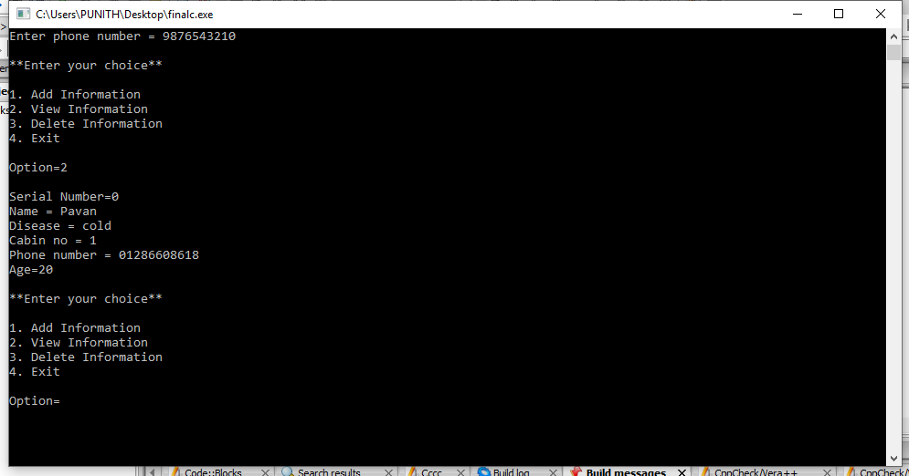

**Case 2:**

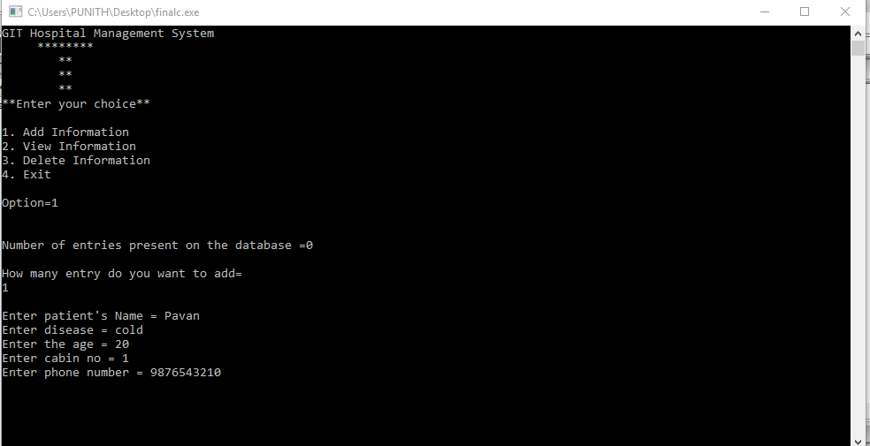

**Case 3:**

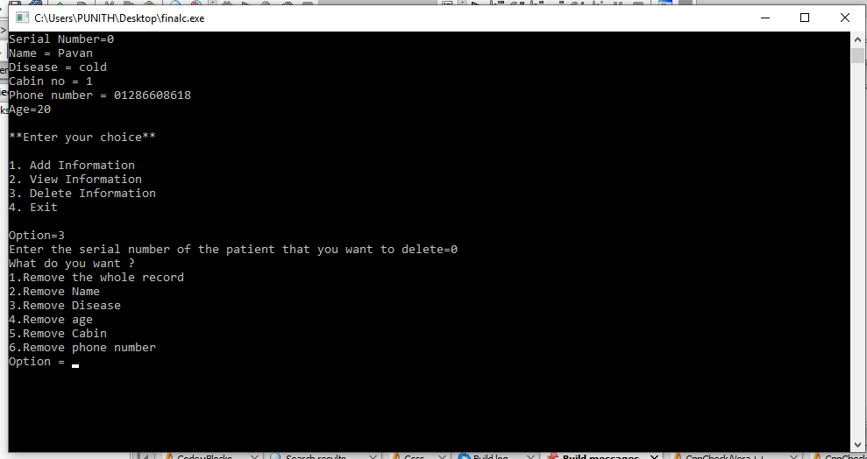

**Limitations:**

* Cannot edit the data
* Code has restricted stored data

**Improvements:**

* Editing the stored patients data.
* Adding some more options for data.