ECE PARIS — OMNES EDUCATION
MSc Data Management & Artificial Intelligence
MASTER THESIS
QPromote: Automating Quantum Circuit Promotion
Through Declarative Quality-Gated Pipelines
Pavan Kumar Naganaboina
Student ID: Mas25-R-1804
Supervisory Team:
Dr. Hassan Soubra — ECE Paris / ÉTS Montréal (Primary)
Dr. Tuna Hacaloglu — ÉTS Montréal (Co-Supervisor)
Dr. Donatien Koulla Moulla — UNISA (Co-Supervisor)
September 2026

Abstract
Deploying a quantum circuit to real hardware without prior quality filtering is costly and unreliable. Quantum processing unit (QPU) time is scarce, expensive, and subject to queuing. A circuit that could have been caught as noise-sensitive by a noisy simulator has no business consuming those resources. Yet current quantum development practice has no automated mechanism to make that judgment.
This thesis introduces QPromote, a declarative progressive delivery pipeline that applies automated quality gates to quantum circuit deployment. Given a YAML configuration file, QPromote runs a circuit through three ordered stages: ideal simulation on AerSimulator, noisy simulation on a hardware-derived noise model, and a hardware proxy stage. At each stage boundary, configurable fidelity metrics determine whether the circuit is promoted to the next stage or blocked. Blocked circuits do not proceed further; their Stage 3 record is marked SKIPPED in the audit trail rather than silently omitted.
A working prototype, QPromote v1.2.0, was implemented in Python 3.12 using Qiskit 2.5.2, qiskit-aer 0.17.2, qiskit-ibm-runtime 0.49.0, and PyYAML 6.0.2. Five benchmark circuits were evaluated: Bell state, GHZ state, Grover search, Bernstein-Vazirani (BV), and Quantum Fourier Transform (QFT). All five passed Stage 1 (ideal simulation). In a clean fresh run, Bell and BV passed Stage 2, while GHZ, Grover, and QFT were blocked under the Hellinger fidelity threshold of 0.90 and TVD threshold of 0.10 on FakeManilaV2. No real QPU execution was performed. Stage 3 for blocked circuits is recorded as SKIPPED, producing a complete 15-record audit trail. A repeated Stage 2 experiment of 20 executions per circuit found pass rates of 100% for Bell, 100% for BV, 0% for GHZ, 30% for Grover, and 0% for QFT. The Grover result is therefore threshold-sensitive rather than categorically stable.
The implementation directly addresses the peer-review feedback that rejected an earlier version of this concept at QUANCOM 2026 for lacking implementation and empirical validation. Both are now provided. Source code is publicly available at https://github.com/pavansri8886/qpromote.

Keywords: Quantum DevOps, Progressive Delivery, Qiskit, Hellinger Fidelity, NISQ, Quality Gates, Evidence Bundle, COSMIC FSM, Selective Promotion

Acknowledgements
My sincere gratitude goes to Dr. Hassan Soubra, whose guidance shaped this project from research gap discovery through implementation and thesis writing. I thank Dr. Tuna Hacaloglu and Dr. Donatien Koulla Moulla for their co-supervision and feedback throughout. I also thank Samuel Richard, Pierre Bourque, and Alain Abran, whose collaboration on the QUANCOM 2026 paper established the conceptual foundation from which this thesis was built.
GitHub Copilot was used during implementation to assist with code scaffolding, debugging, and GitHub Actions configuration. Claude (Anthropic) was used for literature search support, document structuring, and language editing. All experimental design, result interpretation, and academic conclusions are the author's own. AI tool use is disclosed in accordance with ECE Paris academic integrity policy.

Chapter 1 — Introduction

1.1 The Problem
Quantum computers are cloud-accessible and increasingly used for research. IBM Quantum, Amazon Braket, and Azure Quantum all offer QPU access. The hardware works well enough. The problem is that using it responsibly requires infrastructure that does not yet exist.
A quantum circuit that looks correct in ideal simulation may degrade badly on real hardware. The causes are physical: qubits decohere, gate operations introduce errors, and measurements are probabilistic. The standard development practice is to manually inspect simulation results and decide whether to submit to hardware. There is no automated check, no standard for what "good enough" means, and no mechanism to prevent a noise-sensitive circuit from consuming QPU resources that a quick noisy simulation could have flagged as wasted.

1.2 What QPromote Does
QPromote automates this judgment. A developer writes a YAML file specifying circuits, backends, and fidelity thresholds. QPromote executes the pipeline and at each stage boundary makes a binary decision: promote or block. Promoted circuits advance to the next stage. Blocked circuits stop immediately. Every stage execution — including skipped stages — is recorded in a SQLite evidence bundle for audit.
The three stages mirror Gheorghe-Pop et al.'s (2020) Quantum DevOps paradigm:
- Stage 1: ideal simulation on AerSimulator(method="statevector") — checks circuit logic against the known theoretical output distribution.
- Stage 2: noisy simulation on FakeManilaV2 — checks noise tolerance using Hellinger fidelity and Total Variation Distance against the Stage 1 baseline.
- Stage 3: hardware proxy on FakeSherbrooke — records a demonstration run for circuits that passed Stage 2. This stage is SKIPPED for blocked circuits.

1.3 Research Questions
- RQ1: Can automated, declarative quality gates govern selective quantum circuit promotion across the simulator-to-hardware continuum?
- RQ2: Do those gates reduce unnecessary hardware proxy resource consumption in practice?
- RQ3: What Hellinger fidelity threshold at Stage 2 provides the most reliable signal for blocking noise-sensitive circuits?

1.4 Contribution
The primary contribution is a working implementation of selective promotion: circuits that pass noise simulation advance to the hardware proxy; circuits that fail do not. Stage 3 records for blocked circuits are marked SKIPPED, preserving a complete 15-record audit trail without falsely implying hardware execution. This directly addresses the QUANCOM 2026 rejection, which cited absence of implementation and empirical validation.

Chapter 2 — Context and Related Work

2.1 Quantum Software Engineering
The Talavera Manifesto (Piattini et al., 2020) established that quantum software requires dedicated engineering methodology. Murillo et al. (2025) synthesised the field into a roadmap identifying testing automation, deployment orchestration, and reproducibility as open problems — a direct academic motivation for QPromote.
Gheorghe-Pop et al. (2020) formalised Quantum DevOps through a three-phase testing paradigm: ideal simulation, noisy simulation, and real hardware. This paradigm is now broadly accepted and provides the structural basis for QPromote's three pipeline stages.

2.2 Testing Metrics
García de la Barrera et al. (2023) surveyed quantum software testing approaches and identified Hellinger fidelity and Total Variation Distance as the principal metrics for comparing output distributions across execution environments. Hellinger fidelity, bounded between zero and one, measures distributional similarity. TVD captures worst-case divergence, complementing Hellinger by detecting localised errors that fidelity may underweight. QPromote uses both as Stage 2 gate conditions.
Quantum outputs are probabilistic: the same circuit run twice will produce slightly different result histograms. This has direct implications for how threshold decisions are interpreted — any Hellinger or TVD value reported is from a finite-shot sample and will vary between runs. The qualitative PASS/BLOCK outcome at a given threshold is stable across runs for clearly noise-sensitive or clearly noise-tolerant circuits, but circuits near the threshold boundary may vary.

2.3 Related Tools
Romero-Álvarez et al. (2024) built a continuous deployment workflow for quantum services using GitHub Actions and Docker. It automates service-level deployment across cloud providers but operates at the service rather than circuit quality level, with no stage-based promotion gates.
QEF (Gierisch and Mauerer, 2025) is the closest published work. It provides configuration-driven experiment execution across multiple backends with structured metadata logging. Every configured experiment runs regardless of output quality — there is no promote-or-block mechanism. QPromote addresses precisely this gap: the governance layer that decides what runs next.
Qonscious (Lammers et al., 2025) implements conditional execution based on hardware resource availability, not output quality. Qubernetes (Stirbu et al., 2024) provides Kubernetes-based scheduling without quality gates. Both address orthogonal concerns from QPromote.

2.4 Functional Size Measurement
COSMIC ISO 19761 measures software functional size by counting data movements across the system boundary. Khattab, Elsayed, and Soubra (2022) adapted this for quantum circuits using the Gates' Occurrences approach: each gate contributes two CFP (Entry and Exit), each measurement contributes two CFP (Write and Read). QPromote tracks CFP in its evidence bundle as an additional structural metric per stage, allowing detection of functional expansion during transpilation.

2.5 Gap
No existing tool combines staged execution, metric-driven quality gates, selective promotion, and a complete audit trail including SKIPPED records for non-executed stages into a unified declarative pipeline. QPromote occupies this gap.

Chapter 3 — Design

3.1 Selective Promotion
The core design principle of QPromote is selective promotion: only circuits that satisfy all configured quality gate conditions at a given stage are allowed to advance to the next stage. Circuits that fail a gate are blocked. Blocked circuits do not execute at subsequent stages; their audit records for those stages are written with decision SKIPPED.
This is different from a logging or tracking tool, which would run all stages regardless of output quality and record the results. In QPromote, the gate evaluation actively governs what happens next. A BLOCK decision is an intervention, not just an observation.

3.2 Declarative Configuration
The pipeline is defined in YAML. Key top-level fields are: project name, database path for evidence storage, shot count, halt_on_block flag, and report_path for the HTML evidence report. Each stage entry specifies a circuit name, backend identifier, and threshold conditions.
The halt_on_block flag controls pipeline-level behaviour on BLOCK: when false (the evaluation setting used in this thesis), all circuits are evaluated even if some are blocked at Stage 2. Stage 3 records for blocked circuits are written as SKIPPED rather than omitted, preserving a complete 15-record audit trail.

project: QPromote Thesis Evaluation
halt_on_block: false
stages:
- name: "Bell Stage 2 (Noisy)"
backend: FakeManilaV2
circuit: bell
thresholds:
hellinger_fidelity: 0.90
tvd: 0.10

3.3 Stage Definitions
Stage 1 uses AerSimulator configured with method="statevector" for noise-free exact simulation. The output is compared against the known theoretical probability distribution for the circuit. For Bell state the ideal is {"00": 0.5, "11": 0.5}; for Grover the ideal is {"11": 1.0}; for QFT the Stage 1 measured output serves as the comparison baseline for Stage 2 (because QFT under uniform superposition input does not have a simple closed-form distribution that is independent of circuit implementation choices).
Stage 2 uses FakeManilaV2, a V2 snapshot fake backend that encodes calibration data from a real IBM Manila QPU including T1/T2 decoherence times, gate error rates, and readout errors. The gate evaluates Hellinger fidelity and TVD of the noisy output against the Stage 1 baseline. Both conditions must hold for a PASS: Hellinger ≥ 0.90 and TVD ≤ 0.10.
Stage 3 uses FakeSherbrooke as a hardware proxy. Results here are labelled DEMONSTRATION — they represent execution on a fake backend, not a real QPU. No real quantum hardware was used in this work. Circuits blocked at Stage 2 have their Stage 3 record marked SKIPPED; no FakeSherbrooke execution is performed for them.

3.4 Evidence Bundle and HTML Report
Each stage execution writes one row to a SQLite database with run ID, timestamp, circuit name, stage name, backend name, shots, Hellinger fidelity, TVD, simple fidelity, gate count, qubit count, classical bit count, CFP, Aer version, IBM Runtime version, decision, and notes. The pipeline produces exactly 15 records per complete run: 5 circuits x 3 stages, with SKIPPED used for Stage 3 records of blocked circuits. Repeated Stage 2 and threshold-scan experiments are also identified by run ID.
The pipeline also generates an HTML file (qpromote_report.html) containing a colour-coded evidence table showing all 15 records with PASS in green, BLOCK in red, DEMONSTRATION in purple, and SKIPPED in grey. In GitHub Actions, both the database and the HTML report are uploaded as the qpromote-results artifact for download and inspection.

Chapter 4 — Implementation

4.1 Technology Stack
The prototype is written in Python 3.12. Dependencies are pinned to Qiskit 2.5.2, qiskit-aer 0.17.2, qiskit-ibm-runtime 0.49.0, and PyYAML 6.0.2. No external database server, no cloud services, and no real QPU access are required for Stages 1 and 2.
The choice of Qiskit 2.x was required: Qiskit 2.0 removed the deprecated V1 FakeBackend classes. FakeManilaV2 and FakeSherbrooke are the correct V2 replacements, providing calibration-derived noise models through the updated interface.

4.2 Circuit Implementations and Key Fixes
Two circuit implementations required specific engineering decisions that are documented here because they directly affect metric interpretation.
The Bernstein-Vazirani circuit has 3 qubits but only 2 classical bits — the ancilla qubit is not measured. The normalize_counts function uses circuit.num_clbits (not num_qubits) to generate the probability distribution state space. Without this fix, the function generates 8 states (for 3 qubits) while counts contain 2-bit strings, producing a keyspace mismatch that returns Hellinger = 0 regardless of actual circuit performance. The ideal output for BV with hidden string "11" is {"11": 1.0}.
The QFT circuit uses a manual gate-by-gate implementation to avoid the deprecated QFT class removed in Qiskit 2.x. QFT applied to a uniform superposition input does not have a simple analytical ideal distribution, so Stage 2 compares the noisy output against the Stage 1 measured baseline rather than against a fixed theoretical distribution. The Stage 1 record's measured distribution is retrieved and used as the reference for Stage 2 metric computation.

4.3 SKIPPED Stage Logic
When a circuit is blocked at Stage 2, the pipeline does not execute Stage 3 for that circuit. Instead it writes a SKIPPED record to the evidence database with NULL metric values and the note "Stage 2 BLOCK; hardware proxy execution skipped." This design ensures the audit trail always contains exactly 15 records per run, making completeness verification straightforward. Repeated experiments produce additional records with distinct run IDs.

4.4 GitHub Actions Integration
The repository includes a GitHub Actions workflow that executes the full pipeline on push. The workflow installs dependencies, runs python qpromote.py run pipeline.yaml, and uploads qpromote_report.html and qpromote_evidence.db as the qpromote-results artifact. This enables any reviewer to inspect the full evidence record without installing any software locally.

4.5 Source Code and Reproducibility
The complete implementation is available at:
https://github.com/pavansri8886/qpromote
To reproduce the evaluation:
git clone https://github.com/pavansri8886/qpromote
cd qpromote
pip install -r requirements.txt
python qpromote.py run pipeline.yaml

Because Stage 2 and Stage 3 use fake backends with fixed calibration snapshots, the PASS/BLOCK qualitative outcomes are stable across independent runs. Exact Hellinger and TVD values will vary slightly between runs due to finite-shot sampling (4,096 shots per stage), which is expected behaviour for any quantum simulation.

Chapter 5 — Experiments and Results

5.1 Experimental Setup
Five circuits were evaluated across three pipeline stages using 4,096 shots per stage execution. Stage 1 used AerSimulator(method="statevector"). Stage 2 used FakeManilaV2 with Hellinger fidelity threshold 0.90 and TVD threshold 0.10. Stage 3 used FakeSherbrooke as a hardware proxy and was skipped for circuits blocked at Stage 2.
Results in this chapter come from a clean fresh run stored in qpromote_fresh_evidence.db, plus a separate repeated Stage 2 experiment with 20 executions per circuit and a five-value threshold scan. Exact Hellinger and TVD values vary because each execution uses finite-shot sampling. The repeated experiment is therefore used to report means, standard deviations, and empirical pass rates rather than claiming deterministic outcomes.

5.2 Stage 1 Results — Ideal Simulation
All five circuits passed Stage 1 under ideal simulation, confirming that each circuit is logically correct. Stage 1 Hellinger fidelity was at or above 0.999 for all circuits, and TVD was at or below 0.010. This result is expected: AerSimulator in statevector mode produces near-perfect output for any correctly implemented quantum circuit.

5.3 Stage 2 Results — Noisy Simulation
Stage 2 produced the key discriminating results. Table 5.1 reports the clean fresh run using 4,096 shots and FakeManilaV2. Bell and BV passed both conditions. GHZ, Grover, and QFT failed in this particular run. The repeated experiment below shows that Grover is a boundary case whose decision varies with shot sampling.

Circuit | Hellinger (Stage 2) | TVD (Stage 2) | Decision
Bell | 0.9374 | 0.0623 | PASS
GHZ | 0.8636 | 0.1350 | BLOCK
Grover | 0.8987 | 0.1013 | BLOCK
BV | 0.9304 | 0.0696 | PASS
QFT | 0.8660 | 0.1340 | BLOCK

Table 5.1 — Stage 2 gate results (clean fresh run, 4,096 shots, FakeManilaV2)

Bell and BV passed both conditions in the clean fresh run. GHZ, Grover, and QFT were blocked because their Hellinger fidelity and TVD did not satisfy the two-condition gate. Across the 100 repeated Stage 2 executions, 46 passed overall. Bell and BV passed all 20 repetitions; GHZ and QFT passed none; Grover passed 6 of 20.

5.4 Stage 3 and Audit Trail
Bell and BV advanced to Stage 3 and were executed on FakeSherbrooke, producing DEMONSTRATION records. GHZ, Grover, and QFT were not executed at Stage 3 in the clean fresh run; their Stage 3 records are marked SKIPPED. The complete audit trail therefore contains 15 records: 5 circuits x 3 stages, with no missing entries.

Circuit | Stage 1 | Stage 2 | Stage 3
Bell | PASS | PASS | DEMONSTRATION
GHZ | PASS | BLOCK | SKIPPED
Grover | PASS | BLOCK | SKIPPED
BV | PASS | PASS | DEMONSTRATION
QFT | PASS | BLOCK | SKIPPED

Table 5.2 — Full 15-record audit trail summary per circuit and stage

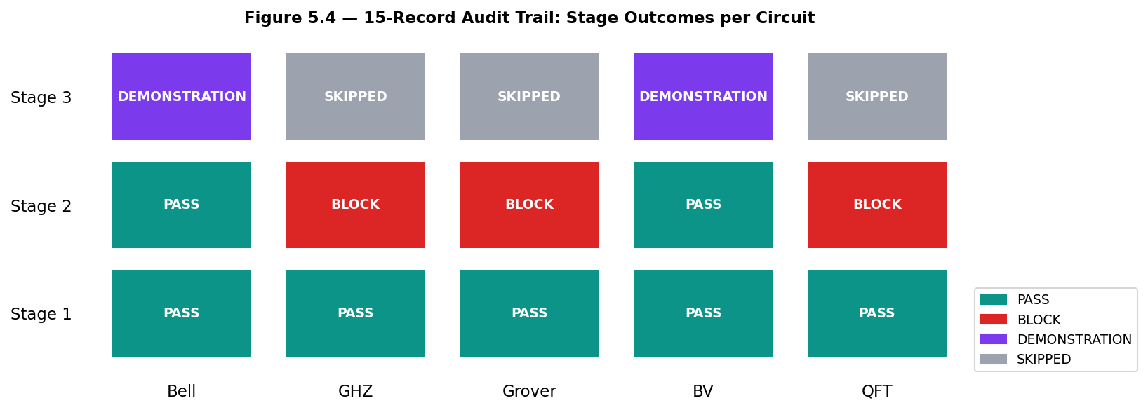
Figure 5.4 — Visual summary of the 15-record audit trail. PASS (green), BLOCK (red), DEMONSTRATION (purple), SKIPPED (grey).

5.5 Hellinger Fidelity Comparison
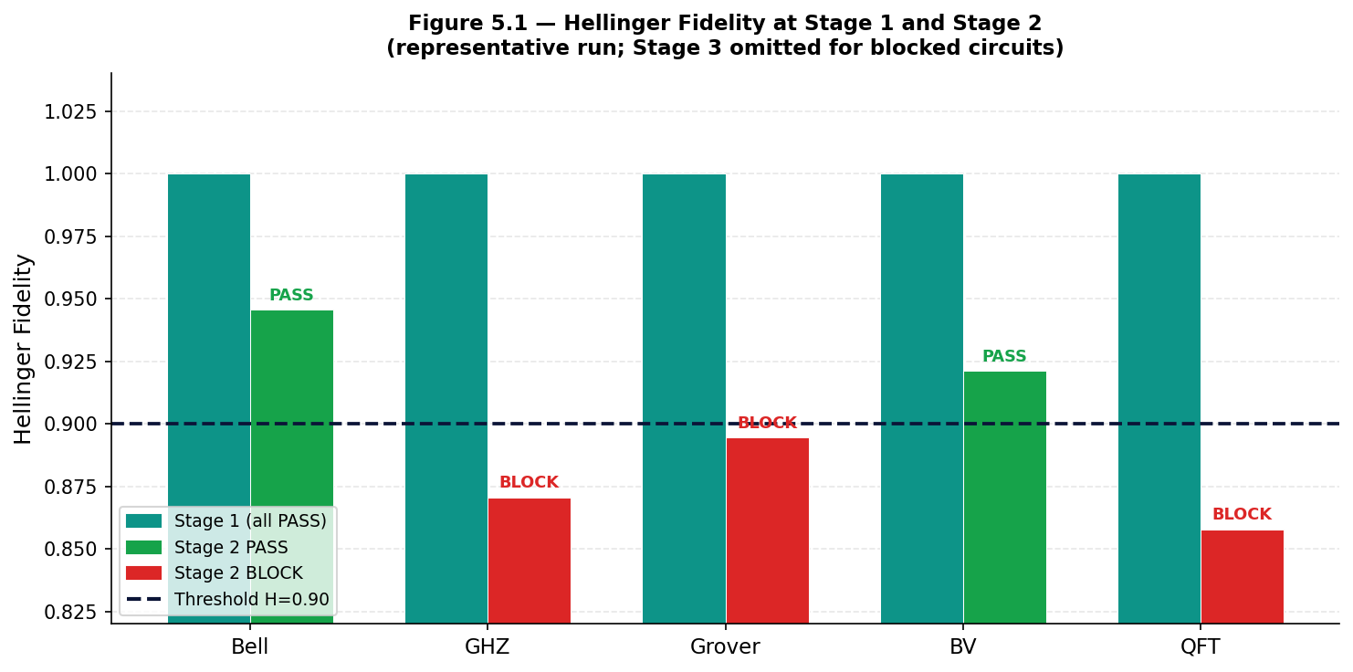
Figure 5.1 — Hellinger fidelity at Stage 1 and Stage 2 in the clean fresh run. The repeated Stage 2 experiment is summarized separately.
Figure 5.1 illustrates the fidelity divergence between ideal and noisy simulation. All circuits show near-perfect fidelity at Stage 1. In the clean fresh run, Bell and BV are above the Stage 2 threshold, while GHZ, Grover, and QFT are below it. The 20-run experiment adds uncertainty information, especially for Grover near the boundary.

5.6 TVD Comparison
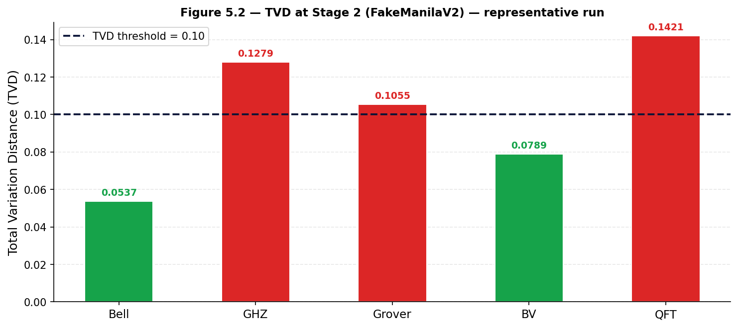
Figure 5.2 — Total Variation Distance at Stage 2 in the clean fresh run. Red dashed line marks TVD threshold 0.10.
Figure 5.2 shows Stage 2 TVD in the clean fresh run. GHZ (0.1350), Grover (0.1013), and QFT (0.1340) exceeded the 0.10 threshold, while Bell (0.0623) and BV (0.0696) remained below it.

5.7 Stage 2 Decisions
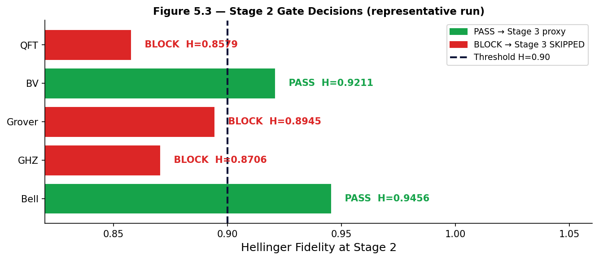
Figure 5.3 — Stage 2 Hellinger fidelity and gate decisions in the clean fresh run. Grover is additionally a boundary case in repeated execution.

5.8 Counterfactual Hardware Proxy Saving — RQ2
In a hypothetical pipeline without quality gates, all five circuits would be submitted to the Stage 3 hardware proxy. In the clean fresh run, two of five circuits advanced, so the counterfactual reduction is 60 percent. The repeated experiment provides a more cautious view: Grover passed only 6 of 20 Stage 2 executions, so a production estimate should report uncertainty rather than treat the 60 percent figure as invariant.

Scenario | Circuits to Stage 3 | Estimated Saving
Without Stage 2 gates | 5/5 circuits | —
With QPromote Stage 2 gates | 2/5 circuits | 60% reduction (clean run; estimated)

Table 5.3 — Counterfactual estimate of Stage 3 execution reduction

This is a counterfactual estimate, not a measured QPU saving. FakeSherbrooke is a hardware proxy; no real QPU was used. The threshold scan evaluated 0.80, 0.85, 0.90, 0.925, and 0.95 for each circuit while holding TVD <= 0.10. Bell passed through 0.925 but failed at 0.95; BV passed through 0.90 but failed at 0.925 and above; Grover passed at 0.80 and 0.85 but failed at 0.90 and above; GHZ and QFT failed at every tested threshold because their TVD remained above 0.10. These results provide the empirical basis for the threshold discussion, but threshold selection remains backend- and workload-specific.

5.9 Functional Size — RQ Supplementary
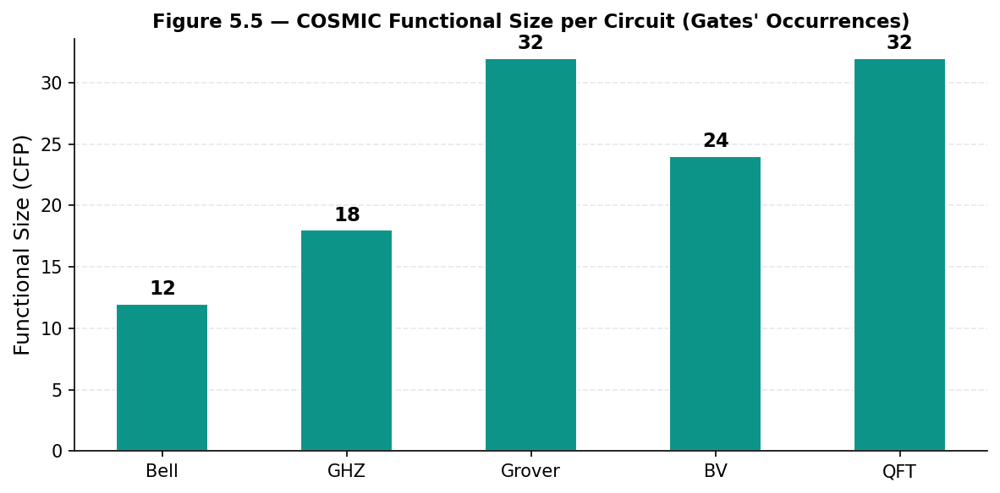
Figure 5.5 — COSMIC Functional Size in CFP per circuit (Gates' Occurrences approach).
CFP values range from 12 (Bell, simplest) to 32 (Grover and QFT, most gate-intensive). These values are consistent across stages because the circuit structure does not change between Stage 1 and Stage 2. In a production implementation with real hardware transpilation, gate decomposition into the target ISA could increase gate count and therefore CFP at Stage 3, providing a quantitative measure of transpilation overhead.

Chapter 6 — Discussion

6.1 What the Results Show
The clean fresh run confirms that the pipeline distinguishes the benchmark circuits under the selected noise model: Bell and BV passed Stage 2, while GHZ, Grover, and QFT were blocked. The repeated experiment refines this conclusion. Bell and BV were robust across 20 repetitions, GHZ and QFT remained below the gate in every repetition, and Grover was the only boundary case.
Bell and BV passed comfortably in the repeated experiment, with mean Hellinger values of 0.939960 and 0.927515 respectively. Their empirical pass rates were both 100 percent. This supports the use of the selected gate for these two circuits under the FakeManilaV2 calibration snapshot.
Grover requires a qualified interpretation. Its mean Hellinger fidelity was 0.897314 with a standard deviation of 0.004958, and it passed 6 of 20 repetitions. The clean single run was a BLOCK at H=0.8987, but the repeated data show that finite-shot variation can move the decision across the 0.90 boundary. This is evidence for a boundary-handling policy, such as confidence intervals, a margin, or repeated confirmation before promotion.

6.2 Comparison with Related Work
QEF would record all fifteen stage results regardless of quality. It provides no mechanism to prevent blocked circuits from running at Stage 3. The 15-record audit trail in QPromote is structurally identical to what QEF would produce, but three of those records are SKIPPED because QPromote actually prevented the execution — not merely observed its outcome.
Romero-Álvarez et al. (2024) automate quantum service deployment across cloud providers. Their pipeline operates at the software service level; there is no equivalent of a per-circuit fidelity gate. The concerns are complementary: QPromote governs circuit promotion; Romero-Álvarez governs service deployment.

6.3 Limitations
No real QPU hardware was used. Stage 3 runs on FakeSherbrooke, a calibration snapshot from a real device, not a live quantum processor. FakeSherbrooke does not capture hardware drift, thermal fluctuations, or the temporal non-reproducibility of real QPU behaviour. All Stage 3 results are labelled DEMONSTRATION to make this explicit in the evidence record.
The benchmark set is limited to five circuits. These circuits span a range of qubit counts and gate depths but do not represent the variational circuit families (VQE, QAOA) most relevant for near-term quantum computing applications. Those circuits have parameterised gates and no simple closed-form ideal distribution, requiring extensions to the metric framework.
Thresholds are fixed values validated for FakeManilaV2 on the circuits tested. They may not transfer directly to other backends or circuit types without recalibration.

6.4 Threats to Validity
Stochastic results: finite-shot sampling means all Hellinger and TVD values are sample statistics. The 20-run experiment quantified this variation: standard deviations ranged from 0.003717 for Bell to 0.008053 for QFT. Grover's 6/20 pass rate demonstrates that near-threshold decisions cannot be described as fully stable.
Calibration snapshot validity: FakeManilaV2 and FakeSherbrooke use fixed calibration data. Real IBM hardware recalibrates periodically; the noise model in the fake backend does not capture this drift. Results are reproducible because the snapshot is fixed, but this reproducibility is a property of the test fixture, not of real hardware.
Counterfactual cost estimate: the 60 percent Stage 3 reduction applies to the clean single run and is an estimate, not a measured QPU saving. Because Grover passed 6 of 20 repetitions, the expected reduction depends on the decision policy used for borderline circuits.

Chapter 7 — Conclusion

7.1 Summary
QPromote is a working implementation of selective quantum circuit promotion. It runs, it blocks circuits, it produces a complete 15-record audit trail, and it generates a colour-coded HTML evidence report. In the clean fresh run, two of five benchmark circuits advanced to the Stage 3 hardware proxy, corresponding to an estimated 60 percent reduction in proxy-stage executions compared with submitting all five circuits.
The three research questions receive qualified answers. Automated, declarative quality gates can govern selective quantum circuit promotion (RQ1). The gates prevent blocked circuits from advancing to the proxy stage in the clean run (RQ2). The Hellinger threshold of 0.90 provides useful discrimination for this benchmark set, but the repeated experiment shows that Grover is a boundary case rather than a stable categorical decision (RQ3).

7.2 Future Work
The single most important next step is Stage 3 on real IBM QPU hardware. The IBM Open Plan provides limited QPU time per month, but even two or three real hardware runs on the Bell and BV circuits would validate the end-to-end pipeline against actual quantum noise.
Statistical robustness has now been added through 20 Stage 2 executions per circuit and a five-value threshold scan. Future work should extend this analysis with confidence intervals, more shots, and real-QPU validation so that borderline promotion decisions can be calibrated against hardware variability rather than only a fixed simulator snapshot.
Extending the circuit set to include variational circuits (VQE, QAOA) with parameterised gates requires adapting the ideal distribution comparison to use expected energy values or classical pre-computation of ideal distributions — a meaningful research extension.
Finally, fault-tolerant circuit support — incorporating Target Code Distance and Mitigation Overhead Factor as additional gate conditions — would extend QPromote toward the post-NISQ era, where Soubra et al.'s functional size analysis (71 to 86 percent QEC overhead in fault-tolerant circuits) becomes directly relevant to deployment governance.

7.3 Closing Remark
Quantum computing is at the stage where the hardware works well enough to use, but the software engineering discipline around it has not caught up. Most quantum development still involves running circuits, inspecting output by hand, and making subjective decisions about hardware submission. QPromote is a small step toward treating quantum circuit deployment with the rigour that classical software deployment has accumulated over decades. It is not the final tool — it is a first concrete demonstration that declarative, metric-driven governance for quantum circuits is feasible and can be built today.

References
[1] I.-D. Gheorghe-Pop, N. Tcholtchev, T. Ritter, and M. Hauswirth, "Quantum DevOps: Towards Reliable and Applicable NISQ Quantum Computing," in Proc. IEEE Globecom Workshops, 2020.
[2] J. M. Murillo et al., "Quantum Software Engineering: Roadmap and Challenges Ahead," ACM Trans. Softw. Eng. Methodol., vol. 34, no. 5, 2025.
[3] M. Piattini et al., "The Talavera Manifesto for Quantum Software Engineering and Programming," QANSWER 2020, CEUR-WS Vol-2561, 2020.
[4] J. García de la Barrera et al., "Quantum Software Testing: State of the Art," J. Softw. Evol. Process, vol. 35, no. 4, e2419, 2023.
[5] M. Paltenghi and M. Pradel, "A Survey on Testing and Analysis of Quantum Software," arXiv:2410.00650, 2024.
[6] R. Abreu et al., "Software Testing in the Quantum World," Computer, vol. 59, no. 4, 2026.
[7] A. Romero-Álvarez et al., "Enabling Continuous Deployment Techniques for Quantum Services," Softw. Pract. Exp., vol. 54, no. 8, pp. 1491–1515, 2024.
[8] V. Stirbu et al., "Qubernetes: Towards a Unified Cloud-Native Execution Platform for Hybrid Classic-Quantum Computing," Inf. Softw. Technol., vol. 175, 107529, 2024.
[9] O. Kinanen et al., "Toolchain for Faster Iterations in Quantum Software Development," Computing, vol. 107, art. 99, Springer, 2025.
[10] M. Gierisch and R. Mauerer, "QEF: Reproducible and Exploratory Quantum Software Experiments," arXiv:2511.04563, 2025.
[11] B. Weder et al., "QProv: A Provenance System for Quantum Computing," IET Quantum Commun., vol. 2, no. 4, pp. 171–181, 2021.
[12] I. Cosentino et al., "Metriq: A Collaborative Platform for Benchmarking Quantum Computers," arXiv:2603.08680, 2026.
[13] M. G. Lammers et al., "Quantum Resource Management in the NISQ Era," arXiv:2508.19276, 2025.
[14] H. Soubra et al., "Comprehensive Review of Metrics and Measurements of Quantum Systems," Metrics, vol. 2, no. 2, art. 9, MDPI, 2025.
[15] Y. Adel, H. Soubra et al., "Functional Size Measurement of Error Correction Overhead in Quantum Software," SSRN:5759456, 2025.
[16] IEEE Computer Society, Software Engineering Body of Knowledge (SWEBOK) v4.0a, 2024.
[17] H. Soubra, P. K. Naganaboina et al., "QPromote: A Proposed Declarative Progressive Deployment Pipeline for Simulator-to-Hardware Quantum Circuit Promotion," submitted to QUANCOM 2026.
[18] Khattab, Elsayed, and Soubra, "Functional Size Measurement of Quantum Software: Gates' Occurrences Approach," IWSM-Mensura 2022, CEUR-WS Vol-3272.
[19] E. Hellinger, "Neue Begründung der Theorie quadratischer Formen," J. Reine Angew. Math., vol. 136, pp. 210–271, 1909.
[20] QPromote v1.2.0 source code, reproducible evidence, and GitHub Actions results: https://github.com/pavansri8886/qpromote

