Ultimate MySQL Bootcamp - From Beginner SQL to Expert

SECTION - 2: - **GETTING STARTED: OVERVIEW/INSTALLATION**

MySQL: - Why Databases are Awesome

**What is a database?** - A collection of data like a phone book! A method for accessing & manipulating that data. A structured set of computerized data with an accessible interface.

**DB vs. RDMS?** :-

**Why do they Matter?** - Data is knowledge – Data is money.

**MySQL vs. SQL?** :-

SQL is the language we use to “talk” to our databases. Like “Find all users”, “Find all users who are 18 years old”, “Add a new user”, “Delete every single user”. Once you learn SQL, it’s pretty easy to switch to another DB that uses SQL.

What makes databases (DBMS) unique are the features they offer, not the language.

SECTION - 3: - **CREATING DATABASSE AND TABLES**

**A** Database is the bunch of tables. In a relational database, at least. Tables holds the Data! It’s a collection of related data held in a structured format within a database.

Columns are the headers (need to specify data types) & rows are actual data in a given table. Databases are made up of lots of tables. Data types are really important for tables. In reality they are a lot of different MySQL data types.

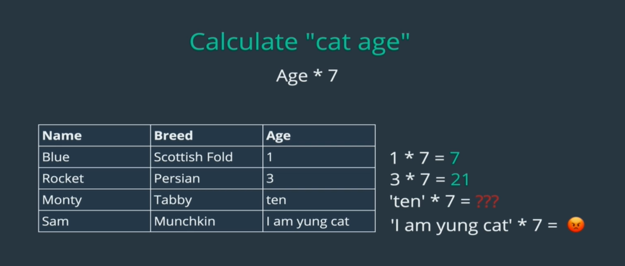

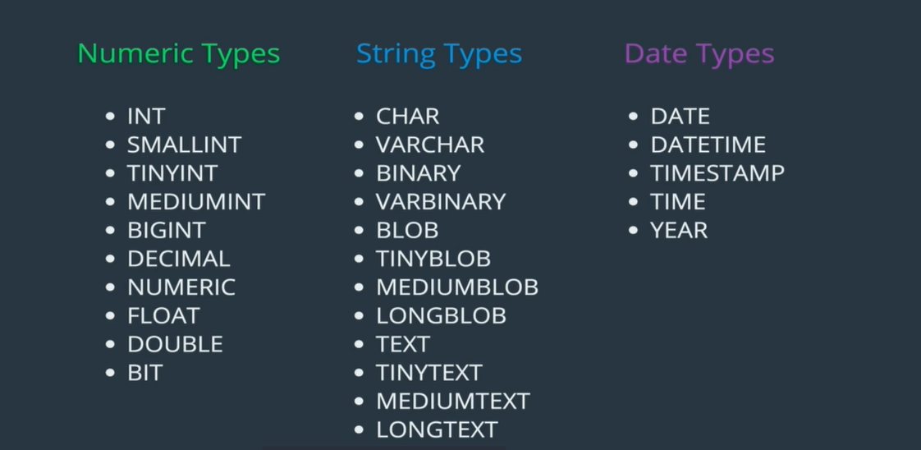

* INT
  + A whole number with max value of 4294967295, it can be negative or zero.
* VARCHAR (character-length)
  + A variable length string, between 1 and 255 characters.

SECTION - 4: - **INSERTING**