Low Level Design

Concrete Strength Prediction

|  |  |
| --- | --- |
| Written By | P Pavan Teja, K Rahul Shashank |
| Document Version | 0.2 |
| Last Revised Date | 20 – July -2023 |

**Document Control**

### **Change Record:**

|  |  |  |  |
| --- | --- | --- | --- |
| **Version** | **Date** | **Author** | **Comments** |
| 0.1 | 19 – July -  2023 | P Pavan Teja | Introduction & Architecture defined |
| 0.2 | 20 – July -  2023 | K Rahul Shashank | Architecture & Architecture Description appended and updated |
|  |  |  |  |
|  |  |  |  |
|  |  |  |  |
|  |  |  |  |

### **Reviews:**

|  |  |  |  |
| --- | --- | --- | --- |
| **Version** | **Date** | **Reviewer** | **Comments** |
| 0.2 | 20 – Julyy -  2023 |  | Document Content , Version Control and Unit Test Cases to be added |

### **Approval Status:**

|  |  |  |  |  |
| --- | --- | --- | --- | --- |
| **Version** | **Review**  **Date** | **Reviewed By** | **Approved By** | **Comments** |
|  |  |  |  |  |

|  |
| --- |
| Contents |
| 1. [**Introduction** **1**](https://docs.google.com/document/d/11ZsH8kpfHudKxEpP882RrH1Ay4Ax44Sf/edit#heading=h.gjdgxs) |
| 1. [**What is Low-Level design document?** **1**](https://docs.google.com/document/d/11ZsH8kpfHudKxEpP882RrH1Ay4Ax44Sf/edit#heading=h.30j0zll) |
| 1. [**Scope** **1**](https://docs.google.com/document/d/11ZsH8kpfHudKxEpP882RrH1Ay4Ax44Sf/edit#heading=h.1fob9te) |
| 1. [**Architecture** **2**](https://docs.google.com/document/d/11ZsH8kpfHudKxEpP882RrH1Ay4Ax44Sf/edit#heading=h.3znysh7) |
| 1. [**Architecture Description** **3**](https://docs.google.com/document/d/11ZsH8kpfHudKxEpP882RrH1Ay4Ax44Sf/edit#heading=h.2et92p0) |
| 1. [**Data Preprocessing** **3**](https://docs.google.com/document/d/11ZsH8kpfHudKxEpP882RrH1Ay4Ax44Sf/edit#heading=h.tyjcwt) |
| 1. [**Splitting Data** **3**](https://docs.google.com/document/d/11ZsH8kpfHudKxEpP882RrH1Ay4Ax44Sf/edit#heading=h.3dy6vkm) |
| 1. [**Data Transformation** **3**](https://docs.google.com/document/d/11ZsH8kpfHudKxEpP882RrH1Ay4Ax44Sf/edit#heading=h.1t3h5sf) |
| 1. [**Data Insertion into Database** **3**](https://docs.google.com/document/d/11ZsH8kpfHudKxEpP882RrH1Ay4Ax44Sf/edit#heading=h.4d34og8) |
| 1. [**Export Data from Database** **3**](https://docs.google.com/document/d/11ZsH8kpfHudKxEpP882RrH1Ay4Ax44Sf/edit#heading=h.2s8eyo1) |
| 1. [**Data Clustering** **3**](https://docs.google.com/document/d/11ZsH8kpfHudKxEpP882RrH1Ay4Ax44Sf/edit#heading=h.3rdcrjn) |
| 1. [**Model Building** **4**](https://docs.google.com/document/d/11ZsH8kpfHudKxEpP882RrH1Ay4Ax44Sf/edit#heading=h.26in1rg) |
| 1. [**Data from User** **4**](https://docs.google.com/document/d/11ZsH8kpfHudKxEpP882RrH1Ay4Ax44Sf/edit#heading=h.lnxbz9) |
| 1. [**Data Validation** **4**](https://docs.google.com/document/d/11ZsH8kpfHudKxEpP882RrH1Ay4Ax44Sf/edit#heading=h.35nkun2) |
| 1. [**User Data Inserting into Database** **4**](https://docs.google.com/document/d/11ZsH8kpfHudKxEpP882RrH1Ay4Ax44Sf/edit#heading=h.1ksv4uv) |
| 1. [**Deployment** **4**](https://docs.google.com/document/d/11ZsH8kpfHudKxEpP882RrH1Ay4Ax44Sf/edit#heading=h.3j2qqm3) |
| 1. [**Unit Test Cases** **5**](https://docs.google.com/document/d/11ZsH8kpfHudKxEpP882RrH1Ay4Ax44Sf/edit#heading=h.1y810tw) |
|  |

**1 Introduction**

**1.1 What is Low-Level design document?**

The goal of LLD or a low-level design document (LLDD) is to give the internal logical design of the actual program code for Food Recommendation System. LLD describes the class diagrams with the methods and relations between classes and program specs. It describes the modules so that the programmer can directly code the program from the document.

## **1.2 Scope**

Low-level design (LLD) is a component-level design process that follows a step-by-

step refinement process. This process can be used for designing data structures, required software architecture, source code and ultimately, performance algorithms. Overall, the data organization may be defined during requirement analysis and then refined during data design work

**2 ARCHITECTURE DIAGRAM:**

**FLOWCHART:**

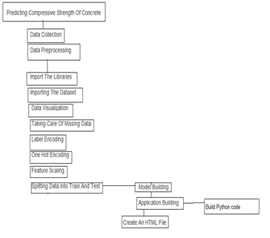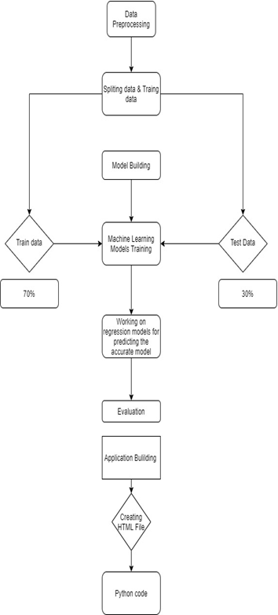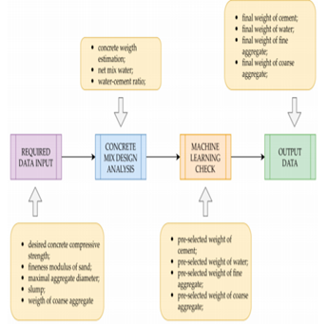

**3 Architecture Description**

**3.1 Data Processing:**

Data processing is the crucial step in machine learning, involving cleaning and transforming raw data to make it suitable for model training. This step ensures data accuracy, consistency, and relevance, enabling the machine learning algorithms to learn patterns effectively.

**3.2 Splitting Data:**

Data splitting is the practice of dividing the dataset into three subsets: training, validation, and test data. The training set is used to teach the model, the validation set helps in tuning hyperparameters, while the test set evaluates the model's performance on unseen data, assessing its generalization capability.

## **3.2 Data Transformation:**

In the Transformation Process, we will convert our original dataset which is in JSON format to CSV Format. And will merge it with the Scrapped dataset.

## **3.4 Data Insertion into Database:**

1. Database Creation and connection - Create a database with name passed. If the database is already created, open the connection to the database.
2. Table creation in the database.
3. Insertion of files in the table

## **3.5 Export Data from Database:**

Data Export from Database - The data in a stored database is exported as a CSV file to be used for Data Pre-processing and Model Training.

## **3.6 Data Clustering:**

K-Means algorithm will be used to create clusters in the pre-processed data. The optimum number of clusters is selected by plotting the elbow plot. The idea behind clustering is to implement different algorithms to train data in different clusters. The K-means model is trained over pre-processed data and the model is saved for further use in prediction.

**3.7 Model Building:**

Model building involves selecting an appropriate machine learning algorithm for the problem and training the chosen model using the training data. The algorithm learns patterns from the training data, enabling it to make predictions on new, unseen data.

## **3.8 Data from User:**

Here we will collect physiological data from user such as user height and weight, heart rate, burned calories, daily physical activity level; as well as information directly provided by the user such as daily food intake

## **3.9 Data Validation:**

Here Data Validation will be done, given by the user

## **3.10 User Data Inserting into Database:**

Collecting the data from the user and storing it into the database. The database can be either MySQL or Mongo DB.

# **4 Unit Test Cases**

|  |  |  |
| --- | --- | --- |
| **Test Case Description** | **Pre-Requisite** | **Expected Result** |
| Verify whether the Application URL is  accessible to the user | 1. Application URL  should be defined | Application URL should be  accessible to the user |
| Verify whether the Application loads completely for the user when the URL is accessed | 1.Application URL is accessible  2.Application is deployed | The Application should load completely for the user when the URL is accessed |
| Verify whether user is able to see input fields on logging in | 1.Application is accessible  2.User is signed up to the application  3.User is logged in  to the application | User should be able to see input fields on logging in |
| Verify whether user is able to edit all input fields | 1.Application is accessible  2.User is signed up to the application  3.User is logged in to the application | User should be able to edit all input fields |
| Verify whether user gets Submit button to submit the inputs | 1.Application is accessible  2.User is signed up to the application  3.User is logged in to the application | User should get Submit button to submit the inputs |
| Verify whether user is presented with recommended results on clicking  submit | 1.Application is accessible  2.User is signed up to the application  3.User is logged in  to the application | User should be presented with recommended results on clicking  submit |
| Verify whether the recommended results are in accordance to the selections user made | 1.Application is accessible  2.User is signed up to the application  3.User is logged in to the application | The recommended results should be in accordance to the selections user made |
| Verify whether user has options to filter the recommended results as well | 1.Application is accessible  2.User is signed up | User should have options to filter the recommended results as well |