1. Setting Up Federated Credentials in Azure (OIDC for GitHub Actions)

Go Azure portal
Search Azure Active Directory (Entra Id)

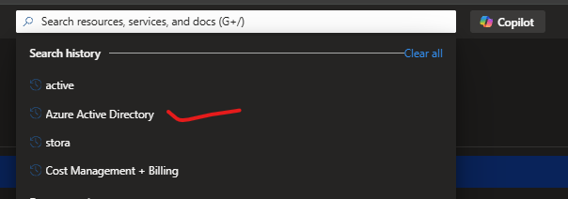

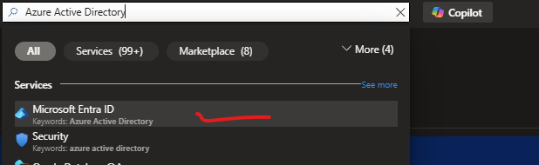

Select App Registration

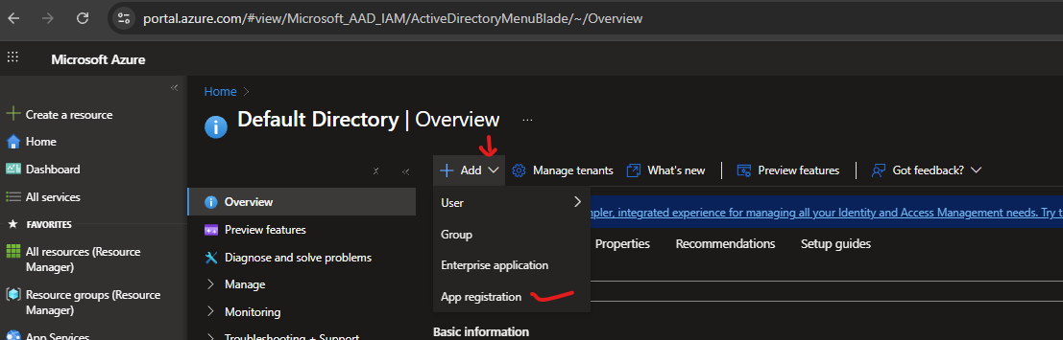

A. Register an Azure AD Application (Service Principal):
- Go to the Azure Portal → Azure Active Directory → App registrations.
- Click New registration and follow the steps.
  - Name: e.g., GitHub-Actions-OIDC.
  - Supported account types: Single tenant is usually sufficient.

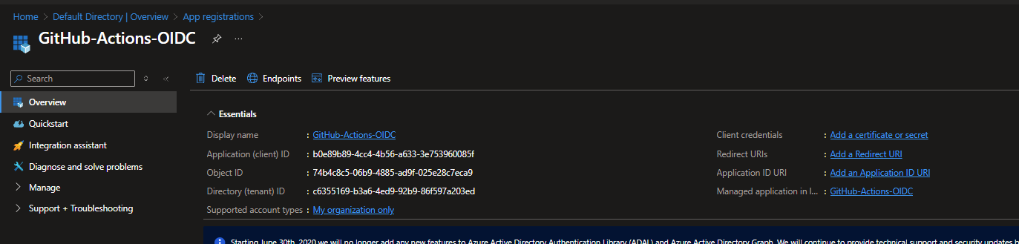

B. Copy Your IDs:
- Application (client) ID → will be used for AZUREAPPSERVICE_CLIENTID.
- Directory (tenant) ID → will be used for AZUREAPPSERVICE_TENANTID.
- Subscription ID → get from Subscriptions blade, used for AZUREAPPSERVICE_SUBSCRIPTIONID.

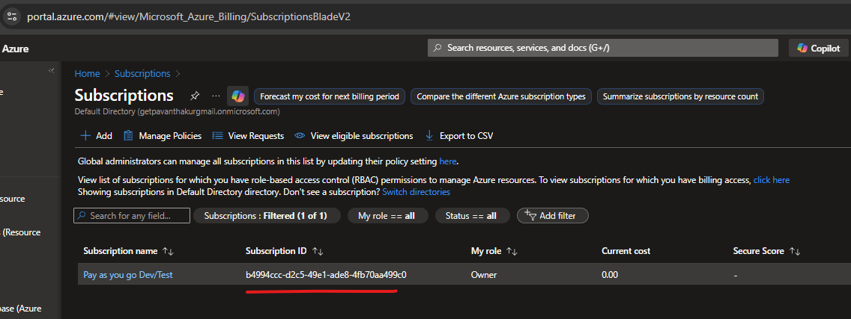

Mapped Azure IDs for GitHub Actions (OIDC)
Azure Value | Maps To (GitHub Actions Secret) | Your Value
Application (client) ID | AZUREAPPSERVICE_CLIENTID | b0e89b89-4cc4-4b56-a633-3e753960085f
Directory (tenant) ID | AZUREAPPSERVICE_TENANTID | c6355169-b3a6-4ed9-92b9-86f597a203ed
Subscription ID | AZUREAPPSERVICE_SUBSCRIPTIONID | b4994ccc-d2c5-49e1-ade8-4fb70aa499c0
Object ID | (not used for secrets) | 74b4c8c5-06b9-4885-ad9f-025e28c7eca9

Now go to github
https://github.com/getpavanthakur/TestAppXY_OrderProcessingSystem/settings/environments

1. Add GitHub Secrets
GitHub → Repo → Settings → Secrets and variables → Actions → New repository secret
Add each exactly:
- Name: AZUREAPPSERVICE_CLIENTID / Value: b0e89b89-4cc4-4b56-a633-3e753960085f
- Name: AZUREAPPSERVICE_TENANTID / Value: c6355169-b3a6-4ed9-92b9-86f597a203ed
- Name: AZUREAPPSERVICE_SUBSCRIPTIONID / Value: b4994ccc-d2c5-49e1-ade8-4fb70aa499c0
(You don’t need to add a publish profile secret since we’re using OIDC.)

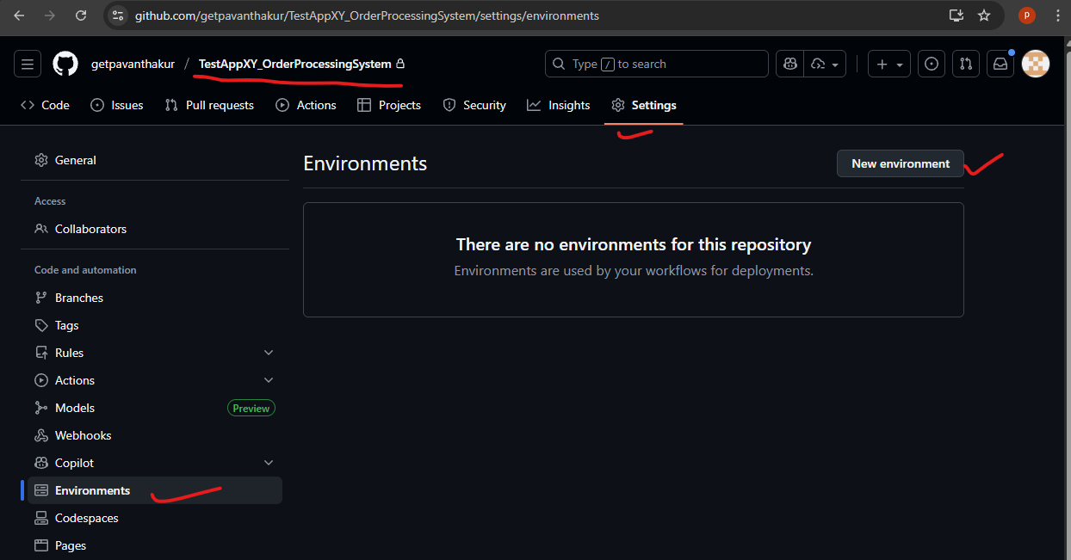

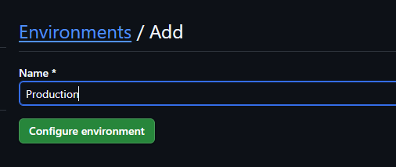

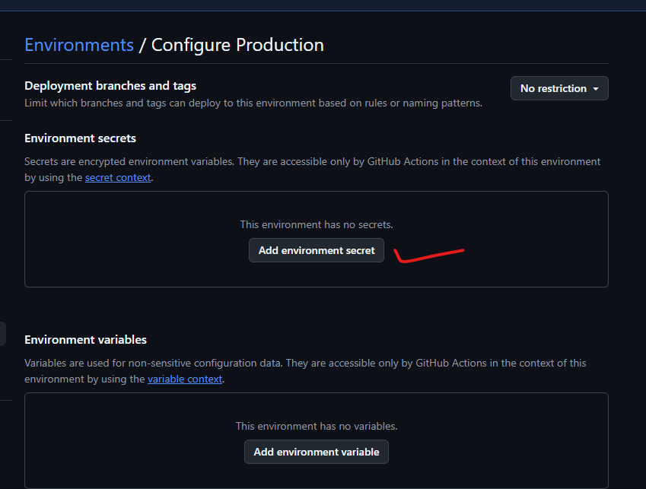

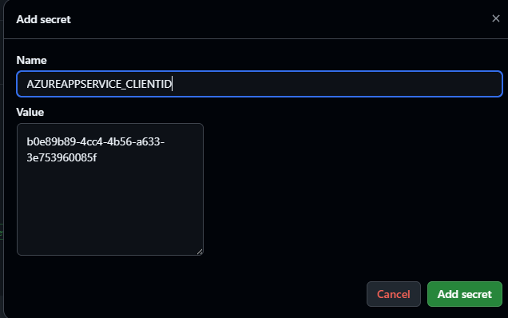

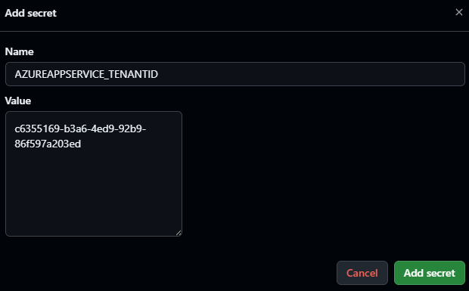

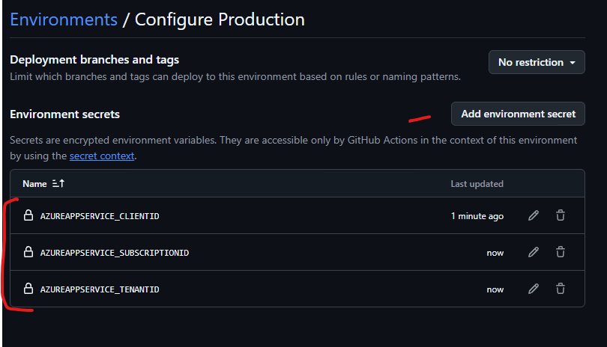

2. Create Federated Credential (OIDC)
Azure Portal → Microsoft Entra ID → App registrations → (select your app with client ID b0e8…) → Certificates & secrets → Federated credentials → Add credential:
- Select GitHub
- Organization: (your GitHub org or username)
- Repository: TestAppXY_OrderProcessingSystem
- Entity type: Branch
- Branch name: main
- Name: github-main-oidc
Save.
Repeat for other branches/environments later (e.g., staging) if needed.

3. Confirm Setup
Optional CLI checks (just informational):
az account show --output table
az webapp show --name orderprocessing-api-xyapp --resource-group rg-orderprocessing-dev --query "{name:name, state:state, host:defaultHostName}" --output table
4. Run Workflow
GitHub → Actions → Deploy API to Azure App Service → Run workflow → Use main branch.
Watch steps: azure/login should show “Federated credentials detected” and token acquisition success; deploy step uploads package.
5. Verify Deployment
Browse: https://orderprocessing-api-xyapp.azurewebsites.net
If you add Swagger later: https://orderprocessing-api-xyapp.azurewebsites.net/swagger
Troubleshooting Quick Tips
- Login step fails: Ensure federated credential exists and branch matches (case-sensitive).
- 404 after deploy: Confirm project path in workflow matches XYDataLabs.OrderProcessingSystem.API.csproj.
- Runtime mismatch errors: Re-check Portal Stack = .NET, Version = 8 (LTS).

