**GIS PROJECT REPORT**

**Cellular Automata (CA) Model**

By Pavan Thanay M (IMT2020024)

**REFERENCE PAPER**

Monitoring and modelling spatio-temporal urban growth of Delhi using Cellular Automata and geoinformatics by Pratyush Tripathy, Amit Kumar. (Published in February, 2019)

**INTRODUCTION**

* The CA model is one of the first models that was implemented to model urban growth.
* In the project, a plain vanilla CA model is used to model urban growth of Bangalore City from 2015 to 2022 and accuracy results for the same are obtained.

**DATA USED**

* All the maps that are used have:
  + Coordinate Reference System: EPSG:32643 - WGS 84 / UTM zone 43N
  + Origin: 751605, 1463685
  + (X: 2268 Y: 2068) dimension
  + 30m × 30m spatial resolution
* Land Use Land Cover Maps of Bangalore city from 2014 to 2022 have been considered for urban growth modelling.
* Following raster maps are the driving factors to the CA Model:
  + Population Density Maps from 2014 to 2021 (from Landscan)
    - Range: 0 to 63,243 (roughly)
  + Water Maps from 2014 to 2022:
    - Binary map of water bodies obtained from LULC maps.
    - Range: {0, 1}
  + Slope Map (from DEM)
    - Range: 0° to 48°
  + Road Proximity Map:
    - Assuming primary roads remain the same from 2014 to 2022, proximity map is created from road map obtained from GeoFabrik.
    - Range: 0m to 500m

**HOW DOES CA MODEL WORK?**

* LULC map of year ‘y’ is considered to predict LULC map of year ‘(y + 1)’.
* A kernel (filter) scans the LULC map image of year ‘y’ as shown.

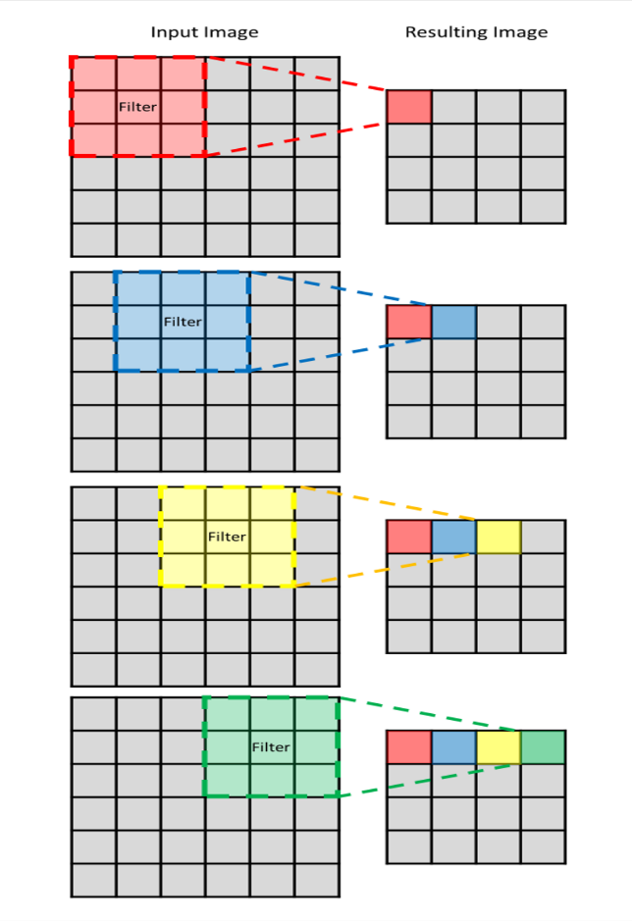

* According to CA Model, a location (pixel) become urban if certain conditions, as prescribed by the kernel, are met.
* Hence, LULC map of year ‘(y + 1)’ is predicted by changing pixel values of LULC map of year ‘y’.
* The predicted LULC map is compared with the original LULC map of year ‘(y + 1)’ for accuracy assessment.

**MORE DETAILS**

* The considered LULC maps have 5 types of pixel values (feature classes):
  + 1 – Built-Up (Urban) area. It includes residential and commercial areas, etc.
  + 2 – Vegetation. It includes all green areas such as parks, protected forests, etc.
  + 3 – Water. It includes all water bodies like lakes, reservoirs, etc.
  + 4 – Other. It includes all other features that do not fall in the above categories.
  + 0 – Used for pixels whose feature class is unknown.
* It is assumed that once a location becomes urban, it will continue to remain urban.
* The model allows a location to become urban if the following conditions are met:
  + The location is initially not urban and not a water body.
  + Number of urban locations in the kernel, placed at the current location, is more than some threshold (built-up threshold).
  + The pixel value of the location in at least one of the driving factors maps meets the threshold corresponding to the driving factor.

**MODEL PARAMETERS AND THRESHOLDS**

Following was obtained after trial and error for best possible spatial accuracy:

* Kernel size = 3
* Built-up Threshold = 4
* Thresholds for driving factors:
  + Population Density Maps:  >= 30,000
  + Water Maps: <= 0.5
  + Slope Map: <= 15°
  + Road Proximity Map: <= 50m

**RESULTS**

Results obtained when CA model is implemented with specified parameters and thresholds

|  |  |  |  |  |
| --- | --- | --- | --- | --- |
| **Y** | **Y + 1** | **Actual Change in Urban area (in sq. km)** | **Predicted Change in Urban area (in sq. km)** | **Spatial Accuracy (%)** |
| 2014 | 2015 | 385 | 105 | 57.169156 |
| 2015 | 2016 | 361 | 127 | 55.460526 |
| 2016 | 2017 | 310 | 115 | 58.645264 |
| 2017 | 2018 | 274 | 100 | 54.841767 |
| 2018 | 2019 | 312 | 108 | 61.308477 |
| 2019 | 2020 | 327 | 127 | 64.824606 |
| 2020 | 2021 | 301 | 132 | 53.987868 |
| 2021 | 2022 | 322 | 108 | 64.034441 |

Results obtained when predicted LULC maps are compared with test data

|  |  |  |
| --- | --- | --- |
| **Year** | **Overall Accuracy (%)** | **Kappa hat classification** |
| 2015 | 79.6994 | 0.6983 |
| 2016 | 95.8667 | 0.9374 |
| 2018 | 75.1272 | 0.5687 |
| 2022 | 85.5824 | 0.7877 |

**ASSESSMENT**

Actual vs Predicted Change in Urban Area for different years

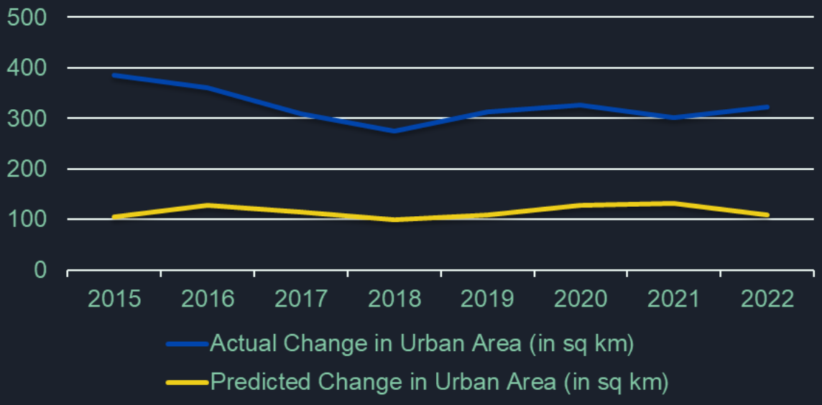

* Note that change in urban area means the sum of areas that were urban in one year and became non – urban in the next year and vice-versa.
* We can see that there is almost a difference of 200 sq. km between actual change in urban are and predicted change in urban area. This is because we have assumed that once an area becomes urban, it will continue to remain urban.
* Hence, for predicted change in urban area, only those areas are considered that have changed from being non-urban to urban. But according to the obtained LULC maps, lot of area changed from being urban to non-urban.

**LIMITATIONS**

* Choice of driving factors, thresholds and model parameters may affect accuracy. The values have been chosen based on certain observations. Hence, these values are subjective in nature.
* Assumptions are not very practical for the study location. In the model, it has been assumed that a water body will not convert into an urban area and once a pixel becomes urban, it will continue to be urban. There are many instances where this does not hold true when the original maps are studied.
* Temporal information is not considered. We just take LULC map of year ‘y’ and predict it for the very next year, by using the appropriate model parameters and thresholds. We do not consider, say, how the changes have occurred from the year ‘y + 1’ to year ‘y + 2’.