Software Requirements Specification
for
Employee Management System
Prepared by P Pavan [15IT224]
Submitted to Ms. Raksha R Nadigar
On January 9th 2018
Table of Contents
Table of Contents ii
Revision History ii
1. Introduction 1
1.1 Purpose 1
1.2 Document Conventions 1
1.3 Intended Audience and Reading Suggestions 1
1.4 Product Scope......................................................................................................................... 1,2
1.5 References 2
2. Overall Description 2
2.1 Product Perspective 2
2.2 Product Functions 3
2.3 User Classes and Characteristics 3
2.4 Operating Environment 4
2.5 Design and Implementation Constraints 4
2.6 User Documentation 4
2.7 Assumptions and Dependencies 4
3. External Interface Requirements 4
3.1 Hardware Interfaces………………………….……………….…………………………………...4
3.2 Software Interfaces…………………………………....……………………..……………………4
3.3 Communication Interfaces …………...……………………………………………………………5
4. System Features 5
4.1 Functional Requirements 5
5. Nonfunctional Requirements 6
5.1 Performance Requirements 6
5.2 Safety Requirements 6
5.3 Security Requirements 6
5.4 Software Quality Attributes 7
5.5 Business Rules 7
6. Other Requirements 7
Appendix A: Glossary 7
Appendix B: Analysis Models 7

Revision History
Name | Date | Reason For Changes | Version

Introduction

Purpose
Employee Management System keeps track of employees in a specific company or organization. Employee Management System provides an online platform for an existing manual system for keeping track of employees in an organization or company. Administrator can add roles to employees so that employee can see their respective roles in a project and work on the same. Administrator can add or remove employees.

In big companies keeping track of all employees and assigning roles to individual employees is a difficult task. Employees are backbone of the company and Employee Management System keeps track of all information about employees. Employees can register and login to their respective accounts and view their current roles assigned and can check all information about them in a single web page.

Document Conventions
Headings are written in times font with size 18, Subheadings are written is times with font size 14 and contents of this document is written using font style arial with font size 11. The rest of the conventions will be mentioned as and when it is used.

Intended Audience and Reading Suggestions
The document is intended for different kinds of audience. Employees of the organization can be an audience. The administrator of the organization is also an audience. The marketing management, Project Managers and all employees can be audience for this document.

The document begins with purpose of the project or management system to be built for the organization or company. The initial part of the document consists of purpose, scope and all information related to reading the document. The next part contains the overall description of the project. Overall description involves project perspective, operating environment and many other information which describes how project is seen by the developers and different tools and environment being considered to build the management system.
The next part of the document is intended for External interface requirements which describes all interface requirements of the project such as user interface, software and hardware interfaces and communication requirements. The functional and non-functional requirements of the project is described in the latter part of the document.

Product Scope
In this world of growing technologies everything has been computerized. With large number of work opportunities the Human workforce has increased. Thus there is a need of a system which can handle the data of such a large number of Employees. This project simplifies the task of maintaining records because of its user friendly nature.
The objective of this project is to provide a comprehensive approach towards the management of employee information. This will be done by designing and implementing an employee management system what will bring up a major paradigm shift in the way that employee information is handled.
The objectives of this system include:
1. Well-designed database to store employee information.
2. A user friendly front-end for the user to interact with the system.

Scope of this project will be limited to the following:
1. Employee profiles:
Employees will have access to their personal profiles and will be able to view their roles and their personal details as per company’s or organization’s records.
2. Administrator access:
I. Administrator will have access to edit details about employees.
II. Project Management: He can manage employees and assign roles to all employees.
III. Recruitment process: An Administrator can add or delete employees.

References
The references used for writing this document is listed as follows:
1. http://www.academia.edu/8480922/EMPLOYEE_MANAGEMENT_SYSTEM

The references which will be used in the due course will be added in this section.

Overall Description

Product Perspective
In this world of growing technologies everything has been computerized. With large number of work opportunities the Human workforce has increased. Thus there is a need of a system which can handle the data of such a large number of Employees. This project simplifies the task of maintaining records because of its user friendly nature.
The product being developed is a trial at creating user-friendly online platform for employee management system. As employees are backbone of a company or organization, management of details about employees previously was done manually. As this is tiresome and time consuming task, creating online platform for the same simplifies the whole procedure of employee management.
The system will contain interaction between two interfaces. The two interfaces being one of the employees and other end interface will be a single administrator who will be in-charge of project management and recruitment procedure.
User-friendly system creates a simple interface for employee to register, login and view all details about him according to company’s records and he can view the role being assigned to him for a particular project.
Administrator interface side will give superior access to administrator to add or delete employees, assign specific roles to all employees regarding any project.

Product Functions
Major functions that employee management system must provide are:
1. Must provide user-friendly environment for employees to create their own accounts with which they can access into their personalized accounts.
2. Must provide superior access to administrator so that he can add, delete employees, Can manage his/her records and can assign roles to each employee.

The diagram describing the proper functioning of the system will be prepared in due course.

User Classes and Characteristics
The most important user classes are Employee and administrator. User class Employee will describe all attributes of the employee and administrator user class describes all attributes of administrator.
Project management is important and it will be carried out by administrator, employee can be an administrator for many other employees. Other classes such as Role, Departments and grades are used in this project.
Role class: Specifies the role assigned to each employee.
Department class: Specifies the department to which an employee belongs to.
Grades class: Describes the pay-grade scale of an employee.

The Entity-Relation Diagram which is used to store data entries in the database describing different class interaction is shown below.
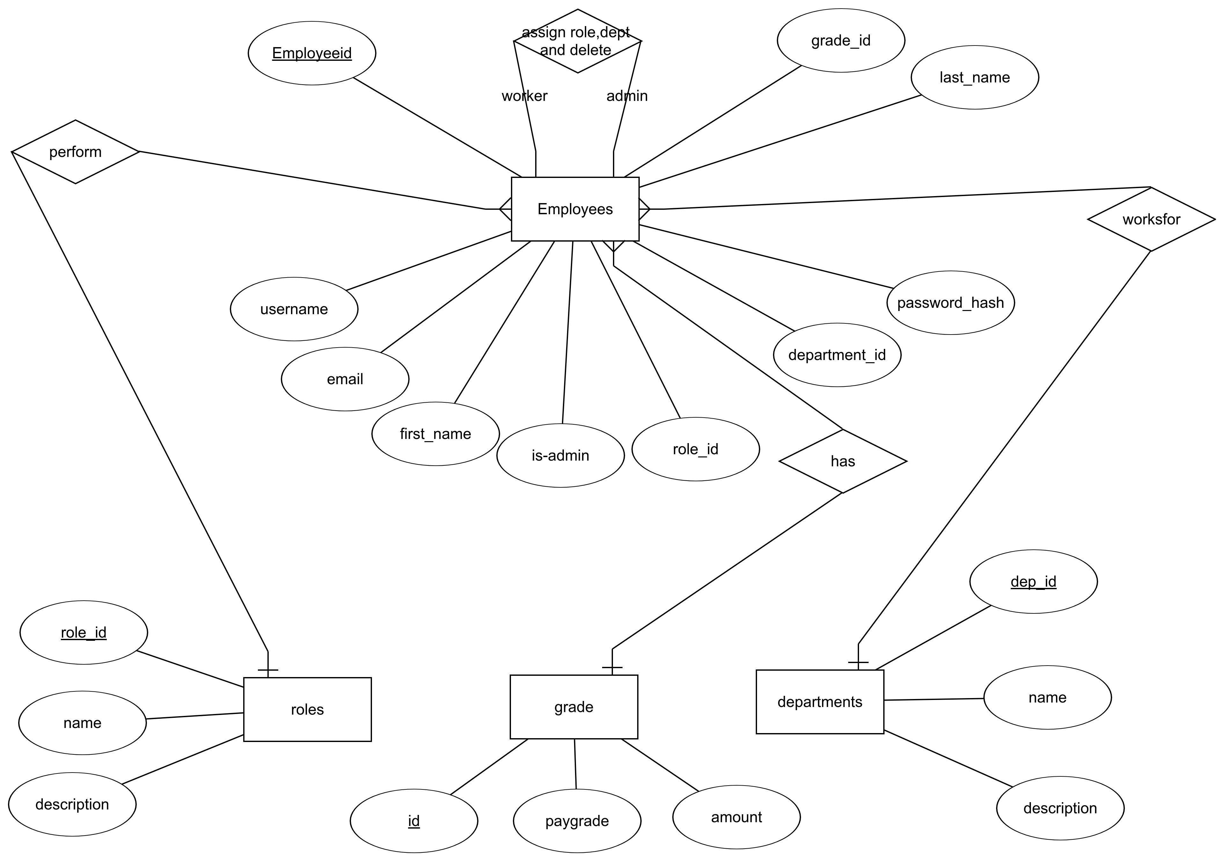

Operating Environment
The minimum operating environment requirement for the system are:
1. Operating System: Windows XP / Vista / 7 / 8 and Linux.
The detailed description about external operating requirements will be specified in section 3.

Design and Implementation Constraints
There are few constraints that is must while designing the system to allow smooth functioning of the system. The following design and implementation constraints are as follows:
1. Password should be encrypted while saving in the database. This should be done to provide protection to all employees as an employee can be an administrator to another employee in a project.
2. The system should be implemented in such a way that developers who wish to further develop the existing system will be able to easily read and understand the implementation of the system.

The constraints which will be deemed necessary while implementation will be mentioned in this section.

User Documentation
No manuals were referred while writing the document. However scribd is used as reference for documentation and lucid-charts is used to draw diagrams.

Assumptions and Dependencies
Employee Management System is assumed and represented as EMS. DataBase Management System is assumed as DBMS. Human Resource Management System is used as HRMS.The assumptions and dependencies which will be made during project implementation will be written in this section.

External Interface Requirements

Hardware Interfaces
The interactions between varies hardware interfaces will be specified when implementation of the project starts.

Software Interfaces
The software interactions between varies classes and interaction and activity diagrams will be written once project implementation commences.

Communications Interfaces
As the system does not involve transfer of information from one server to another, no complex protocols are required. However local host is used with HTTP which helps in interaction of back-end and database. The detailed description of communication will be shown in a diagram.

System Features
The system feature requirements are as follows:

Hardware Requirements:
1. OS: Windows XP/Vista/7/8 and linux
2. CPU: Pentium III [700MHz] and above
3. Memory: 128MB and above
4. Capacity: 4GB of hard drive
Others: Network interface card, mouse, keyboard and monitor.

Software Requirements:
1. As EMS application is a web-based application, internet connection must be established.
2. The EMS software personal database will support MySQL environment as DBMS.

Functional Requirements
1. Authentication
I. Register : User can register to create his own login credentials.
II. Login : The user can login to the HRMS with his/her username and password.
III. Logout: The user can log out from the HRMS system.
Login Failure - If the user does not exist in the database or the user has not yet being authorized by HRMS admin.

2. Authorization:
I. User role check : After logging in, the user role will be checked from the database and the user interface will be displayed according to their role.

3. Process Data:
I. User can access and view the data/records stored in database.
II. Administrator can edit employee records.
III. Administrator can add roles to each employee.

4. Project Management
I. The project manager shall be able to create a team or assign to departments.
II. Assigning roles to all employees to break work structure [ Work Breakdown Structure (WBS)].

5. Grade Management
I. Administrator can view or edit salary details of an employee.

6. Work Disbursement
I. Administrator can assign different employees to different department to distribute work as per WBS.

Nonfunctional Requirements

Performance Requirements
There is no restriction on the number of users to be added to the database.

Safety Requirements
Protecting data stored in database. Authorized access to user. The rest of the safety requirements will be specified as implementation commences.

Security Requirements
Providing online platform to users without the threat of attackers who can crack passwords by encrypting passwords. Providing secure network to carry out the system functionalities. Other security requirements will be specified as and when it arises during implementation.

Software Quality Attributes
Software Quality Attributes will be specified during analysis phase of software design.

Business Rules
Business Rules will be written during Testing phase of software design.

Other Requirements
Other Requirements will be specified during Analysis Phase of the software design.

Appendix A: Glossary
Glossary will be written in analysis phase.
Appendix B: Analysis Models
All diagram will be shown during development phase of software designing.

