Disaster Recovery Solution Document

Application Name | CRIS-SATSANG
App Owner | CRIS-SATSANG
Description | Disaster Recovery Solution for the Cris-Satsang Application

Prepared for: 19-May-2020
Cris-Satsang Version 1.0

Prepared by:

Minfy Technologies


Table of Contents

1 Overview 4
1.1 Pre-Requisites Checklist 4
2 Application Design and DR Approach 5
2.1 Application Name – Cris-Satsang 5
2.1.1 Current Environment 5
2.1.2 DR-Environment design 8
3 Operational Integration Design 11
3.1 Backup of the Amazon Machine Image (AMI) 11
3.2 Cloudendure DR: 13
3.3 DR Setup Execution steps: 16

Revision History
Date | Author(s) | Version | Comments
05/19/2020 | Praveen | 1.0 | Initial Version

Overview
This document captures the following details for Cris-Satsang application.
- Application Details
- High-Level Target state AWS Deployment architecture & topology
- Low Level Design for AWS Deployment (EC2, ELB, EFS, VPC, Subnets, Security Groups etc.)
  - All environments including DR
  - Disaster Recovery Tools to be used

Pre-Requisites Checklist

S.No | Pre-Requisite | Owner | Status
1 | Availability of target VPC | Minfy Team | Completed
2 | Cloud Endure Agent Installation | Minfy Team | Completed
3 | Inventory Validation | Minfy Team | Completed

Application Design and DR Approach

Application Name – Cris-Satsang

Current Environment

AWS High-Level Deployment Architecture

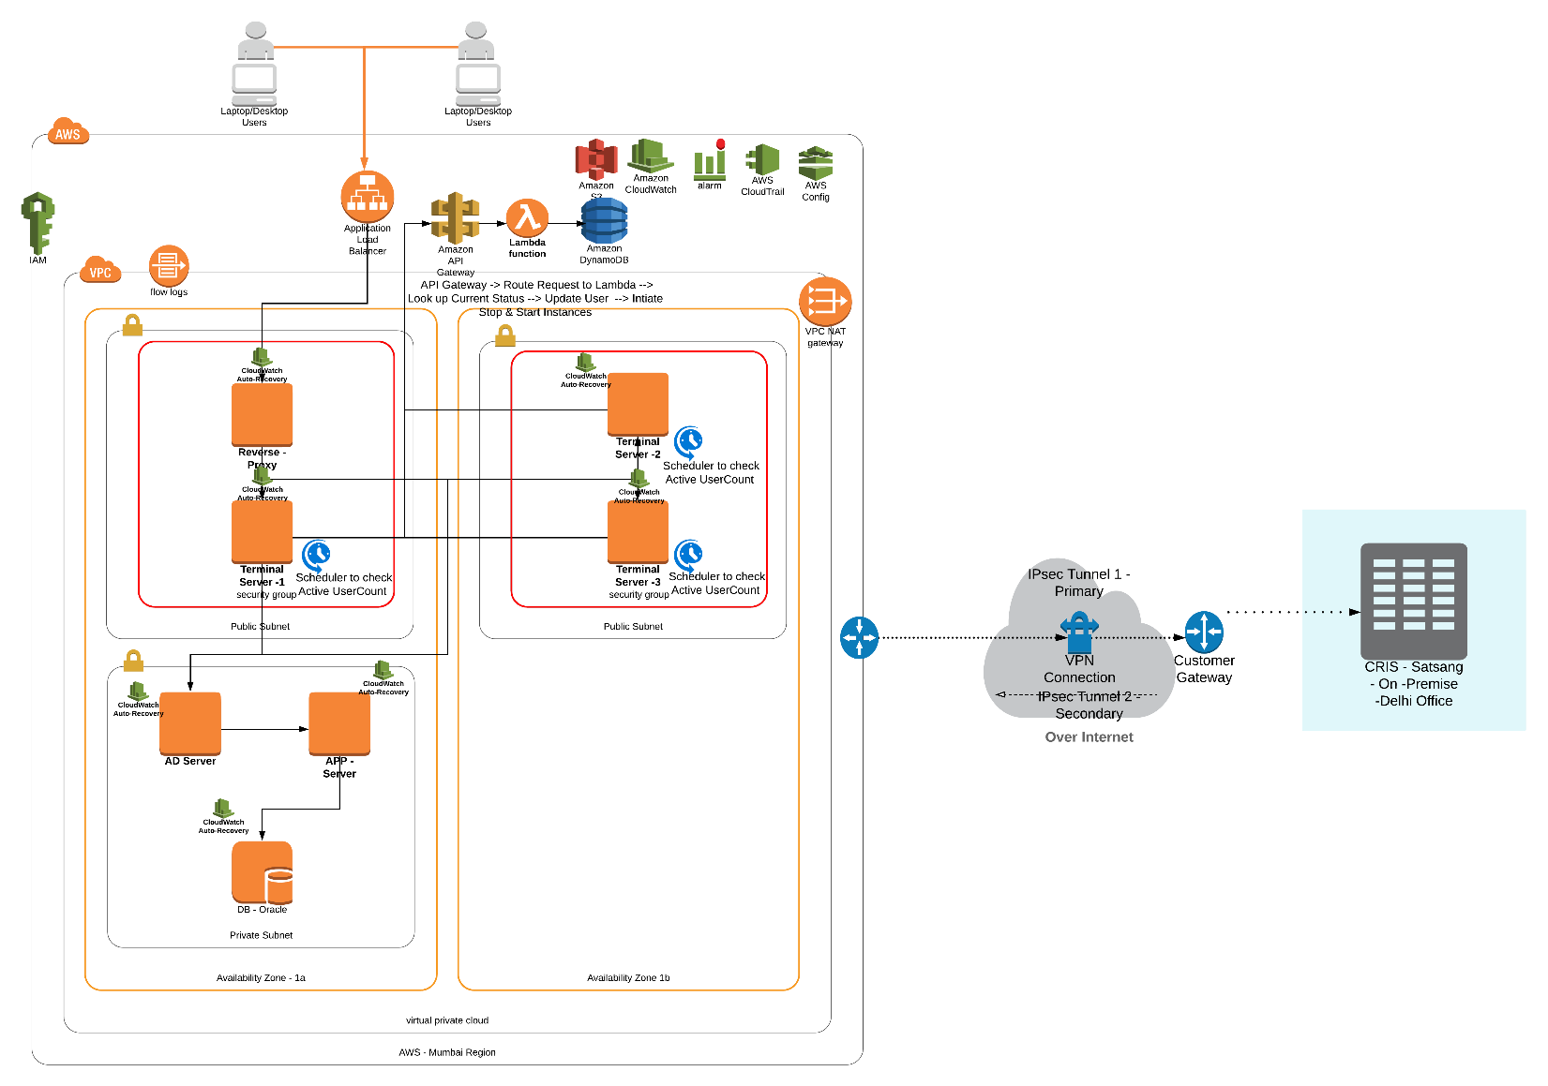

Fig 1:Current Infrastructure High Level Architecture

Source server details:

Instance Names | PCLSATSAS1-App-Server  PCLSATSTS1-Proxy-Server  PCLSATSDC-DC  PCLSATSTS4-Terminal-Server-4  PCLSATSTS3-Terminal-Server-3  PCLSATSTS2-Terminal-Server-2  PCLSATSTS1-Terminal-Server-1  PCLSATSDB2-Database
Instance Type | PCLSATSAS1-App-Server c5.xlarge  PCLSATSTS1-Proxy-Server t2.micro  PCLSATSDC-DC c5.large  PCLSATSTS4-Terminal-Server-4 r5.xlarge  PCLSATSTS3-Terminal-Server-3 r5.xlarge  PCLSATSTS2-Terminal-Server-2 r5.xlarge  PCLSATSTS1-Terminal-Server-1 r5.xlarge  PCLSATSDB2-Database m5.2xlarge
Host Names | PCLSATSAS1-App-Server PCLSATSAS1  PCLSATSTS1-Proxy-Server PCLSATSRP  PCLSATSDC-DC PCLSATSDC  PCLSATSTS4-Terminal-Server-4 PCLSATSTS4  PCLSATSTS3-Terminal-Server-3 PCLSATSTS3  PCLSATSTS2-Terminal-Server-2 PCLSATSTS2  PCLSATSTS1-Terminal-Server-1 PCLSATSTS1  PCLSATSDB2-Database PCLSATSDB2
Public IP | PCLSATSAS1-App-Server N/A  PCLSATSTS1-Proxy-Server 13.126.205.122  PCLSATSDC-DC N/A  PCLSATSTS4-Terminal-Server-4 13.232.70.135  PCLSATSTS3-Terminal-Server-3 13.233.38.228  PCLSATSTS2-Terminal-Server-2 13.232.98.227  PCLSATSTS1-Terminal-Server-1 13.233.3.142  PCLSATSDB2-Database N/A
Private IP | PCLSATSAS1-App-Server 10.55.3.115  PCLSATSTS1-Proxy-Server 10.55.3.45  PCLSATSDC-DC 10.55.3.121  PCLSATSTS4-Terminal-Server-4 10.55.3.60  PCLSATSTS3-Terminal-Server-3 10.55.3.11  PCLSATSTS2-Terminal-Server-2 10.55.3.34  PCLSATSTS1-Terminal-Server-1 10.55.3.56  PCLSATSDB2-Database 10.55.3.70
Subnet(Public/Private) | PCLSATSAS1-App-Server subnet-009660748ef2c36d3--Private  PCLSATSTS1-Proxy-Server subnet-0df11a494cbec0975--Public  PCLSATSDC-DC subnet-009660748ef2c36d3--Private  PCLSATSTS4-Terminal-Server-4 subnet-0df11a494cbec0975--Public  PCLSATSTS3-Terminal-Server-3 subnet-0df11a494cbec0975--Public  PCLSATSTS2-Terminal-Server-2 subnet-0df11a494cbec0975--Public  PCLSATSTS1-Terminal-Server-1 subnet-0df11a494cbec0975--Public  PCLSATSDB2-Database subnet-009660748ef2c36d3—Private
VPC | VPC Name: CRIS-SATSANG-VPC-55-3  VPC ID: vpc-0e1e0eee05aa632dd
APP Type | PCLSATSAS1-App-Server Application  PCLSATSTS1-Proxy-Server Proxy  PCLSATSDC-DC Domain Controller  PCLSATSTS4-Terminal-Server-4 Terminal Servers  PCLSATSTS3-Terminal-Server-3 Terminal Servers  PCLSATSTS2-Terminal-Server-2 Terminal Servers  PCLSATSTS1-Terminal-Server-1 Terminal Servers  PCLSATSDB2-Database Database—Oracle
Security Group | PCLSATSAS1-App-Server PCLSATSAS1-Web-Server-SG  PCLSATSTS1-Proxy-Server Proxy-SG-55-3  PCLSATSDC-DC CRIS-Satasang-SG-55-3-DC-AD  PCLSATSTS4-Terminal-Server-4 CRIS-Satasang-SG-55-3  PCLSATSTS3-Terminal-Server-3 CRIS-Satasang-SG-55-3  PCLSATSTS2-Terminal-Server-2 CRIS-Satasang-SG-55-3  PCLSATSTS1-Terminal-Server-1 CRIS-Satasang-SG-55-3  PCLSATSDB2-Database CRIS-Satasang-SG-55-3-Database
Availability Zone | PCLSATSAS1-App-Server ap-south-1b  PCLSATSTS1-Proxy-Server ap-south-1b  PCLSATSDC-DC ap-south-1b  PCLSATSTS4-Terminal-Server-4 ap-south-1b  PCLSATSTS3-Terminal-Server-3 ap-south-1b  PCLSATSTS2-Terminal-Server-2 ap-south-1b  PCLSATSTS1-Terminal-Server-1 ap-south-1b  PCLSATSDB2-Database ap-south-1b
Port Specifications | With in VPC

DR-Environment design

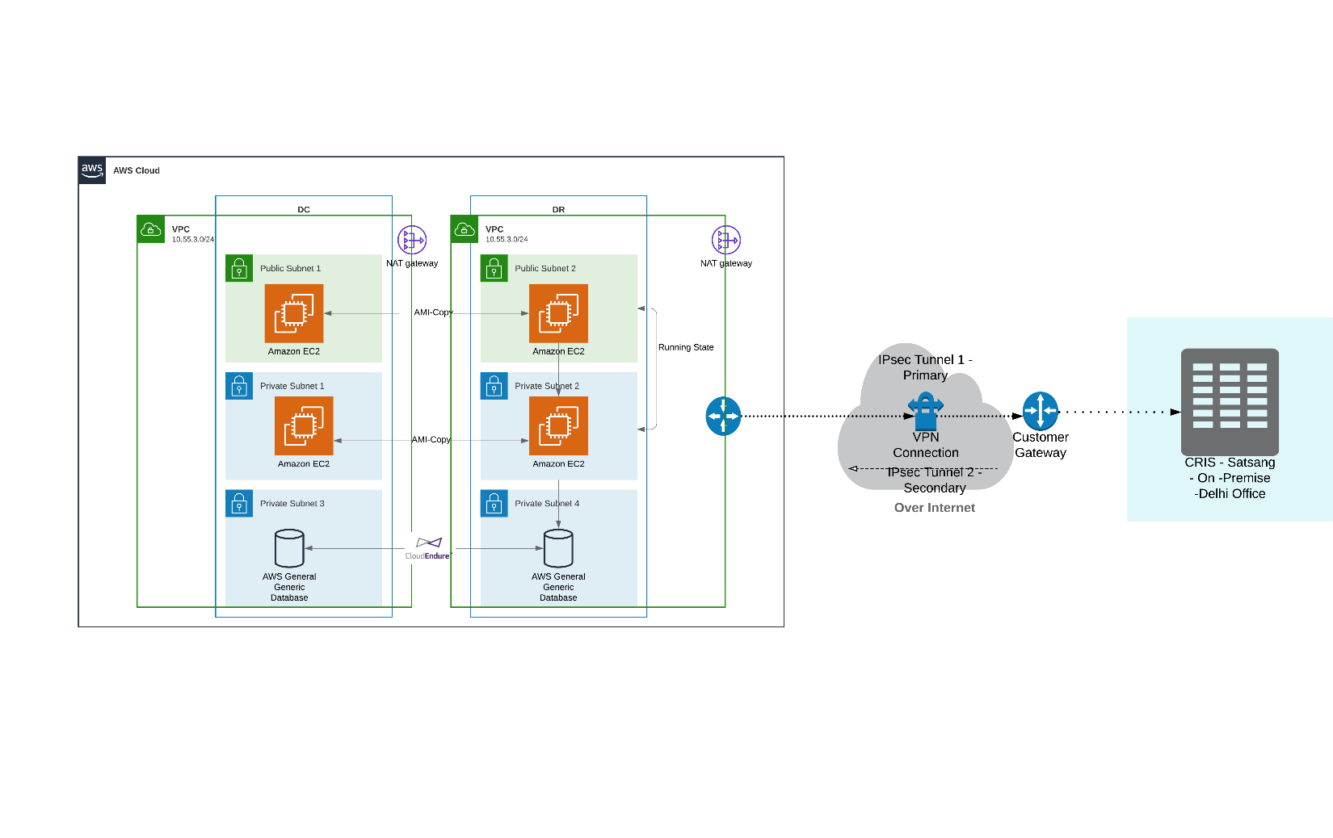Fig 2:DR Environment High Level Architecture

Target server details:

Instance Names | PCLSATSAS1-App-Server-DR  PCLSATSTS1-Proxy-Server-DR  PCLSATSDC-DC-DR  PCLSATSTS4-Terminal-Server-4-DR  PCLSATSTS3-Terminal-Server-3-DR  PCLSATSTS2-Terminal-Server-2-DR  PCLSATSTS1-Terminal-Server-1-DR  PCLSATSDB2-Database-DR
Instance Type | PCLSATSAS1-App-Server-DR c5.xlarge  PCLSATSTS1-Proxy-Server-DR t2.micro  PCLSATSDC-DC-DR c5.large  PCLSATSTS4-Terminal-Server-4-DR r5.xlarge  PCLSATSTS3-Terminal-Server-3-DR r5.xlarge  PCLSATSTS2-Terminal-Server-2-DR r5.xlarge  PCLSATSTS1-Terminal-Server-1-DR r5.xlarge  PCLSATSDB2-Database-DR m5.2xlarge
Host Names | PCLSATSAS1-App-Server-DR PCLSATSAS1  PCLSATSTS1-Proxy-Server-DR PCLSATSRP  PCLSATSDC-DC-DR PCLSATSDC  PCLSATSTS4-Terminal-Server-4-DR PCLSATSTS4  PCLSATSTS3-Terminal-Server-3-DR PCLSATSTS3  PCLSATSTS2-Terminal-Server-2-DR PCLSATSTS2  PCLSATSTS1-Terminal-Server-1-DR PCLSATSTS1  PCLSATSDB2-Database-DR PCLSATSDB2
Public IP | PCLSATSAS1-App-Server-DR N/A  PCLSATSTS1-Proxy-Server-DR 13.126.205.122  PCLSATSDC-DC-DR N/A  PCLSATSTS4-Terminal-Server-4-DR 13.232.70.135  PCLSATSTS3-Terminal-Server-3-DR 13.233.38.228  PCLSATSTS2-Terminal-Server-2-DR 13.232.98.227  PCLSATSTS1-Terminal-Server-1-DR 13.233.3.142  PCLSATSDB2-Database-DR N/A
Private IP | PCLSATSAS1-App-Server-DR 10.55.3.115  PCLSATSTS1-Proxy-Server-DR 10.55.3.45  PCLSATSDC-DC-DR 10.55.3.121  PCLSATSTS4-Terminal-Server-4-DR 10.55.3.60  PCLSATSTS3-Terminal-Server-3-DR 10.55.3.11  PCLSATSTS2-Terminal-Server-2-DR 10.55.3.34  PCLSATSTS1-Terminal-Server-1-DR 10.55.3.56  PCLSATSDB2-Database-DR 10.55.3.70
Subnet(Public/Private) | PCLSATSAS1-App-Server-DR subnet-0dfe77031e1198b71--Private  PCLSATSTS1-Proxy-Server-DR subnet-0faec156ed7a7b133--Public  PCLSATSDC-DC-DR subnet-0dfe77031e1198b71--Private  PCLSATSTS4-Terminal-Server-4-DR subnet-0faec156ed7a7b133--Public  PCLSATSTS3-Terminal-Server-3-DR subnet-0faec156ed7a7b133--Public  PCLSATSTS2-Terminal-Server-2-DR subnet-0faec156ed7a7b133--Public  PCLSATSTS1-Terminal-Server-1-DR subnet-0faec156ed7a7b133--Public  PCLSATSDB2-Database-DR subnet-0dfe77031e1198b71--Private
VPC | VPC Name: Cris-Satsang-DR-VPC  VPC ID: vpc-08334406627550837
APP Type | PCLSATSAS1-App-Server-DR Applcation  PCLSATSTS1-Proxy-Server-DR Proxy  PCLSATSDC-DC-DR Domain Controller  PCLSATSTS4-Terminal-Server-4-DR Terminal Servers  PCLSATSTS3-Terminal-Server-3-DR Terminal Servers  PCLSATSTS2-Terminal-Server-2-DR Terminal Servers  PCLSATSTS1-Terminal-Server-1-DR Terminal Servers  PCLSATSDB2-Database-DR Database--Oracle
Security Group | PCLSATSAS1-App-Server-DR PCLSATSAS1-Web-Server-SG-DR  PCLSATSTS1-Proxy-Server-DR Proxy-SG-55-3-DR  PCLSATSDC-DC-DR CRIS-Satasang-SG-55-3-DC-AD-DR  PCLSATSTS4-Terminal-Server-4-DR CRIS-Satasang-SG-55-3-DR  PCLSATSTS3-Terminal-Server-3-DR CRIS-Satasang-SG-55-3-DR  PCLSATSTS2-Terminal-Server-2-DR CRIS-Satasang-SG-55-3-DR  PCLSATSTS1-Terminal-Server-1-DR CRIS-Satasang-SG-55-3-DR  PCLSATSDB2-Database-DR CRIS-Satasang-SG-55-3-Database-DR
Availability Zone | PCLSATSAS1-App-Server-DR ap-south-1a  PCLSATSTS1-Proxy-Server-DR ap-south-1a  PCLSATSDC-DC-DR ap-south-1a  PCLSATSTS4-Terminal-Server-4-DR ap-south-1a  PCLSATSTS3-Terminal-Server-3-DR ap-south-1a  PCLSATSTS2-Terminal-Server-2-DR ap-south-1a  PCLSATSTS1-Terminal-Server-1-DR ap-south-1a  PCLSATSDB2-Database-DR ap-south-1a
Port Specifications | With in VPC

DR Strategy

DR Tool

- AWS AMI for Applications

- AWS CloudEndure for database

Operational Integration Design

Backup of the Amazon Machine Image (AMI)

Next we look at “machine images.” AWS stores system images in what are called Amazon Machine Images or AMI for short. These images consist of the template for the root volume required to launch an instance. To save your instance’s as a machine image you simply backup the root volume as an AMI.

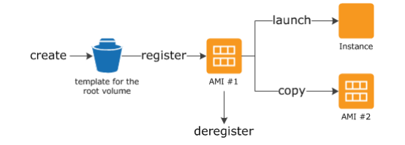

Fig 3: Using AMI to backup and launch an instance

An AMI that you register is automatically stored in your account using Amazon EBS snapshots. These snapshots reside in Amazon S3 and are highly durable. This means that the underlying storage mechanism for the AMIs is protected from multiple failure scenarios.

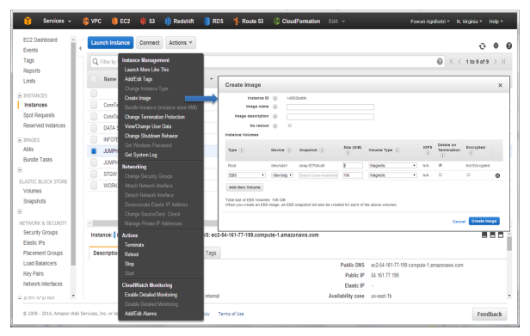

Fig 4: Using the EC2 console to create a machine image

Once you have created an AMI of your Amazon EC2 instance you can use the AMI to recreate the instance or launch more copies of the instance. It is also possible to copy AMIs from one region to another. Consequently, you can save a copy of a system image to another region.

Backup Policy Details:

S.No | Instance Name | Host Name | Public IP | Private IP | Backup  Policy
1 | PCLSATSAS1-App-Server | PCLSATSAS1 |  | 10.55.3.115 | AMI Backup every 30 mins
2 | PCLSATSTS1-Proxy-Server | pclsatsrp | 13.126.205.122 | 10.55.3.45 | AMI Backup every 30 mins
3 | PCLSATSDC-DC | PCLSATSDC |  | 10.55.3.121 | AMI Backup every 30 mins
4 | PCLSATSTS4-Terminal-Server-4 | PCLSATSTS4 | 13.232.70.135 | 10.55.3.60 | AMI Backup every 30 mins
5 | PCLSATSTS3-Terminal-Server-3 | PCLSATSTS3 | 13.233.38.228 | 10.55.3.11 | AMI Backup every 30 mins
6 | PCLSATSTS2-Terminal-Server-2 | PCLSATSTS2 | 13.232.98.227 | 10.55.3.34 | AMI Backup every 30 mins
7 | PCLSATSTS1-Terminal-Server-1 | PCLSATSTS1 | 13.233.3.142 | 10.55.3.56 | AMI Backup every 30 mins
8 | PCLSATSDB2-Database | pclsatsdb2 |  | 10.55.3.70 | Cloud Endure

Cloudendure DR:
CloudEndure Disaster Recovery is available on AWS Marketplace as a SaaS Contract and a SaaS Subscription, which means AWS customers can sign up directly through their AWS accounts and start replicating machines straight away — no paperwork, no long-term commitment, no minimum number of machines

Registering for a CloudEndure Disaster Recovery Account – Metering

1.Log into your AWS Account and navigate to the AWS MarketplaceCloudEndure Disaster Recovery product page. Click the orange Continue to Subscribe button.
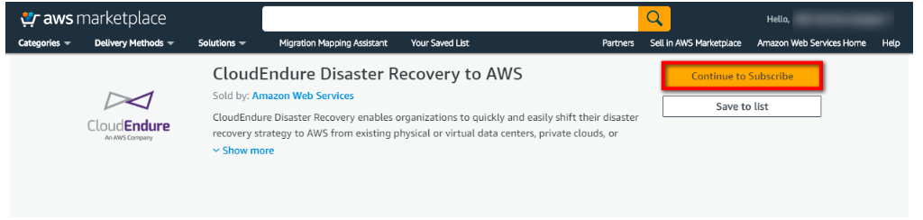

2. Review the software fees and click the orange Subscribe button.
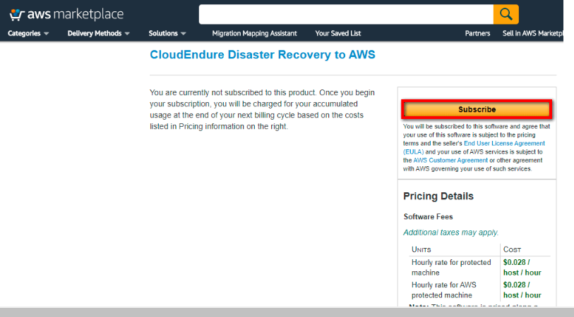

Creation of DR Project after successful login into cloudendure dashboard
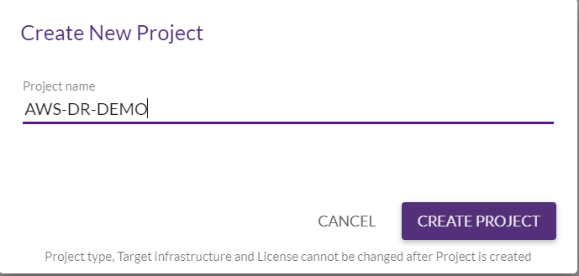

Setting up with AWS credentials
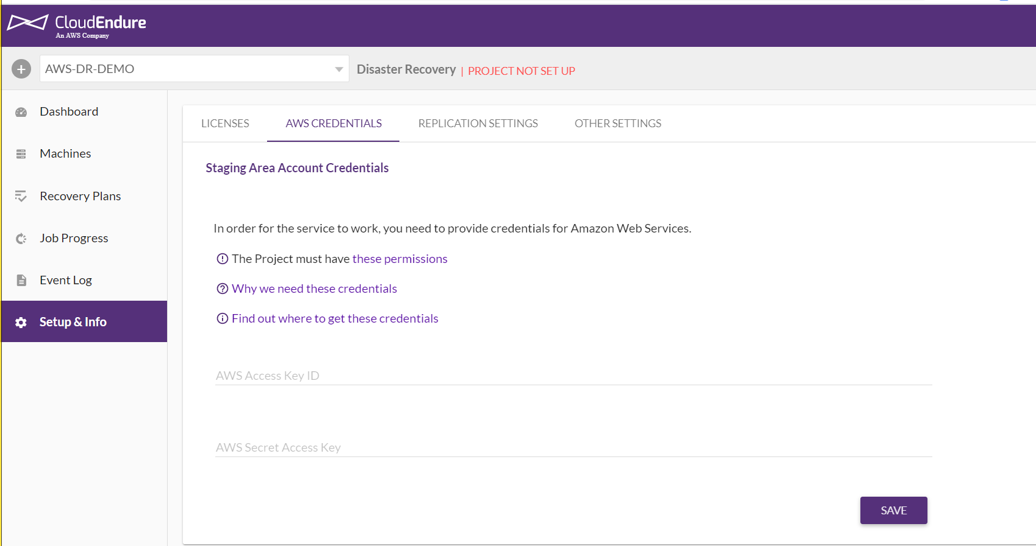

Setting up replication settings to initiate Replication

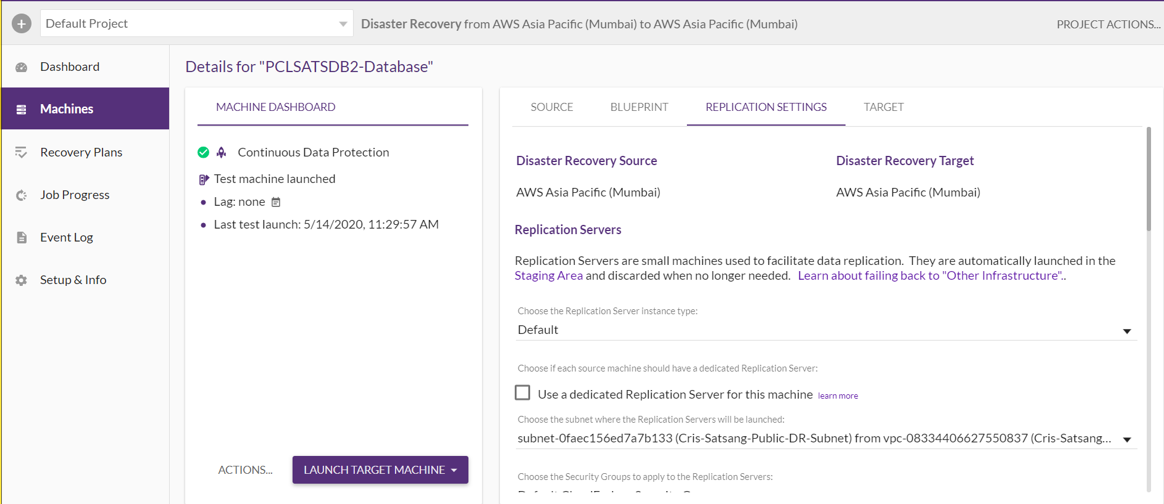

Configuring the Target Machine Blueprint
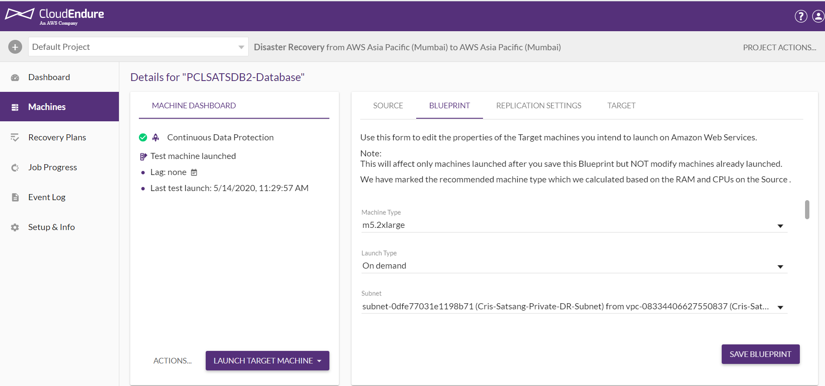

DR Setup Execution steps:

  - AMI backup- Verifying the latest backup creation
  - Cloudendure Dashboard –Checking the state to launch the Target server,To launch the Target server the state should be in Continous Data Replication with no LAG.
  - Provisioning the servers(DC,Proxy,APP,Jump box and Terminal servers) with the latest AMI in the DR VPC.
  - Associating the Elastic IP for the Terminal servers and Proxy servers by disassociating from Source servers.
  - Launching the Database server using Cloudendure dashboard by verifying the Blueprint settings.
  - Checking the DB services running by login into the Jump box server
  - RDP to the APP server and check the APP connectivity
  - Once APP is running make necessary changes for the remaining servers(Terminal servers)
  - Verifying Application (DNS level)
  - DR successful

