* Download mysql
* Unzip
* Open command prompt as Administrator
* Go to bin directory



* Run command **mysqld –initialize --console**

This command initializes the database and generates temporary password for the root account

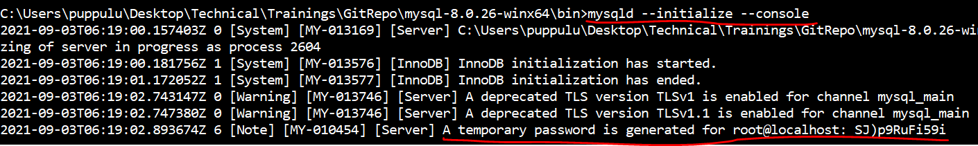

* Make a note of the temporary password
* Now start mysql server using command **mysqld --console**

--console is optional. It is just to display the messages on console

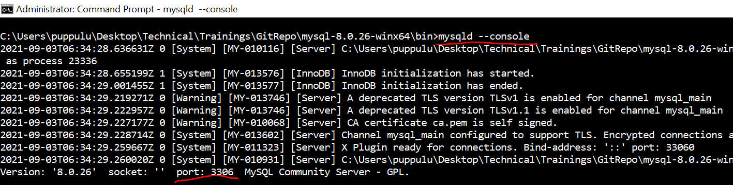

Now mysql server is Up & Running on port 3306.

**Now start mysql to connect to MySql server and write queries**

* Open another command prompt
* Go to directory C:\Users\puppulu\Desktop\Technical\Trainings\GitRepo\mysql-8.0.26-winx64\bin
* Now execute below command **mysql -uroot -p**
* It prompts you to enter the password. Enter the temporary password generated
* Now it opens mysql prompt
* As this is the first time we need to reset the password of root account
* Execute below query to reset the password (In my case my new password is welcome. You can change it as you want)

**ALTER USER 'root'@'localhost' IDENTIFIED BY 'welcome'**

* Now check the available schemas by command **show databases**

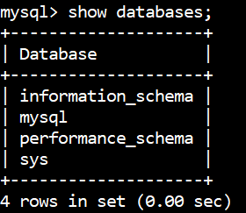

* For my application, I want to create ordermgt database and use it
* Run command **create database ordermgt**

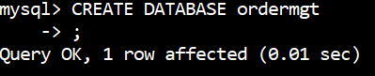

* Run command **show databases**

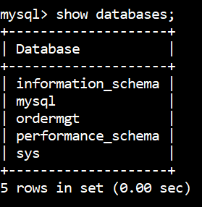

* Now to use this database run command **use ordermgt**

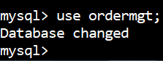

* Now we can run SQL queries