**Simpli Development Project**

**Problem Statement:** To show the list of occurrences along with their respective positions in the top hundred list of items.

**Solution:** User selections a search engine type and enters the search term to get the desired list.

**Technologies:** ASP.Net Core Web API, React, CSS, MSTest

**Architecture:**

React client app using HTTPClient

ASP.NET Core Web API

Network

GET Request

Response

**Extension 1:**

The search result gets cached for 1 hour.

**Extension 2:**

The search is extended to Bing search engine and is open for more browsers.

**Extension 3:**

Performance, availability and reliability are the primary requirements for a web service.

**Performance can be improved by following the below strategies,**

1. Use compression techniques, using GZip or Deflate compression on the Web API to compress data transferred between the server and the client.
2. Using Caching
3. Making asynchronous calls using async and await.

**Availability,**

1. By incorporating proper monitor and provide actionable metrics on the logs.
2. Proper unit tests, integrations test and development standards need be in place.
3. Proper cascading of failure or exceptions for better troubleshooting.
4. the API service endpoints, while serving the client request, can detect if the backend servers are down or the network request has timed out by using service discovery or periodic heartbeats. They can then respond from their local cache if necessary.

**Reliability,**

1. Proper monitoring, testing, securing, and understanding performance, consumption, and limitations across ALL of the API infrastructure would make a web service reliable.

**Screenshots:**

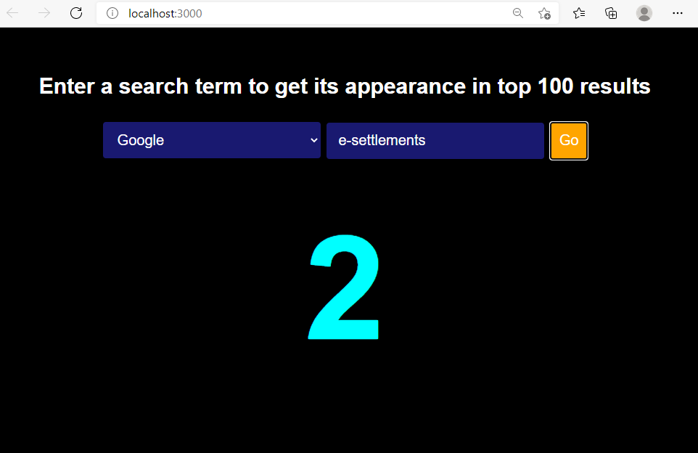

API:

