Documentation
Source: Kaggle.com
Cover page
Table of contents
5 major section
Heading 1
Heading 2
Page number

IIT STUDENTS ADMISSION DATA

OBJECTIVES:
The main objective of this project is to analyze student data to understand enrollment patterns, student demographics, academic fields, fees and discounts, and admission and graduation trends. The analysis aims to identify meaningful patterns and insights from the data and present them through clear visualizations and dashboards to support data-driven decision-making.

Meta Data:
Data source By : Kaggle
Tool used : Microsoft Excel
Number of Columns: 10
Number of Rows : 2,00,001

No.of .Columns | No.of. Rows
10 | 2,00,001

DATA TYPE | COLUMNS
Number | Student ID
General | Student Name
Date | Date of Birth
General | Field of Study
Number | Year of Admission
Number | Excepted year of Graduation
Number | Current semester
General | Specialization
Currency | Fees
Currency | Discount on Fees

Before cleaning:

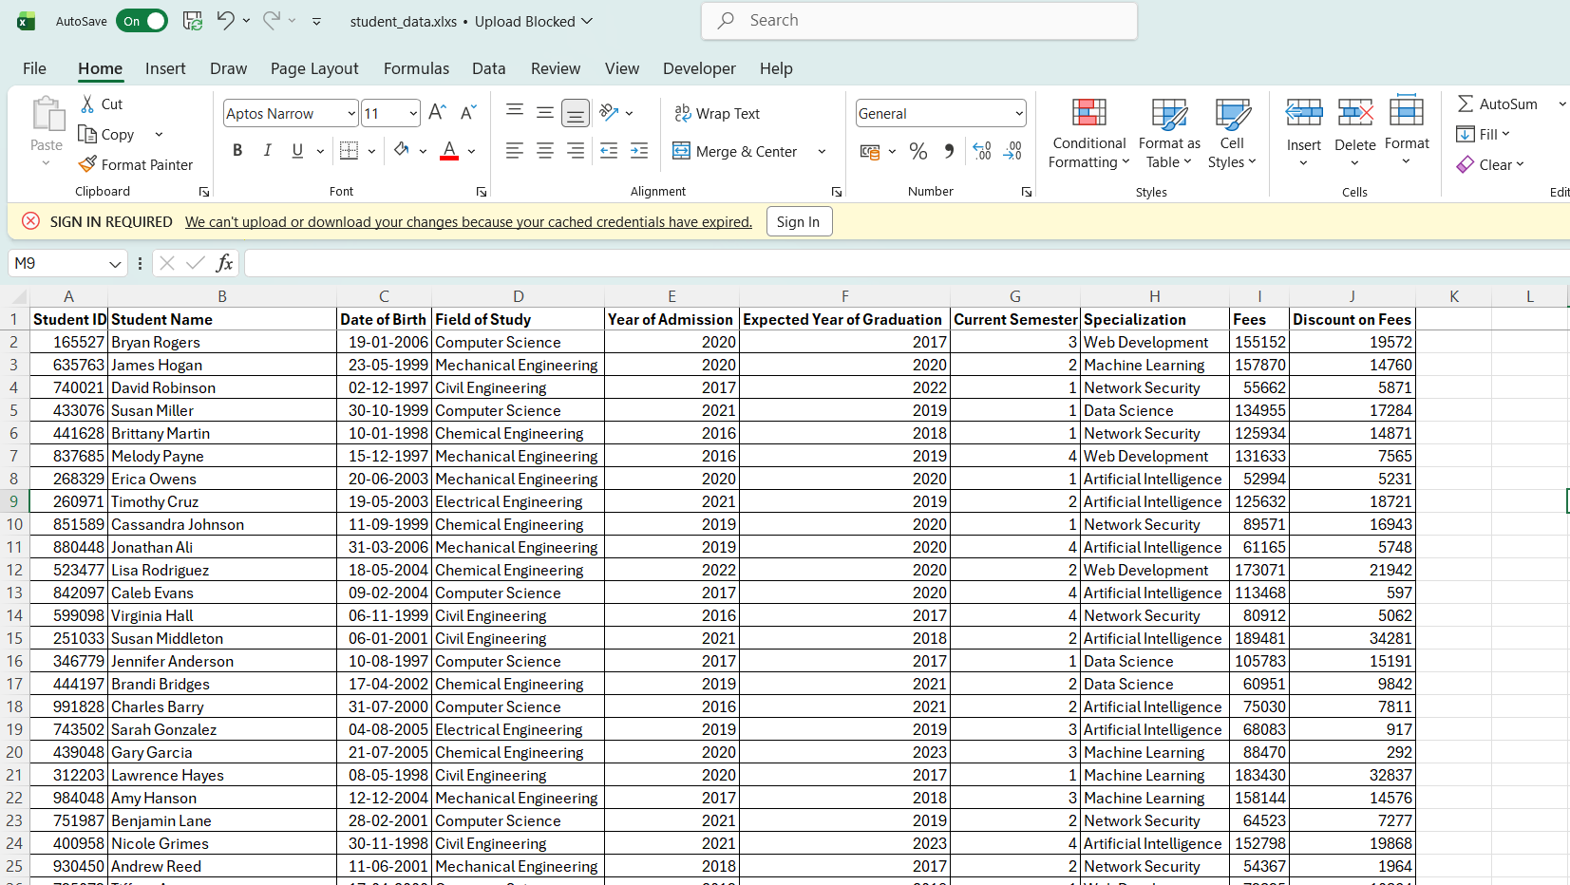

After Cleaning:

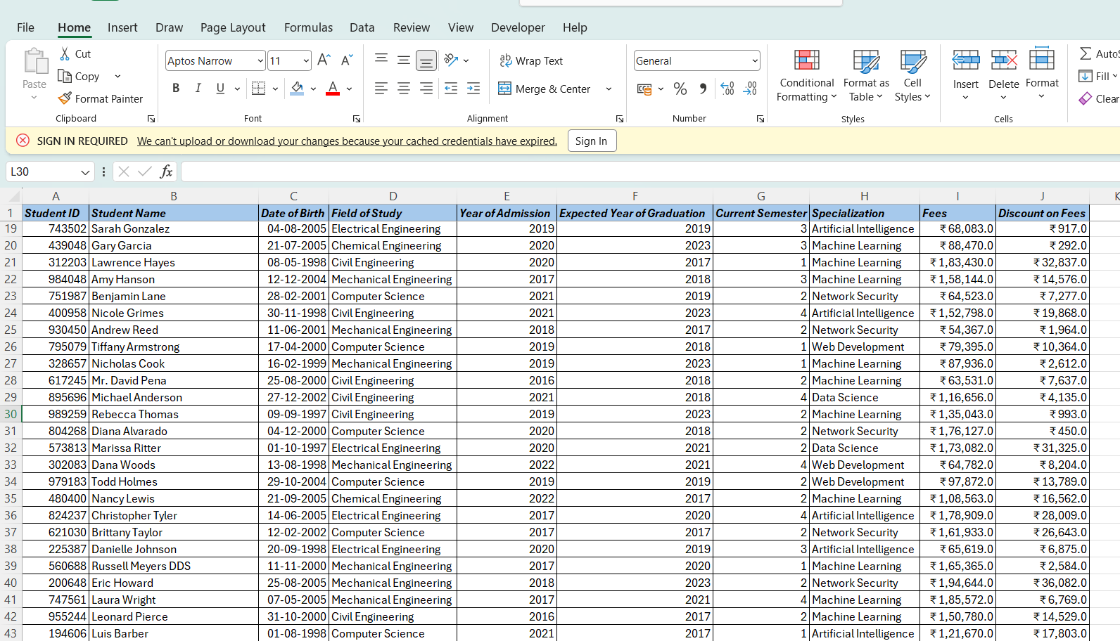
Table of contents

Header
Footer
Foot notes
Reference
Each content minimun 1.5 or 2 page

