**Паттерны проектирования**

**ИСиТ,ПОИБМС-2**

**Лекция 11/2**

**Итоги**

**Всего 22 паттерна**

1. **Пошаговое исполнение**

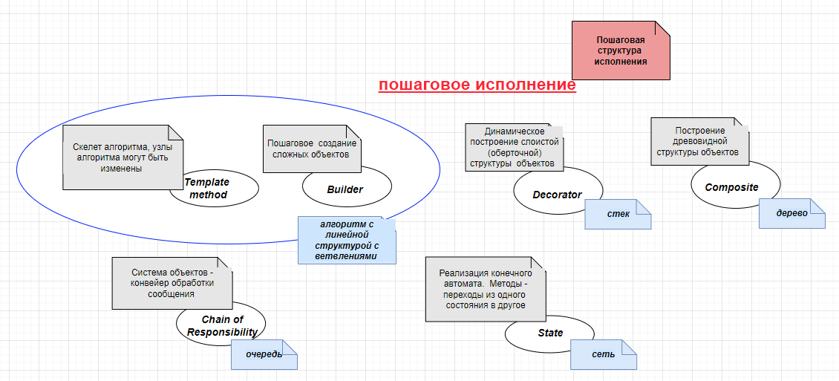

1. **State** [**https://metanit.com/sharp/patterns/3.6.php**](https://metanit.com/sharp/patterns/3.6.php)

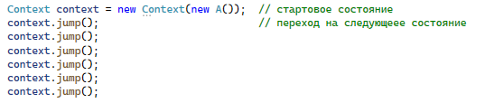

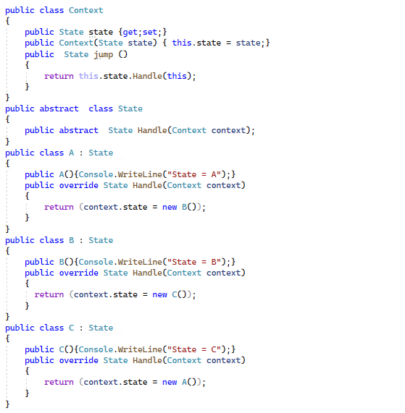

1. **Builder** [**https://metanit.com/sharp/patterns/2.5.php**](https://metanit.com/sharp/patterns/2.5.php)

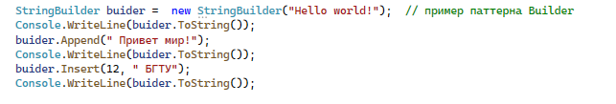

**Composite** [**https://metanit.com/sharp/patterns/4.4.php**](https://metanit.com/sharp/patterns/4.4.php)

**Chain of Responsibility** [**https://metanit.com/sharp/patterns/3.7.php**](https://metanit.com/sharp/patterns/3.7.php)

**Builder** [**https://metanit.com/sharp/patterns/2.5.php**](https://metanit.com/sharp/patterns/2.5.php)

**Template method** [**https://metanit.com/sharp/patterns/3.4.php**](https://metanit.com/sharp/patterns/3.4.php)

**Decorator** [**https://metanit.com/sharp/patterns/4.1.php**](https://metanit.com/sharp/patterns/4.1.php)

1. **Снижение сложности интерфейса**

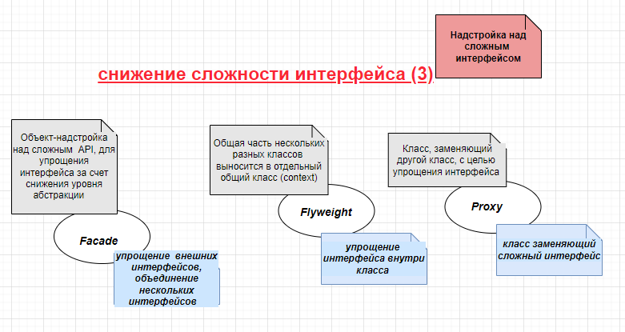

**Facade** [**https://metanit.com/sharp/patterns/4.3.php**](https://metanit.com/sharp/patterns/4.3.php)

**Flyweight** [**https://metanit.com/sharp/patterns/4.7.php**](https://metanit.com/sharp/patterns/4.7.php)

**Proxy** [**https://metanit.com/sharp/patterns/4.5.php**](https://metanit.com/sharp/patterns/4.5.php)

1. **Генерация алгоритмов**

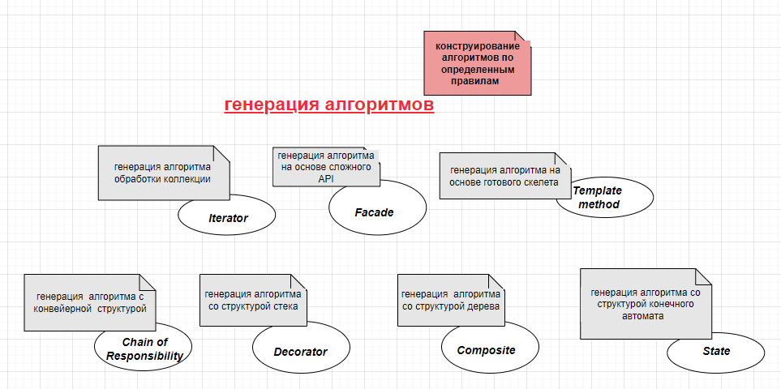

**Iterator** [**https://metanit.com/sharp/patterns/3.5.php**](https://metanit.com/sharp/patterns/3.5.php)

1. **Внедрение зависимостей**

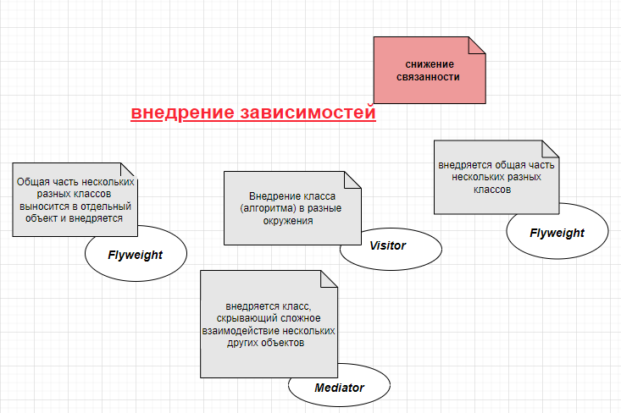

**Visitor** [**https://metanit.com/sharp/patterns/3.11.php**](https://metanit.com/sharp/patterns/3.11.php)

**Mediator** [**https://metanit.com/sharp/patterns/3.9.php**](https://metanit.com/sharp/patterns/3.9.php)

1. **Посредник для интерфейсов**

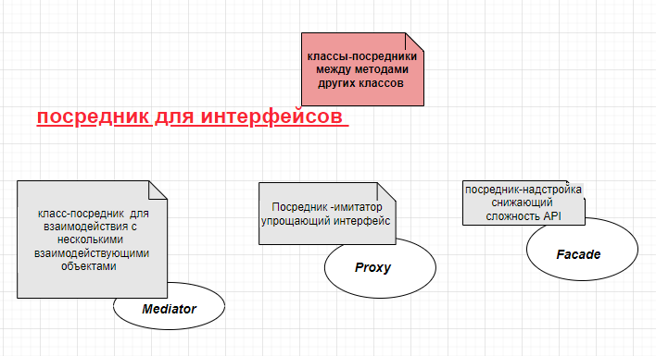

1. **КОНЕЦ**