BUG #CT_@ Unable to create a tour

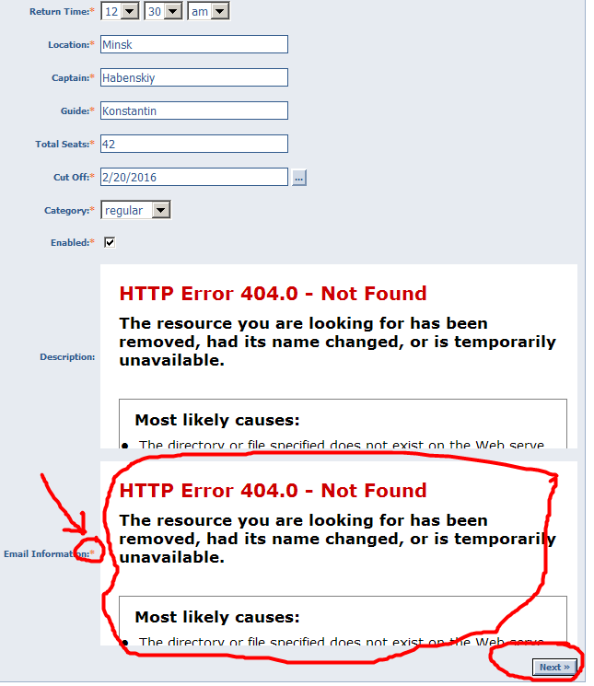

BUG #LogIN1 The menu bar is located below the tab menu items
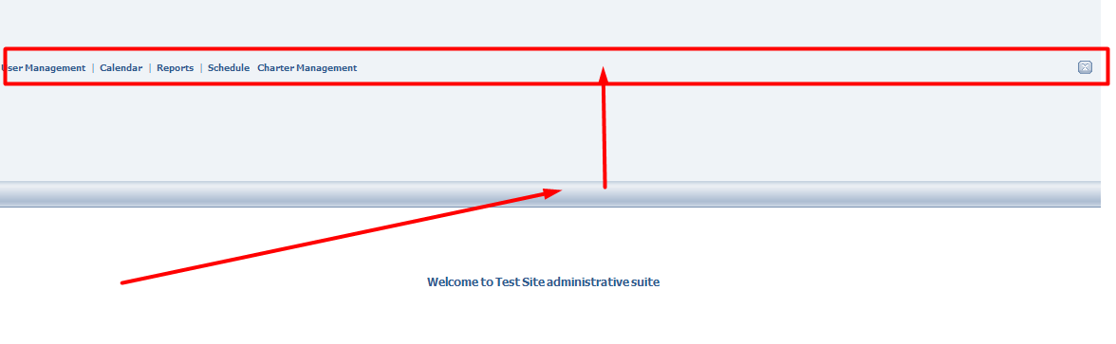

BUG #STPAS It’s impossible to change the password for the account Office Staff

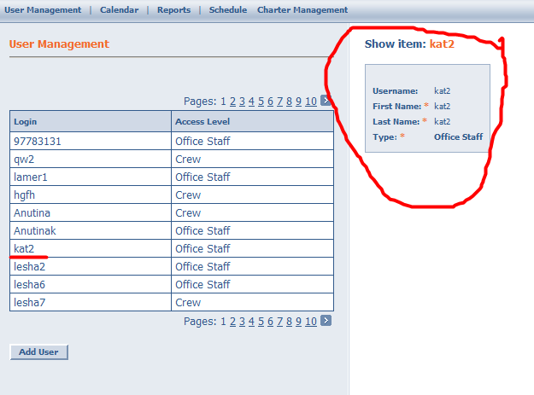

BUG #CRPAS It’s impossible to change the password for the account Crew
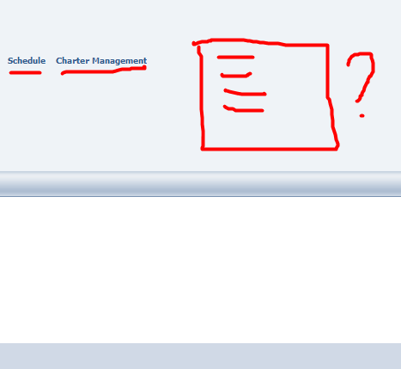

BUG #Cat1 The position is beyond the scope the table of list
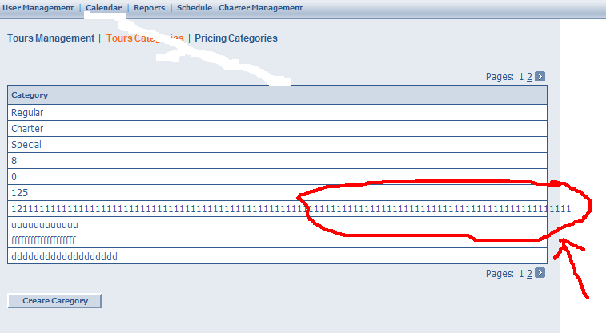

BUG #SPEC1 The discrepancy in the description specification
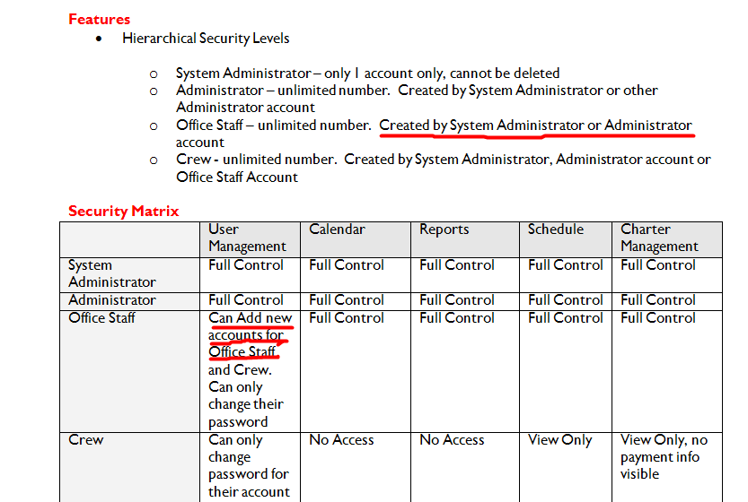

BUG #MTab1 Section isn’t highlighted (color or not active)
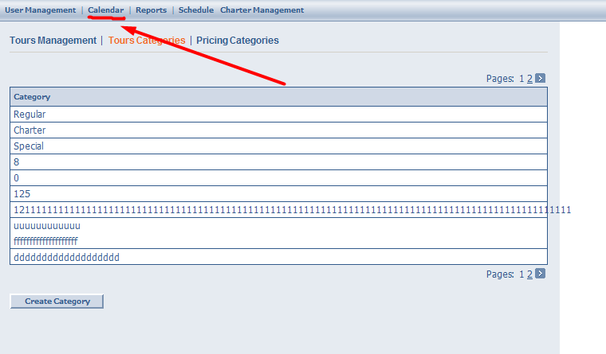

BUG #SCBT1 Disappear field’s lines when the page scalability %:
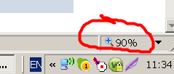
98% | 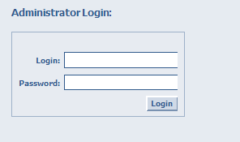 | 95% | 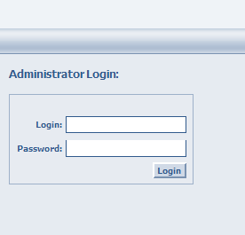
92% | 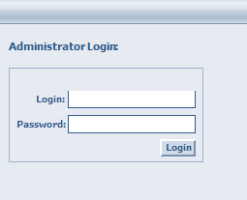 | 86% | 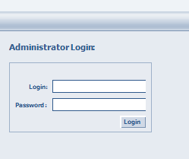
81% | 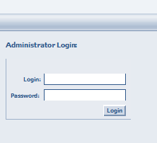 | 76% | 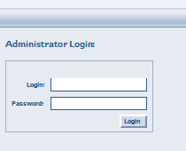
73% | 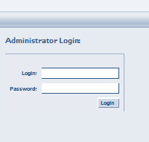 | 70% | 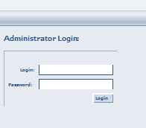

BUG #CNUM1 An asterisk in the mandatory fields to be commented
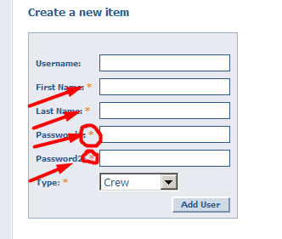

BUG #NSA1 According to the specification of the level of access should be called System Administrator
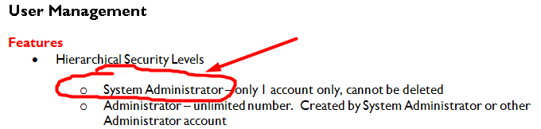
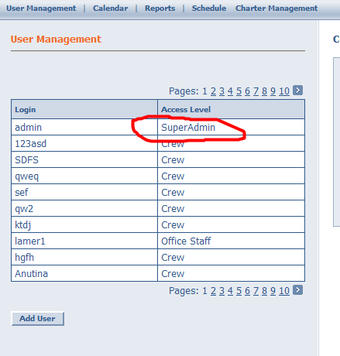

BUG #SPUM1 There is no ability to search your account in the list

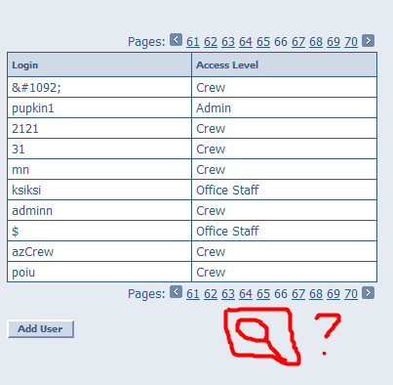

BUG #CALPC Link “Pricing Categories” shouldn’t be transferred to another line

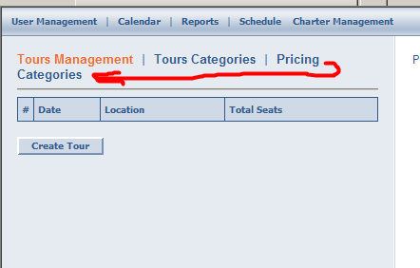

BUG #CALPC The "date" takes the value date to January 19, 2038 inclusive
System error in the report “Tour date must be between 1970 and 2100 years”
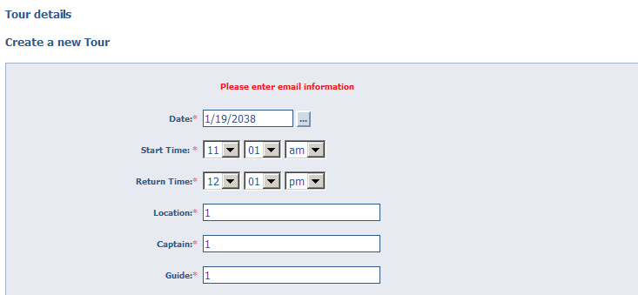

Notes
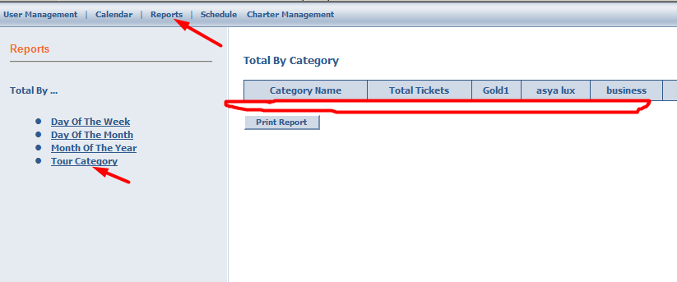

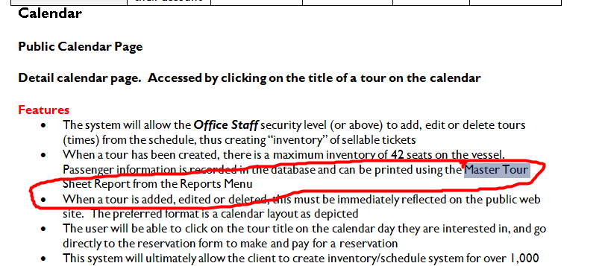отсутствует

отсутствует

In the field “Date” type incorrect number “15/33/2016”  In the field “Date” type null date “0/0/0000”  In the field “Date” type date “03.02.2016” | 