**Beet Seed**

2. When we are sending the requests according to the swagger document (<https://reqres.in/api-docs>) there will be numerous errors. But I found that the information in the landing page of <https://reqres.in/> are accurate and managed to send all the requests according to that information without any bugs.

**Beet Sprout**

2. Retrieving all the users in browser while viewing through dev tools

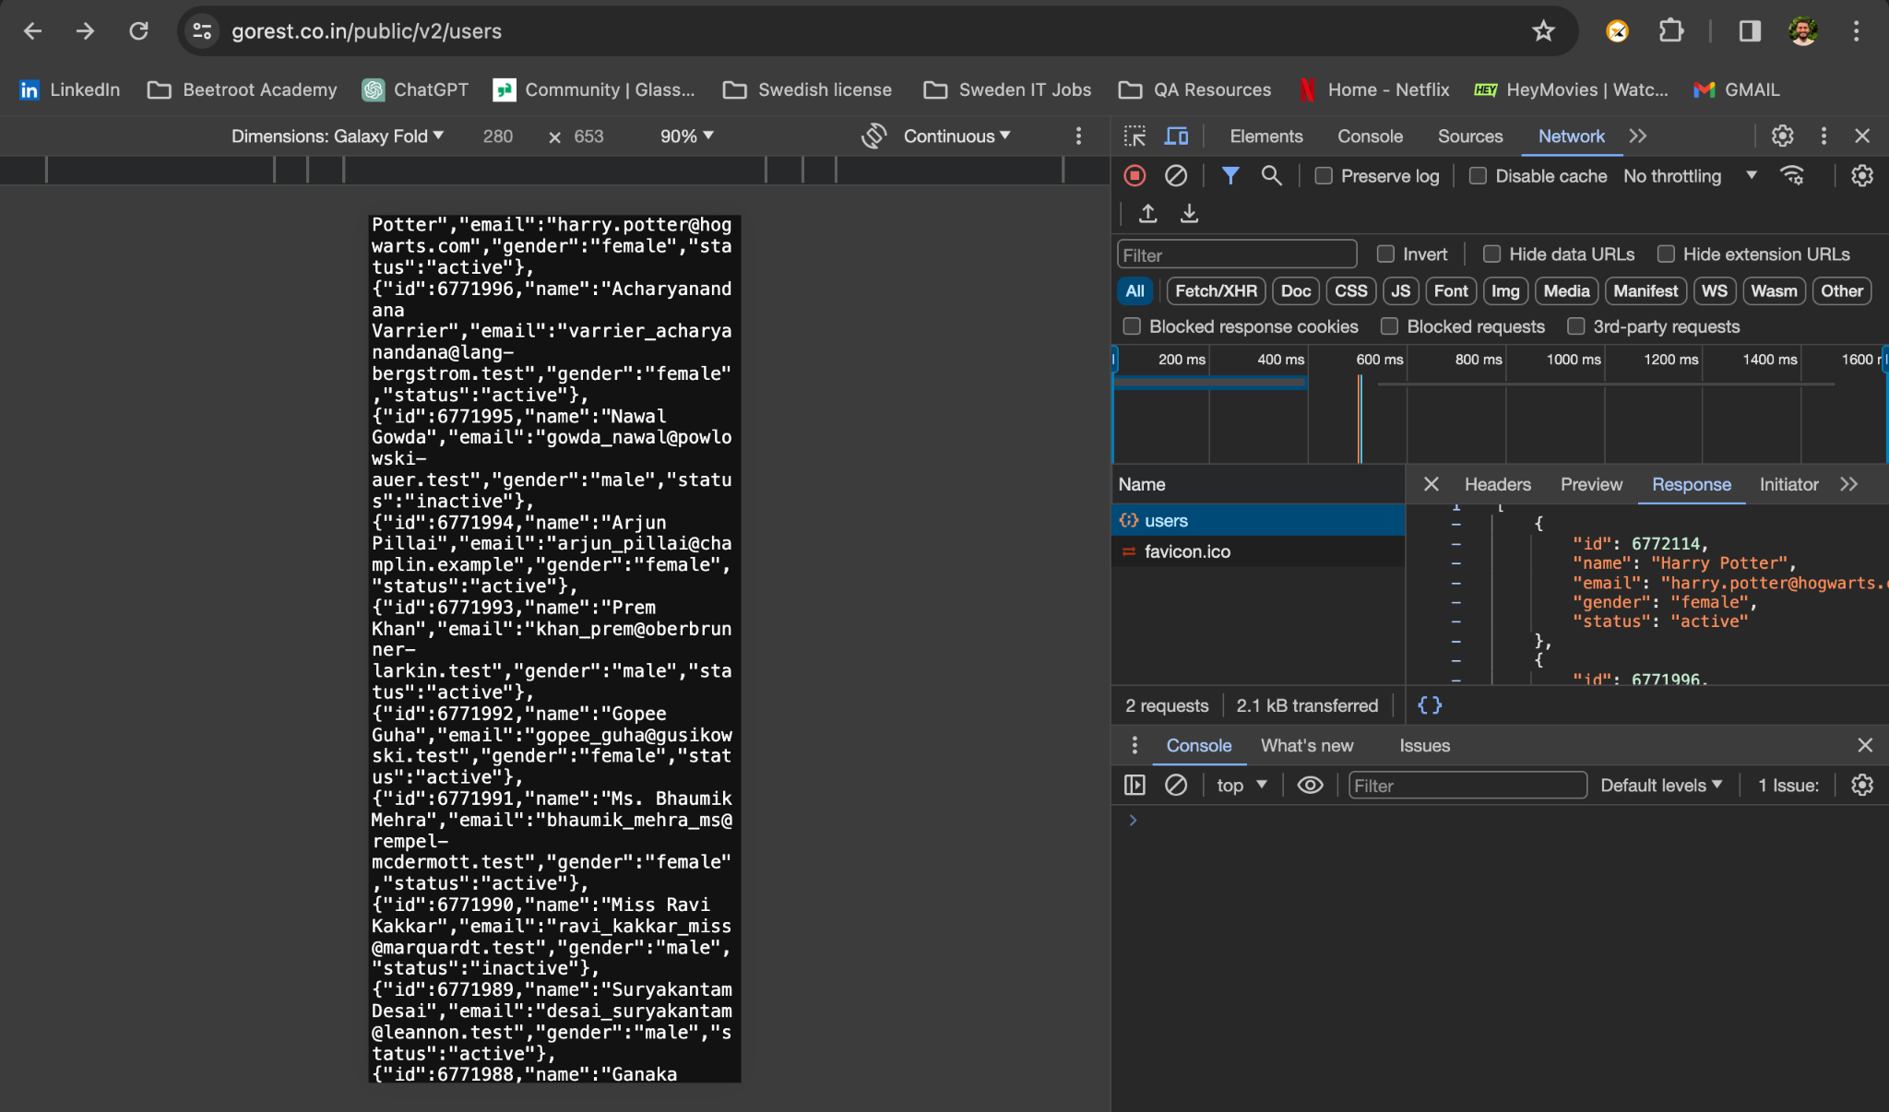

Managed to do the same with the help of postman tool

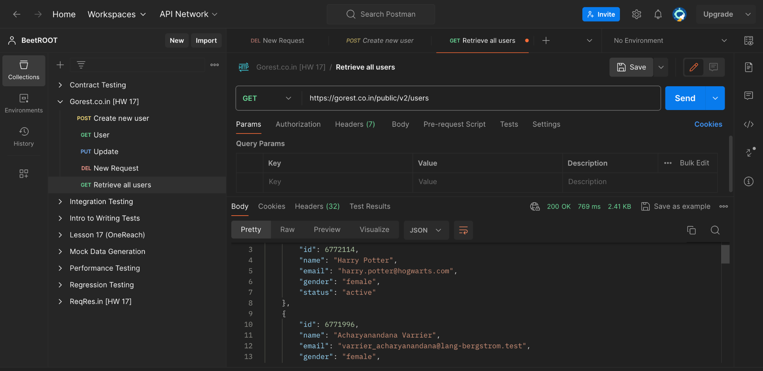

**Mighty Beet**