

Skimium Pro / SPRINT

Functional specifications



Version | Date | Action | Author
1.0 | 28/06/2013 | Initialisation: front-office templates | L Poinsignon
1.1 | 15/07/2013 | BO templates | L. Poinsignon
1.2 | 17/07/2013 | Feedbacks from Benoît | L. Poinsignon
1.3 | 24/07/2013 | BO Création de commande | L. Poinsignon
1.4 | 01/08 | Màj BO edit order | L. Poinsignon

Content summary

General elements 3
Overview 3
Site map 4
Browsers compatibility 5
Front-office templates 6
General zoning 6
Navigation 11
Recurring elements 12
Home page 14
Order process 14
CMS Page (static page) 17
Mon compte 18
Page contact 26
Page catégorie 27
Page produit (immediate mode) 28
Page produit (implantation mode) 28
Recherche 29
Back-office templates 30
Main dashboard 30
Produits 31
Catalogues 37
Add/edit a catalogue 38
Commandes 39
Factures 44
Promotions 45
Utilisateurs 46
Reporting 47
Pages statiques 47

General elements

Overview
Skimium-pro.com is a B2B e-commerce platform between Skimium and his network of about 300 afiliated stores. The website is being rebuilt on Drupal commerce, and targets stores in France and Andorre.
The site’s content is focused on products, with manual management of catalogues, promotions and news on home page.
2 types of orders are proposed:
- Immediate : similar to usual e-commerce sites
- Implantation: possibility to order in advance (choice of delivery date) products that are not yet in stock.

Services
Site is connected to external sources of Oxylane information system:
- Catalogue
- Stock
- ERP
- Shipping
- Product images

Users roles
- [BO] Administrator:
  - has overall access to the site including site settings and modules configuration
- [BO] Editor:
  - manages users accounts and users information, orders, catalogs, categories, products, prices and promotions, reporting, news and promotion blacks on home page. He receives email notifications and alerts related to orders follow up and issues.
- [FO] Member:
  - he can see the products prices, view his profile and edit his contact information, place an order, follow his orders, deliveries, bills and avoirs. He can login and reset his password.
- [FO] Anonymous:
  - He can only browse the site catalogue but cannot see prices and availability of products in storage. He cannot place an order.
(possible special role for Accounting, tbc)

Site map

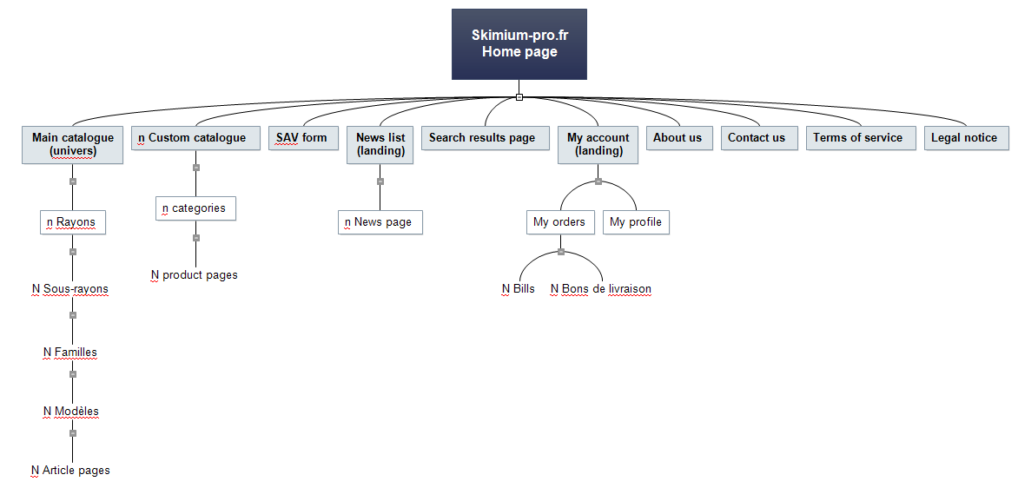

Browsers compatibility

Site display is optimized for the following browsers (minimum version indicated, the more recent versions are included:
- Safari 4, PC
- Safari 5, Mac
- Chrome current version, Mac & PC
- Firefox 3.6, Mac & PC
- IE 8, PC

Front-office templates

General zoning
All pages of the site will use the following layout
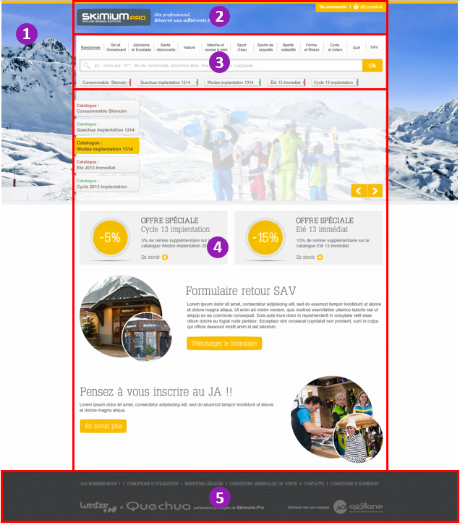
Area | Description | Action
1 Background image | Single image
2 Header | Logo + caption on the left,  login button and cart button  on the right | Click on logo: points to home page  Caption is static text  Rollover login: underline  Click on login: opens the authentication form  Cart: static when user is unauthenticated
3 Navigation and search | Top menu, search form,  and catalogs buttons (limit to 5, hidden on home page) | Rollover top menu element: expands dropdown list  Type text in search: expands autocomplete suggestions list  Validate a search query: points to search results page  Click a catalog button: points to the catalog main page
4 Main content area | Mixed content
5 Footer | Text, logos | Links to static pages and external sites (opens new window)

General behavior of elements on resize:
- Background image :
  - Automatically resized to fit horizontally in the browser window width.
  - Vertically centered to show the middle part of the image, depending on the height of the browser window.
- Areas 2 to 5:
  - Always 1000px width
  - Footer dark background takes full width of browser window
Visible area of the page without vertical scroll: (to be updated with new version of design)

Header
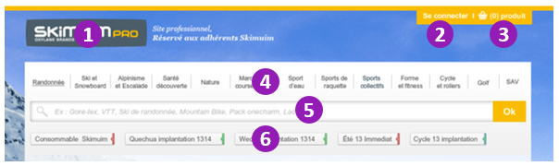
Item | Description | Action
1 Logo | image+ caption | Click on logo: points to home page  Caption is static text
2 Login | Text | Unauthenticated:  Rollover login: underline  Click on login: opens the authentication form
3 Cart | Icon, text | Unauthenticated: static text
4 Top menu | Drop down menu | Rollover top menu element: expands dropdown list
5 Search | Form | Type text in search: expands autocomplete suggestions list  Validate a search query: points to search results page
6 Catalog buttons | Text (limit to 5, hidden on home page) | Click a catalog button: points to the catalog main page

Preview of expanded menu item
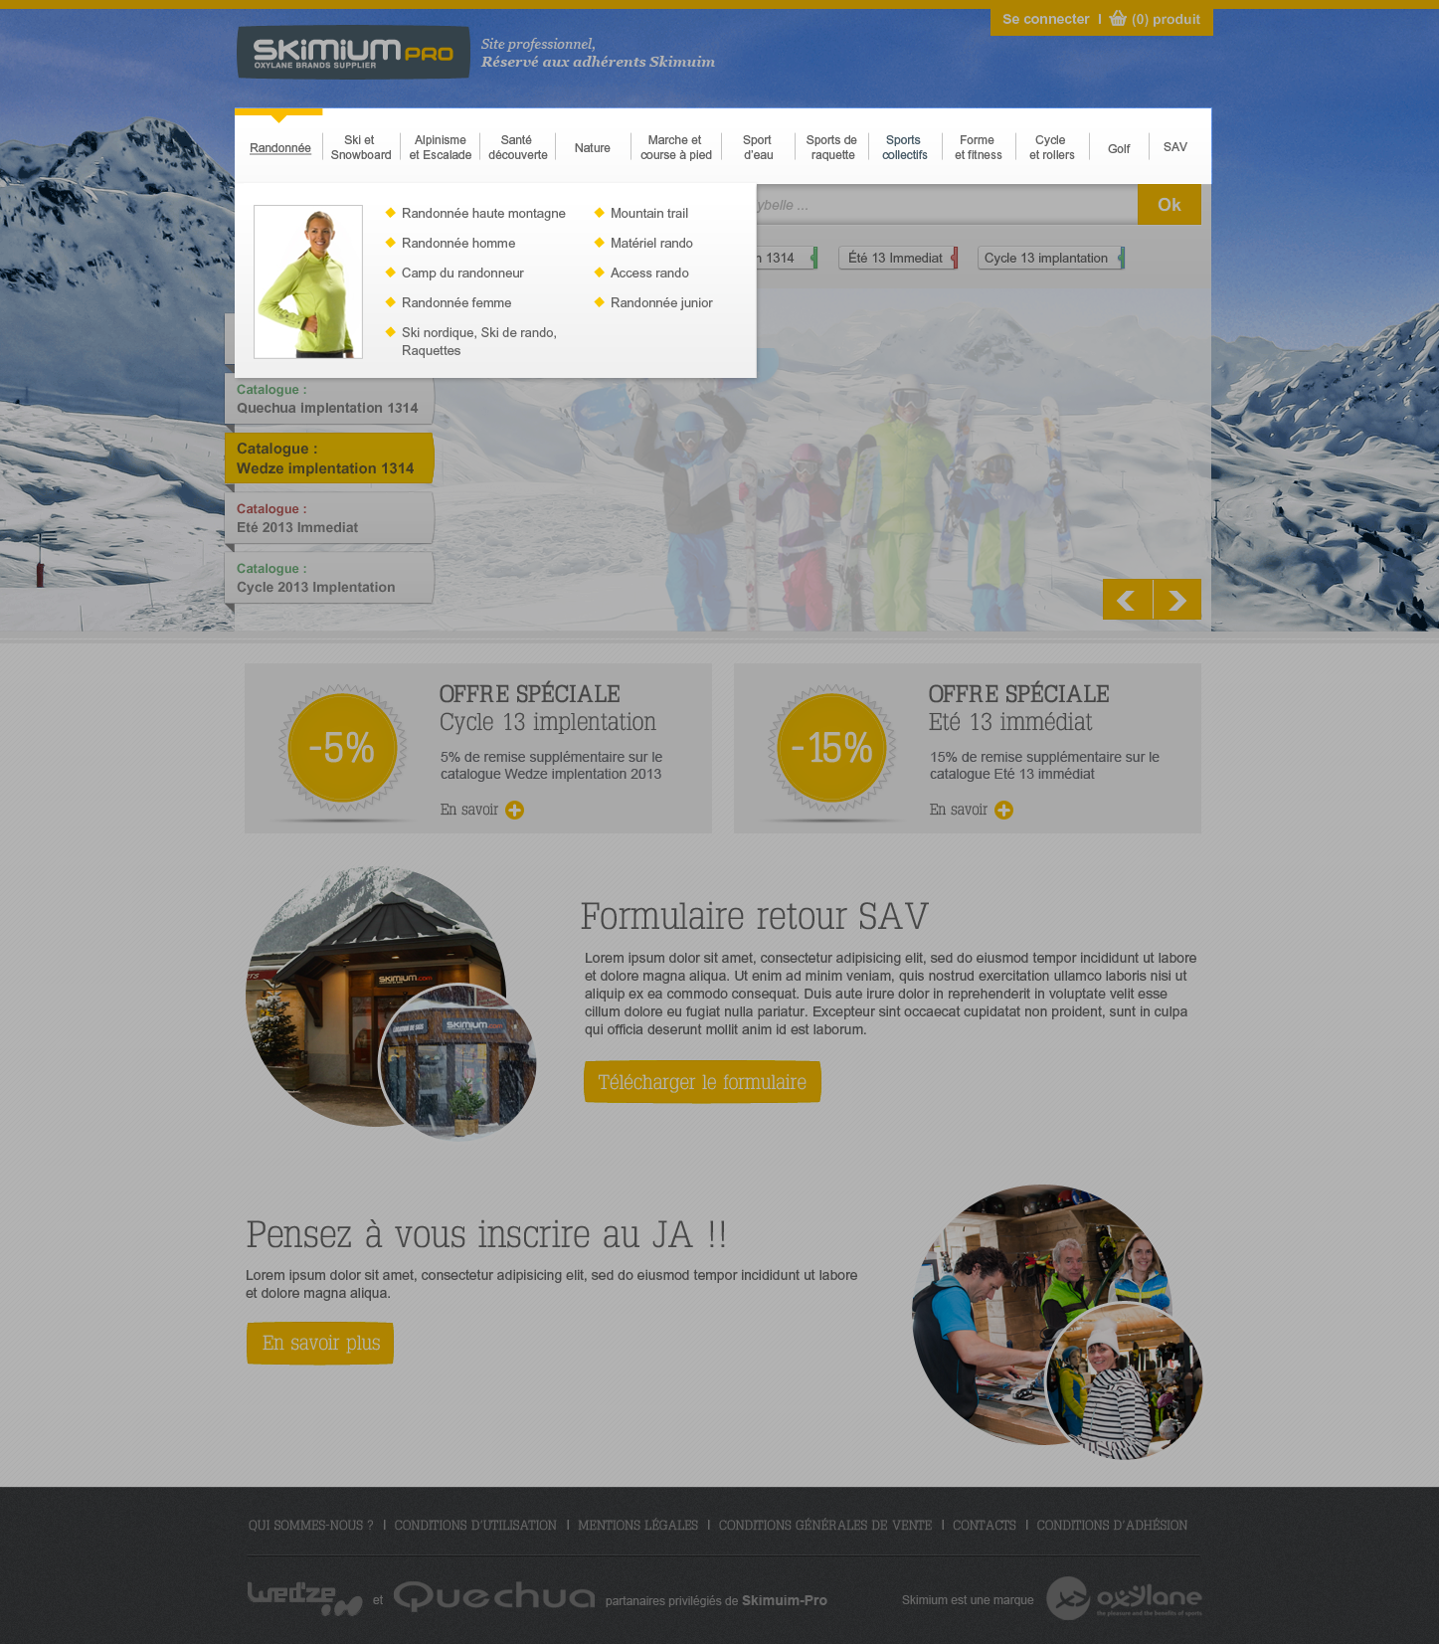
Image: custom illustration of the element (108x153px, ratio of 0,7)
- List of links: unlimited, displayed in columns of 5 items

In Oxylane’s products catalogue:
- Menu items level 1 are “universes”
- Menu items level 2 are brands
Top menu is populated manually from Drupal BO.

Authentication form

Preview of login form
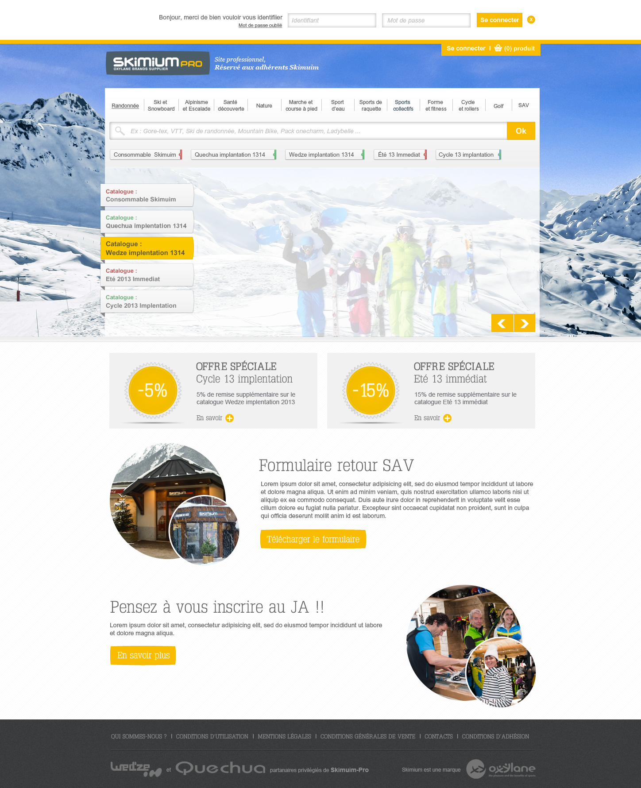
- Link to the forget password page
- Login and password fields
- Button Se connecter
- Close button
After user validates the form, current page reloads :
- In case credentials were incorrects, display form again with error message
- If logged in, buttons Se connecter and cart becomes at this format
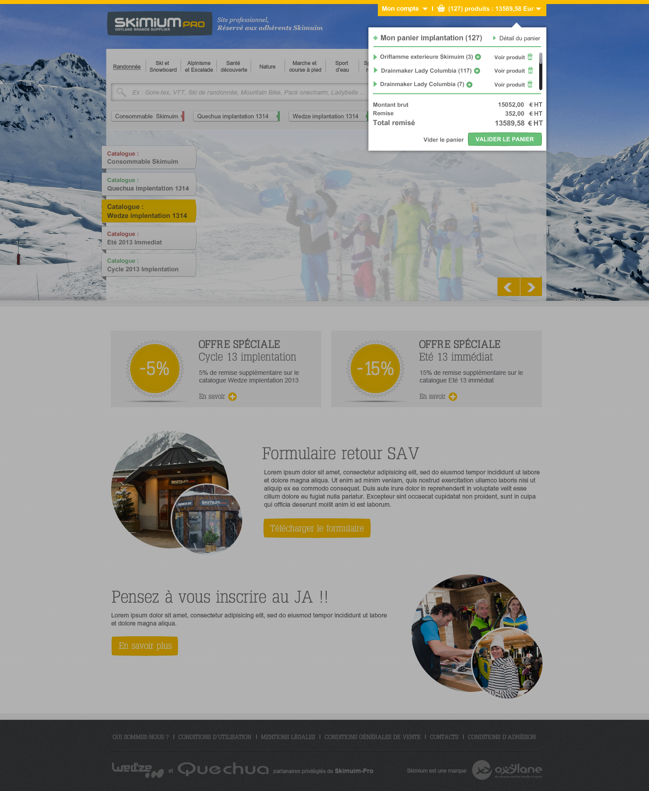

Preview of mode selection popin
Each time user logs in, a popin prompt him to chose in which mode he wants to order.
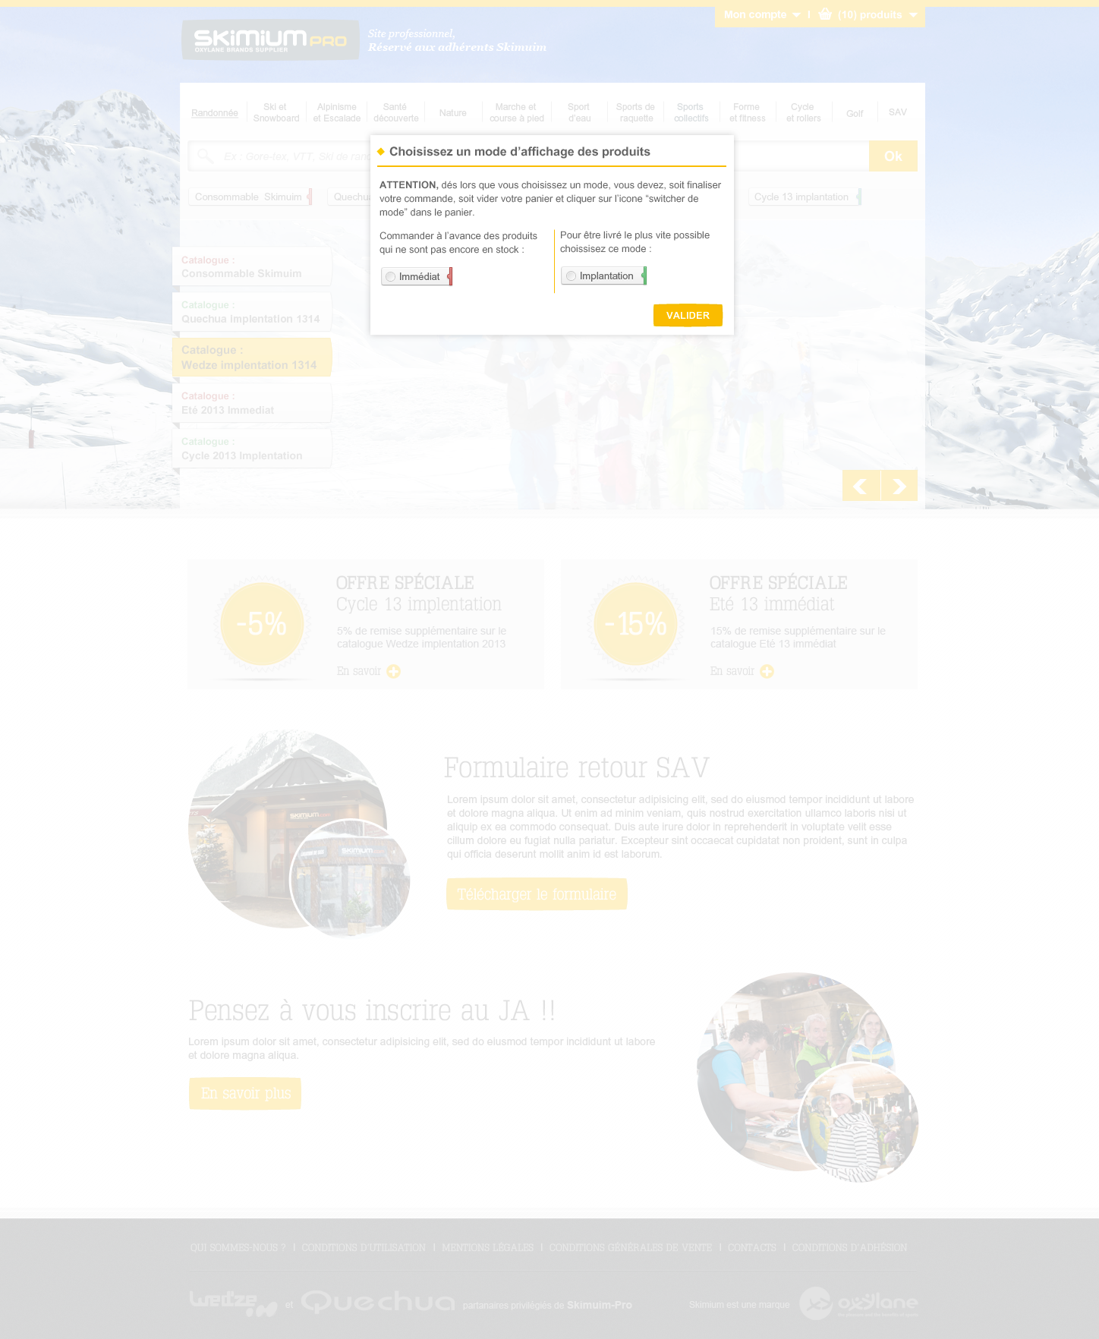
2 radio buttons are displayed. User select a button and click on Valider. Popin closes and display of the site is put according to the mode selected by user.

Mon compte & cart dropdowns
Preview of Mon compte drop down
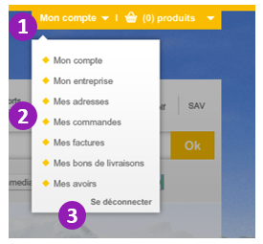
On rollover of Mon compte button, a drop down menu is displayed
Item | Description | Action
1 Mon compte | Button | Rollover: displays drop down menu and a dark overlay behind menu  Rollout: hides menu and overlay  Click: no action
2 Mon compte menu | Text | Rollover: underline  Click: points to the relative page of Mon compte
3 Se déconnecter | Text | Rollover: underline  Click: logs out user and reload the page

Preview of Cart, folded in Implantation mode
Cart display and hide behavior follows the same behavior as Mon compte button.
Preview of Cart, expanded in Immediate mode
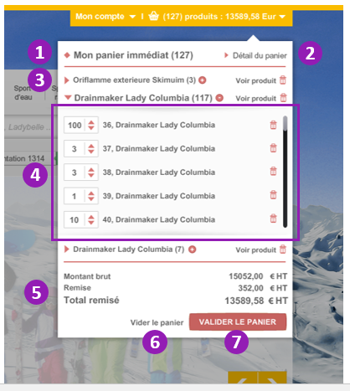
Item | Description | Action
1 Mon panier immediat | Text | Static text, specifies the current mode and amount of products in cart
2 Détail du panier | Text | Rollover: underline  Click: points to the Process step 1 page
3 Folded product | Text | Rollover: underline  Click on triangle, product name, quantity or (+): expands the product declinations list  Click on Voir produit: points ot the product page  Click on bin icon: delete all product declinations from cart
4 Expanded product | Text and form | Arrow up/down: click to change quantity. Pace of the change is linked to the lot of each product declinations (per 1 or other).  Bin icon: click to delete product(s) declinations from cart  Height is limited, if more than 5 items, scrollbar is displayed  Click on triangle, product name, quantity or (+): folds the product declinations list
5 Montant, remise, total | Text | Dynamic display according to the products in cart
6 Vider le panier | Text | Rollover: underline  Click: delete all products from cart
7 Valider le panier | Button | Click: points to the Process step 1 page

Footer
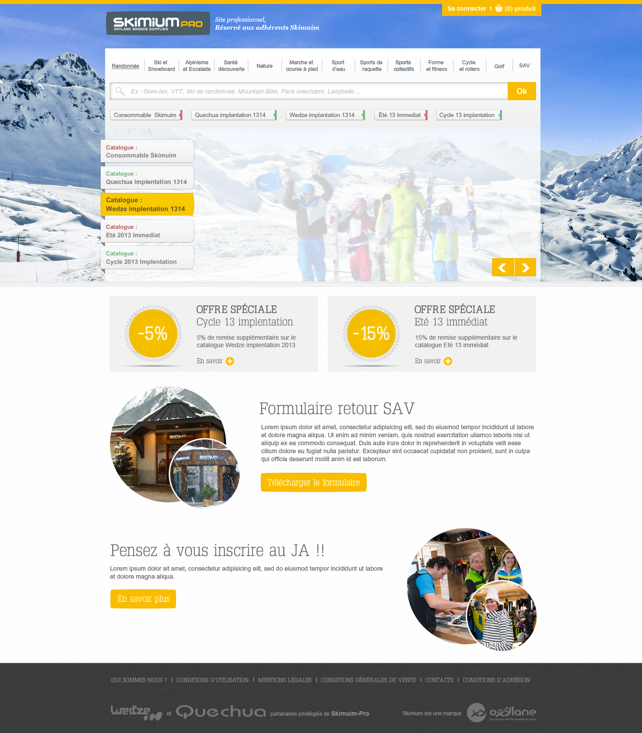
Internal links:
- Qui sommes-nous (static page)
- Conditions d’utilisation (static page)
- Mentions légales (static page)
- Conditions générales de vente (static page)
- Contacts (form)
- Conditions d’adhésion (static page)
External links (opens new window) :
- Wed’ze http://www.wedze.com/
- Quechua http://www.quechua.com/
- Oxylane http://www.oxylane.com/

Navigation

Overview
Products are categorized in a tree of 5 levels:
Level | Name | Description | Example
0 | Universe | Sport or activity | Randonnée
1 | Brand | Brand name | Quechua
2 | Rayon | Sub category | Randonnée femme
3 | Sous-rayon | Sub category | Couche 1 femme
4 | Famille | Sub category | T shirt, Shorts randonnée femme
5 | Modèle | Product | T shirt bleu randonnée femme
 | Article | Declination | T shirt bleu XL randonnée femme

Navigation in Immediate mode
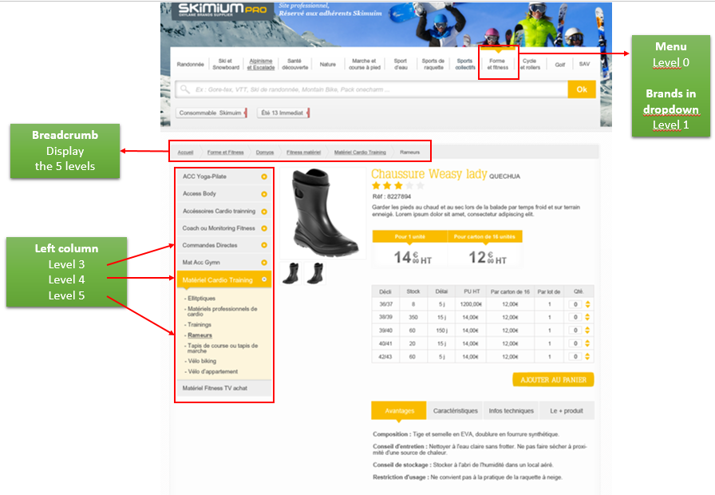
In Immediate mode, top menu is available. Implantation catalogues are not displayed.

Navigation in Implantation mode
Menu and catalogues buttons preview in Implantation mode
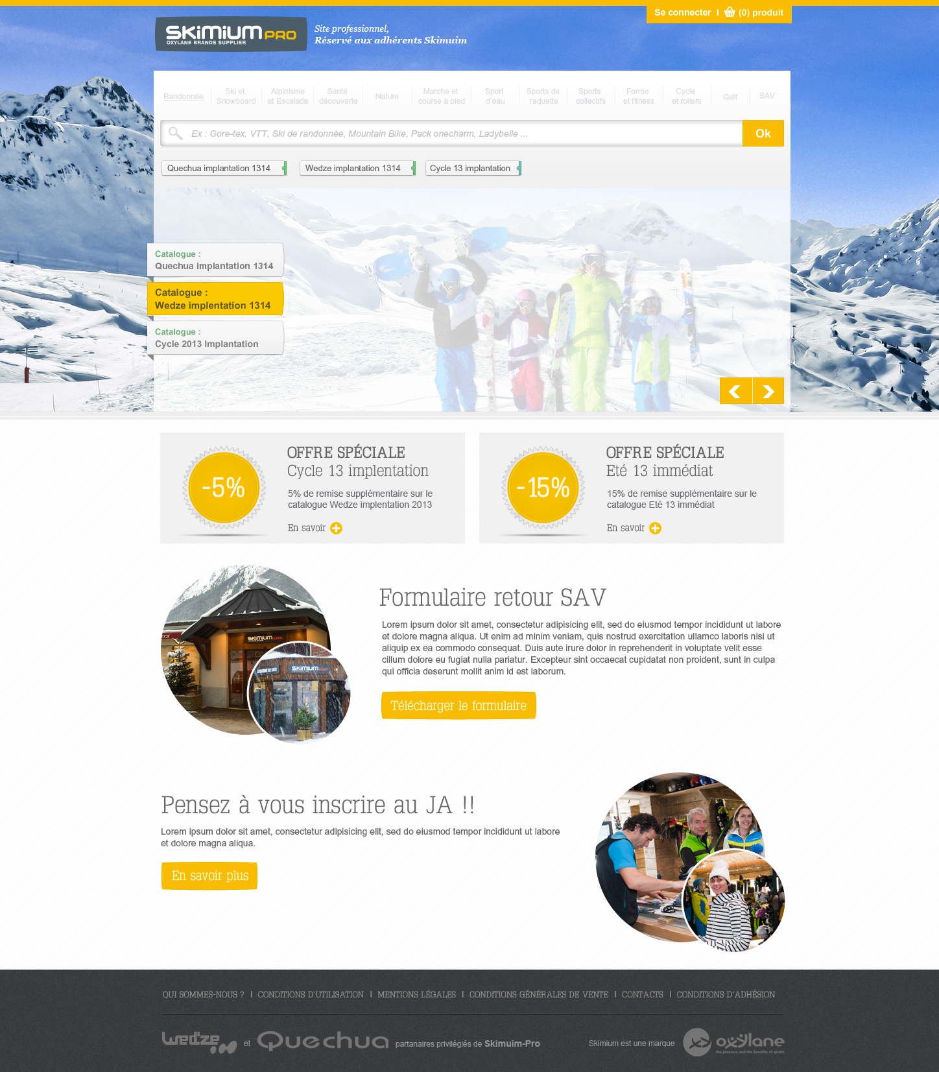
Using menu and access Immediate mode catalogue are not allowed in Implantation mode.
Menu is grey (disabled) and only Implantation catalogues are displayed. Search is available.

Recurring elements

Error/confirmation popin
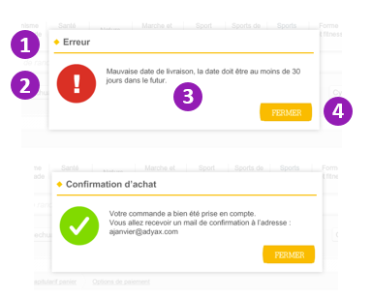
Item | Description | Action
1 Titre | Text
2 Icon | Image
3 description | Text
4 Fermer | Button | Click: closes popin

Breadcrumb
2 formats of breadcrumb are used in the site: hierarchical and payment process.

Preview of the hierarchical breadcrumb:
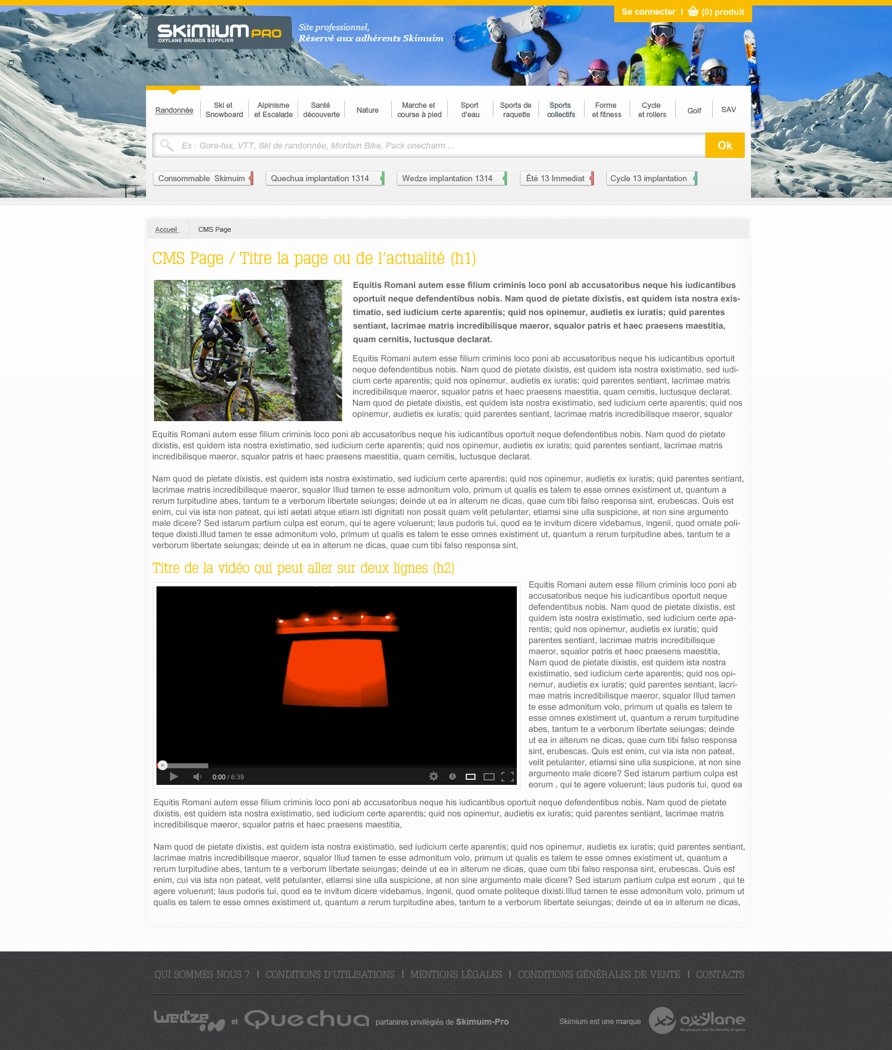
It reflects the levels of the site map from the current page up to the home page.

Preview of the payment process breadcrumb:
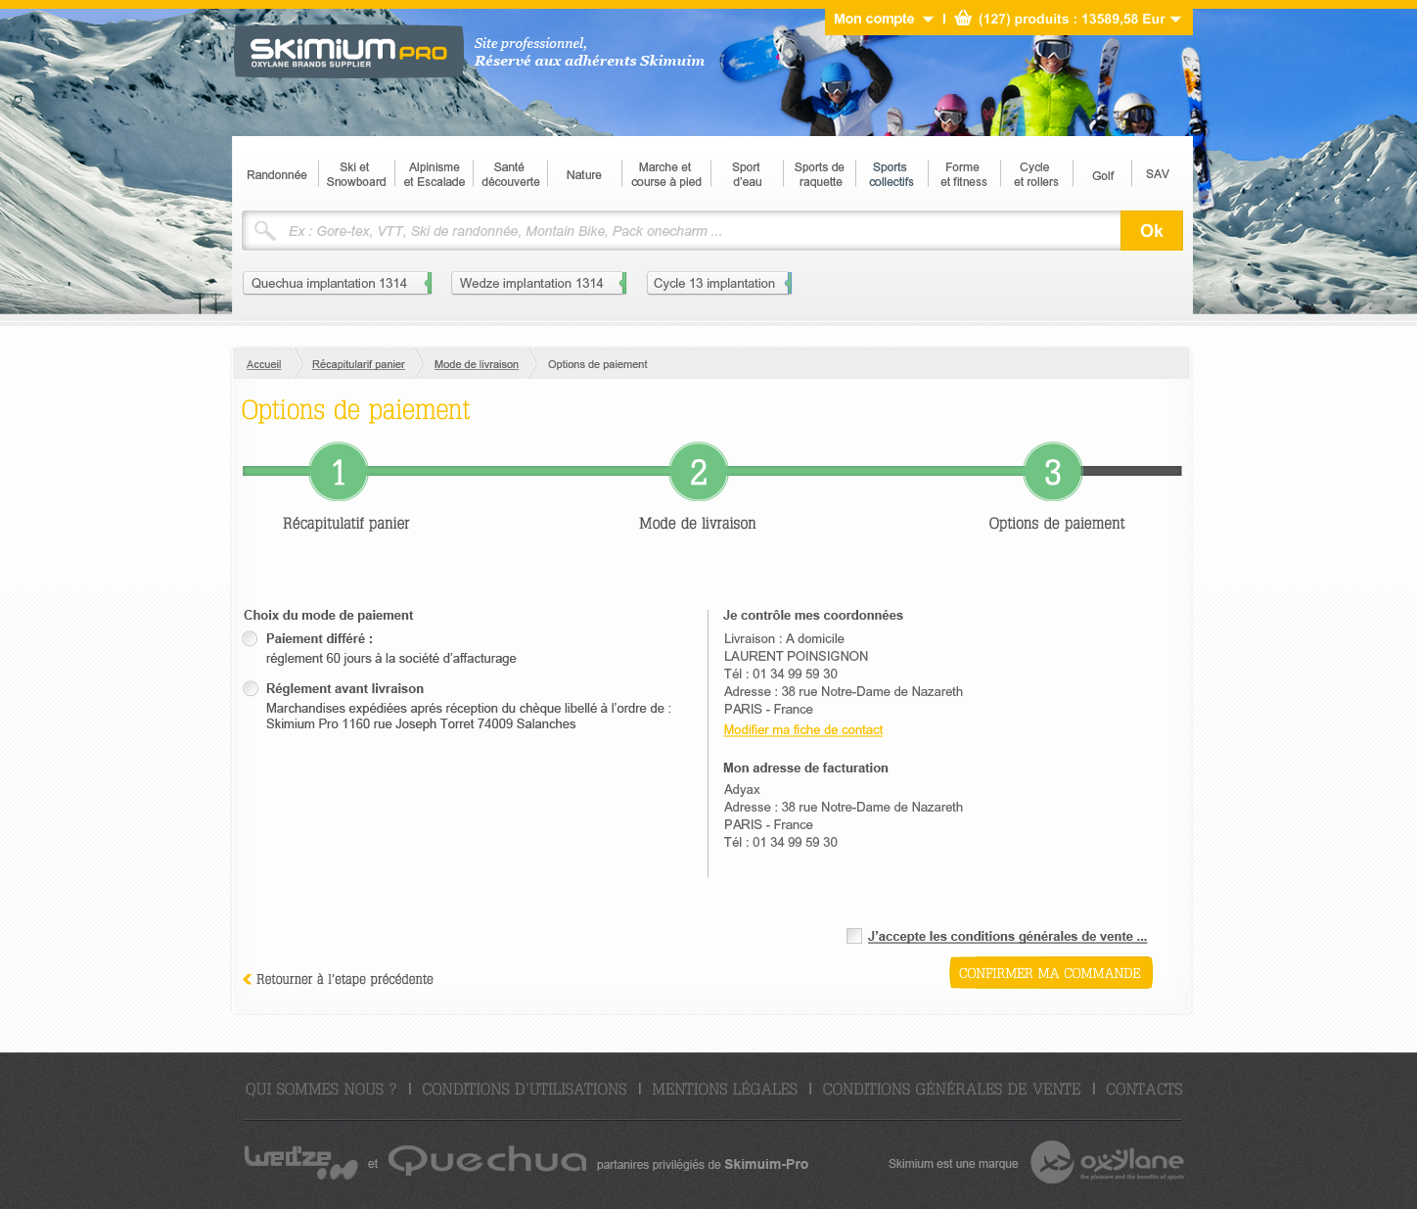
It displays text of current step, and links to previous steps.

Home page
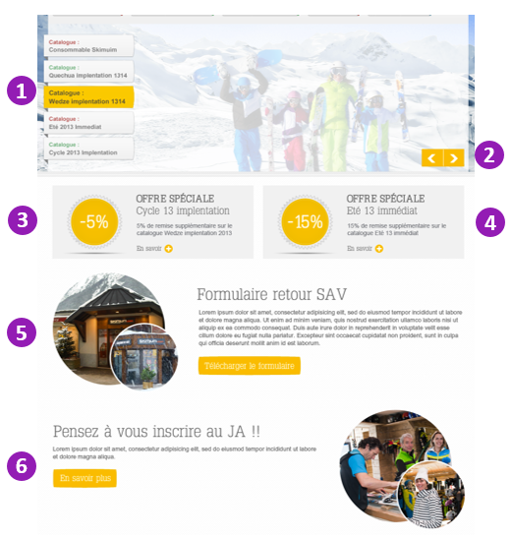
Item | Description | Action
1 Catalogues slider | Images & text | Limited to 5 catalogues (same order as catalogues buttons of navigation area)  User unauthenticated: display all catalogues  User authenticated: display only catalogues of the mode he selected  Rotation of slider: one rotation, from top to bottom (4 sec delay) then freeze slider to the 1st catalogue from top.  Rollover a button: yellow background  Rollout a button: grey background  Click a button or big image: points to the catalogue’s main page
2 Prev/next buttons | Images | Click prev: display previous image of slider  Click next: display next image of slider
3 & 4 Offre spéciale | Title, subtitle, description,  Image (uploaded from BO, ratio 1:1)  Text of 5 characters | Click on any part of the Offre spéciale: points to the custom url
5 & 6 News | Title, description, image (uploaded from BO, ratio 1:1) | Click on En savoir plus: points to the news page

Order process

Step 1
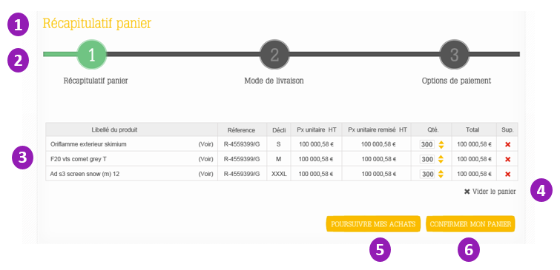

Item | Description | Action
1 Recapitulatif panier | Text
2 Step indicator | Text, images
3 Cart product details | Product name, reference, declination, unit price, unit price after discount(s), quantity, total | Rollover product name: displays thumbnail of product  Click Voir: points to the product page  Up/down quantity: changes the quantity number, and total accordingly  Click red cross icon: delete the product declination from the cart
4 Vider le panier | Icon, Text | Click: delete all products from cart. Popin of Immediate/Implantation mode is displayed.
5 Poursuivre mes achats | button | Click: points to previous page
6 Confirmer mes achats | Button | Click: points to order process step 2

Step 2
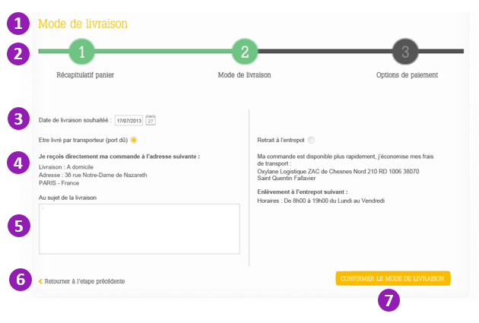
Item | Description | Action
1 Mode de livraison | Text
2 Step indicator | Text, images
3 Date de livraison | Date field.  Displayed only in Implantation mode.  By default at d+1 month. | Click on field: edit date manually  Click on calendar icon: displays a date picker.
4 Delivery mode | Text, radio button.  Positioned by default at “by transporteur” unless setting was changed in user profile | Click on radio button selects the relative option
5 Au sujet de la livraison | Text area field (limited 300 chars)
6 Retour | Text | Click: points to order process step 1
7 Confirmer | Button | Click: points to order process step 3

Step 3
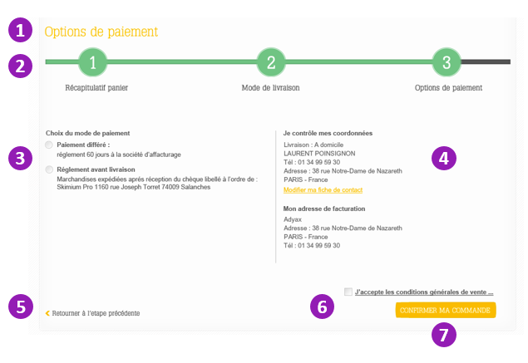
Item | Description | Action
1 Options de paiement | Text
2 Step indicator | Text, images
3 Choix du mode de paiement | Text, radio buttons. Only insured users can chose Paiement différé, This option is not displayed to not insured users | Must be selected by user, or form returns an error
4 Coordonnées | Text | Click on Modifier ma fiche contact: points to the page Mes informations.
5 Retour | Text | Click: points to order process step 2
6 J’accepte | Checkbox | Link points to the CGV page  Box must be checked by user, or form returns an error.
7 Confirmer | Button | Click: points to the order confirmation page with an option to switch mode (Immediat/Implantation) in order to make another order.

Order confirmation

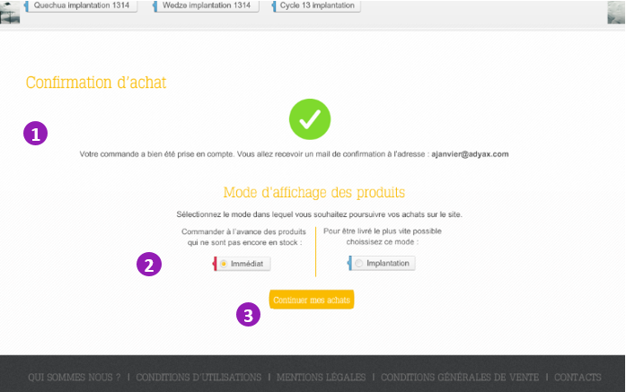

Item | Description | Action
1 Votre commande a bien été… | Confirmation text
2 Immédiat/Implantation | Radio buttons, set by default in the current mode | Select an option
3 Continuer mes achats  Passer une nouvelle commande | Submit button | Click: points to homs page in the appropriate mode.

CMS Page (static page)
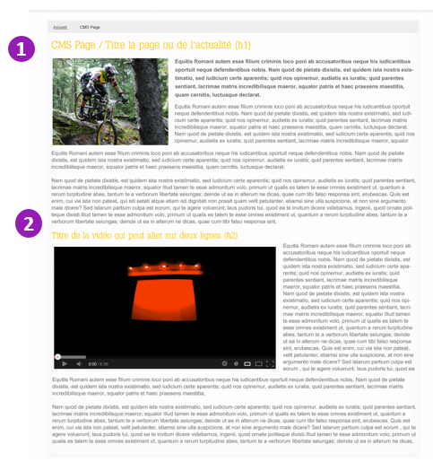
Static page is composed of:
- Title
- Free text styles, images or html (see wysiwyg options details in technical specifications)

Mon compte

Mes addresses
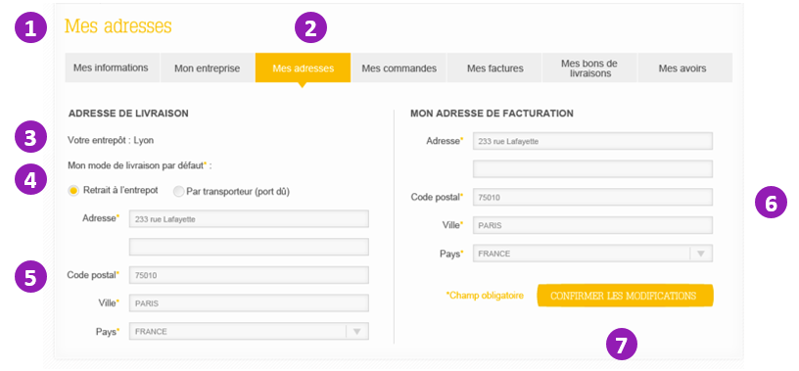
Item | Description | Action
1 Mes adresses | Text
2 Mes adresses | Tab | Current tab not clickable, other tabs points to the relative page
3 Votre entrpôt | Text
4 Mode de livraison | Radio buttons | User selects an option to change the delivery mode that will be displayed by default in process step 2
5 & 6 adresses | Fields read only
7 Confirmer | Button | Click: reloads the page with option updated

Mes avoirs
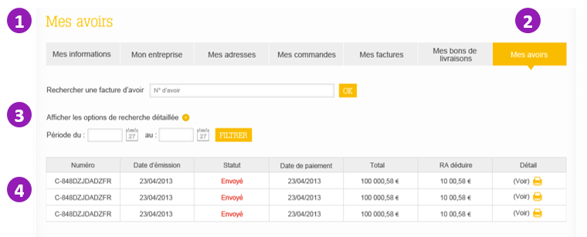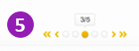

Item | Description | Action
1 Mes avoirs | Text
2 Mes avoirs | Tab | Current tab not clickable, other tabs points to the relative page
3 options de recherche | Search  Expandable box with date range filter | Submit avoir number and click ok: reloads the page with search results on avoirs  Click on (+) : expand / closes box  Click in date field: enter date manually  Click on calendar icon: displays a date picker  After selecting start and end date and click Filtrer: displays avoirs dated within the date range.
4 Avoirs list | Nb, sent date, status, payment date, total, left to deduct  Sort by sent date DESC, limited to 20 per page | Click on voir/print: displays avoir in pdf format (new window)
5 pager | Display current page and buttons to change page | Click on << : points to first page  Click on < : points to previous page  Rollover a grey dot : dot color yellow  Click on a grey dot: points to relative page  Click on > : points to next page  Click on >> : points to last page

Mes bons de livraison
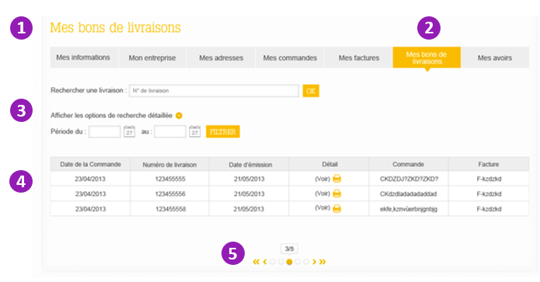
Item | Description | Action
1 Mes bons de livraison | Text
2 Mes bons de livraison | Tab | Current tab not clickable, other tabs points to the relative page
3 options de recherche | Search  Expandable box with date range filter | Submit bl number and click ok: reloads the page with search results on bl  Click on (+) : expand / closes box  Click in date field: enter date manually  Click on calendar icon: displays a date picker  After selecting start and end date and click Filtrer: displays bl dated within the date range.
4 bl liste | Display order date, delivery nb, bl creation date, detail link, order nb, bill nb  Sort by bl creation date DESC, limited to 20 per page | Click on voir/print: displays bl in pdf format (new window)
5 pager | Display current page and buttons to change page | Click on << : points to first page  Click on < : points to previous page  Rollover a grey dot : dot color yellow  Click on a grey dot: points to relative page  Click on > : points to next page  Click on >> : points to last page

Mes commandes
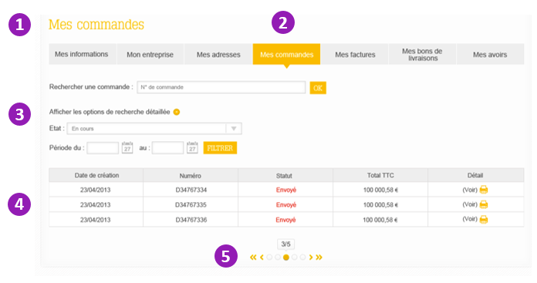
Item | Description | Action
1 Mes commandes | Text
2 Mes commandes | Tab | Current tab not clickable, other tabs points to the relative page
3 options de recherche | Search  Expandable box with status and date range filters | Submit order number and click ok: reloads the page with search results on order  Click on (+) : expand / closes box  Click in date field: enter date manually  Click on calendar icon: displays a date picker  Select status from select list, select start and end date, click Filtrer: displays orders results.
4 order list | Display creation date, nb, status, total, detail link.  Sort by creation date DESC, limited to 20 per page | Click on voir/print: displays order details in popin
5 pager | Display current page and buttons to change page | Click on << : points to first page  Click on < : points to previous page  Rollover a grey dot : dot color yellow  Click on a grey dot: points to relative page  Click on > : points to next page  Click on >> : points to last page

Détail d’une commande
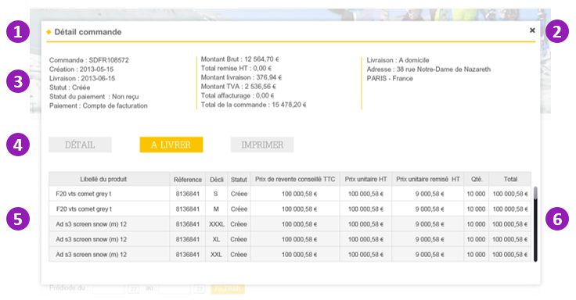
Item | Description | Action
1 Détail commande | Text
2 Close | Button | Click: closes popin  (click outside popin also closes popin)
3 Order main information | Text
4 Détail / A livrer / Imprimer | Buttons | Détail / A livrer is a switch view. Default is Detail. Click A livrer filters the product list to only display the ones with status different to Expédié.  Click Imprimer: opens pdf version of the order (new window)
5 products list | Product name, ref, decli, status, resold price, unit price, discount, quantity, total  Alternate white/grey background to differentiate groups of declinations
6 scrollbar | Displayed if more than 5 lines

Mon entreprise
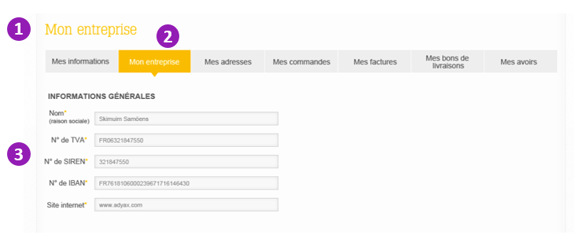
Item | Description | Action
1 Mon entreprise | Text
2 Mon entreprise | Tab | Current tab not clickable, other tabs points to the relative page
3 Informations générales | Company details in read-only fields

Mes factures
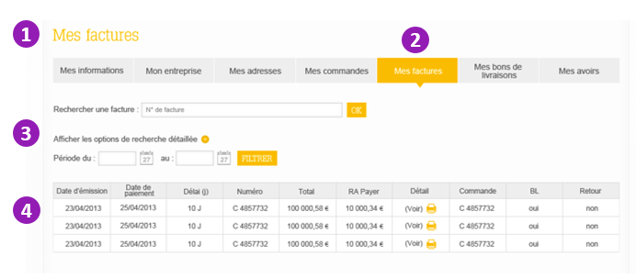
Item | Description | Action
1 Mes factures | Text
2 Mes factures | Tab | Current tab not clickable, other tabs points to the relative page
3 options de recherche | Search  Expandable box with date range filter | Submit invoice number and click ok: reloads the page with search results on invoice  Click on (+) : expand / closes box  Click in date field: enter date manually  Click on calendar icon: displays a date picker  After selecting start and end date and click Filtrer: displays invoices dated within the date range.
4 Invoice list | Display invoice date, payment date, delay nb, total, to pay, detail, order nb, bl, returned status  Sort by date DESC, limited to 20 per page | Click on voir/print: displays invoice in pdf format (new window)
5 pager | Display current page and buttons to change page | Click on << : points to first page  Click on < : points to previous page  Rollover a grey dot : dot color yellow  Click on a grey dot: points to relative page  Click on > : points to next page  Click on >> : points to last page

Mes informations
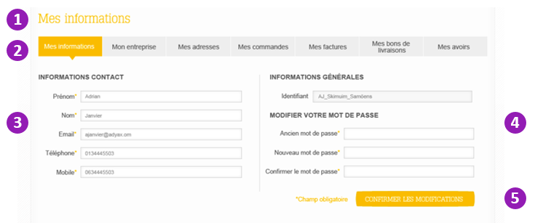
Item | Description | Action
1 Mes informations | Text
2 Mes informations | Tab | Current tab not clickable, other tabs points to the relative page
3 Informations contact | Text fields
4 Informations générales | Read only field
4 Modifier votre mot de passe | Fields in password format | To update his password, user enter current, new and repeat new password.
5 Confirmer les modifications | Submit button | After click on Confirmer les modifications, page reloads and display errors (field missing or format incorrect) or a confirmation message.

Page contact
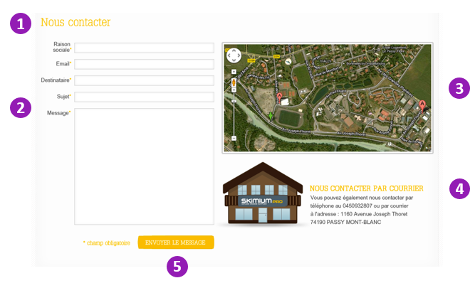
Item | Description | Action
1 Nous contacter | Text
2 Contact form | Text fields | If user is connected, Raison sociale and email fields are pre-filled with his data
3 Location map | Google map iframe | User can zoom and move the map
4 Postal address | Text
5 Envoyer le message | Submit button | User fills out the form and click Envoyer. Page reloads and displays errors (see below) on fields or a confirmation message.

Preview of errors display :
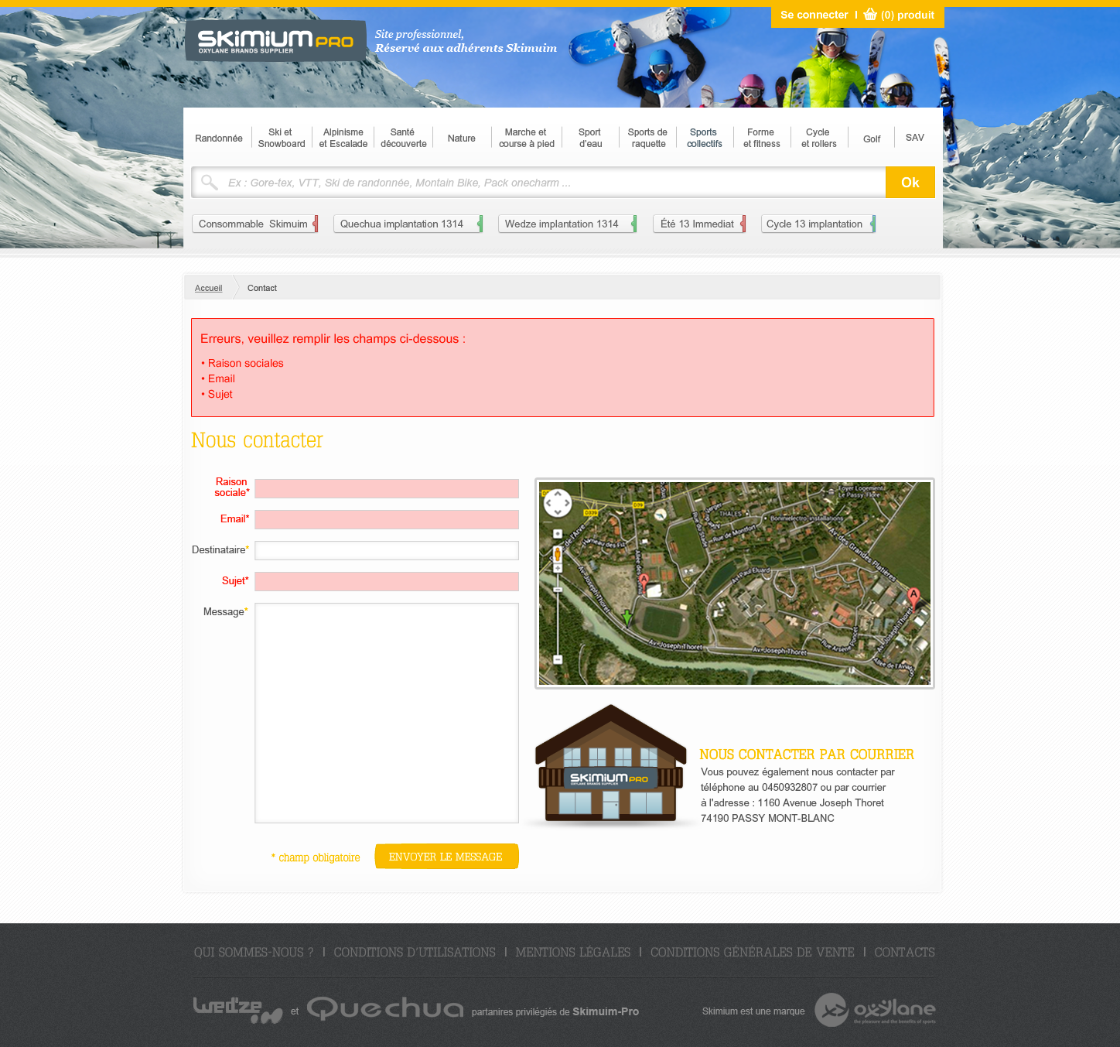

Page catégorie
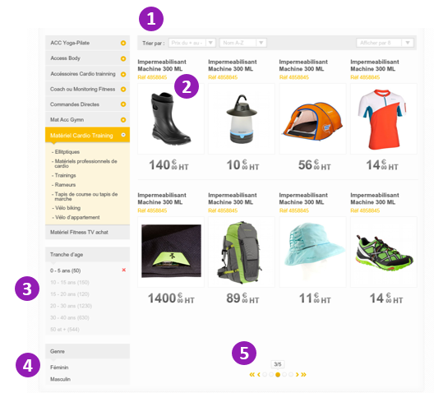
Item | Description | Action
1 Trier par | Permanent filters as select lists  Select price options:  + to - / - to + / Désactivé  Select name options:  A-Z / Z-A / Désactivé  Select pager options:  By 8  By 16  By 32  All | Default: display products as ordered in OBA flow (Price deactivated, Name deactivated), Pager by 8.  After user change a select list option, product list refreshes with the option applied.
2 Product bloc | Name, ref nb, thumbnail, lowest unit UE price.  If no photo is available, display default thumbnail. | Click on any element: points to product page
3 Tranche d’âge | Contextual filter: range of items. Example with age, depends on the available common criteria of the category displayed | Default text color: black  Each click on the items list refreshes the product list.  First click on an item: the other items become grey.  Click on grey item: item becomes black.  Click on red cross on the right: item becomes grey if other filters are applied, or list returns to default.
4 Genre | Contextual filter: example with men/women. | Same behavior
5 Pager | Display current page and buttons to change page | Click on << : points to first page  Click on < : points to previous page  Rollover a grey dot : dot color yellow  Click on a grey dot: points to relative page  Click on > : points to next page  Click on >> : points to last page

Page produit (immediate mode)
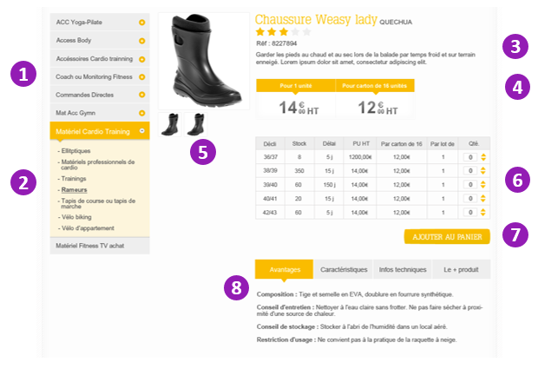
Item | Description | Action
1 Contextual menu items | Siblings sub-categories (level 3) | Rollover: underline  Click: expand sub-category (accordion menu, only 1 sub-category is expanded at a time)
2 Current category menu | Product sub-category (level 3) and list of product sub-category (level 4) | Level 3 rollover: yellow background  Level 3 click: expand/fold  Level 4 rollover: underline  Level 4 click: points to the sub-category level 4 page.  Note: one of the level 4 items will be called “Voir tous les produits”. This link points to the sub-category level 3 page.
3 Product main information | Title, brand, voting score, ref. nb, description | Voting score is a static display.
4 Prices | Lowest Unit price, lowest PCB price
5 Photos | Main photo (big) + all photos (thumbnails)  If photo is not available,  display the default thumbnail. | Rollover the big photo: display zoom of larger image.  Click on thumbnail: this image replaces the big image
6 Product declinations list | Declination, stock, delay, unit price, PCB price, per lot, quantity | Click quantity up/down arrows: change quantity number, according to the lot (if lot is 2, quantity change by 2)  Edit manually quantity field is also possible.
7 Ajouter au panier | Submit to cart button | Click: add all products where quantity is not null to cart (visual animation where the product declinations list moves and reduces to the cart button on top right corner of the page – see illustration below), updates the cart information (amount of products, total of order).  If quantities are not multiples of lot, opens an error popin asking user to enter correct quantity.
8 Product detailed information | Content in tabs (text, video) | Default tab: Avantages.  Click on other tabs display the relative content.

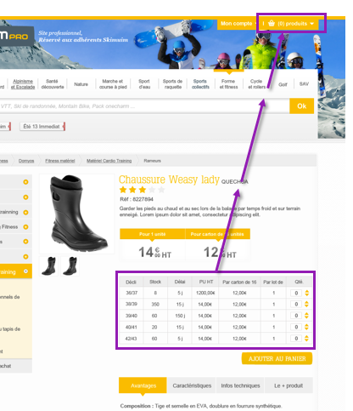

Page produit (implantation mode)
In implantation mode, columns Stock and Delay are not displayed in the Product declinations list.

Recherche
Preview of autocomplete suggestions when user type text in search bar:
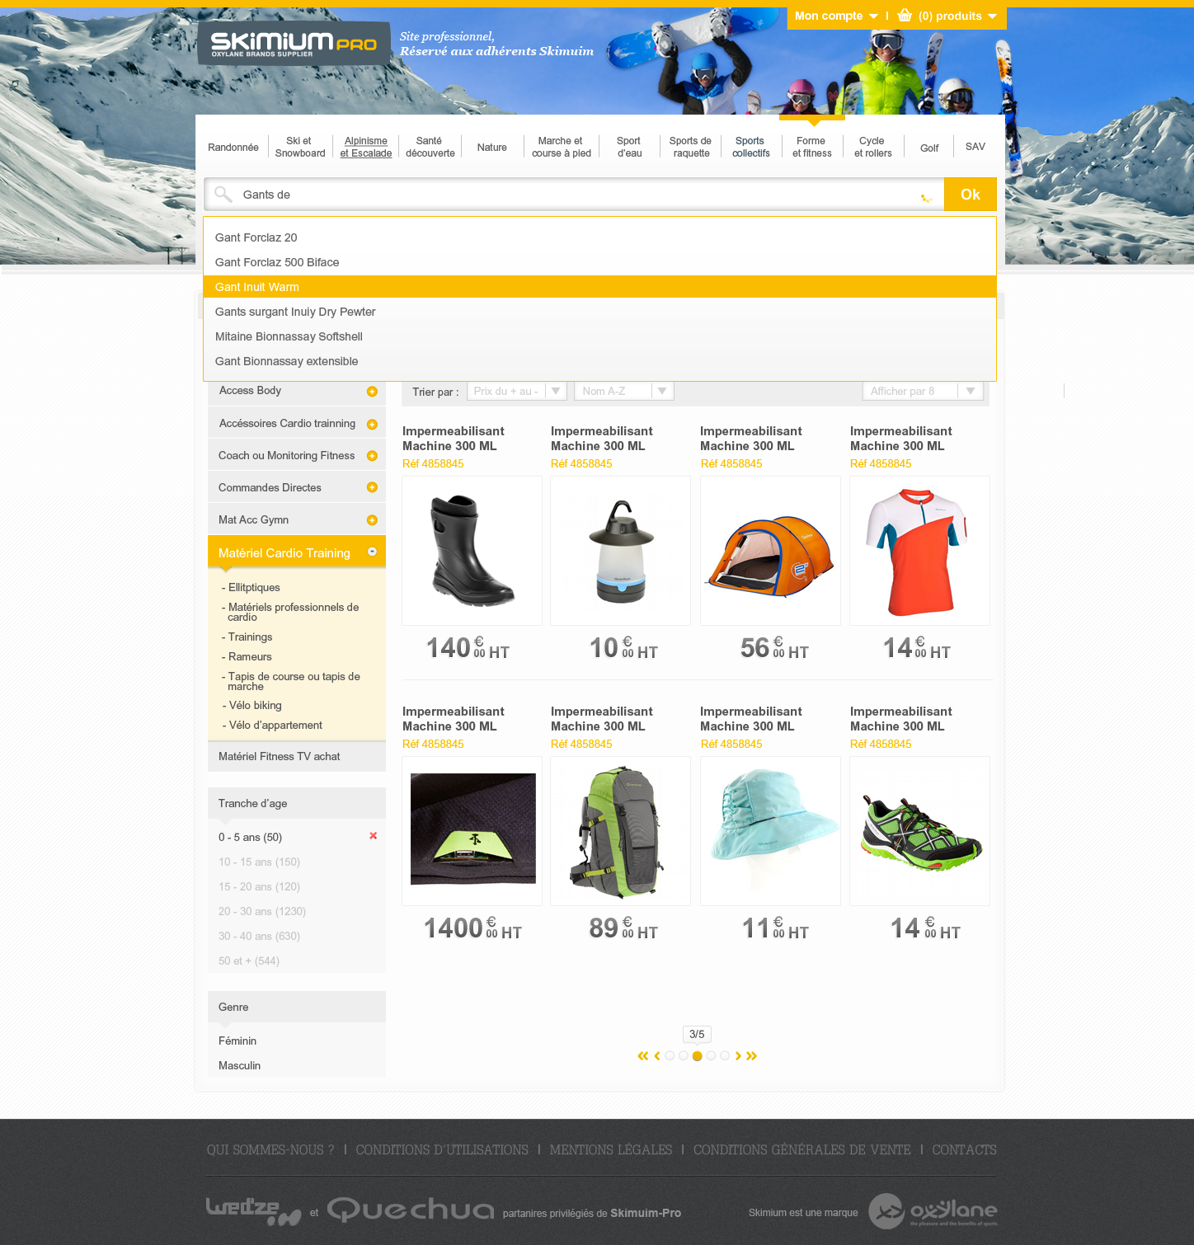
Rollover the suggestions list: yellow background.
Click on the item: points to the product or category page.
Click on Ok: points to the search results page.

Preview of the search results page:
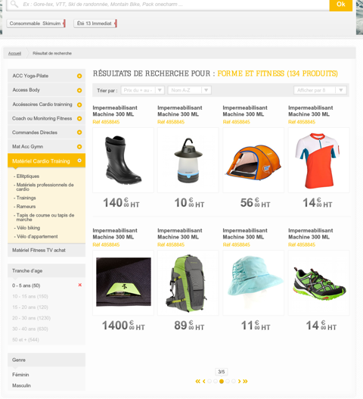
This page is same as page catégorie, with a text that displays the search query and amount of results.

Back-office templates

Main dashboard
Overview:
Main dashboard is the default page when Admin user accesses BO.
Important note: this version is temporary. Complete dashboard will also include a table with the latest alerts (issues with catalog & models feed, orders/R3, preparation from stock, delivery GECell, product info & images)

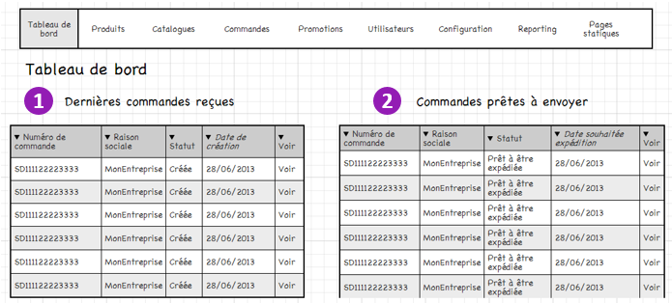
Item | Description | Action
1 Dernières commandes reçues | Display the 10 latest orders created, sorted by date DESC. | Click on voir: points to the order page
2 Commandes prêtes à envoyer | Display the 10 latest orders with status “Prêt à être expédié”, sorted by Date souhaitée expedition DESC. | Click on voir: points to the order page

Produits

Modèles list
Overview :
This dashboard allows to see the Modèles imported from OBA.

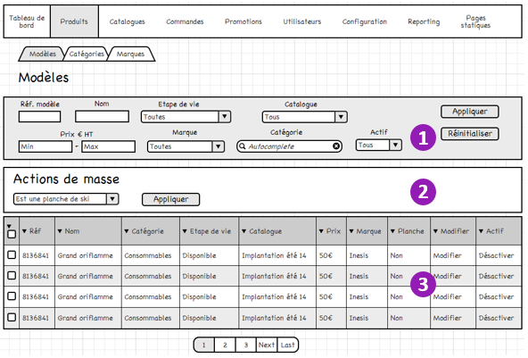
Item | Description | Action
1 Filters | Multi criteria filters: by Ref, by name, by Etape de vie, by catalogue, by price range, by brand, by category, is active | - Fill out one or several fields  - Click on appliquer: page refreshes the models list, filtered  - Click Réinitialiser: resets filters
2 Actions de masse | Set ‘Est une planche de ski’ to yes/no for the modèles checked in the list. | - Select modèles by click on the checkboxes in the list.  - Chose an option in the select list field  - Click Appliquer  - See the changes in the Planche column.
3 Modèles list | Display 50 modèles, sorted by Ref DESC | Click Modifier: points to the modèle edit page  Click on Désactiver: set product to Désactivé and reloads the page.

Filter options details:
- Etapes de vie: Nouveau, Disponible, Plus approvisionné en CAC, Stock 0 en CAC, Stock 0 en CAC & CAR, Stock 0.
- Actif/Désactivé est un état géré au niveau Drupal.

Modèle Edit page
Overview :
This page shows all information regarding the modèle in FO, and options only available in BO.

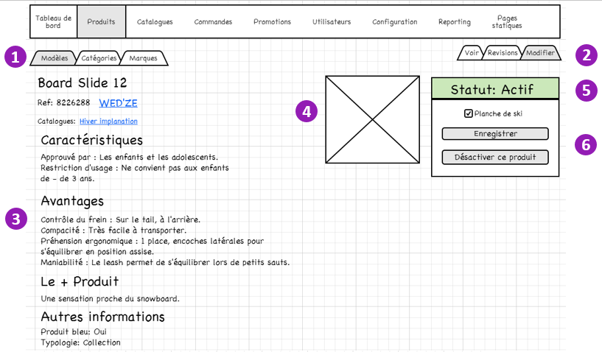
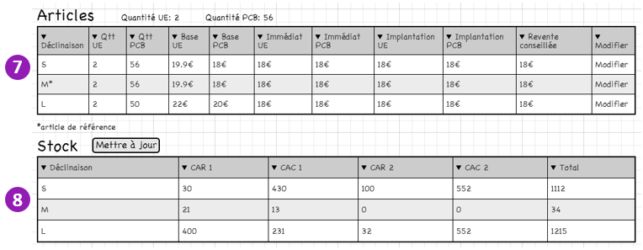
Item | Description | Action
1 Modèles / Catégories / Marques | Submenu, “Modèles” is highlighted | Click on a tab: access the corresponding list
2 Voir / Révisions / Modifier | Edit options of the page, “Modifier” is highlighted | Click Révisions: points to the revisions details page, to view a previous version of the Modèle.  Click Voir: points to the Modèle page in FO
3 | Modèle informations, read-only. Except modèle reference. | Change Modèle reference and click submit: new value will be displayed in FO and will not be deleted in the next feed import of OBA.
4 Image(s) | Modèle thumbnail(s)
5 Statut Actif | Status active/deactived of the modèle
6 Planche de Ski / Enregistrer / Désactiver | Buttons | Check box Planche de ski : only for BO and reporting, no impact on FO.  Click Désactiver and submit: modèle will not be displayed in FO.
7 Articles | Declinations details of the modèle. | Click Modifier: points to the Article edit page
8 Stock | Stock details of the modèle | Click Mettre à jour: update table with real time info.  Add incoming products quantity and date in CAR and in CAR  Add transit quantities

Article Edit page
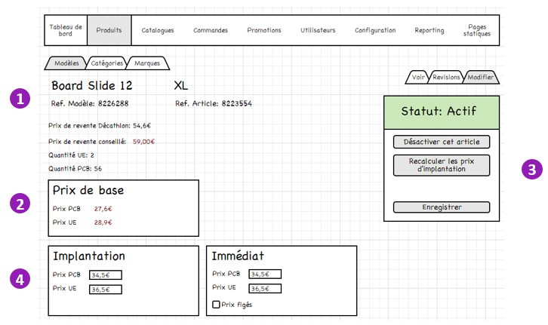
Item | Description | Action
1 | Article information details
2 Prix de base | OBA price details.
3 Désactiver / Recalculer / Enregistrer | Buttons | Click Désactiver: article will not be displayed in FO  Click Recalculer: updates Implantation price for this article.  Click Enregistrer: Saves modifications.
4 Implantation, Immédiat | Price details in Implantation and immediate modes. | Fill out price and click Enregistrer: sets a fixed value of the price and overrides the OBA value.  Tick Prix figés : immédiat prices values will not be overriden by next price updates

Categories list
Overview: display the categories tree.
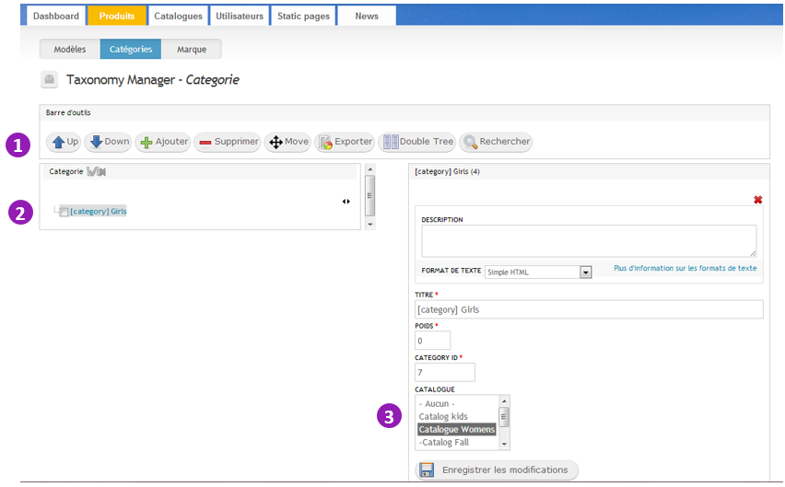

Catégorie edit page
Overview :
Displays association between OBA categories and the site catalogues.
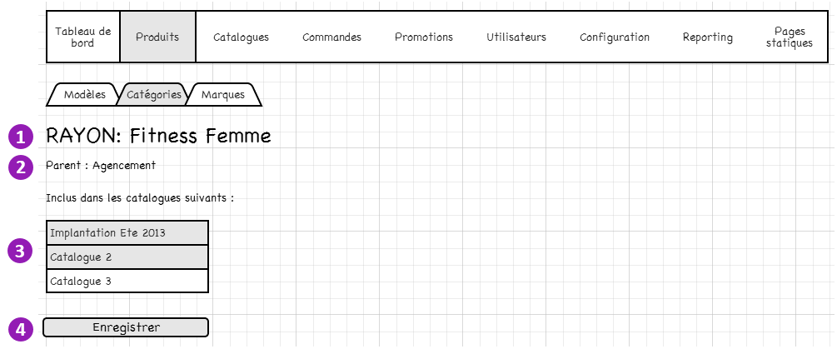

Item | Description | Action
1 Rayon: Fitness Femme | Category title
2 Parent: Agencement | Parent category in tree
3 Inclus dans les catalogues | Multi-select field, displays in which catalogues the category is associated | Select a catalogue: current category and all child categories will be associated to the catalogue  Unselect a catalogue: current category and all child categories will be dissociated from the catalogue
4 Enregistrer | Submit button | Saves the changes and loads the categories list page.

Marques list

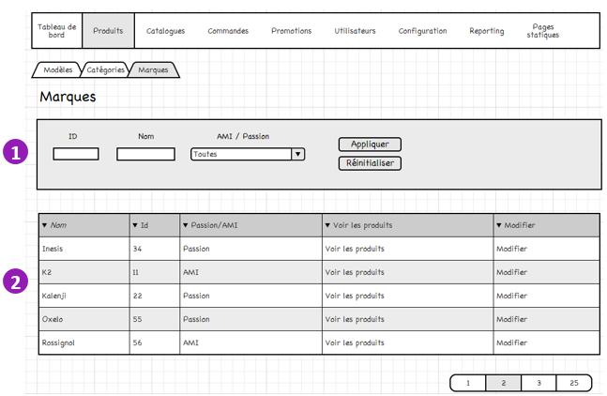
Item | Description | Action
1 | Filter list by ID, name, AMI/Passion | Multi criteria filters.
2 Marques list | List 20 brands, sorted by name ASC | Click Modifier: points to the brand edit page

Marque Edit page

Catalogues
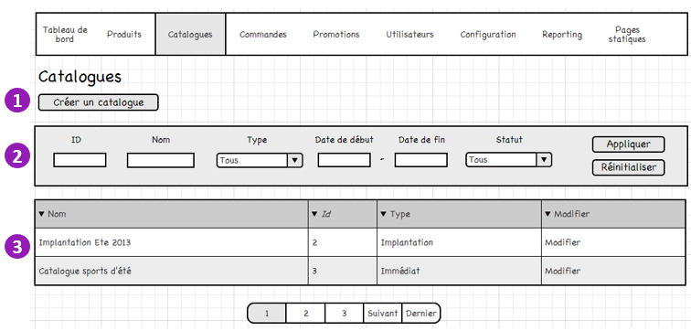
Item | Description | Action
1 Créer un catalogue | Button | Click: points to the create catalogue page
2 Filters | Multi criteria filters: by ID, Nom, Type, Période, Statut | - Fill out one or several fields  - Click on appliquer: page refreshes the models list, filtered  - Click Réinitialiser: resets filters
3 Catalogues list | Display 50 catalogues sorted by ID ASC | Click on Modifier: points to the catalogue edit page

Type: Implantation / Immédiat
Statut: actif/désactivé

Add/edit a catalogue

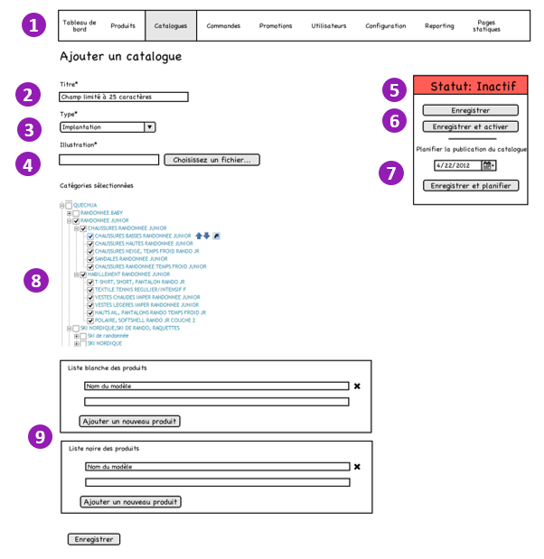
Item | Description | Action
1 Catalogue | Menu item in BO | Click: points to the catalogues list page
2 Titre* | Catalogue title, simple text limited to 25 chars (this limit allows the catalogue buttons in header to fit in 1 line)
3 Type | Select list options: Implantation / Immédiat
4 Illustration | Image field, single. Will be displayed in home page slider. Image dimensions must be 982x343px | Click to upload image. If image already uploaded, display thumbnail and allow replace.
5 Statut inactif | Display current status of catalogue with color code: actif (green) / inactive (red).  Status is actif only if current date is in the range of start and end date of the catalogue.
6 Enregistrer  Enregistrer et activer | Save button  and Save & activate button (button becomes inactivate if current status is Actif) | Click Enregistrer: saves the catalogue  Click Engistrer et activer : saves and force catalogue status to active
7 Planifier | Publication scheduler | Maybe clarify this part. We need end date too.
8 Sélectionner les categories | Taxonomy selection tree to select categories by branches
9 Liste blanche / noire | Autocomplete simple text field, linked to Modèles. | Add Modèle to white list: this specific modèle is added in the catalogue.  Add Modèle to black list: this specific modèle is excluded from the catalogue.

Commandes

Commandes list
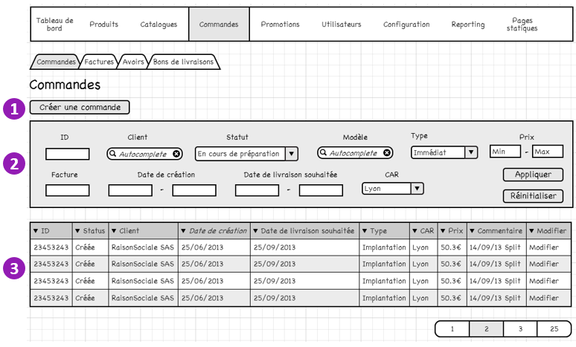

Item | Description | Action
1 Créer une commande | Button | Click: points to the create order page
2 Filters | Multi criteria filters: by Id, by status, by client, by modèle in the order, by type, by price range, by bill number in the order, by creation date range, by delivery date range, by CAR | - Fill out one or several fields  - Click on appliquer: page refreshes the models list, filtered  - Click Réinitialiser: resets filters
3 Order list | Display 50 orders sorted by Date de création DESC | Click on modifier: points to the order edit page

Create Commande
Overview:
Creating an order from BO requires 2 steps. First step is selecting a client and type of order. Second step use info of step 1 to apply appropriate promotions and stock verification.

Step 1
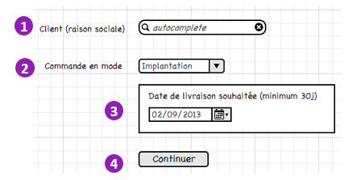
Item | Description | Action
1 Client* | Text field, autocomplete | Select user from autocomplete suggestions when typing.  Or type manually the client Raison sociale
2 Commande en mode* | Select list: Immédiat / Implantation | If select Implantation, display #3. If select immediate, don’t display #3
3 Date de livraison souhaitée | Date picker, default date is +30J from today | Select date or type date manually
4 Continuer | Submit button | Points to step 2 page

Step 2
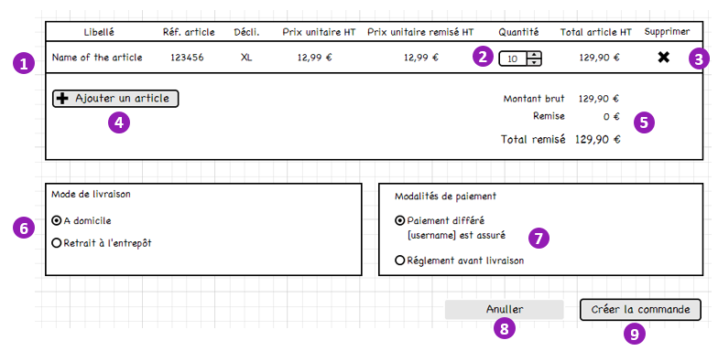
Item | Description | Action
1 Product declination | Display details of articles selected by user
2 Quantité | Stepper input semi-manual | Pace of the change is linked to the lot of each product declinations (per 1 or other).  Manual input is possible.  Total article is refreshed each time value changes in field.  Check on the value is done when click on Créer la commande: on lot and in immediate mode on available stock.
3 Supprimer | Button | Click: removes product from the list
4 Ajouter un article | Button | Click: opens the search form in popin
5 Total | Text | Refreshed each time total article values changes.
6 Mode de livraison | Radio buttons. Default is A domicile | Click on button changes mode de livraison
7 Modalités de paiement | Radio buttons. Display insurance info from user profile (est assure / n’est pas assure). If user is assure, allow Paiement différé, else only allow Règlement avant livraison. | Click on button changes modalités de paiement
8 Anuller | Button | Click: points to step 1 page
9 Créer la commande | Button | Click: creates order and send notification email to client (same as order creation from FO).

Product declination search form
User can fill out one or several
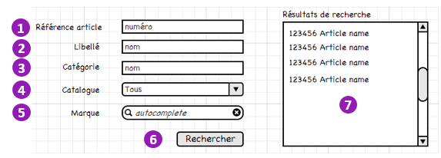
Item | Description | Action
1 Réf article | Text field
2 Libellé | Text field
3 Catégorie | Text field
4 Catalogue | Select list, with all published catalogues
5 Marque | Autocomplete field | Returns marques of available products in FO
6 Rechercher | Submit button | Click : populates the search result list with product declinations (Ref + name).
7 Résultats de recherché | Display the search results in a scrollable list. | Click on a search result closes popin and add the product in the order list.

Edit Commande

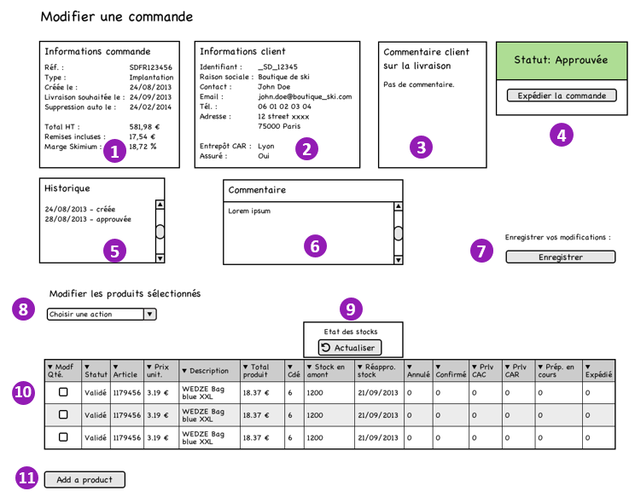

Item | Description | Action
1 Informations commande | Information details about the order: ref number, type implantation/immédiat, date of creation, wished delivery date (only if order is implantation), automatic deletion date (delay configured in BO), total price, total promotions and Skimium margin
2 Informations client | Client details (from his profile): SD code, raison sociale, contact name, email, telephone, address, attached CAR, has insurance (bolean) | Click on identifiant: points to the client profile page  Click on email: mailto link
3 Commentaire client | If not empty, display field_ship_user_comment, else display “Pas de commentaire”
4 Statut | Current status of the order (créée / Approuvée / Expédiée / Cloturée*)  Button to change status is dynamic, according to the order flow. | Click button changes status of order.
5 Historique | Display list of events on the order (with scrollbar), including: status changed, split order, and shipment updates from feed.
6 Commentaire | Free multiline text for BO usage only | Edit textarea
7 Enregistrer | Submit button | Saves changes to the order (done through #4, #6, #8, #11)
8 Modifier produits | Mass edit of products: change quantity, remove product from order, split order. | Check boxes of first column in table, then select option in drop down list.
9 Etat des stocks | Refresh button | Click: updates values in columns “Stocks en amont” and “Réappro. Stock” in the table
10 Product details | List of products in the order. Display: checkbox, status, article ref, unit price, description, total price of product, quantity ordered, stock upcoming quantity, date of reprovision, quantity cancelled, quantity confirmed, quantity shipped from CAC, quantity shipped from CAR, quantity in preparation, quantity shipped to client
11 Ajouter un produit | Button to add a product | Click: similar behavior as #4 in the Create order wireframe.

* = Created/Approved/Expedited/Closed

Factures
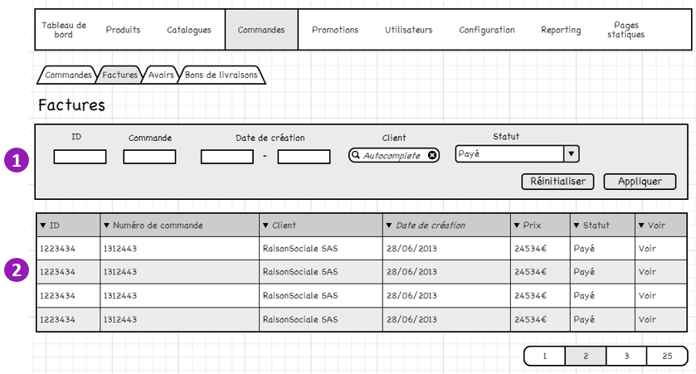
Item | Description | Action
1 Filters | Multi criteria filters: by Id, by order, by creation date range, by client (raison sociale), by status | - Fill out one or several fields  - Click on appliquer: page refreshes the models list, filtered  - Click Réinitialiser: resets filters
2 | Displays 50 bills sorted by Date de creation DESC: ID, order number, user Raison sociale, creation date, total price, status (payé/à payer), voir. | Click Voir: points to the bill page (pdf)

Promotions
La gestion des promotions utilisera l’interface native du module Rules

Utilisateurs
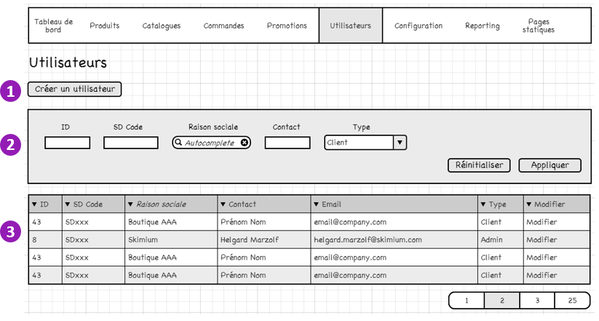
Item | Description | Action
1 Créer un utilisateur | Bouton | Click: points to the create user page
2 Filters | Multi criteria filters: by Id, by SD Code, by Raison sociale, by contact name, by type (client/admin) | - Fill out one or several fields  - Click on appliquer: page refreshes the models list, filtered  - Click Réinitialiser: resets filters
3 Users list | Display 50 users sorted by Raison sociale ASC | Click on modifier: points to the user edit page

Note: SD code is the ID from Pulse to be migrated in Drupal, and used as user ID for OBA (for continuity purpose).

Reporting

Pages statiques

