**3.Querying Restaurants Collection:**

**1. How many “Chinese” (cuisine) restaurants are in “Queens” (borough)?**

**Query:**

db.restaurants.find({"borough": "Queens", "cuisine": "Chinese"}).count()

**Result:** 728

**2. What is the _id of the restaurant which has the grade with the highest ever score?**

**Query:** db.restaurants.find({}, {restaurant_id:1}).sort({"grades.score":-1}).limit(1).pretty()

**Result:**

{

"_id" : ObjectId("5de538cd2c61c0d4fa8c190c"),

"restaurant_id" : "40372466"

}

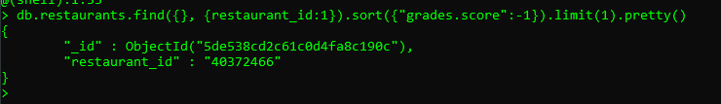

**3. Add a grade { grade: "A", score: 7, date: ISODate() } to every restaurant in “Manhattan” (borough).**

**Query:**

db.restaurants.updateMany({ borough: 'Manhattan' },{ $push: { grades: { grade: "A", score: 7, date: ISODate() }}})

**Result:**

{ "acknowledged" : true, "matchedCount" : 10259, "modifiedCount" : 10259 }



**4. What are the names of the restaurants which have a grade at index 8 with score less then 7? Use projection to include only names without _id.**

**Query:**

db.restaurants.find({ 'grades.8.score': { $lt: 7 }}, { _id: 0, name: 1 }).pretty()

**Result:**

{ "name" : "Silver Krust West Indian Restaurant" }

{ "name" : "Pure Food" }



**5. What are _id and borough of “Seafood” (cuisine) restaurants which received at least one “B” grade in period from 2014-02-01 to 2014-03-01? Use projection to include only _id and borough.**

**Query:**

db.restaurants.find({cuisine: 'Seafood', grades:{$elemMatch: { date: { $gte: ISODate("2014-02-01"), $lt: ISODate("2014-03-01") }, grade: 'B' }}}, { borough: 1 }).pretty()

**Result:**

{ "_id" : ObjectId("5de538ce2c61c0d4fa8c4d09"), "borough" : "Bronx" }

{ "_id" : ObjectId("5de538ce2c61c0d4fa8c4f82"), "borough" : "Manhattan" }



**4. Indexing Restaurants:**

**1. Create an index which will be used by this query and provide proof (from explain() or Compass UI) that the index is indeed used by the winning plan:**

**db.restaurants.find({ name: "Glorious Food" })**

**Query:**

db.restaurants.createIndex({ name: 1 })

**Result:**

{

"createdCollectionAutomatically" : false,

"numIndexesBefore" : 1,

"numIndexesAfter" : 2,

"ok" : 1

}

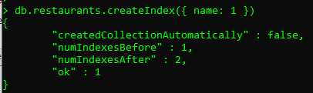

**Query:**

db.restaurants.find({ name: "Glorious Food" }).explain()

**Result:**

{

"queryPlanner" : {

"plannerVersion" : 1,

"namespace" : "frontcamp.restaurants",

"indexFilterSet" : false,

"parsedQuery" : {

"name" : {

"$eq" : "Glorious Food"

}

},

"queryHash" : "01AEE5EC",

"planCacheKey" : "4C5AEA2C",

"winningPlan" : {

"stage" : "FETCH",

"inputStage" : {

"stage" : "IXSCAN",

"keyPattern" : {

"name" : 1

},

"indexName" : "name_1",

"isMultiKey" : false,

"multiKeyPaths" : {

"name" : [ ]

},

"isUnique" : false,

"isSparse" : false,

"isPartial" : false,

"indexVersion" : 2,

"direction" : "forward",

"indexBounds" : {

"name" : [

"[\"Glorious Food\", \"Glorious Food\"]"

]

}

}

},

"rejectedPlans" : [ ]

},

"serverInfo" : {

"host" : "EPBYMINW8582",

"port" : 27017,

"version" : "4.2.1",

"gitVersion" : "edf6d45851c0b9ee15548f0f847df141764a317e"

},

"ok" : 1

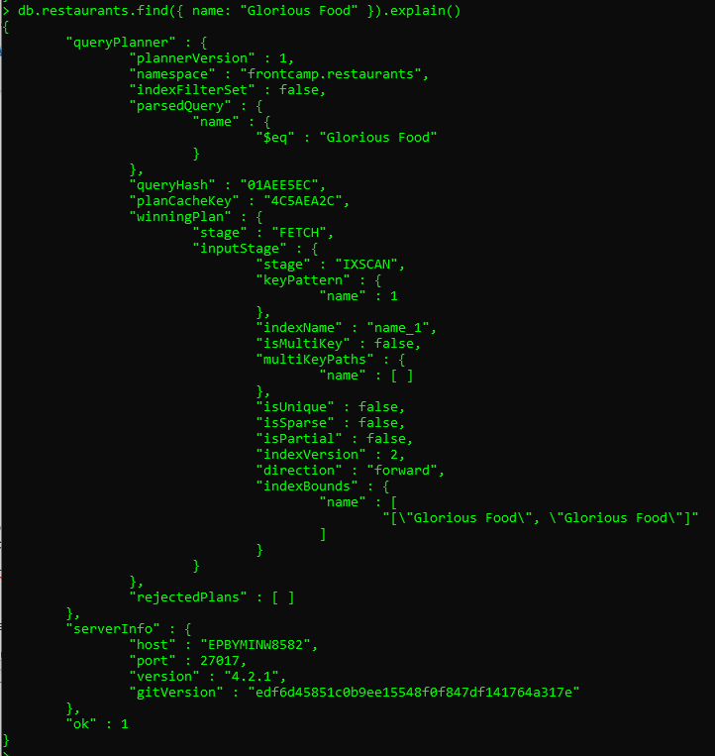

**2. Drop index from task 4.1**

**Query:**

db.restaurants.dropIndex('name_1')

**Result:**

{ "nIndexesWas" : 2, "ok" : 1 }

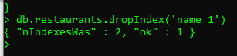

**Query:**

db.restaurants.find({ name: "Glorious Food" }).explain()

**Result:**

{

"queryPlanner" : {

"plannerVersion" : 1,

"namespace" : "frontcamp.restaurants",

"indexFilterSet" : false,

"parsedQuery" : {

"name" : {

"$eq" : "Glorious Food"

}

},

"queryHash" : "01AEE5EC",

"planCacheKey" : "01AEE5EC",

"winningPlan" : {

"stage" : "COLLSCAN",

"filter" : {

"name" : {

"$eq" : "Glorious Food"

}

},

"direction" : "forward"

},

"rejectedPlans" : [ ]

},

"serverInfo" : {

"host" : "EPBYMINW8582",

"port" : 27017,

"version" : "4.2.1",

"gitVersion" : "edf6d45851c0b9ee15548f0f847df141764a317e"

},

"ok" : 1

}

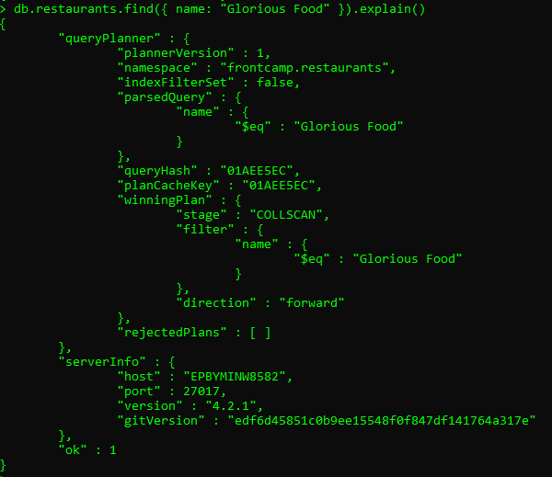

**3. Create an index to make this query covered and provide proof (from explain() or Compass UI) that it is indeed covered:**

**db.restaurants.find({ restaurant_id: "41098650" }, { _id: 0, borough: 1 })**

**Query:**

db.restaurants.createIndex({ restaurant_id: 1 })

**Result:**

{

"createdCollectionAutomatically" : false,

"numIndexesBefore" : 1,

"numIndexesAfter" : 2,

"ok" : 1

}

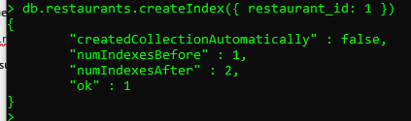

**Query:**

db.restaurants.find({ restaurant_id: "41098650" }, { _id: 0, borough: 1 }).explain()

**Result:**

{

"queryPlanner" : {

"plannerVersion" : 1,

"namespace" : "frontcamp.restaurants",

"indexFilterSet" : false,

"parsedQuery" : {

"restaurant_id" : {

"$eq" : "41098650"

}

},

"queryHash" : "11B8AFCC",

"planCacheKey" : "A2837C36",

"winningPlan" : {

"stage" : "PROJECTION_SIMPLE",

"transformBy" : {

"_id" : 0,

"borough" : 1

},

"inputStage" : {

"stage" : "FETCH",

"inputStage" : {

"stage" : "IXSCAN",

"keyPattern" : {

"restaurant_id" : 1

},

"indexName" : "restaurant_id_1",

"isMultiKey" : false,

"multiKeyPaths" : {

"restaurant_id" : [ ]

},

"isUnique" : false,

"isSparse" : false,

"isPartial" : false,

"indexVersion" : 2,

"direction" : "forward",

"indexBounds" : {

"restaurant_id" : [

"[\"41098650\", \"41098650\"]"

]

}

}

}

},

"rejectedPlans" : [ ]

},

"serverInfo" : {

"host" : "EPBYMINW8582",

"port" : 27017,

"version" : "4.2.1",

"gitVersion" : "edf6d45851c0b9ee15548f0f847df141764a317e"

},

"ok" : 1

}

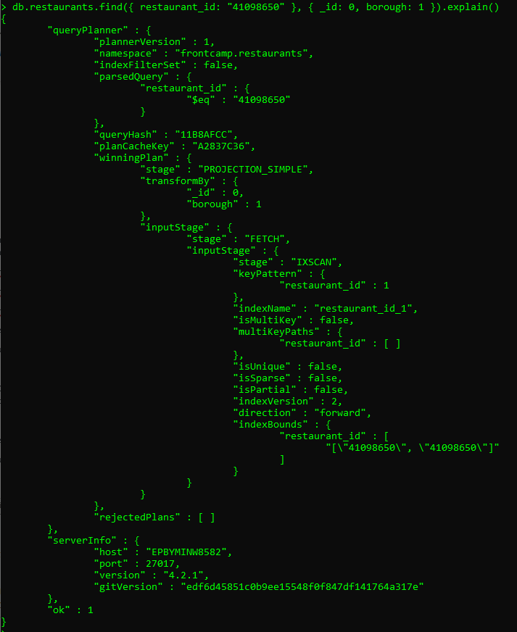

**4. Create a partial index on cuisine field which will be used only when filtering on borough equal to “Staten Island”:**

**db.restaurants.find({ borough: "Staten Island", cuisine: "American" }) – uses index**

**db.restaurants.find({ borough: "Staten Island", name: "Bagel Land" }) – does not use index**

**db.restaurants.find({ borough: "Queens", cuisine: "Pizza" }) – does not use index**

**Query:**

db.restaurants.createIndex({ cuisine: 1 }, { partialFilterExpression: { borough: 'Staten Island'} } )

**Result:**

{

"createdCollectionAutomatically" : false,

"numIndexesBefore" : 2,

"numIndexesAfter" : 3,

"ok" : 1

}

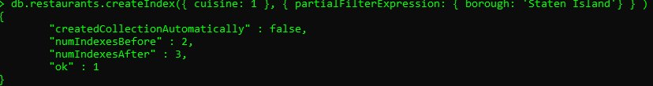

**Query:**

db.restaurants.find({ borough: "Staten Island", cuisine: "American" }).explain()

**Result:**

{

"queryPlanner" : {

"plannerVersion" : 1,

"namespace" : "frontcamp.restaurants",

"indexFilterSet" : false,

"parsedQuery" : {

"$and" : [

{

"borough" : {

"$eq" : "Staten Island"

}

},

{

"cuisine" : {

"$eq" : "American"

}

}

]

},

"queryHash" : "DBDC0200",

"planCacheKey" : "C53EF8BB",

"winningPlan" : {

"stage" : "FETCH",

"filter" : {

"borough" : {

"$eq" : "Staten Island"

}

},

"inputStage" : {

"stage" : "IXSCAN",

"keyPattern" : {

"cuisine" : 1

},

"indexName" : "cuisine_1",

"isMultiKey" : false,

"multiKeyPaths" : {

"cuisine" : [ ]

},

"isUnique" : false,

"isSparse" : false,

"isPartial" : true,

"indexVersion" : 2,

"direction" : "forward",

"indexBounds" : {

"cuisine" : [

"[\"American\", \"American\"]"

]

}

}

},

"rejectedPlans" : [ ]

},

"serverInfo" : {

"host" : "EPBYMINW8582",

"port" : 27017,

"version" : "4.2.1",

"gitVersion" : "edf6d45851c0b9ee15548f0f847df141764a317e"

},

"ok" : 1

}

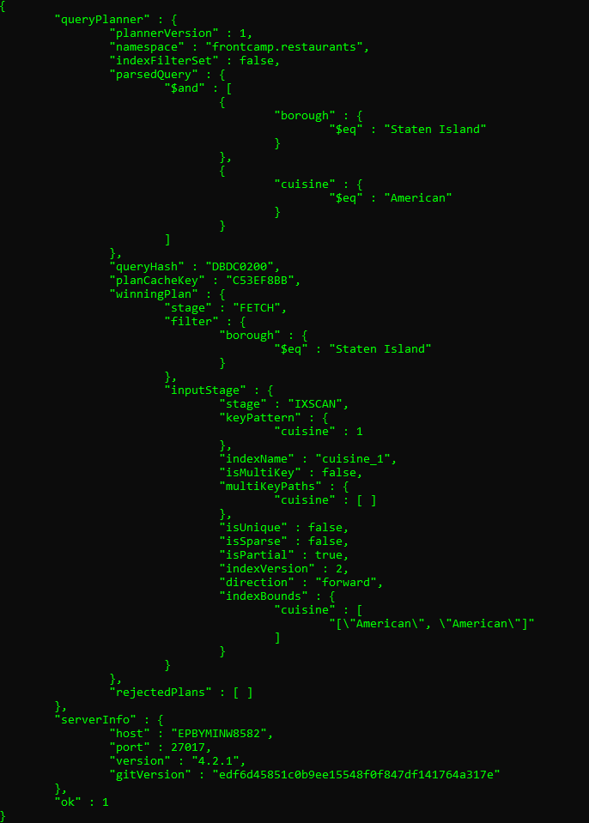

**Query:**

db.restaurants.find({ borough: "Staten Island", name: "Bagel Land" }).explain()

**Result:**

{

"queryPlanner" : {

"plannerVersion" : 1,

"namespace" : "frontcamp.restaurants",

"indexFilterSet" : false,

"parsedQuery" : {

"$and" : [

{

"borough" : {

"$eq" : "Staten Island"

}

},

{

"name" : {

"$eq" : "Bagel Land"

}

}

]

},

"queryHash" : "D9E6DF40",

"planCacheKey" : "7175E33A",

"winningPlan" : {

"stage" : "COLLSCAN",

"filter" : {

"$and" : [

{

"borough" : {

"$eq" : "Staten Island"

}

},

{

"name" : {

"$eq" : "Bagel Land"

}

}

]

},

"direction" : "forward"

},

"rejectedPlans" : [ ]

},

"serverInfo" : {

"host" : "EPBYMINW8582",

"port" : 27017,

"version" : "4.2.1",

"gitVersion" : "edf6d45851c0b9ee15548f0f847df141764a317e"

},

"ok" : 1

}

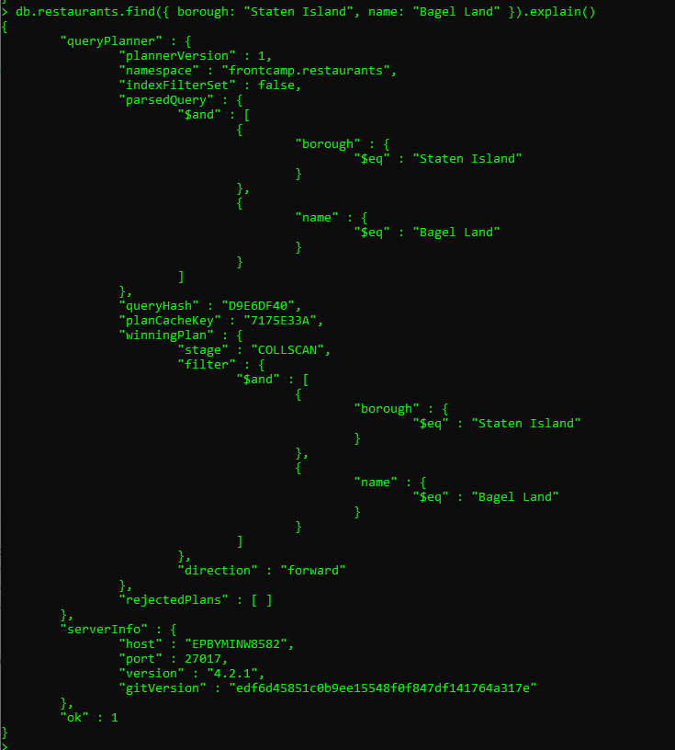

**Query:**

db.restaurants.find({ borough: "Queens", cuisine: "Pizza" }).explain()

**Result:**

{

"queryPlanner" : {

"plannerVersion" : 1,

"namespace" : "frontcamp.restaurants",

"indexFilterSet" : false,

"parsedQuery" : {

"$and" : [

{

"borough" : {

"$eq" : "Queens"

}

},

{

"cuisine" : {

"$eq" : "Pizza"

}

}

]

},

"queryHash" : "DBDC0200",

"planCacheKey" : "037B0B97",

"winningPlan" : {

"stage" : "COLLSCAN",

"filter" : {

"$and" : [

{

"borough" : {

"$eq" : "Queens"

}

},

{

"cuisine" : {

"$eq" : "Pizza"

}

}

]

},

"direction" : "forward"

},

"rejectedPlans" : [ ]

},

"serverInfo" : {

"host" : "EPBYMINW8582",

"port" : 27017,

"version" : "4.2.1",

"gitVersion" : "edf6d45851c0b9ee15548f0f847df141764a317e"

},

"ok" : 1

}

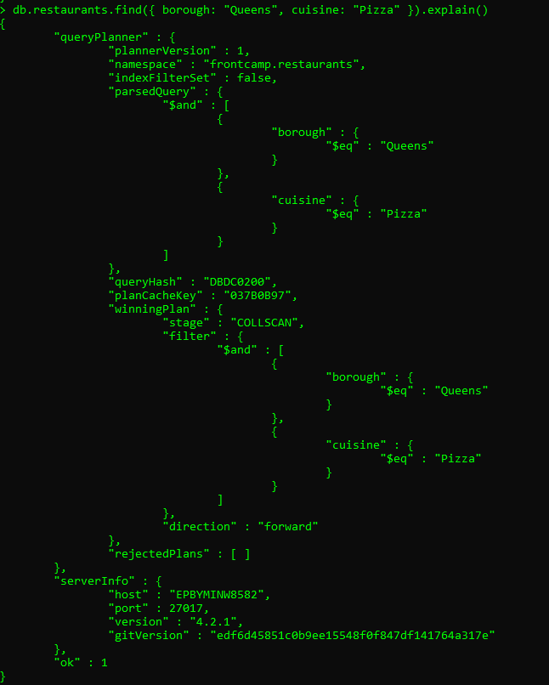

**5. Create an index to make query from task 3.4 covered and provide proof (from explain() or Compass UI) that it is indeed covered**

**Query:**

db.restaurants.createIndex({ 'grades.8.score': 1 })

**Result:**

{

"createdCollectionAutomatically" : false,

"numIndexesBefore" : 3,

"numIndexesAfter" : 4,

"ok" : 1

}

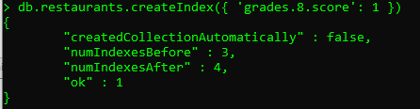

**Query:**

db.restaurants.find({ 'grades.8.score': { $lt: 7 }}, { _id: 0, name: 1 }).explain()

**Result:**

{

"queryPlanner" : {

"plannerVersion" : 1,

"namespace" : "frontcamp.restaurants",

"indexFilterSet" : false,

"parsedQuery" : {

"grades.8.score" : {

"$lt" : 7

}

},

"queryHash" : "03034A2A",

"planCacheKey" : "3B1B8634",

"winningPlan" : {

"stage" : "PROJECTION_SIMPLE",

"transformBy" : {

"_id" : 0,

"name" : 1

},

"inputStage" : {

"stage" : "FETCH",

"inputStage" : {

"stage" : "IXSCAN",

"keyPattern" : {

"grades.8.score" : 1

},

"indexName" : "grades.8.score_1",

"isMultiKey" : true,

"multiKeyPaths" : {

"grades.8.score" : [

"grades"

]

},

"isUnique" : false,

"isSparse" : false,

"isPartial" : false,

"indexVersion" : 2,

"direction" : "forward",

"indexBounds" : {

"grades.8.score" : [

"[-inf.0, 7.0)"

]

}

}

}

},

"rejectedPlans" : [ ]

},

"serverInfo" : {

"host" : "EPBYMINW8582",

"port" : 27017,

"version" : "4.2.1",

"gitVersion" : "edf6d45851c0b9ee15548f0f847df141764a317e"

},

"ok" : 1

}

