**Baliulin Pavlo**

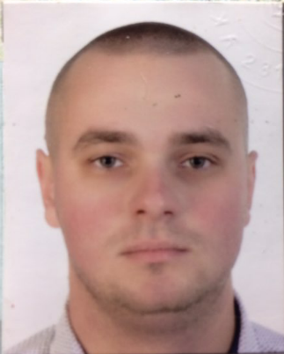

**Date of Birth:** 16 Sep 1992

**Phone:** +38 (099) 289 – 92 - 33

**Email:** [baliulin.pavel@gmail.com](mailto:baliulin.pavel@gmail.com)

**Objective:** getting coder position.

**Education:** 2009 - 2014, Classical Private University, The Institute of  
Information Technology, Speciality:   
System Analysis, Degree: Master.  
2019, BrainAcademy, Front-End Developer.

**Experience:** 02 Oct 2018 - now:   
cutting machine operator, printing house production, OOO Print Master.

**Technical Proficiencies**: knowledge of: CSS3, SCSS, Git. Basic   
basic knowledge: JavaScript, React

**Additional information:** Ukrainian - native speaker, Russian - proficiency,  
English - pre-intermediate.