logOS
Belfield 1.0

A RISC-V Operating System

Pavel Gladyshev
with Claude.ai

Contents
Contents 2
Foreword 3
Operating system interfaces 4
1.1 Processes and spawn 5
1.2 File descriptors and I/O 7
1.3 The filesystem 8
1.4 Device files 8
1.5 Environment variables 9
1.6 The shell 9
1.7 Real world 10
1.8 Exercises 11
Operating system organization 12
2.1 The hardware platform 12
2.2 Kernel organization 12
2.3 Memory layout 13
2.4 The boot sequence 15
2.5 Real world 16
2.6 Exercises 16

Foreword
logOS is a teaching operating system inspired by the Unix operating system. It provides a subset of the services and system calls that Unix kernels traditionally offer: processes, file descriptors, a filesystem with directories, and a shell. The system is intentionally small — the entire kernel is under 3,000 lines of C and assembly — making it feasible for you, a student, to read and understand every line of code. logOS is designed for single-core RV32 systems with no virtual memory, like a microcontroller. logOS 1.0 does not provide preemptive multitasking and is functionally more akin to MS-DOS than modern operating systems like Linux, Windows, or macOS — a kernel reduced to its essence.
The simplicity of logOS 1.0 is deliberate. By running on a CPU simulated in Logisim, you can observe the hardware and software in a single, integrated environment. There is no MMU, so the concepts of address spaces and memory protection are replaced by the simpler (and historically older) approach of fixed memory partitions. There is no preemptive multitasking, so the complexities of concurrent scheduling and locking vanish. What remains is a clear illustration of the core mechanisms: how a system call enters the kernel, how the filesystem translates paths to data on disk, how a shell spawns programs.
The text assumes familiarity with C programming and a basic understanding of computer architecture, particularly registers, memory, and instruction execution. RISC-V-specific details are introduced as they arise.
Each chapter follows a consistent structure. It begins with a conceptual introduction explaining why the mechanism exists and what problem it solves. It then walks through the actual logOS source code, function by function. Each chapter concludes with a "Real world" section that compares the logOS approach to production systems like Linux, and an "Exercises" section with questions and implementation tasks.

Chapter 1

Operating system interfaces

The job of an operating system is to share a computer among multiple programs and to provide a more useful set of services than the hardware alone supports. An operating system manages and abstracts the low-level hardware, so that, for example, a user program need not concern itself with which block of disk stores a particular file. An operating system arranges for programs to run, and provides controlled ways for them to use, organise, and eventually share data.
An operating system provides services to user programs through an interface. Designing a good interface turns out to be difficult. On the one hand, we would like the interface to be simple and narrow because that makes it easier to get the implementation right. On the other hand, we may be tempted to offer many sophisticated features to applications. The trick is to design interfaces that rely on a few mechanisms that can be combined to provide much generality.
This text uses a single operating system as a concrete example to illustrate operating system concepts. That operating system, logOS, provides a subset of the interfaces introduced by Ken Thompson and Dennis Ritchie's Unix operating system. Unix provides a narrow interface whose mechanisms combine well, offering a surprising degree of generality. This interface has been so successful that modern operating systems — BSD, Linux, macOS, and even, to a lesser extent, Microsoft Windows — have Unix-like interfaces. Understanding logOS is a good start toward understanding any of these systems.
logOS takes the traditional form of a kernel, a special program that provides services to running programs. Each running program, called a process, has memory containing instructions, data, and a stack. The instructions implement the program's computation. The data are the variables on which the computation acts. The stack organizes the program's procedure calls. There can be several processes in memory at the same time, but only a single kernel.
When a process needs to invoke a kernel service, it invokes a system call, one of the calls in the operating system's interface. The system call enters the kernel; the kernel performs the service and returns. Thus a process alternates between executing in user space and kernel space.
The collection of system calls that the logOS kernel provides is the interface that user programs see. Figure 1.1 lists all of logOS's system calls.

System call | Description
exit(status) | Terminate the current process with the given exit status
read(fd, buf, n) | Read n bytes from file descriptor fd into buf
write(fd, buf, n) | Write n bytes from buf to file descriptor fd
open(path, flags) | Open a file; returns a file descriptor
close(fd) | Release the file descriptor fd
spawn(path, argv) | Load and run a program; returns its exit code
readdir(path, buf, max) | Read directory entries into buf
mkdir(path) | Create a directory
rmdir(path) | Remove an empty directory
mknod(path, major, minor) | Create a device file
setenv(name, value) | Set an environment variable
getenv(name, buf, len) | Get the value of an environment variable
unsetenv(name) | Remove an environment variable
chdir(path) | Change the current working directory
Figure 1.1: logOS system calls. Not all arguments are shown.
The rest of this chapter outlines logOS's services — processes, file descriptors, the filesystem, and the shell — and illustrates them with code snippets and discussions of how the shell uses them. The shell, logOS's command-line user interface, is an ordinary user program that reads commands from the user and executes them; the fact that the shell is a user program, and not part of the kernel, illustrates the power of the system call interface.

1.1 Processes and spawn
A logOS process consists of user-space memory (instructions, data, and stack) plus per-process state private to the kernel (a trap frame, file descriptors, environment variables, and a process identifier or "PID").
logOS provides the spawn() system call to create a new process. It loads an executable from the filesystem into a fresh memory slot, sets up its stack, and begins executing it. The calling process is suspended until the child terminates; when the child calls exit(), the parent resumes and spawn() returns the child's exit code.
This is different from Unix's fork()/exec() pair. In Unix, fork() creates a copy of the calling process, and exec() replaces the copy's memory with a new program. logOS 1.0 combines these into a single spawn() call, which is simpler and avoids copying the parent process'es entire memory content. The trade-off is that logOS cannot support the Unix pattern of having the child modify its file descriptors between fork() and exec(), which is how Unix implements I/O redirection and pipelines. This will be addressed in the next version of logOS.
Here is an example user program (user/hello.c):

#include "libc.h"
int main(int argc, char *argv[])
{
puts("Hello from user program!\n");
printf("main() is at address 0x%x\n", (unsigned int)main);
printf("argc = %d\n", argc);
for (int i = 0; i \< argc; i++) {
printf("argv[%d] = \"%s\"\n", i, argv[i]);
}
return 42;
}

The program prints a greeting, the starting address of its main() in memory, its arguments, and returns exit code 42. The return from main() is converted to an exit(42) system call by the user C runtime startup code (user/user_crt0.S). This startup code is the first thing that runs when a program starts:

_start:
jal main # Call main(argc, argv)
li a7, 0 # SYS\_exit = 0
ecall # Exit with main's return value in a0
1: j 1b # Should never reach here

The kernel passes argc in register a0 and argv in a1, following the RISC-V calling convention. After main() returns (its return value left in a0), _start issues the exit system call.
A program that wants to run another program uses spawn(). For example (user/spawn_demo.c):

int main(int argc, char *argv[])
{
char *child_argv[4]; /* Build argv array at runtime */
child_argv[0] = "hello";
child_argv[1] = "arg1";
child_argv[2] = "arg2";
child_argv[3] = (char *)0;
int result = spawn("/bin/hello", child_argv);
printf("spawn returned %d\n", result);
return 0;
}

Note that the child_argv array is built at runtime rather than using a static initializer. This is necessary because logOS user programs must be position-independent executables (PIE) in order to be loaded at arbitrary addresses. Static pointer arrays would contain absolute addresses baked in at link time, which would be incorrect after relocation. Chapter 7 explains this in detail.

1.2 File descriptors and I/O
A file descriptor is a small integer representing a kernel-managed object that a process can read from or write to. A process obtains a file descriptor by opening a file or device. logOS pre-opens three file descriptors for every process:

fd | Name | Description
0 | Standard input (stdin) | Console keyboard
1 | Standard output (stdout) | Console display
2 | Standard error (stderr) | Console display

The read and write system calls read and write bytes through file descriptors. A call to read(fd, buf, n) reads at most n bytes from the file descriptor fd, copies them into memory at address buf, and returns the number of bytes read. Each file descriptor that refers to a regular file has an associated offset. read reads data from the current offset and advances it.
The write(fd, buf, n) system call writes n bytes from buf to file descriptor fd and returns the number of bytes written. For device files such as the console, write sends characters to the display. For regular files, write writes data at the current offset.
The following code fragment (from the user library) writes a string to standard output (user/libc.c):
void puts(const char *s) {
write(STDOUT_FILENO, s, strlen(s));
}

A process can open additional files using the open system call:
int fd = open("/bin/hello", 0); /* Open a file for reading */
char buf[128];
int n = read(fd, buf, sizeof(buf)); /* Read some data */
close(fd); /* Release the file descriptor */

logOS supports up to 8 file descriptors per process. Three are pre-allocated for the standard I/O channels, leaving 5 available for user programs.

1.3 The filesystem
The logOS filesystem provides a tree of named files and directories. At the top is the root directory, represented by the path /. Files within directories are named by pathnames such as /bin/hello, where bin is a directory and hello is a file within it.
Several system calls operate on the filesystem. mkdir creates a new directory. rmdir removes an empty directory. readdir reads the entries of a directory. mknod creates a device file, which is not a file containing data but rather a name that refers to a hardware device.
The chdir system call changes the process's current working directory. Once set, relative paths (those not starting with /) are resolved relative to the current directory:
chdir("/bin");
int fd = open("hello", 0); /* Opens /bin/hello */

Every directory contains two special entries: . (dot), which refers to the directory itself, and .. (dot-dot), which refers to its parent. For the root directory, .. points back to the root.

1.4 Device files
logOS represents hardware devices as files in the filesystem. A device file (also called a device node) is identified by two numbers: a major number that selects a device driver, and a minor number that the driver interprets. For example, the console is major 1, minor 0. When multiple devices of the same type are connected to the system, the minor number can be used to distinguish them, even though they all have the same major number.
The mknod system call creates a device file:
mknod("/dev/tty", 1, 0); /* Create console device node */

Once created, the device can be opened and used with the same read and write calls as regular files. This uniformity — treating devices and files through the same interface — is one of the enduring design principles of Unix.

1.5 Environment variables
Each process in logOS has a set of environment variables: named string values stored within the kernel's process table. The setenv, getenv, and unsetenv system calls manipulate these.
Environment variables serve several purposes. The PATH variable tells the shell which directories to search for commands. The CWD variable stores the current working directory of the process. The ? variable holds the exit status of the last program spawned by the process.
When a process spawns a child, the child inherits a copy of the parent's environment. Changes made by the child do not affect the parent — this follows standard Unix semantics.

1.6 The shell
The logOS shell (user/shell.c) is an ordinary user program that reads commands from the console and executes them. It is not part of the kernel. The kernel simply loads /bin/sh at startup and restarts it if it exits.
The shell reads a line, expands $VAR references, parses the line into words, and either executes a built-in command or spawns an external program. The shell's main loop (simplified) is:

for (;;) {
puts(getenv("CWD"));
puts("$ ");
gets(line, MAX_CMD_LEN);

expand_vars(line, expanded, MAX_CMD_LEN);
argc = parse_cmd(expanded, argv, MAX_ARGS);

if (strcmp(argv[0], "exit") == 0)
exit(code);
else if (strcmp(argv[0], "cd") == 0)
chdir(argv[1]);
else
… check for other built-in commands …
else
run_external(argc, argv); / Search PATH and spawn /
}

The run_external function searches the directories listed in $PATH for the command name, constructs the full path, and calls spawn(). Given below are some examples of shell commands:

$ hello # Runs /bin/hello (found via PATH=/bin)
$ /bin/hello # Runs with explicit full path
$ echo $PATH # Variable expansion: prints "/bin"
$ set FOO=bar # Set environment variable
$ echo $FOO # Prints "bar"
$ ls /bin # List directory contents
$ mkdir /tmp # Create a directory
$ cd /tmp # Change working directory

1.7 Real world
The logOS system call interface is a much simplified version of what Unix and its descendants provide. Production Unix-like systems have hundreds of system calls (Linux has over 400), while logOS has 16. logOS omits many foundational Unix features:
multitasking. logOS 1.0 does not provide the multitasking (timesharing) required for Unix shell pipelines.
fork and exec. Unix separates process creation (fork) from program loading (exec), allowing the child to set up I/O redirection between the two calls. This, together with multitasking, enables pipelines (ls | grep foo). logOS's combined spawn is simpler but cannot support pipelines.
Pipes. Unix pipes provide a unidirectional byte stream between two processes. They are the mechanism behind the | operator in the shell. logOS 1.0 does not implement pipes.
File permissions. Unix associates permissions (read, write, execute) with every file, controlling access based on user and group identity. logOS has no concept of users or permissions.
Signals. Unix uses signals to notify processes of events (e.g., Ctrl-C sends SIGINT). logOS has no signal mechanism.
Virtual memory. Modern Unix systems give each process its own virtual address space via hardware page tables. logOS runs on hardware without an MMU and instead uses fixed physical memory partitions.
Despite these omissions, logOS illustrates the fundamental Unix design principles: everything is a file, system calls are the interface between user programs and the kernel, the shell is just a user program, and the kernel manages resources on behalf of processes.

1.8 Exercises
1. Look at the system call table in Figure 1.1. Which system calls would you need to implement the cat command (print the contents of a file)? Write a cat program using the logOS user library.
2. The spawn() system call blocks the parent until the child exits. What advantages and disadvantages does this have compared to Unix's non-blocking fork()?
3. logOS has no pipe system call. How could you implement a functional equivalent of the Unix shell command ls | grep hello without pipes? What additional system calls would be needed?
4. Environment variables in logOS are stored in the kernel. In many Unix systems, they are stored in the process's own memory (on the stack, above argv). What are the trade-offs of each approach?
5. Write a user program that creates a file /tmp/test, writes some data to it, closes it, reopens it, reads the data back, and verifies it matches.

Chapter 2

Operating system organization

This chapter provides an overview of how logOS is organized to achieve these goals. It describes the hardware platform, the kernel's structure, the memory layout, and the boot sequence that brings the system to life.

2.1 The hardware platform
logOS runs on a RISC-V processor simulated in UCD’s version of Logisim Evolution, an educational digital logic simulator. The simulated system consists of:
• A 32-bit RISC-V CPU supporting the RV32IM instruction set (integer arithmetic plus multiply/divide) with the Zicsr extension for control and status registers (CSRs).
• ROM at address 0x00000000, containing the bootloader code.
• RAM starting at address 0x00100000, used for the kernel program, data, and process memory slots.
• A block storage device at addresses 0x00200000-0x002000F, providing persistent storage via memory-mapped I/O registers.
• A system timer counting the number of clock cycles passed since the last reset at addresses 0x02004000 (mtimecmp) and 0x0200BFF8 (mtime)
• A console display (TTY) at the address 0xFFFF000C, and keyboard at the addresses 0xFFFF0004 (RCR) and 0xFFFF0008 (RDR) providing keyboard input and text output.

This is a single-core machine with no memory management unit (MMU). All memory addresses are physical addresses. There is no hardware memory protection: any instruction can access any address. Isolation between processes is maintained by convention (each process stays within its assigned memory slot) rather than by hardware enforcement.

2.2 Kernel organization
logOS is a monolithic kernel: all operating system services run in a single program that handles system calls. This contrasts with a microkernel design, where services like the filesystem run as separate user-level processes.
The kernel source is organized into layers, where each layer depends only on layers below it:

Layer | Source files | Purpose
Block I/O | block.c/h | Read/write disk blocks, bitmap allocation
Inode | inode.c/h | Read/write inodes, allocate/free
Directory | dir.c/h | Directory entry lookup, add/remove
File | file.c/h | File create/delete, read/write data
Filesystem | fs.c/h | Format, mount, open paths
Device | device.c/h, console\_dev.c/h | Character device driver framework
Trap handling | trap.S, trap.h | Context save/restore, trap dispatch
Process | process.c/h | Process table, slot allocation
System calls | syscall.c/h | System call dispatch and implementation
ELF loader | loader.c/h | Load executables from filesystem
Kernel main | main.c, crt0.S | Initialization and shell loop

Figure 2.1: logOS kernel source organization.

2.3 Memory layout
logOS divides the physical address space into fixed regions, as shown in Figure 2.2 below. The ROM contains the bootloader, which is the first code to run after a CPU reset. The bootloader loads the kernel binary from the filesystem on the block device into RAM at 0x00100000 and then jumps to it. The bootloader places its own BSS section high in RAM (at 0x001F0000) so that loading the kernel does not overwrite the bootloader’s mutable state.

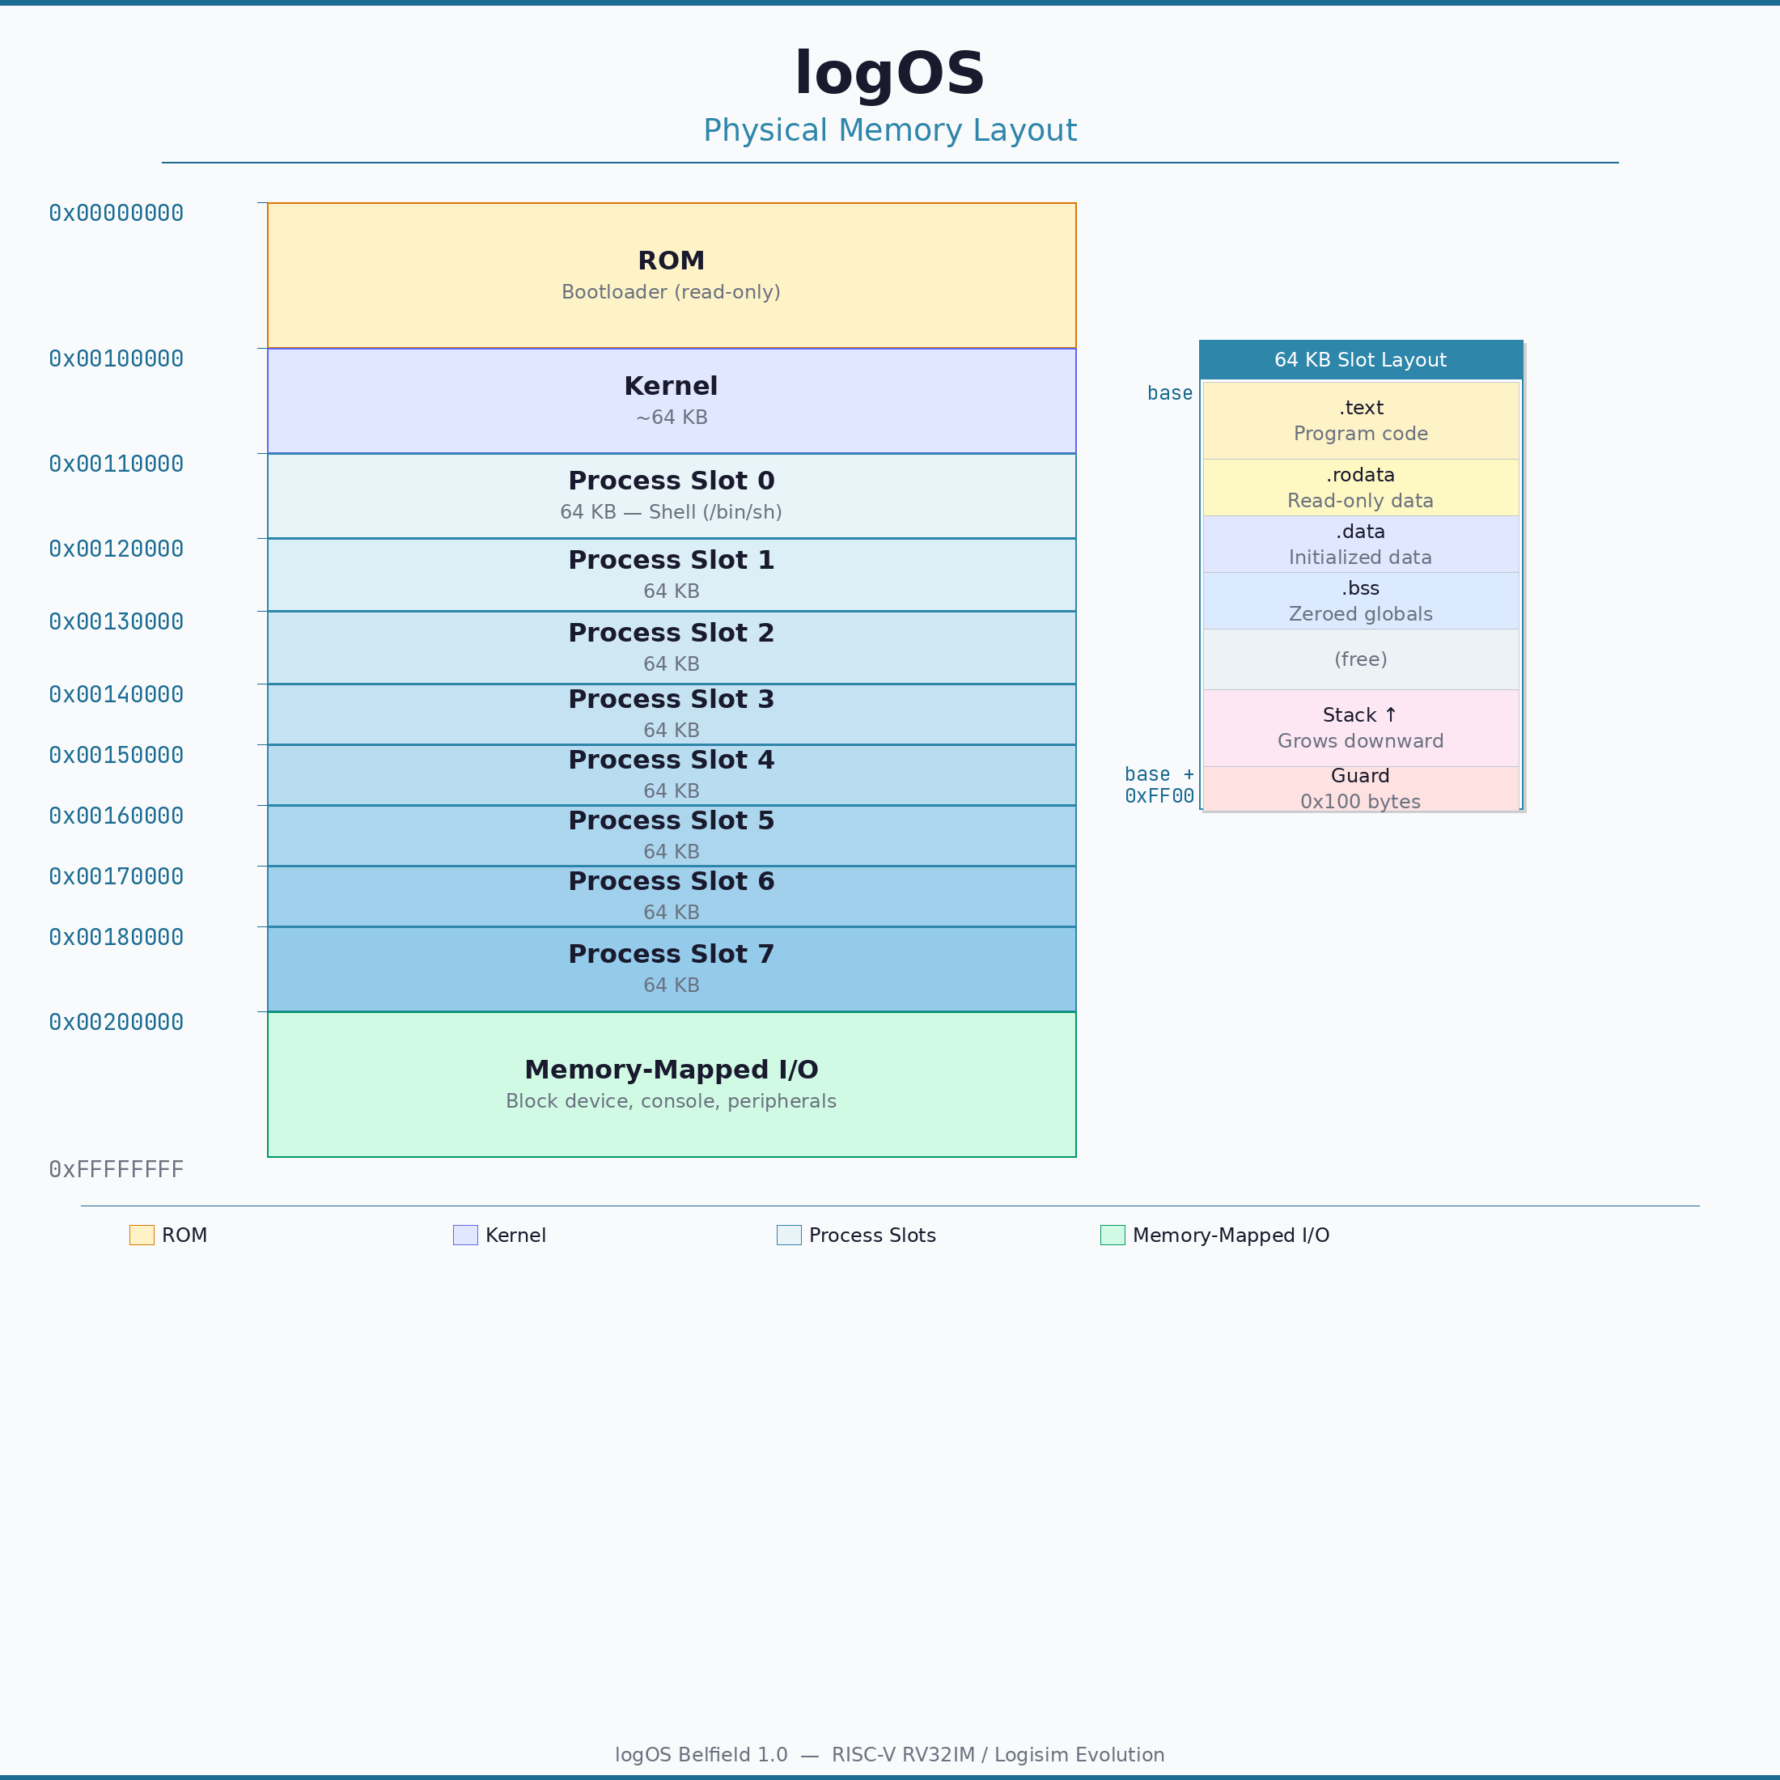
Figure 2.2: logOS physical memory layout.
Each process slot is 64KB. The slot contains the program's code (starting at the slot base), its data and BSS sections, and its stack (growing downward from near the top of the slot). The kernel reserves 256 bytes at the very top of each slot as a guard, so the stack pointer starts at slot\_base + 0xFF00.
The process table data structure (kernel/process.h) records the base address and stack top for each slot:

#define PROC_SLOT_SIZE 0x10000 / 64KB per process /
#define PROC_MEM_START 0x00110000 / First slot base address /
#define PROC_SLOT_BASE(n) (PROC_MEM_START + (n) * PROC_SLOT_SIZE)
#define PROC_SLOT_STACK(n) (PROC_SLOT_BASE(n) + PROC_SLOT_SIZE - 0x100)

There are 8 process slots (numbered 0 through 7). Slot 0 is always used for the shell. When the shell spawns a command, the command is loaded into slot 1. If that command spawns another program, it goes into slot 2, and so on.

2.4 The boot sequence
logOS uses a three-stage boot process: the bootloader (in ROM) loads the kernel from the filesystem into RAM, the kernel initialises subsystems, and then the kernel loads the shell into a process slot and transfers control to it.
Stage 1: The bootloader
When the RISC-V processor starts, it begins executing instructions at address 0, which is in ROM. The bootloader’s startup code (boot/boot_crt0.S) sets the stack pointer to 0x001FFFFC (top of RAM), zeroes the bootloader BSS section at 0x001F0000, and calls boot_main(). The bootloader’s BSS is placed high in RAM by its linker script (boot/boot.lds) to avoid collision with the kernel, which will be loaded at 0x00100000.
The boot_main() function (boot/boot_main.c) reads the kernel from the filesystem: it reads and validates the superblock (block 0) from the block device, resolves the path /boot/kernel by walking the directory tree from the root inode, reads the kernel inode to determine the file size and block list, and then DMA-copies the kernel’s data blocks directly into RAM at 0x00100000. The bootloader has its own minimal filesystem implementation (boot/boot_fs.c, boot/boot_io.c) — just enough to traverse directories and read file data.
Once the kernel binary is fully loaded, the bootloader casts the load address to a function pointer and calls it. Execution transfers to the kernel’s entry point at 0x00100000, and the bootloader never runs again.
Stage 2: Kernel initialisation
The kernel’s entry point (kernel/crt0.S) is structurally identical to the bootloader’s: it sets the stack pointer, zeroes the kernel’s BSS, and calls main(). The kernel and the bootloader share the same initial stack pointer value (0x001FFFFC), but since the bootloader has finished and will not run again, there is no conflict. The BSS zeroing is essential because C requires that global variables initialised to zero actually be zero.
The kernel’s main() function (kernel/main.c) initialises all subsystems in a specific order. First, console_dev_init() registers the console character device driver (major number 1), which is needed before any output can be produced. Next, proc_init() initialises the 8 process slots with their fixed memory addresses. Finally, fs_mount() reads the superblock to make the filesystem accessible. Only after all subsystems are initialised can the shell be loaded.
Stage 3: Loading the shell
The kernel then enters an infinite loop that loads and runs the shell. Each iteration allocates a process slot (slot 0), initialises the per-process environment (setting PATH=/bin and CWD=/), and calls elf_load_at("/bin/sh", ...) to load the shell’s ELF binary from the filesystem into the process slot at address 0x00110000.
The kernel sets up a trap frame with the shell’s entry point and stack pointer, installs the trap handler in the machine-mode CSRs (mtvec and mscratch), opens file descriptors 0, 1, and 2 on the console device, and calls run_user_program(). This function saves the kernel’s register state and executes mret to transfer control to the shell’s _start address. At this point the shell is running, and the kernel is effectively suspended — it will resume only when the shell calls sys_exit.

2.5 Real world
logOS’s organisation is intentionally simpler than that of production kernels. Linux, for example, has millions of lines of code organised into dozens of subsystems. However, the basic structure is the same: a bootloader that loads the kernel into memory, a startup sequence that initialises hardware and mounts filesystems, a trap handler that dispatches system calls, and a process table that tracks running programs.
The logOS bootloader is much simpler than production bootloaders—systems like GRUB or U-Boot support multiple boot targets, configuration files, and hardware initialisation sequences. The logOS bootloader needs only to read one file from a known path. The most significant architectural difference is the lack of hardware memory protection. Production systems use an MMU to give each process its own virtual address space, making it impossible for one process to read or write another’s memory. logOS relies on software conventions instead. This was actually how early Unix systems worked on the PDP-7, before hardware memory protection became common.

2.6 Exercises
1. Both the bootloader’s boot_crt0.S and the kernel’s crt0.S zero their respective BSS sections at startup. What would happen if this step were omitted in the kernel? Which parts of the kernel might malfunction?
2. logOS has 8 process slots. What is the maximum depth of nested spawn() calls possible? What happens if a program tries to exceed this?
3. The kernel restarts the shell in an infinite loop. What would happen if elf_load_at for /bin/sh failed (e.g., the filesystem was corrupted)? How does the kernel handle this?
4. Draw a timeline showing the sequence of function calls from power-on to the shell printing its first prompt. Include the bootloader stage (boot_crt0.S, boot_main), the kernel stage (crt0.S, main), and the user-space stage (user_crt0.S, shell main). Show where control transfers between the three stages.
5. logOS places the bootloader in ROM and the kernel in RAM (loaded from the filesystem by the bootloader). Why is the bootloader in ROM rather than in RAM? What would need to change if the kernel were placed in ROM instead?

