Student: Pavel Krolevets 117033990005

**Compressing images using Eugen-decomposition and SVD**

**Research goal:** compress an image using Singular Value Decomposition based on eigenvalues and eigenvectors .

**Programming language:** Python

**Abstract**

The Singular Value Decomposition (SVD) was named one of the top 10 achievements in mathematics in the history of humanity. The SVD has many applications and one of the very important is in the image processing. The SVD can be used to restore a corrupted image by separating significant information from the noise in the image data set. If the image, when considered as a matrix, has low rank, or can be approximated sufficiently well by a matrix of low rank, then SVD can be used to find this approximation, and further this low rank approximation can be represented much more compactly than the original image.

In this paper we provide an image compression method based on SVD decomposition with rank reduction of the singular matrix. Also, we show that eigenvalue decomposition can be used to find SVD of any symmetrical nonsingular matrix (image).

**1. Theory.**

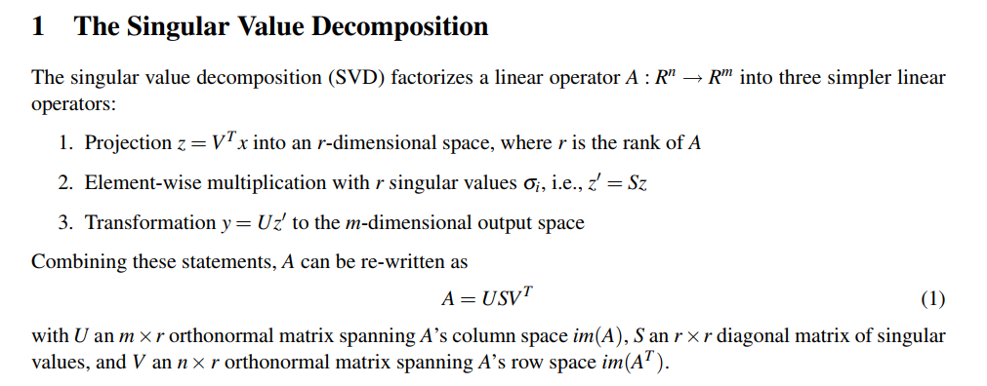

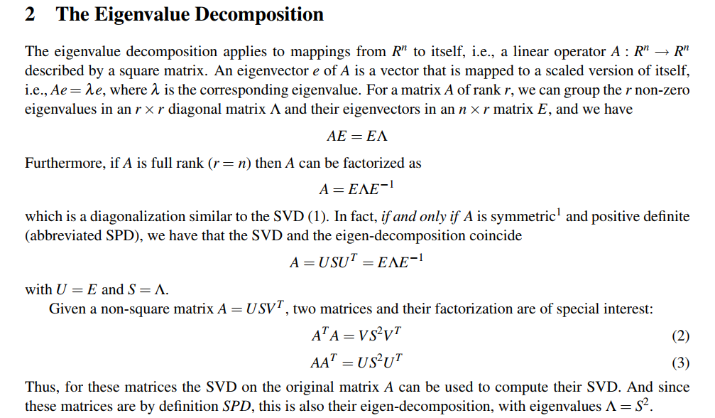

To get eigenvalues and eigen vectors we will use QR factorization algorithm.

**The QR algorithm**

In 1958 Rutishauser of ETH Zurich experimented with a similar algorithm that we are going to present, but based on the LR factorization, i.e., based on Gaussian elimination without pivoting. That algorithm was not successful as the LR factorization (nowadays called LU factorization) is not stable without pivoting. Francis noticed that the QR factorization would be the preferred choice and devised the QR algorithm with many of the bells and whistles used nowadays.



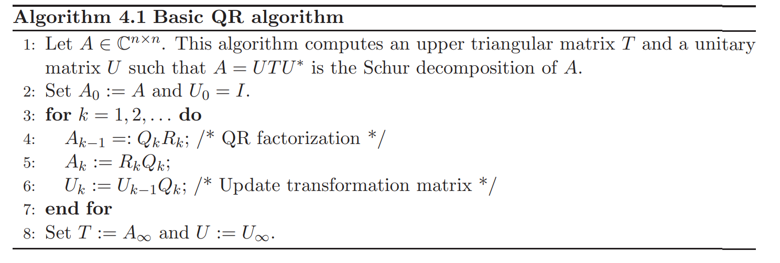

Because the original QR algorithm is too slow, we will use QR algorithm with shifting.

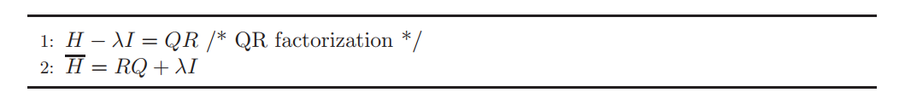

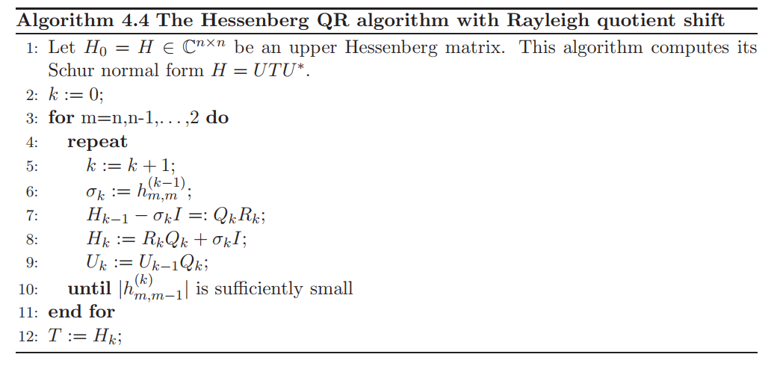Implementation in python

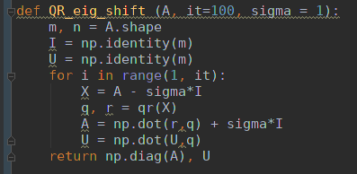

**Experiment:**

We take a picture of a size of 100*100 pixels and convert it to a matrix form.



We extract eigenvalues and eigenvectors from this picture and calculate singular values and singular vectors.

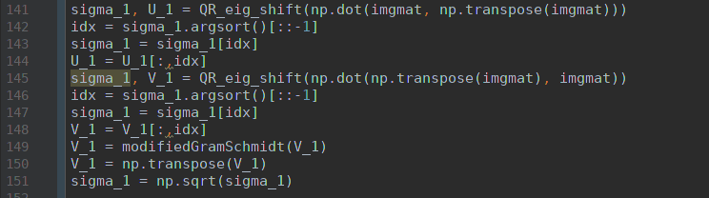

The last step, we reconstruct the image using only 10 eigenvalues with the highest value.



The output image preserves original characteristics, but has lower dimensions.

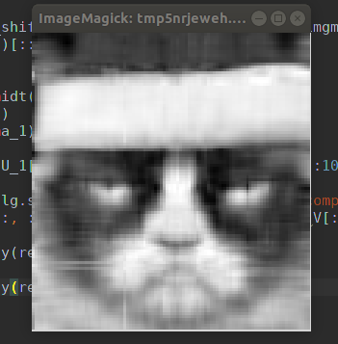

**Conclusion:**

In this research we were able to achieve a compression of an array using eigenvalue decomposition and SVD. These are very powerful technics which has a lot of applications in almost every computational processes.

The code with power method, inverse power method, QR decomposition, SVD may be found in Appendix A.

**References:**

1. Singular Value and Eigenvalue Decompositions Frank Dellaert. <https://www.cc.gatech.edu/~dellaert/ftp/svd-note.pdf>
2. Singular Value Decomposition (SVD) tutorial. <http://web.mit.edu/be.400/www/SVD/Singular_Value_Decomposition.htm>
3. Z. Bai, J. Demmel, J. Dongarra, A. Ruhe, and H. van der Vorst: *Templates for the Solution of Algebraic Eigenvalue Problems: A Practical Guide.* SIAM, Philadelphia, 2000.
4. Y. Saad: *Numerical Methods for Large Eigenvalue Problems,* 2nd revised edition. SIAM, Philadelphia, 2011.