УО «Белорусский государственный университет информатики и радиоэлектроники»

Кафедра ПОИТ

Отчет по лабораторной работе №6.1

по предмету «Основы алгоритмизации и программирования»

Вариант 12

Выполнил:

Галуха П. А.

Гр. 351005

Проверил:

Данилова Г. В.

Минск 2024

**Задание:**

**Код программы Delphi:**

Unit MainUnit;

Interface

Uses

Winapi.Windows, Winapi.Messages, System.SysUtils, System.Variants,

System.Classes, Vcl.Graphics,

Vcl.Controls, Vcl.Forms, Vcl.Dialogs, Vcl.StdCtrls, Vcl.ExtCtrls;

Const

WATCH_IMAGE_PADDING_LEFT_RIGHT = 80;

WATCH_IMAGE_PADDING_TOP_BOTTOM = 20;

WATCH_IMAGE_BOX_PEN_WIDTH = 10;

SAND_LEVEL_FALLING = 10;

Type

TMainForm = Class(TForm)

StartButton: TButton;

WatchTimer: TTimer;

WatchImage: TImage;

Procedure MainFormCreate(Sender: TObject);

Function MainFormHelp(Command: Word; Data: NativeInt; Var CallHelp: Boolean): Boolean;

Procedure StartButtonClick(Sender: TObject);

Procedure WatchTimerTimer(Sender: TObject);

Private

{ Private declarations }

Public

{ Public declarations }

End;

Var

MainForm: TMainForm;

Implementation

{$R *.dfm}

Var

WatchLeftSide, WatchTopSide: Integer;

TopHalfSandLevel, BottomHalfSandLevel, TopHalfLeftSandLevel, TopHalfRightSandLevel,

SandLineBottom: Integer;

Procedure PaintWatch(WatchImage: TImage);

Begin

With WatchImage.Canvas Do

Begin

Pen.Width := WATCH_IMAGE_BOX_PEN_WIDTH;

Pen.Color := clRed;

Brush.Color := clWhite;

Polygon([Point(WatchLeftSide, WatchTopSide),

Point(WatchImage.Width - WatchLeftSide, WatchTopSide),

Point(WatchLeftSide, WatchImage.Height - WatchTopSide),

Point(WatchImage.Width - WatchLeftSide, WatchImage.Height - WatchTopSide)]);

End;

End;

Procedure TMainForm.MainFormCreate(Sender: TObject);

Begin

WatchLeftSide := WATCH_IMAGE_PADDING_LEFT_RIGHT;

WatchTopSide := WATCH_IMAGE_PADDING_TOP_BOTTOM;

PaintWatch(WatchImage);

WatchTimer.Enabled := False;

End;

Procedure PaintSand(WatchImage: TImage);

Begin

With WatchImage.Canvas Do

Begin

PaintWatch(WatchImage);

Pen.Width := 0;

Brush.Color := clYellow;

Polygon([Point(TopHalfLeftSandLevel,

TopHalfSandLevel),

Point(TopHalfRightSandLevel,

TopHalfSandLevel),

Point(WatchImage.Width Div 2,

(WatchImage.Height - WATCH_IMAGE_BOX_PEN_WIDTH) Div 2)]);

Polygon([Point(WatchLeftSide + WATCH_IMAGE_BOX_PEN_WIDTH,

WatchImage.Height - WatchTopSide - WATCH_IMAGE_BOX_PEN_WIDTH Div 2),

Point(WatchImage.Width - WatchLeftSide - WATCH_IMAGE_BOX_PEN_WIDTH,

WatchImage.Height - WatchTopSide - WATCH_IMAGE_BOX_PEN_WIDTH Div 2),

Point(WatchImage.Width Div 2,

BottomHalfSandLevel)]);

End;

End;

Function TMainForm.MainFormHelp(Command: Word; Data: NativeInt; Var CallHelp: Boolean): Boolean;

Begin

CallHelp := False;

MainFormHelp := False;

End;

Procedure TMainForm.StartButtonClick(Sender: TObject);

Begin

TopHalfSandLevel := 0 + WATCH_IMAGE_PADDING_TOP_BOTTOM + WATCH_IMAGE_BOX_PEN_WIDTH Div 2;

BottomHalfSandLevel := WatchImage.Height - WATCH_IMAGE_PADDING_TOP_BOTTOM - WATCH_IMAGE_BOX_PEN_WIDTH Div 2;

TopHalfLeftSandLevel := WatchLeftSide + WATCH_IMAGE_BOX_PEN_WIDTH;

TopHalfRightSandLevel := WatchImage.Width - WatchLeftSide - WATCH_IMAGE_BOX_PEN_WIDTH;

SandLineBottom := WatchImage.Height Div 2 + WATCH_IMAGE_BOX_PEN_WIDTH;

WatchTimer.Enabled := True;

End;

Procedure TMainForm.WatchTimerTimer(Sender: TObject);

Begin

If TopHalfSandLevel < WatchImage.Height Div 2 Then

Begin

PaintSand(WatchImage);

WatchImage.Canvas.Pen.Color := clYellow;

WatchImage.Canvas.Polygon([Point(WatchImage.Width Div 2 - 2, WatchImage.Height Div 2 +

WATCH_IMAGE_BOX_PEN_WIDTH),

Point(WatchImage.Width Div 2 + 2, WatchImage.Height Div 2 +

WATCH_IMAGE_BOX_PEN_WIDTH),

Point(WatchImage.Width Div 2 + 2, SandLineBottom),

Point(WatchImage.Width Div 2 - 2, SandLineBottom)]);

If SandLineBottom + 60 < WatchImage.Height - WatchTopSide Then

Inc(SandLineBottom, 60)

Else

Begin

SandLineBottom := WatchImage.Height - WatchTopSide - WATCH_IMAGE_BOX_PEN_WIDTH;

Inc(TopHalfSandLevel, SAND_LEVEL_FALLING);

Dec(BottomHalfSandLevel, SAND_LEVEL_FALLING);

Inc(TopHalfLeftSandLevel, SAND_LEVEL_FALLING * (WatchImage.Width - 2 *

(WatchLeftSide - WATCH_IMAGE_BOX_PEN_WIDTH)) Div (WatchImage.Height - 2 *

WatchTopSide));

Dec(TopHalfRightSandLevel, SAND_LEVEL_FALLING * (WatchImage.Width - 2 *

(WatchLeftSide - WATCH_IMAGE_BOX_PEN_WIDTH)) Div (WatchImage.Height - 2 *

WatchTopSide));

End;

End

Else

WatchTimer.Enabled := False;

End;

End.

**Скриншоты**

**Delphi:**

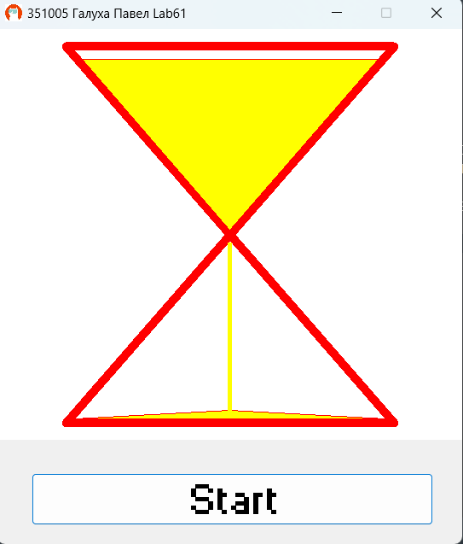

**Блок-схема**

