**The Hamming Code – Lab Work**

**Introduction**

In this lab session, we aim to understand error detection and correction through the usage of the Hamming code and to develop/correct an application on this topic.

For a short definition, the Hamming code is a set of error-correction algorithms that can be used to detect and correct the errors that can occur when data is moved or stored from the sender to the receiver. It is a great technique to use because of its simplicity and efficiency and it does not require a lot of resources, making it ideal for usage in low-power and low-bandwidth communication networks.

**Method**

In this section, I will go over the Hamming code algorithm and I will try to explain it together with the problem-solving part of the assignment. The Hamming code is done for 4 bit numbers and 8 bit numbers.

Firstly, I had to create the encoder functions for the 4 bit and the 8 bit cases:

For the 4 bits case, we calculate the parity bits c1, c2 and c4 based on specific combinations and for the 8 bits case we calculate the parity bits c1, c1, c4 and c8 using their combinations.

We also need to modify the code in the hamming.js file (server folder) for both 4 bits and 8 bits cases in this way:  
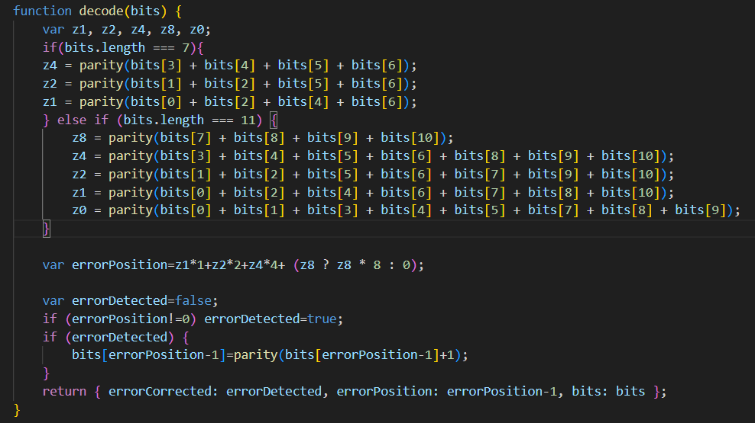

Lastly, we need to modify the index.HTML file in this way:  
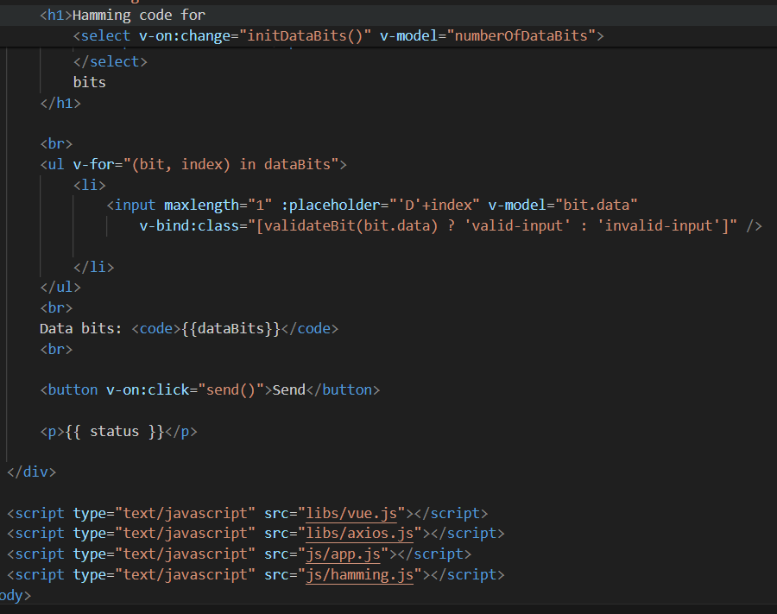

**Results**

Unfortunately, my code is not working and it’s not showing any output (dunno why). I hope I will be able to fix this tomorrow at the lab.

**Analysis**

* Hamming Distance is the distance given by the number of positions for which 2 vectors are different and indicates the number of errors that transform one vector into another.
* Using double error detection Hamming code allows us to only correct one error.
* Parity bit, also known as control bit, is a bit noted with C0 and added at the beginning of the code word V in order to help with the correction of single errors and the detection double errors