1.Write a Java program to create a class called Employee with methods called work() and getSalary(). Create a subclass called HRManager that overrides the work() method and adds a new method called addEmployee().

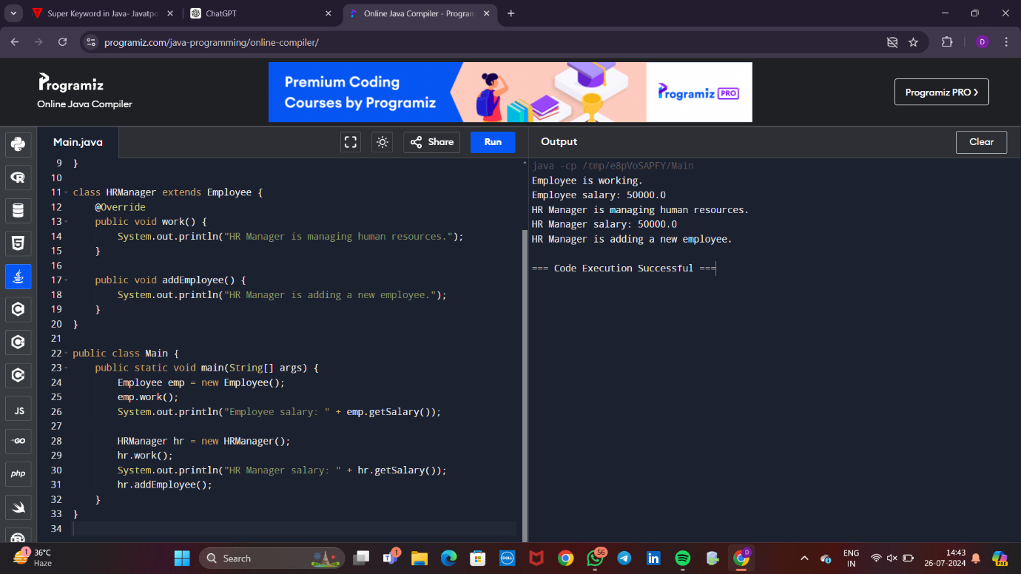

2.Write a Java program to create a vehicle class hierarchy. The base class should be Vehicle, with subclasses Truck, Car and Motorcycle. Each subclass should have properties such as make, model, year, and fuel type. Implement methods for calculating fuel efficiency, distance traveled, and maximum speed.

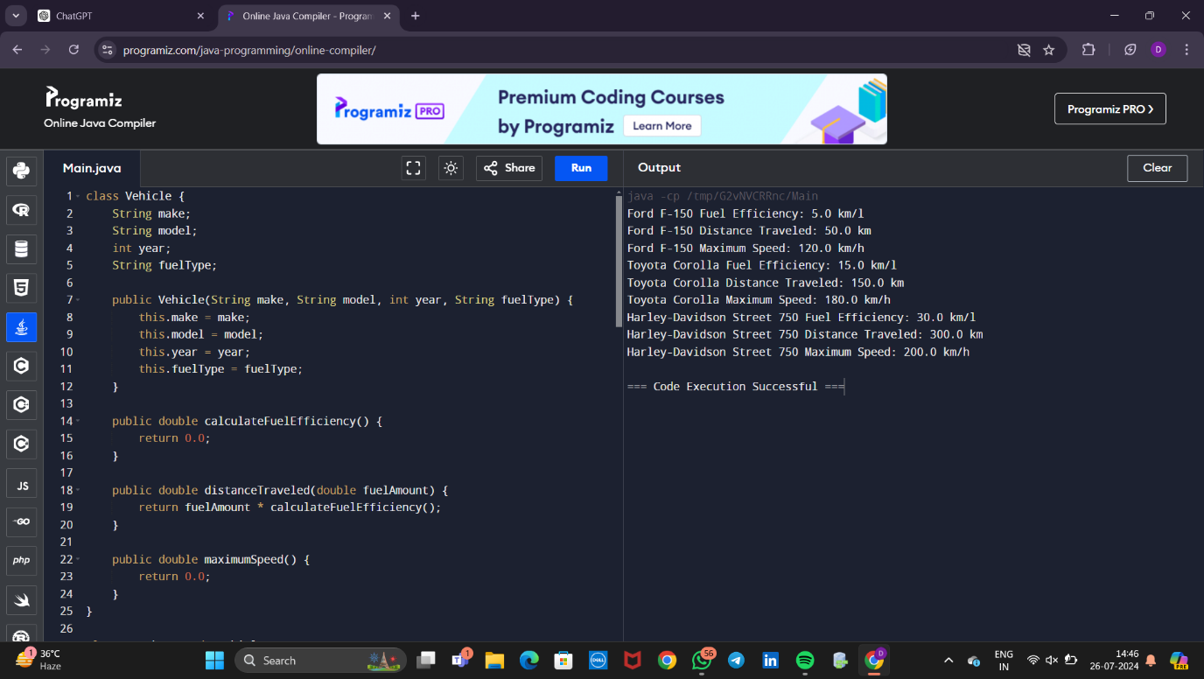

3.Write a Java program that creates a class hierarchy for employees of a company. The base class should be Employee, with subclasses Manager, Developer, and Programmer. Each subclass should have properties such as name, address, salary, and job title. Implement methods for calculating bonuses, generating performance reports, and managing projects.

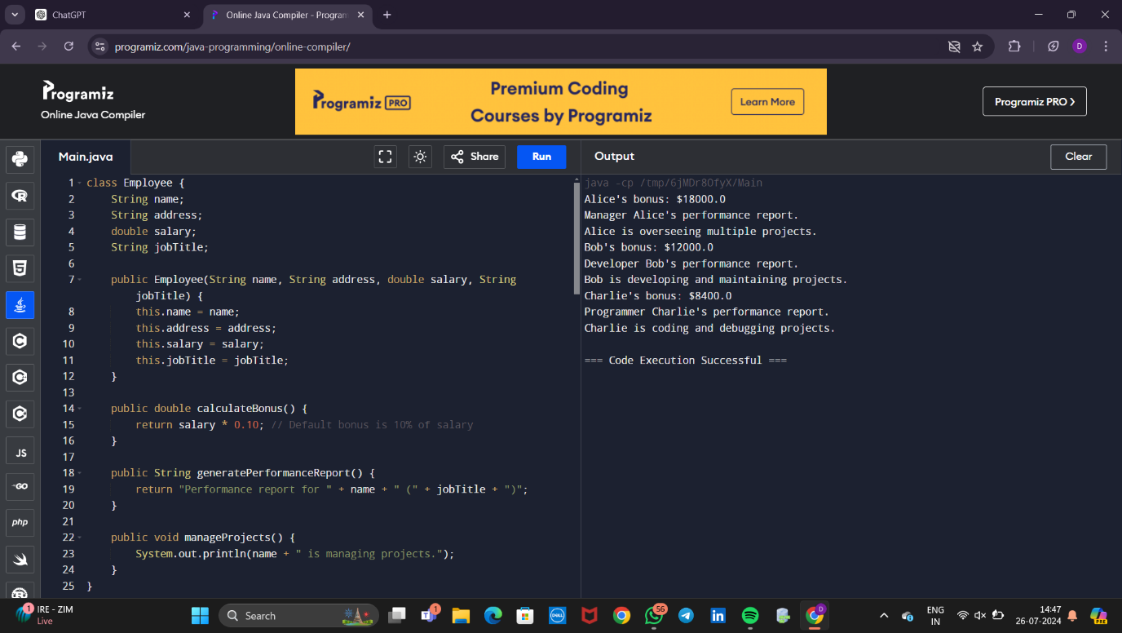

4. Write a Java program to create an abstract class Shape with abstract methods calculateArea() and calculatePerimeter(). Create subclasses Circle and Triangle that extend the Shape class and implement the respective methods to calculate the area and perimeter of each shape

