**Setup and Requirements**

**Qwiklabs setup**

**Before you click the Start Lab button**

Read these instructions. Labs are timed and you cannot pause them. The timer, which starts when you click **Start Lab**, shows how long Google Cloud resources will be made available to you.

This Qwiklabs hands-on lab lets you do the lab activities yourself in a real cloud environment, not in a simulation or demo environment. It does so by giving you new, temporary credentials that you use to sign in and access Google Cloud for the duration of the lab.

**What you need**

To complete this lab, you need:

* Access to a standard internet browser (Chrome browser recommended).
* Time to complete the lab.

**Note:** If you already have your own personal Google Cloud account or project, do not use it for this lab.

**Note:** If you are using a Pixelbook, open an Incognito window to run this lab.

**Cloud Console**

**How to start your lab and sign in to the Google Cloud Console**

1. Click the **Start Lab** button. If you need to pay for the lab, a pop-up opens for you to select your payment method. On the left is a panel populated with the temporary credentials that you must use for this lab.

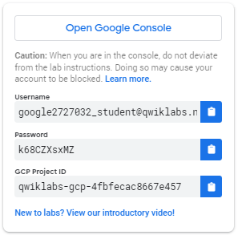

1. Copy the username, and then click **Open Google Console**. The lab spins up resources, and then opens another tab that shows the **Sign in** page.

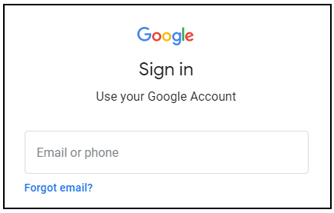

***Tip:*** Open the tabs in separate windows, side-by-side.

If you see the **Choose an account** page, click **Use Another Account**. 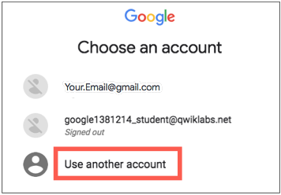

1. In the **Sign in** page, paste the username that you copied from the Connection Details panel. Then copy and paste the password.

***Important:*** You must use the credentials from the Connection Details panel. Do not use your Qwiklabs credentials. If you have your own Google Cloud account, do not use it for this lab (avoids incurring charges).

1. Click through the subsequent pages:
   * Accept the terms and conditions.
   * Do not add recovery options or two-factor authentication (because this is a temporary account).
   * Do not sign up for free trials.

After a few moments, the Cloud Console opens in this tab.

**Note:** You can view the menu with a list of Google Cloud Products and Services by clicking the **Navigation menu** at the top-left. 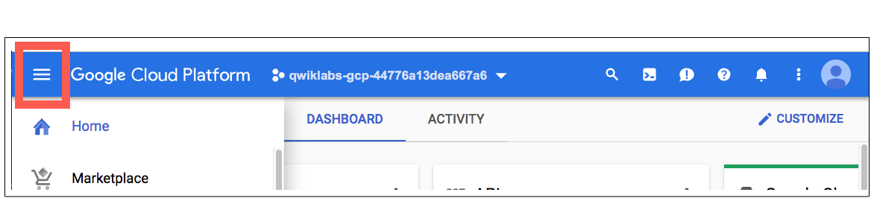

**Cloud Shell**

Activate Cloud Shell

Cloud Shell is a virtual machine that is loaded with development tools. It offers a persistent 5GB home directory and runs on the Google Cloud. Cloud Shell provides command-line access to your Google Cloud resources.

In the Cloud Console, in the top right toolbar, click the **Activate Cloud Shell** button.

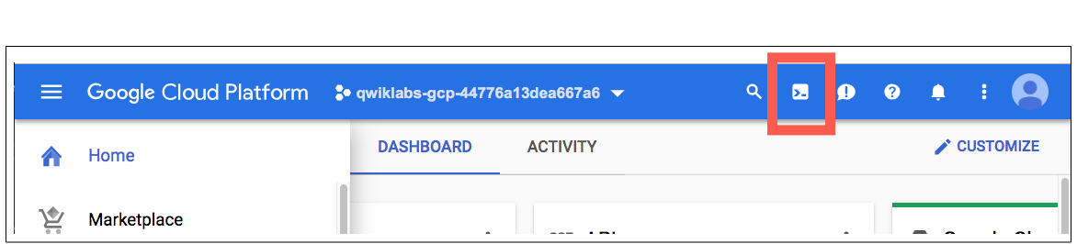

Click **Continue**.

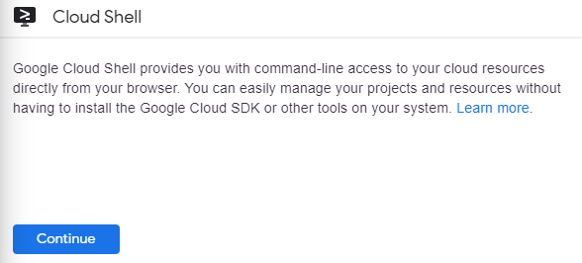

It takes a few moments to provision and connect to the environment. When you are connected, you are already authenticated, and the project is set to your *PROJECT_ID*. For example:

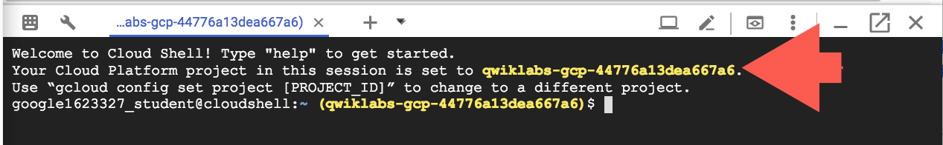

gcloud is the command-line tool for Google Cloud. It comes pre-installed on Cloud Shell and supports tab-completion.

You can list the active account name with this command:

gcloud auth list

(Output)

Credentialed accounts:

- <myaccount>@<mydomain>.com (active)

(Example output)

Credentialed accounts:

- google1623327_student@qwiklabs.net

You can list the project ID with this command:

gcloud config list project

(Output)

[core]

project = <project_ID>

(Example output)

[core]

project = qwiklabs-gcp-44776a13dea667a6

For full documentation of gcloud see the [gcloud command-line tool overview](https://cloud.google.com/sdk/gcloud).

**Create an API Key**

First, you will set an environment variable with your PROJECT_ID which you will use throughout this codelab:

export GOOGLE_CLOUD_PROJECT=$(gcloud config get-value core/project)

Next, create a new service account to access the Natural Language API:

gcloud iam service-accounts create my-natlang-sa \

--display-name "my natural language service account"

Then, create credentials to log in as your new service account. Create these credentials and save it as a JSON file "~/key.json" by using the following command:

gcloud iam service-accounts keys create ~/key.json \

--iam-account my-natlang-sa@${GOOGLE_CLOUD_PROJECT}.iam.gserviceaccount.com

Finally, set the GOOGLE_APPLICATION_CREDENTIALS environment variable. The environment variable should be set to the full path of the credentials JSON file you created, which you can see in the output from the previous command:

export GOOGLE_APPLICATION_CREDENTIALS="/home/USER/key.json"

Create an API Key

Check my progress

**Make an Entity Analysis Request**

In order to perform next steps please connect to the instance provisioned for you via ssh. Open the navigation menu and select **Compute Engine**. You should see the following provisioned linux instance:

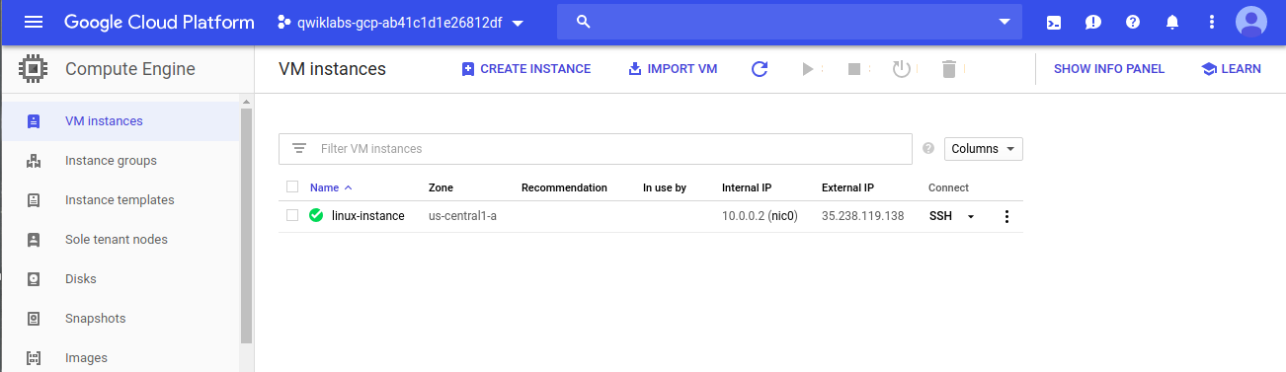

Click on the SSH button. You will be brought to an interactive shell. **Remain in this SSH session for the rest of the lab.**

Now you'll try out the Natural Language API's entity analysis with the following sentence:

*Michelangelo Caravaggio, Italian painter, is known for 'The Calling of Saint Matthew'*

Run the following gcloud command:

gcloud ml language analyze-entities --content="Michelangelo Caravaggio, Italian painter, is known for 'The Calling of Saint Matthew'." > result.json

Make an Entity Analysis Request

Check my progress

Run the below command to preview the output of result.json file.

cat result.json

You should see a response similar to the following in the result.json file:

{

"entities": [

{

"name": "Michelangelo Caravaggio",

"type": "PERSON",

"metadata": {

"wikipedia_url": "http://en.wikipedia.org/wiki/Caravaggio",

"mid": "/m/020bg"

},

"salience": 0.83047235,

"mentions": [

{

"text": {

"content": "Michelangelo Caravaggio",

"beginOffset": 0

},

"type": "PROPER"

},

{

"text": {

"content": "painter",

"beginOffset": 33

},

"type": "COMMON"

}

]

},

{

"name": "Italian",

"type": "LOCATION",

"metadata": {

"mid": "/m/03rjj",

"wikipedia_url": "http://en.wikipedia.org/wiki/Italy"

},

"salience": 0.13870546,

"mentions": [

{

"text": {

"content": "Italian",

"beginOffset": 25

},

"type": "PROPER"

}

]

},

{

"name": "The Calling of Saint Matthew",

"type": "EVENT",

"metadata": {

"mid": "/m/085_p7",

"wikipedia_url": "http://en.wikipedia.org/wiki/The_Calling_of_St_Matthew_(Caravaggio)"

},

"salience": 0.030822212,

"mentions": [

{

"text": {

"content": "The Calling of Saint Matthew",

"beginOffset": 69

},

"type": "PROPER"

}

]

}

],

"language": "en"

}

Read through your results. For each "entity" in the response, you'll see:

* The entity name and type, a person, location, event, etc.
* metadata, an associated Wikipedia URL if there is one
* salience, and the indices of where this entity appeared in the text. Salience is a number in the [0,1] range that refers to the centrality of the entity to the text as a whole.
* mentions, which is the same entity mentioned in different ways.

You've sent your first request to the Cloud Natural Language API.

**Congratulations!**

 

Finish Your Quest

Continue your Qwiklabs [Baseline: Data, ML, AI](https://google.qwiklabs.com/quests/34) or [Intro to ML: Language Processing](https://google.qwiklabs.com/quests/82) Quest. A Quest is a series of related labs that form a learning path. Completing either Quest earns you the badge above, to recognize your achievement. You can make your badge (or badges) public and link to them in your online resume or social media account. Enroll in either Quest above and get immediate completion credit if you've taken this lab. [See other available Qwiklabs Quests](http://google.qwiklabs.com/catalog).

Next Steps / Learn More

This lab is part of a series of labs called Qwik Starts. These labs are designed to give you a little taste of the many features available with Google Cloud. Search for "Qwik Starts" in the [lab catalog](https://google.qwiklabs.com/catalog) to find the next lab you'd like to take!