**Overview**

In this lab, you will learn how to create a streaming pipeline using one of [Google's Cloud Dataflow templates](https://cloud.google.com/dataflow/docs/templates/provided-templates). More specifically, you will use the Cloud Pub/Sub to BigQuery template, which reads messages written in JSON from a Pub/Sub topic and pushes them to a BigQuery table. You can find the documentation for this template [here](https://cloud.google.com/dataflow/docs/templates/provided-templates#cloudpubsubtobigquery).

You'll be given the option to use the Cloud Shell command line or the Cloud Console to create the BigQuery dataset and table. **Pick one method to use**, then continue with that method for the rest of the lab. If you want experience using both methods, run through this lab a second time.

**Setup**

**Before you click the Start Lab button**

Read these instructions. Labs are timed and you cannot pause them. The timer, which starts when you click **Start Lab**, shows how long Google Cloud resources will be made available to you.

This Qwiklabs hands-on lab lets you do the lab activities yourself in a real cloud environment, not in a simulation or demo environment. It does so by giving you new, temporary credentials that you use to sign in and access Google Cloud for the duration of the lab.

**What you need**

To complete this lab, you need:

* Access to a standard internet browser (Chrome browser recommended).
* Time to complete the lab.

**Note:** If you already have your own personal Google Cloud account or project, do not use it for this lab.

**Note:** If you are using a Pixelbook, open an Incognito window to run this lab.

**How to start your lab and sign in to the Google Cloud Console**

1. Click the **Start Lab** button. If you need to pay for the lab, a pop-up opens for you to select your payment method. On the left is a panel populated with the temporary credentials that you must use for this lab.

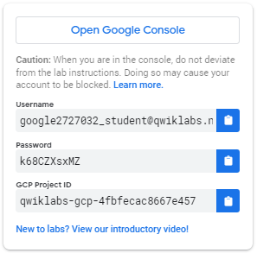

1. Copy the username, and then click **Open Google Console**. The lab spins up resources, and then opens another tab that shows the **Sign in** page.

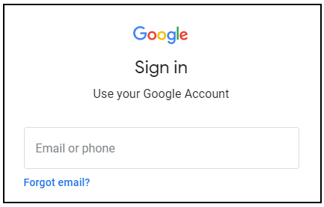

***Tip:*** Open the tabs in separate windows, side-by-side.

If you see the **Choose an account** page, click **Use Another Account**. 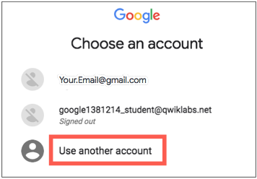

1. In the **Sign in** page, paste the username that you copied from the Connection Details panel. Then copy and paste the password.

***Important:*** You must use the credentials from the Connection Details panel. Do not use your Qwiklabs credentials. If you have your own Google Cloud account, do not use it for this lab (avoids incurring charges).

1. Click through the subsequent pages:
   * Accept the terms and conditions.
   * Do not add recovery options or two-factor authentication (because this is a temporary account).
   * Do not sign up for free trials.

After a few moments, the Cloud Console opens in this tab.

**Note:** You can view the menu with a list of Google Cloud Products and Services by clicking the **Navigation menu** at the top-left. 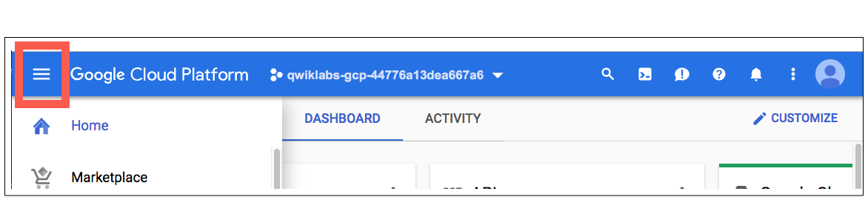

Activate Cloud Shell

Cloud Shell is a virtual machine that is loaded with development tools. It offers a persistent 5GB home directory and runs on the Google Cloud. Cloud Shell provides command-line access to your Google Cloud resources.

In the Cloud Console, in the top right toolbar, click the **Activate Cloud Shell** button.

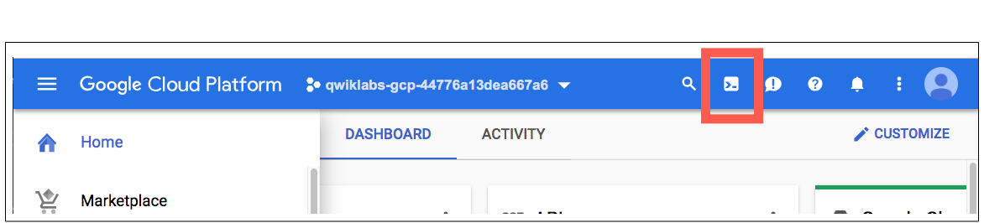

Click **Continue**.

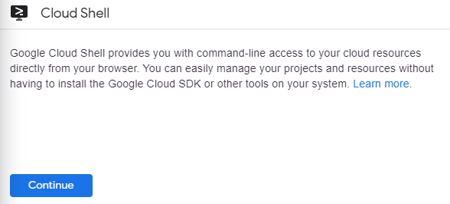

It takes a few moments to provision and connect to the environment. When you are connected, you are already authenticated, and the project is set to your *PROJECT_ID*. For example:

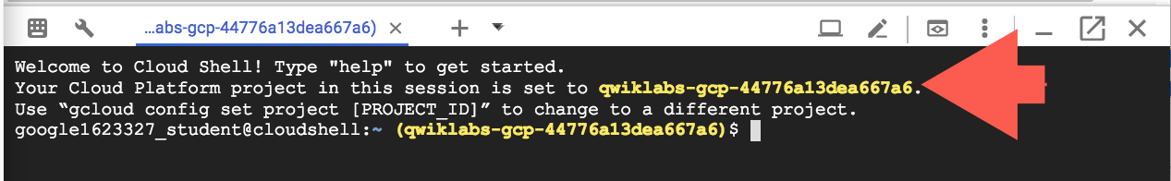

gcloud is the command-line tool for Google Cloud. It comes pre-installed on Cloud Shell and supports tab-completion.

You can list the active account name with this command:

gcloud auth list

(Output)

Credentialed accounts:

- <myaccount>@<mydomain>.com (active)

(Example output)

Credentialed accounts:

- google1623327_student@qwiklabs.net

You can list the project ID with this command:

gcloud config list project

(Output)

[core]

project = <project_ID>

(Example output)

[core]

project = qwiklabs-gcp-44776a13dea667a6

For full documentation of gcloud see the [gcloud command-line tool overview](https://cloud.google.com/sdk/gcloud).

**Create a Cloud BigQuery Dataset and Table Using Cloud Shell**

Let's first create a BigQuery dataset and table.

**Note:**This section uses the bq command-line tool. **Skip down** if you want to run through this lab using the console.

Run the following command to create a dataset called taxirides:

bq mk taxirides

Your output should look similar to:

Dataset '<myprojectid:taxirides>' successfully created

Test Completed Task

Click **Check my progress** to verify your performed task. If you have successfully created BigQuery dataset, you will see an assessment score.

Create a BigQuery Dataset (name: taxirides)

Check my progress

Now that you have your dataset created, you'll use it in the following step to instantiate a BigQuery table. Run the following command to do so:

bq mk \

--time_partitioning_field timestamp \

--schema ride_id:string,point_idx:integer,latitude:float,longitude:float,\

timestamp:timestamp,meter_reading:float,meter_increment:float,ride_status:string,\

passenger_count:integer -t taxirides.realtime

Your output should look similar to:

Table 'myprojectid:taxirides.realtime' successfully created

Test Completed Task

Click **Check my progress** to verify your performed task. If you have successfully created table in BigQuery dataset, you will see an assessment score.

Create a table in BigQuery Dataset

Check my progress

On it's face, the bq mk command looks a bit complicated. However, with some assistance from the [BigQuery command-line documentation](https://cloud.google.com/bigquery/docs/reference/bq-cli-reference), we can break down what's going on here. For example, the documentation tells us a little bit more about **schema**:

* "Either the path to a local JSON schema file or a comma-separated list of column definitions in the form [FIELD]:[DATA_TYPE], [FIELD]:[DATA_TYPE].

In this case, we are using the latter—a comma-separated list.

**Create a storage bucket**

Now that we have our table instantiated, let's create a bucket. Run the following commands to do so:

export BUCKET_NAME=<your-unique-name>

gsutil mb gs://$BUCKET_NAME/

Test Completed Task

Click **Check my progress** to verify your performed task. If you have successfully created Cloud Storage bucket, you will see an assessment score.

Create a storage bucket

Check my progress

It doesn't look like you've completed this step yet. Try again.

Once you've made your bucket, **scroll down to the "Run the Pipeline" section** .

**Create a Cloud BigQuery Dataset and Table Using the Cloud Console**

**Note:**Don't go through this section if you've done the command-line setup!

From the left-hand menu, in the Big Data section, click on **BigQuery**.

Click on your project name in the left-hand navigation, then click **CREATE DATASET** on the right-hand side of the console. Input taxirides as your dataset ID:

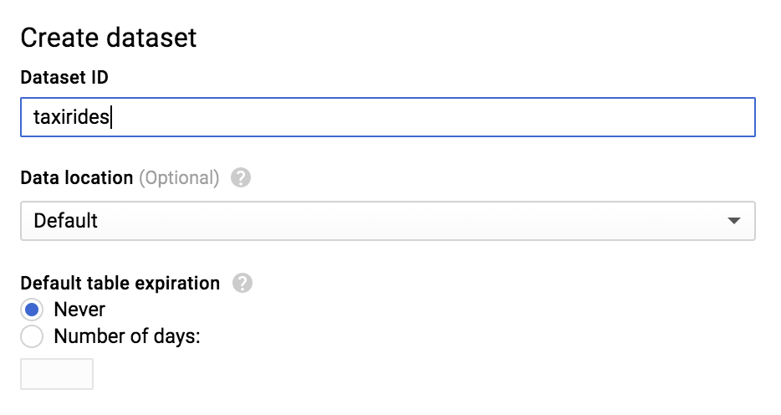

Leave all of the other default settings in place and click **Create dataset**.

Test Completed Task

Click **Check my progress** to verify your performed task. If you have successfully created BigQuery dataset, you will see an assessment score.

Create a BigQuery Dataset (name: taxirides)

Check my progress

You should now see the taxirides dataset underneath your project ID in the left-hand console—click on it and then select **CREATE TABLE** in the right-hand side of the console.

In the **Destination table** input, enter realtime.

Under Schema, toggle the **Edit as text** slider and enter the following:

ride_id:string,point_idx:integer,latitude:float,longitude:float,timestamp:timestamp,

meter_reading:float,meter_increment:float,ride_status:string,passenger_count:integer

Your console should look like the following:

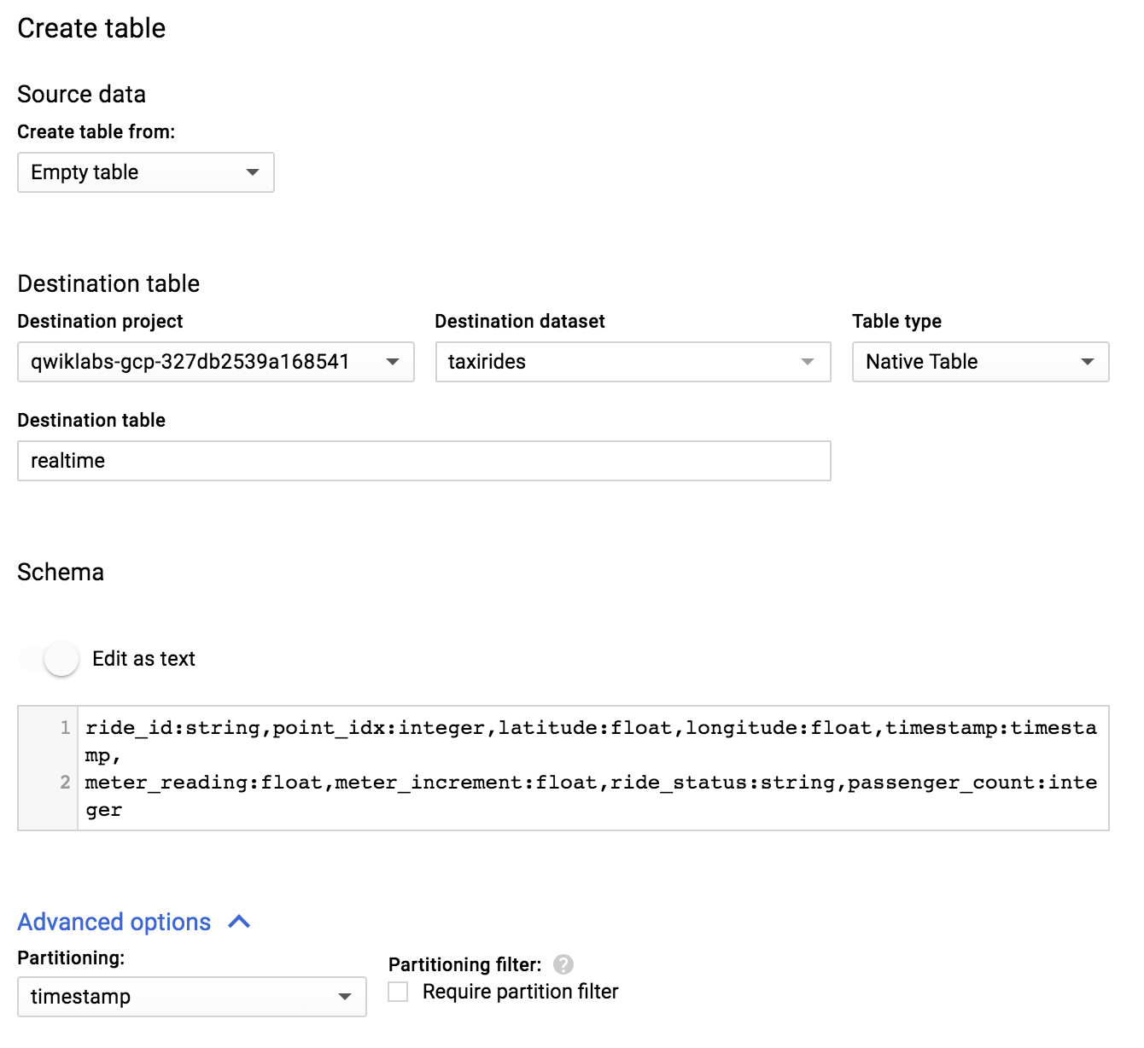

Now, click **Create table**.

Test Completed Task

Click **Check my progress** to verify your performed task. If you have successfully created table in BigQuery dataset, you will see an assessment score.

Create a table in BigQuery Dataset

Check my progress

**Create a storage bucket**

Go back to the Cloud Console and navigate to **Storage** > **Browser** > **Create bucket**:

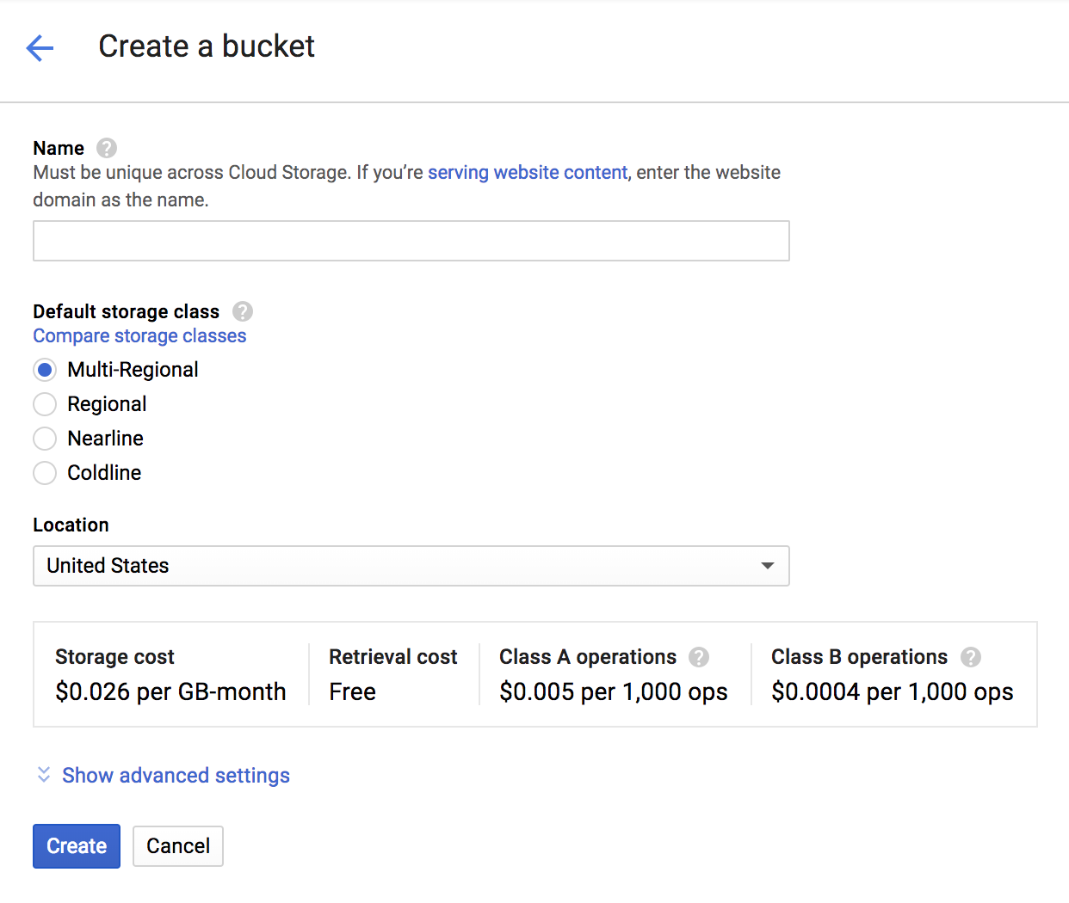

Give your bucket a unique name. Leave all other default settings, then click **Create**.

Test Completed Task

Click **Check my progress** to verify your performed task. If you have successfully created Cloud Storage bucket, you will see an assessment score.

Create a storage bucket

Check my progress

**Run the Pipeline**

From the **Navigation menu** find the Big Data section and click on **Dataflow**.

Click on **+ Create job from template** at the top of the screen.

Enter a **Job name** for your Cloud Dataflow job.

Under **Cloud Dataflow Template**, select the *Cloud Pub/Sub Topic to BigQuery* template.

Under **Cloud Pub/Sub input topic**, enter:

projects/pubsub-public-data/topics/taxirides-realtime

Under **BigQuery output table**, enter the name of the table that was created:

<myprojectid>:taxirides.realtime

Add your bucket as **Temporary Location**:

gs://Your_Bucket_Name/temp

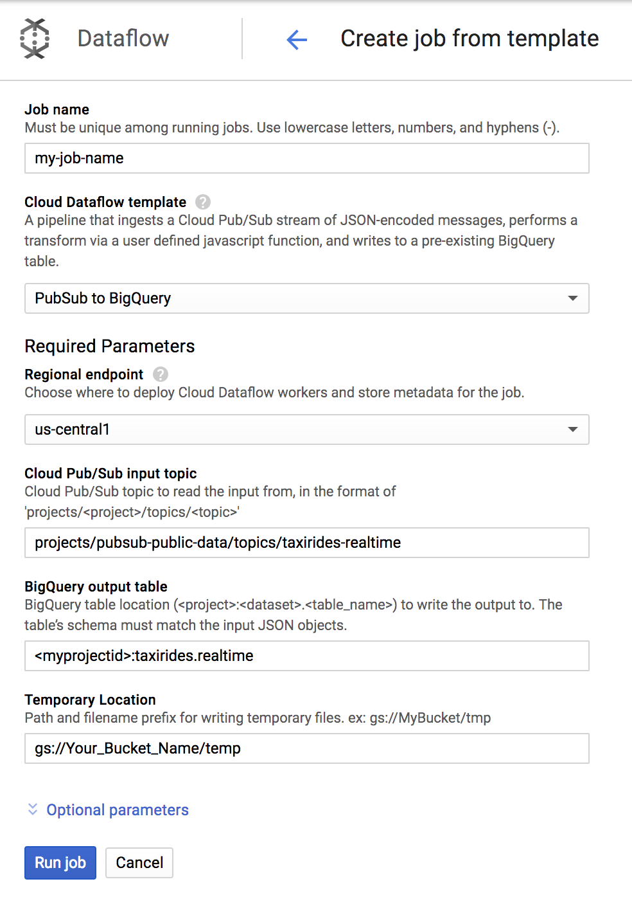

Click the **Run job** button.

Test Completed Task

Click **Check my progress** to verify your performed task. If you have successfully run the Dataflow pipeline, you will see an assessment score.

Run the Pipeline.

Check my progress

You'll watch your resources build and become ready for use.

Now, let's go view the data written to BigQuery by clicking on **BigQuery** found in the Navigation menu.

When the BigQuery UI opens, you'll see the **taxirides** table added under your project name and **realtime** underneath that:

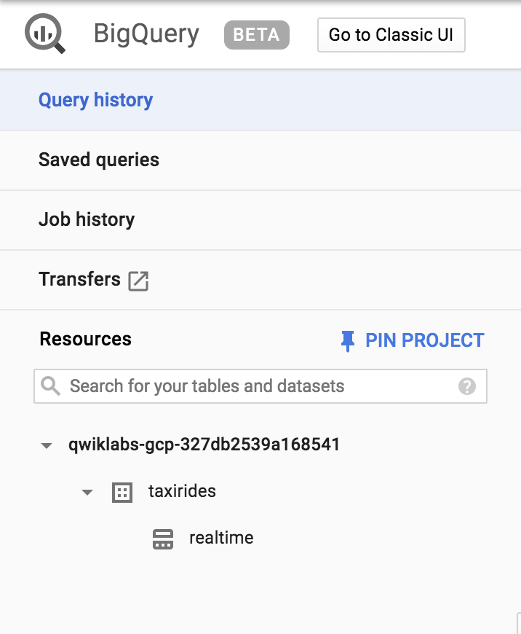

**Submit a query**

You can submit queries using standard SQL.

In the "Query editor" field add the following, replacing *myprojectid* with the Project ID from the Qwiklabs page:

SELECT * FROM `myprojectid.taxirides.realtime` LIMIT 1000

Now click **Run Query**.

If you run into any issues or errors, run the query again (the pipeline takes a minute to start up.)

When the query runs successfully, you'll see the output in the "Query Results" panel as shown below:

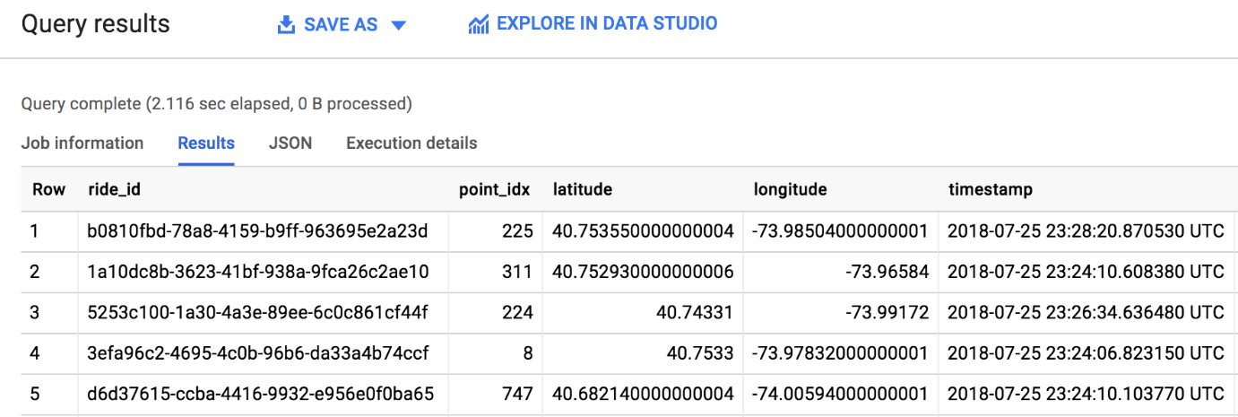

Great work! You just pulled 1000 taxi rides from a Pub/Sub topic and pushed them to a BigQuery table. As you saw firsthand, templates are a practical, easy-to-use way to run Dataflow jobs. Be sure to check out some other Google Templates [here](https://cloud.google.com/dataflow/docs/templates/provided-templates).

**Test your Understanding**

Below are a multiple choice questions to reinforce your understanding of this lab's concepts. Answer them to the best of your abilities.

Google Cloud Dataflow supports batch processing.



True



False

Which Dataflow Template used in the lab to run the pipeline?



Pub/Sub to BigQuery



Bulk Compress Cloud Storage Files



Cloud Storage Text to BigQuery

Submit

**Congratulations!**



Finish Your Quest

Continue your Quest with [Baseline: Data, ML, AI](https://google.qwiklabs.com/quests/34). A Quest is a series of related labs that form a learning path. Completing this Quest earns you the badge above, to recognize your achievement. You can make your badge (or badges) public and link to them in your online resume or social media account. [Enroll in this Quest](https://google.qwiklabs.com/learning_paths/34/enroll) and get immediate completion credit if you've taken this lab. [See other available Qwiklabs Quests](http://google.qwiklabs.com/catalog).

Next Steps / Learn More

This lab is part of a series of labs called Qwik Starts. These labs are designed to give you a little taste of the many features available with Google Cloud. Search for "Qwik Starts" in the [lab catalog](https://google.qwiklabs.com/catalog) to find the next lab you'd like to take!