**Open BigQuery**

The BigQuery console provides an interface to query tables, including [public datasets](https://cloud.google.com/bigquery/public-data) offered by BigQuery. The query you will run accesses a table from a public dataset that BigQuery provides. It uses standard query language to search the dataset, and limits the results returned to 10.

Open BigQuery Console

In the Google Cloud Console, select **Navigation menu** > **BigQuery**:

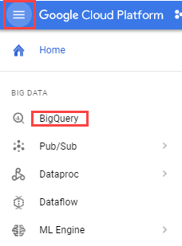

The **Welcome to BigQuery in the Cloud Console** message box opens. This message box provides a link to the quickstart guide and the release notes.

Click **Done**.

The BigQuery console opens.

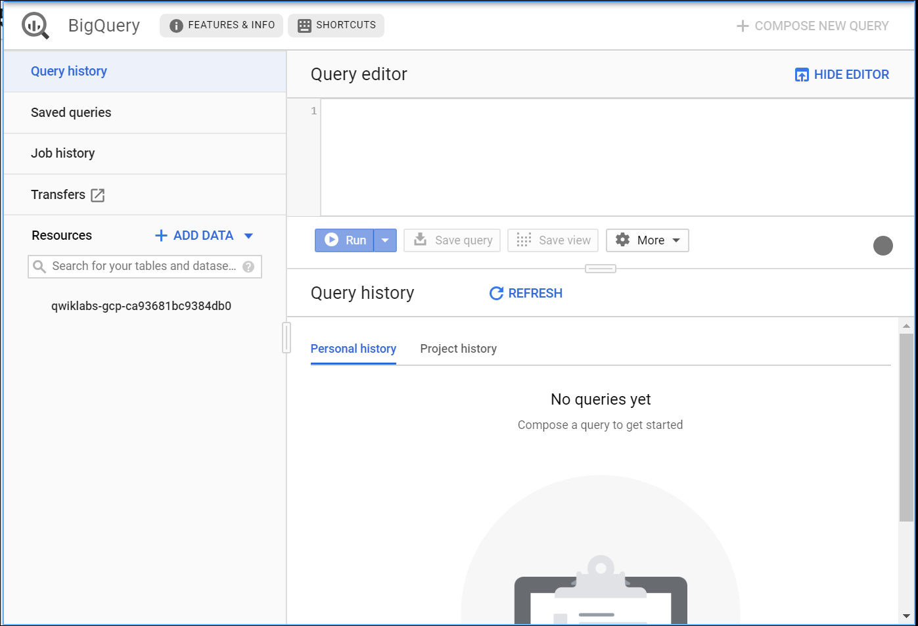

**Query a public dataset**

1. Copy and paste the following query into the BigQuery Query editor,:

#standardSQL

SELECT

weight_pounds, state, year, gestation_weeks

FROM

`bigquery-public-data.samples.natality`

ORDER BY weight_pounds DESC LIMIT 10;

This data sample holds information about US natality (birth rates).

A green or red check displays depending on whether the query is valid or invalid. If the query is valid, the validator also describes the amount of data to be processed after you run the query.

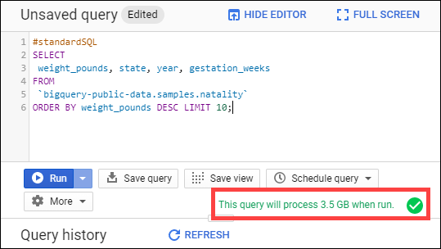

This information helps determine the cost to run a query.

1. Click the **Run** button.

Your query results should resemble the following:

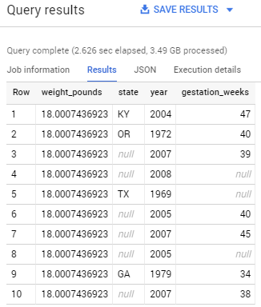

Test Completed Task

Click **Check my progress** to verify your performed task. If you have successfully query against public dataset, you'll see an assessment score.

Query a public dataset (dataset: samples, table: natality)

Check my progress

You can browse the schema of other public datasets in BigQuery by clicking **+ ADD DATA** > **Explore pubic datasets**, then search for "bigquery public data" in the Search field.

**Load custom data into a table**

To load custom data into a table, you perform the following tasks:

* Create a dataset
* Create a table
* Add data to your project (to a storage bucket)
* Load the data from the bucket to the table you created

Create a dataset

Datasets help control access to tables and views in a project. This lab uses only one table, but you still need a dataset to hold the table.

1. In the left pane, click your project name in the **Resources** navigation, then click **Create Dataset**. You may have to widen your browser window to see the **Create Dataset** option.

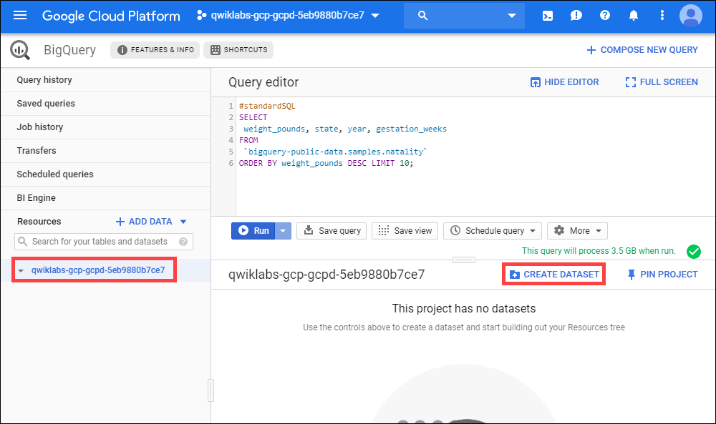

1. Set **Dataset ID** to **babynames**.
2. Leave all other fields at their default settings. Click **Create dataset**.

Now you have a dataset.

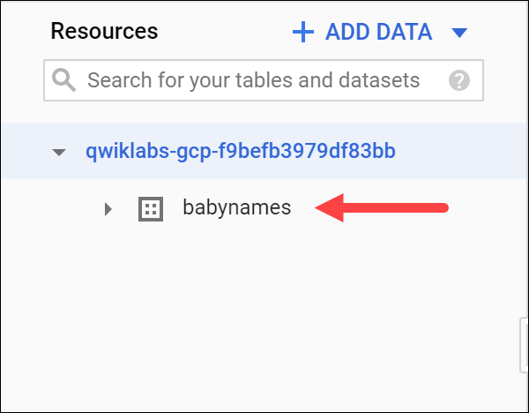

Test Completed Task

Click **Check my progress** to verify your performed task. If you have successfully created BigQuery dataset, you'll see an assessment score.

Create a new dataset

Check my progress

**Add custom data**

The custom data file you'll use contains approximately 7 MB of data about popular baby names, provided by the US Social Security Administration. You'll add the zip file to your project then create a storage bucket for the specific file that you'll need to query against.

In Cloud Shell, run the following commands to add the data files to your project:

gsutil cp gs://spls/gsp072/baby-names.zip .

unzip baby-names.zip

**Create a Cloud Storage bucket**

Now create a Cloud Storage bucket to hold the data files you downloaded.

1. In the Cloud Console, select **Navigation menu** > **Storage** > **Browser**, and then click **Create bucket**.
2. Give your bucket a [universally unique name](https://cloud.google.com/storage/docs/naming), then click **Create**.

Test Completed Task

Click **Check my progress** to verify your performed task. If you have successfully created a storage bucket, you'll see an assessment score.

Create a bucket

Check my progress

1. In Cloud Shell, run the following to move file yob2014.txt into your bucket. Replace <your_bucket> with the name of the bucket you just created:

gsutil cp yob2014.txt gs://<your_bucket>

Test Completed Task

Click **Check my progress** to verify your performed task. If you have successfully uploaded object in cloud storage bucket, you'll see an assessment score.

Copy file in your bucket

Check my progress

Now you can tell BigQuery where to find the data to query against.

**Load the data into a new table**

Next you create a table inside the babynames dataset, then load the data file from your storage bucket into the new table.

1. In the Cloud Console, select **Navigation menu** > **BigQuery** to return to the BigQuery console.
2. Navigate to the **babynames** dataset, then click **Create table**.

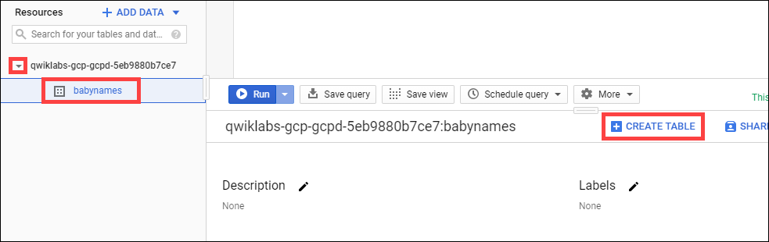

1. In the Create table dialog, set the following fields, leave all others at the default value:

|  |  |
| --- | --- |
| **Field** | **Value** |
| Create table from: | **Google Cloud Storage** |
| Select file from GCS bucket: | <bucket_name>/yob2014.txt, replace <bucket_name> with the name of the bucket you created earlier. |
| File format: | **CSV** |
| Table name | names_2014 |
| **Schema** > Edit as text | Slide on, then add the following in the textbox: name:string,gender:string,count:integer |

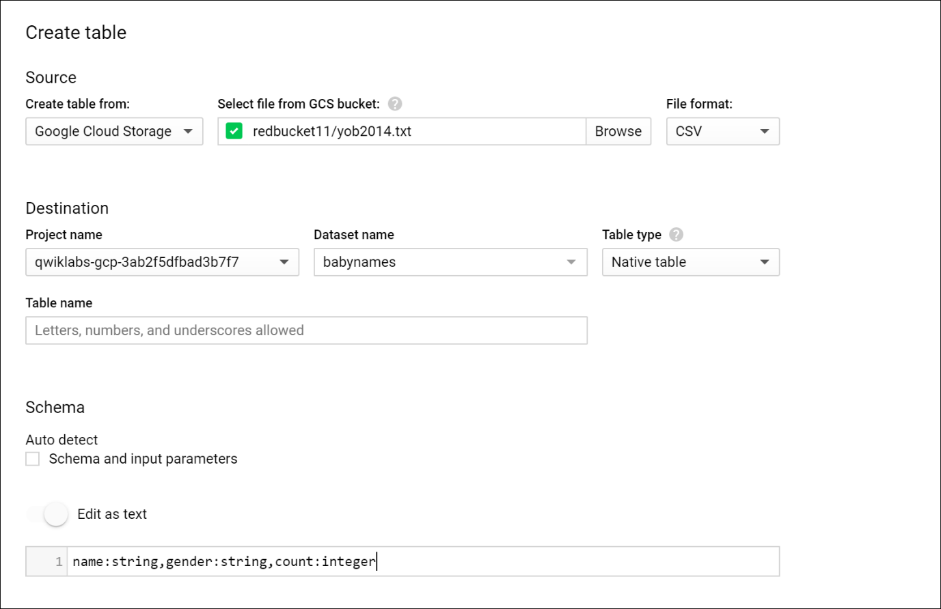

1. Click the **Create Table** button.

When BigQuery is finished creating the table and loading the data, you see the names_2014 table under the babynames dataset.

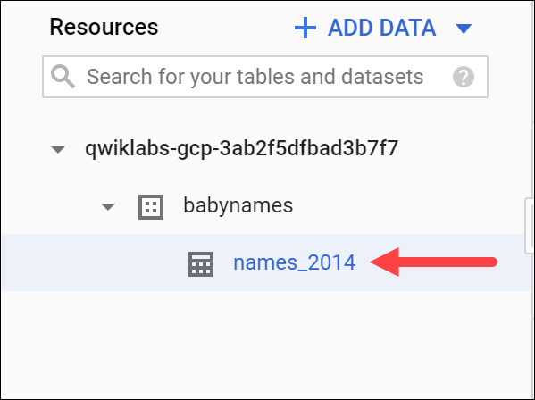

Test Completed Task

Click **Check my progress** to verify your performed task. If you have successfully load data in dataset table, you'll see an assessment score.

Load data into your table

Check my progress

**Test your Understanding**

Below are multiple choice-questions to reinforce your understanding of this lab's concepts. Answer them to the best of your abilities.

BigQuery is fully-managed enterprise data warehouse that enable super-fast SQL queries.

checkTrue



False

**Preview the table**

Check your table! View the first few rows of the data.

Click the names_2014 table in the left-hand menu, then click **Preview**.

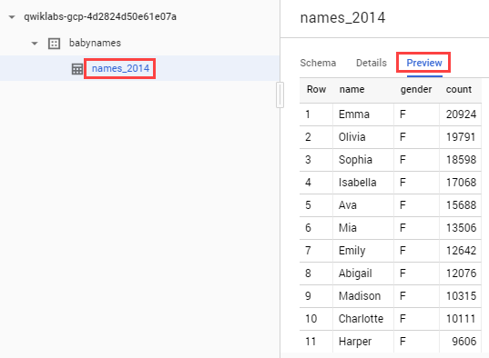

Your table is ready for queries.

**Query a custom dataset**

Running a query against custom data is identical to [querying a public dataset](https://cloud.google.com/bigquery/quickstart-web-ui#query_a_public_dataset) that you did earlier, except that now you're querying your own table instead of a public table.

In BigQuery, click the **Compose New query** button in the top right corner to clear out your previous query.

Paste or type the following query into the **Query editor**.

**Note**: If your table name is something other than **babynames**, update the code with your table name.

#standardSQL

SELECT

name, count

FROM

`babynames.names_2014`

WHERE

gender = 'M'

ORDER BY count DESC LIMIT 5;

Click the **Run** button. The query displays the top 5 boys names for the year of data (2014) you loaded into the table.

Test Completed Task

Click **Check my progress** to verify your performed task. If you have successfully query against custom dataset, you'll see an assessment score.

Query a custom dataset

Check my progress

**Congratulations!**

You used the BigQuery Web UI to query public tables and load sample data into BigQuery.

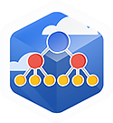

Finish Your Quest

This self-paced lab is part of the Qwiklabs [BigQuery Basics for Data Analysts](https://google.qwiklabs.com/quests/69) Quest. A Quest is a series of related labs that form a learning path. Completing this Quest earns you the badge above, to recognize your achievement. You can make your badge (or badges) public and link to them in your online resume or social media account. Enroll in a Quest and get immediate completion credit if you've taken this lab. See other available [Qwiklabs Quests](http://google.qwiklabs.com/catalog).

Next Steps / Learn More

This lab is part of a series of labs called Qwik Starts. These labs are designed to give you a little taste of the many features available with Google Cloud. Search for "Qwik Starts" in the [lab catalog](https://google.qwiklabs.com/catalog) to find the next lab you'd like to take!