**Introduction**

Google Apps Script and BigQuery

[Google Apps Script](http://developers.google.com/apps-script) is a G Suite development platform that operates as a higher-level than if you use Google REST APIs. It is a serverless development and application hosting environment that's accessible to a large range of developer skill levels. In one sentence, "Apps Script is a serverless JavaScript runtime for G suite automation, extension, and integration."

It is server-side JavaScript, similar to Node.js, but focuses on tight integration with G Suite and other Google services rather than fast asynchronous event-driven application hosting. It also features a development environment that may be completely different from what you're used to. With Apps Script, you:

* Develop in a browser-based code editor but can choose to develop locally if using [clasp](http://developers.google.com/apps-script/guides/clasp), the command-line deployment tool for Apps Script
* Code in a specialized version of JavaScript customized to access G Suite, and other Google or external services (via the Apps Script [URLfetch](https://developers.google.com/apps-script/reference/url-fetch/) or [Jdbc](https://developers.google.com/apps-script/reference/jdbc/) services)
* Avoid writing authorization code because Apps Script handles it for you
* Do not have to host your app—it lives and runs on Google servers in the cloud

**NOTE**: For more information about Apps Script, see the official documentation, which features an [overview with quickstarts](http://developers.google.com/apps-script/overview), [tutorials](http://developers.google.com/apps-script/articles/tutorials), and [videos](https://developers.google.com/apps-script/guides/videos) as well.

Apps Script interfaces with other Google technologies in two different ways:

* built-in service
* advanced service

A [built-in service](https://developers.google.com/apps-script/guides/services/) provides high-level methods that you can use to access to G Suite or Google product data, or other useful utility methods. An [advanced service](https://developers.google.com/apps-script/guides/services/advanced) is merely a thin wrapper around a G Suite or Google REST API. Advanced services provide full coverage of the REST API and can often do more than the built-in services, but require more code complexity (while still being easier to use than the REST API itself).

Advanced services must also [be enabled for a script project](https://developers.google.com/apps-script/guides/services/advanced#enabling_advanced_services) prior to using them. When possible, a built-in service is preferable because they're easier to use and do more heavy-lifting than advanced services. However, some Google APIs don't have built-in services, so an advanced service may be the only option. [BigQuery](http://cloud.google.com/bigquery) is one example of this; No built-in service is available, but a [BigQuery advanced service](https://developers.google.com/apps-script/advanced/bigquery) *does* exist. (Better than *no* service, right?)

If you're new to BigQuery, it's a Google Cloud service you use to perform simple (or complex) queries on very large data corpuses, say on the order of multiple terabytes, yet still can provide results in seconds, not hours or days.

Accessing Google Sheets & Slides from Apps Script

BigQuery is only available as an Apps Script advanced service. However, both Google Sheets and Slides have built-in Apps Script services as well as advanced services, for example, to access features only found in the API and not available built-in. Whenever possible, choose a built-in service over an advanced equivalent as the built-in service provides higher-level constructs and convenience calls, which simplifies development.

For a review before jumping into the code, see [Sheets service](https://developers.google.com/apps-script/guides/sheets) as well as the [Slides service](https://developers.google.com/apps-script/guides/slides/).

**Query BigQuery and log results to Sheet**

You're going to take a big bite out of this lab with this first task. Once you finish this section, you'll be about halfway done with the entire lab.

In this section you'll perform the following:

* Start a new Google Apps Script project
* Enable access to the BigQuery advanced service
* Go to the development editor and enter the application source code
* Go through the app authorization process (OAuth2)
* Run the application which sends a request to BigQuery
* View a brand new Google Sheet created with the results from BigQuery

Create a new Apps Script project

1. Create a new Apps Script project by going to [script.google.com](http://script.google.com/). There are different [G Suite product lines](http://gsuite.google.com/pricing.html), and how you create a new project differs depending on which version you use. For this lab, click the **Start Scripting** button.

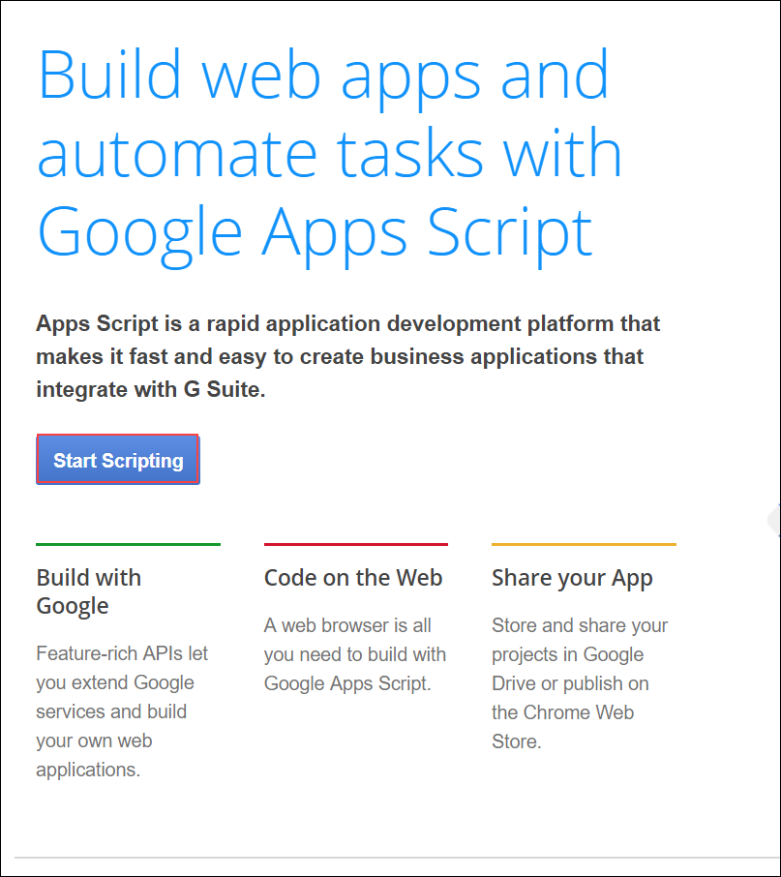

1. Sign in with your Username found in the left panel. Click **Next**.
2. Enter your Password found in the left panel. Click **Next**.
3. Click **Accept** to indicate you understand how this account works and accept Google Terms of Service and Google Privacy Policy.
4. In the **Protect your account** dialog, click **Confirm**.
5. Click **Apps Script**.

The **Apps Script code editor opens**: 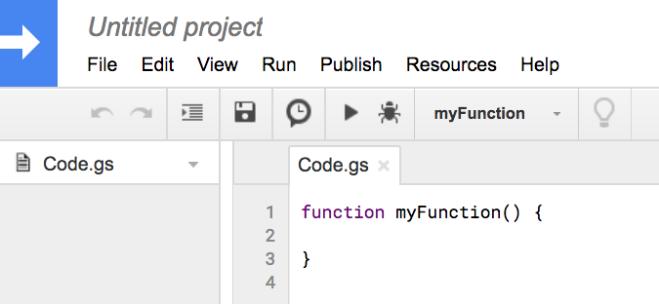

1. Name your project: Click the project name at the top ("Untitled project" in the figure above), and in the Edit project Name dialog, name it whatever you like, "BigQuery, Sheets, Slides demo", "final mile", or whatever suits your fancy. Click **OK**.

Enable the BigQuery advanced service

Enable the BigQuery advanced service for your new project and enable the BigQuery API.

1. Select **Resources** > **Advanced Google Services**.
2. In the Advanced Google Services dialog, click the **Cloud Console Terms of Service**.

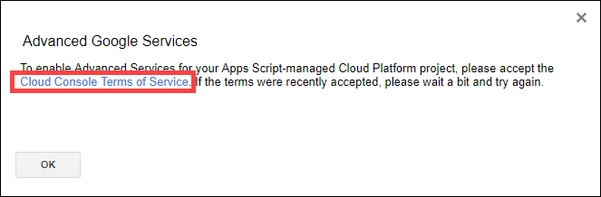

1. Review, click **OK** that you agree to the Cloud Console Terms of Service, and the terms of service of any applicable services and APIs. Click **AGREE AND CONTINUE**.
2. Choose your assigned project and in the left panel, click **Library**.

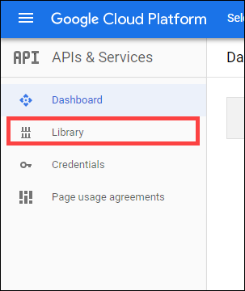

1. Type or paste "BigQuery API" in the search box, then click the **BigQuery API**.

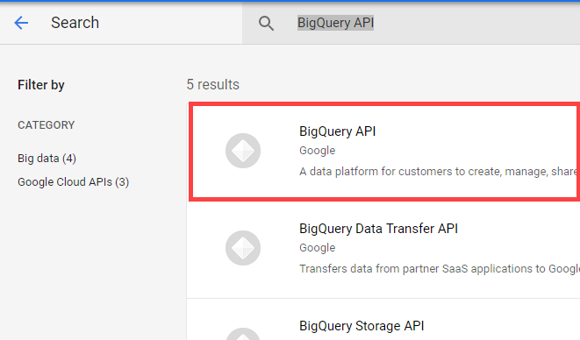

1. Click **Enable** to enable the BigQuery API.

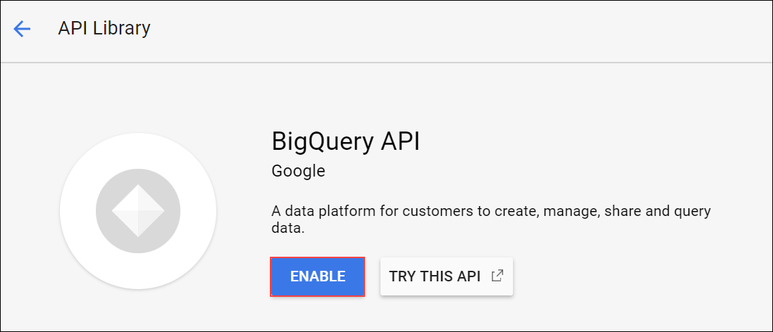

1. Go back to your project, the Advanced Google Services dialog should still be open. Click **OK** to close, and then reselect **Resources** > **Advanced Google Services**.

The Advanced google Services dialog opens.

1. Toggle BigQuery API to **on**, then click **OK** to agree to Terms of Service.

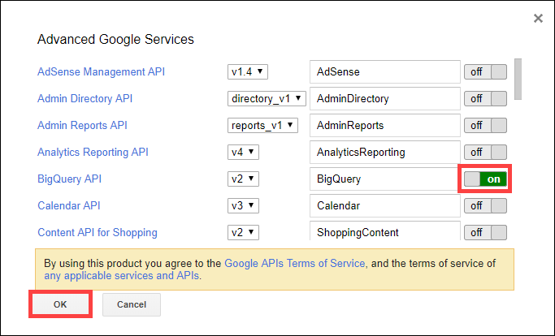

Enter and run your application code

Now you're ready to enter the application code, go through the authorization process, and get the first incarnation of this application working.

1. Copy the code in the box below and paste it over everything in the code editor:

/**

* Copyright 2018 Google LLC

*

* Licensed under the Apache License, Version 2.0 (the "License");

* you may not use this file except in compliance with the License.

* You may obtain a copy of the License at apache.org/licenses/LICENSE-2.0.

*

* Unless required by applicable law or agreed to in writing, software

* distributed under the License is distributed on an "AS IS" BASIS,

* WITHOUT WARRANTIES OR CONDITIONS OF ANY KIND, either express or implied.

* See the License for the specific language governing permissions and

* limitations under the License.

*/

// Filename for data results

var QUERY_NAME = "Most common words in all of Shakespeare's works";

// Replace this value with your Google Cloud API project ID

var PROJECT_ID = '<YOUR_PROJECT_ID>';

if (!PROJECT_ID) throw Error('Project ID is required in setup');

/**

* Runs a BigQuery query; puts results into Sheet. You must enable

* the BigQuery advanced service before you can run this code.

* @see http://developers.google.com/apps-script/advanced/bigquery#run_query

* @see http://github.com/gsuitedevs/apps-script-samples/blob/master/advanced/bigquery.gs

*

* @returns {Spreadsheet} Returns a spreadsheet with BigQuery results

* @see http://developers.google.com/apps-script/reference/spreadsheet/spreadsheet

*/

function runQuery() {

// Replace sample with your own BigQuery query.

var request = {

query:

'SELECT ' +

'LOWER(word) AS word, ' +

'SUM(word_count) AS count ' +

'FROM [bigquery-public-data:samples.shakespeare] ' +

'GROUP BY word ' +

'ORDER BY count ' +

'DESC LIMIT 10'

};

var queryResults = BigQuery.Jobs.query(request, PROJECT_ID);

var jobId = queryResults.jobReference.jobId;

// Wait for BQ job completion (with exponential backoff).

var sleepTimeMs = 500;

while (!queryResults.jobComplete) {

Utilities.sleep(sleepTimeMs);

sleepTimeMs *= 2;

queryResults = BigQuery.Jobs.getQueryResults(PROJECT_ID, jobId);

}

// Get all results from BigQuery.

var rows = queryResults.rows;

while (queryResults.pageToken) {

queryResults = BigQuery.Jobs.getQueryResults(PROJECT_ID, jobId, {

pageToken: queryResults.pageToken

});

rows = rows.concat(queryResults.rows);

}

// Return null if no data returned.

if (!rows) {

return Logger.log('No rows returned.');

}

// Create the new results spreadsheet.

var spreadsheet = SpreadsheetApp.create(QUERY_NAME);

var sheet = spreadsheet.getActiveSheet();

// Add headers to Sheet.

var headers = queryResults.schema.fields.map(function(field) {

return field.name.toUpperCase();

});

sheet.appendRow(headers);

// Append the results.

var data = new Array(rows.length);

for (var i = 0; i < rows.length; i++) {

var cols = rows[i].f;

data[i] = new Array(cols.length);

for (var j = 0; j < cols.length; j++) {

data[i][j] = cols[j].v;

}

}

// Start storing data in row 2, col 1

var START_ROW = 2; // skip header row

var START_COL = 1;

sheet.getRange(START_ROW, START_COL, rows.length, headers.length).setValues(data);

Logger.log('Results spreadsheet created: %s', spreadsheet.getUrl());

}

1. Save the file you just created: Select **File** > **Save** (or Ctrl+s).
2. Rename the file: click the arrow next to the file name and click **Rename**. In the Rename File dialog, change Code.gs to bq-sheets-slides.gs, then click **OK**.

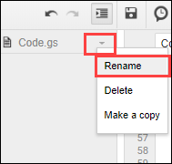

So what does this code do? You know that it queries BigQuery and writes the results into a new Google Sheet, but what is this query?

Look at the query code in the function runQuery():

SELECT

LOWER(word) AS word,

SUM(word_count) AS count

FROM [bigquery-public-data:samples.shakespeare]

GROUP BY word

ORDER BY count

DESC LIMIT 10

This query looks through Shakespeare's works, part of [BigQuery's public data set](https://cloud.google.com/bigquery/sample-tables), and produces the top 10 most frequently-appearing words in all his works, sorted in descending order of popularity. Imagine how (not) fun it would be to do this by hand, and you should have an inkling of an idea of how useful BigQuery is.

1. Almost there! A valid project ID is required to set the PROJECT_ID variable at the top of bq-sheets-slides.gs. Replace <YOUR_PROJECT_ID> with your Project ID found in the left panel.

Here's an example of the code with an example project id. Your actual PROJECT_ID value will be different.

Example code *(do not copy)*

// Filename for data results

var QUERY_NAME = "Most common words in all of Shakespeare's works";

// Replace this value with your Google Cloud API project ID

var PROJECT_ID = 'qwiklabs-gcp-132dd2b9d9e2975a';

if (!PROJECT_ID) throw Error('Project ID is required in setup');

In this code snippet, the **if** statement is there to prevent the application from going any further without a project ID in place.

If the menu selector gets sticky and inoperable, reload the page.

1. Save the file, and run your code by going up to the menu bar and selecting **Run > Run function > runQuery**, then click **Review Permissions**.
2. In the Choose an account from qwiklabs.net dialog, click your **Username** and then click **Allow**.

Once you authorize the app you don't need to repeat this process with each execution. It isn't until you get to section "Put the results data into a slide deck" further on in this LAB that you see this dialog screen again, asking for user permission to create and manage Google Slides presentations.

1. A small message box opens at the top when the function runs.

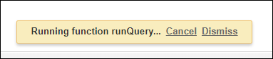

The message box disappears once the function is done, so if you don't see it, the function is probably done running.

1. Go to your [Google Drive](http://drive.google.com/) and look for a new Google Sheet named **Most common words in all of Shakespeare's works** or whatever you assigned to the QUERY_NAME variable: 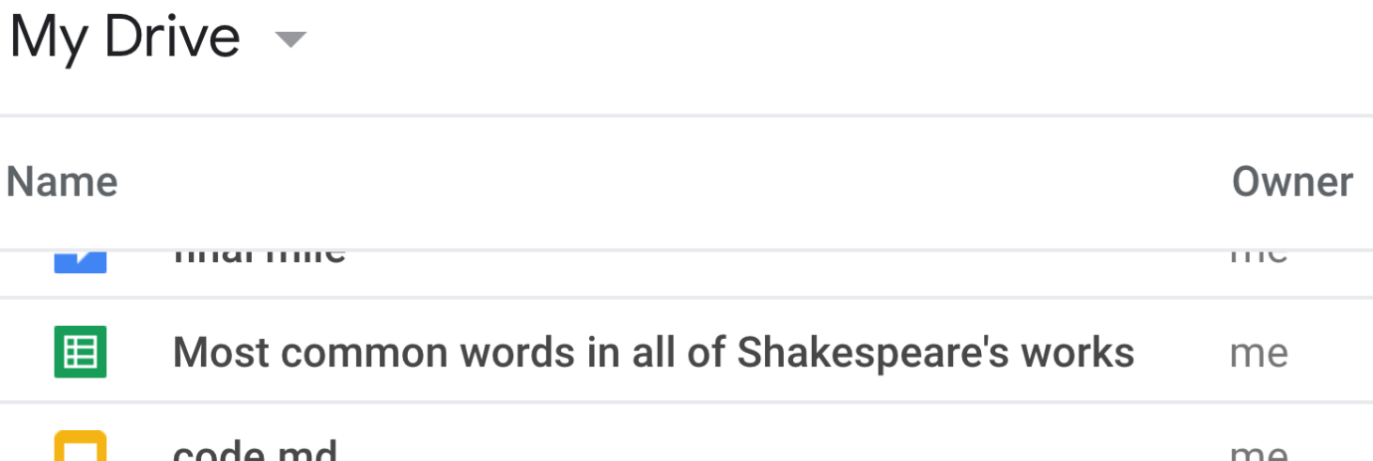

Open the spreadsheet, and you should see 10 rows of words and their total counts sorted in descending order: 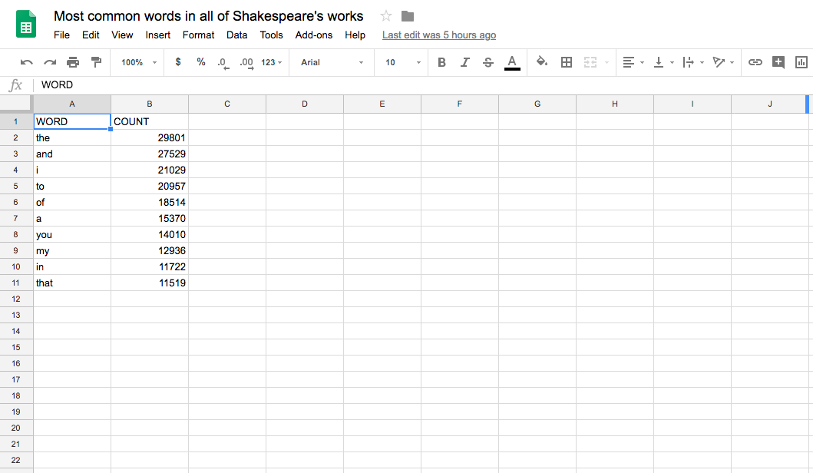

Click *Check my progress* to verify the objective.

Query BigQuery and log results to Sheet

Check my progress

Summary

So what just happened?! You ran code that queried **all** of Shakespeare's works (not a HUGE amount of data, but certainly more text than you can easily scan on your own looking at every word in every play, managing a count of such words, then sorting them in descending order of appearances. Not only did you ask BigQuery to do this on your behalf, but you were able to use the built-in service in Apps Script for Google Sheets to organize the data for easy consumption.

You can always just test the query in the BigQuery console before running it in Apps Script. BigQuery's user interface is available to developers.

1. Go to the Cloud Console and Select **Navigation menu** > **BigQuery**.

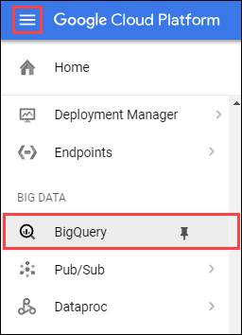

1. Click **DONE** in the Welcome to BigQuery in the Cloud Console dialog.

The BigQuery console opens.

1. Enter your code in the Query editor then click **Run**:

SELECT LOWER(word) AS word, sum(word_count) AS count

FROM `bigquery-public-data.samples.shakespeare`

GROUP BY word ORDER BY count DESC LIMIT 10

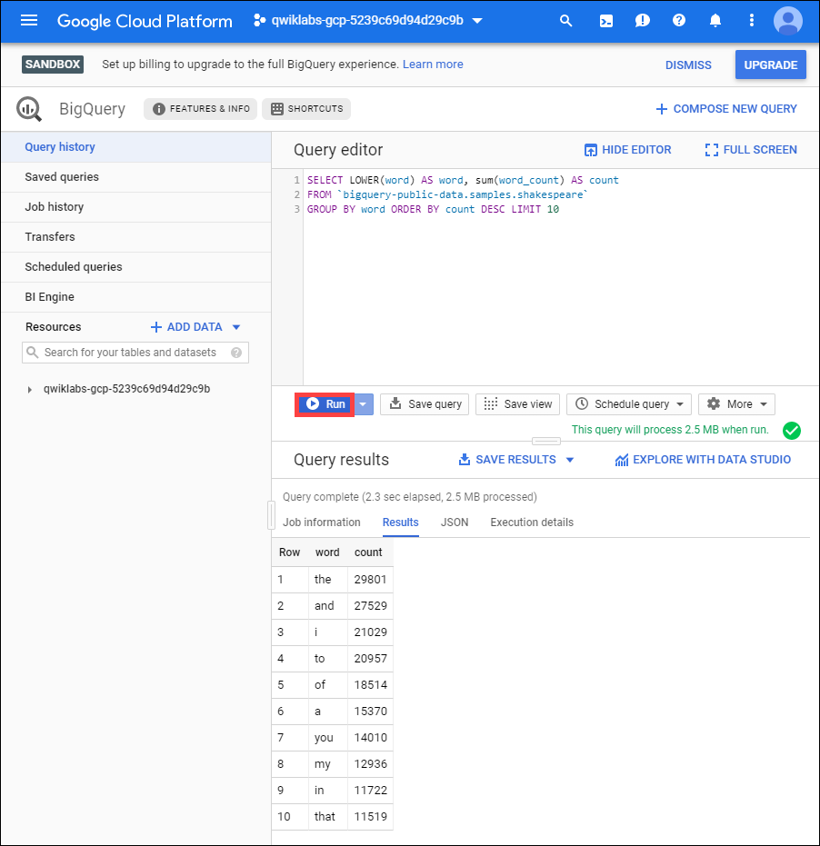

**Create a chart in Google Sheets**

Go back in the Script Editor. So far, you've coded an app that queries Shakespeare's works, sorted, then presented the results in Sheets. In the code, the runQuery() function talks to BigQuery and sends its results into a Sheet. Now you'll add code to chart the data. In this section you make a new function called createColumnChart() that calls the Sheet's newChart() method to chart the data.

The createColumnChart()function gets the sheet with data and requests a columnar chart with all the data. The data range starts at cell A2 because the first row contains the column headers, not data.

1. Create the chart: Add the createColumnChart() function to bq-sheets-slides.gs right after runQuery(). {after the last line of code}

/**

* Uses spreadsheet data to create columnar chart.

* @param {Spreadsheet} Spreadsheet containing results data

* @returns {EmbeddedChart} visualizing the results

* @see http://developers.google.com/apps-script/reference/spreadsheet/embedded-chart

*/

function createColumnChart(spreadsheet) {

// Retrieve the populated (first and only) Sheet.

var sheet = spreadsheet.getSheets()[0];

// Data range in Sheet is from cell A2 to B11

var START_CELL = 'A2'; // skip header row

var END_CELL = 'B11';

// Place chart on Sheet starting on cell E5.

var START_ROW = 5; // row 5

var START_COL = 5; // col E

var OFFSET = 0;

// Create & place chart on the Sheet using above params.

var chart = sheet.newChart()

.setChartType(Charts.ChartType.COLUMN)

.addRange(sheet.getRange(START_CELL + ':' + END_CELL))

.setPosition(START_ROW, START_COL, OFFSET, OFFSET)

.build();

sheet.insertChart(chart);

}

1. Return spreadsheet: In the above code, createColumnChart() needs the spreadsheet object, so tweak app to return spreadsheet object so it can pass it to createColumnChart(). After logging the successful creation of the Google Sheet, return the object at the end of runQuery(). Replace the last line (starts with Logger.log) with the following:

Logger.log('Results spreadsheet created: %s', spreadsheet.getUrl());

// Return the spreadsheet object for later use.

return spreadsheet;

}

1. Drive createBigQueryPresentation() function: Logically segregating the BigQuery and chart-creation functionality is a great idea. Create a createBigQueryPresentation() function to drive the app, calling both and createColumnChart(). The code you add should look like this:

/**

* Runs a BigQuery query, adds data and a chart in a Sheet.

*/

function createBigQueryPresentation() {

var spreadsheet = runQuery();

createColumnChart(spreadsheet);

}

Put the createBigQueryPresentation() function right after this code block:

// Filename for data results

var QUERY_NAME = "Most common words in all of Shakespeare's works";

// Replace this value with your Google Cloud API project ID

var PROJECT_ID = 'project-id-4323960745859879834';

if (!PROJECT_ID) throw Error('Project ID is required in setup');

1. Make code more reusable: You took 2 important steps above: returned the spreadsheet object and created a driving function. What if a colleague wanted to reuse runQuery() and doesn't want the URL logged?

To make runQuery() more digestible for general use, move that log line. The best place to move it? If you guessed createBigQueryPresentation(), you'd be correct!

After moving the log line, it should look like this:

/**

* Runs a BigQuery query, adds data and a chart in a Sheet.

*/

function createBigQueryPresentation() {

var spreadsheet = runQuery();

Logger.log('Results spreadsheet created: %s', spreadsheet.getUrl());

createColumnChart(spreadsheet);

}

With the changes above, your bq-sheets-slides.js should now look like the following (except for PROJECT_ID):

/**

* Copyright 2018 Google LLC

*

* Licensed under the Apache License, Version 2.0 (the "License");

* you may not use this file except in compliance with the License.

* You may obtain a copy of the License at apache.org/licenses/LICENSE-2.0.

*

* Unless required by applicable law or agreed to in writing, software

* distributed under the License is distributed on an "AS IS" BASIS,

* WITHOUT WARRANTIES OR CONDITIONS OF ANY KIND, either express or implied.

* See the License for the specific language governing permissions and

* limitations under the License.

*/

// Filename for data results

var QUERY_NAME = "Most common words in all of Shakespeare's works";

// Replace this value with your Google Cloud API project ID

var PROJECT_ID = 'qwiklabs-gcp-5c0cf6ad321746e4';

if (!PROJECT_ID) throw Error('Project ID is required in setup');

/**

* Runs a BigQuery query, adds data and a chart in a Sheet.

*/

function createBigQueryPresentation() {

var spreadsheet = runQuery();

Logger.log('Results spreadsheet created: %s', spreadsheet.getUrl());

createColumnChart(spreadsheet);

}

/**

* Runs a BigQuery query; puts results into Sheet. You must enable

* the BigQuery advanced service before you can run this code.

* @see http://developers.google.com/apps-script/advanced/bigquery#run_query

* @see http://github.com/gsuitedevs/apps-script-samples/blob/master/advanced/bigquery.gs

*

* @returns {Spreadsheet} Returns a spreadsheet with BigQuery results

* @see http://developers.google.com/apps-script/reference/spreadsheet/spreadsheet

*/

function runQuery() {

// Replace sample with your own BigQuery query.

var request = {

query:

'SELECT ' +

'LOWER(word) AS word, ' +

'SUM(word_count) AS count ' +

'FROM [bigquery-public-data:samples.shakespeare] ' +

'GROUP BY word ' +

'ORDER BY count ' +

'DESC LIMIT 10'

};

var queryResults = BigQuery.Jobs.query(request, PROJECT_ID);

var jobId = queryResults.jobReference.jobId;

// Wait for BQ job completion (with exponential backoff).

var sleepTimeMs = 500;

while (!queryResults.jobComplete) {

Utilities.sleep(sleepTimeMs);

sleepTimeMs *= 2;

queryResults = BigQuery.Jobs.getQueryResults(PROJECT_ID, jobId);

}

// Get all results from BigQuery.

var rows = queryResults.rows;

while (queryResults.pageToken) {

queryResults = BigQuery.Jobs.getQueryResults(PROJECT_ID, jobId, {

pageToken: queryResults.pageToken

});

rows = rows.concat(queryResults.rows);

}

// Return null if no data returned.

if (!rows) {

return Logger.log('No rows returned.');

}

// Create the new results spreadsheet.

var spreadsheet = SpreadsheetApp.create(QUERY_NAME);

var sheet = spreadsheet.getActiveSheet();

// Add headers to Sheet.

var headers = queryResults.schema.fields.map(function(field) {

return field.name.toUpperCase();

});

sheet.appendRow(headers);

// Append the results.

var data = new Array(rows.length);

for (var i = 0; i < rows.length; i++) {

var cols = rows[i].f;

data[i] = new Array(cols.length);

for (var j = 0; j < cols.length; j++) {

data[i][j] = cols[j].v;

}

}

// Start storing data in row 2, col 1

var START_ROW = 2; // skip header row

var START_COL = 1;

sheet.getRange(START_ROW, START_COL, rows.length, headers.length).setValues(data);

Logger.log('Results spreadsheet created: %s', spreadsheet.getUrl());

// Return the spreadsheet object for later use.

return spreadsheet;

}

/**

* Uses spreadsheet data to create columnar chart.

* @param {Spreadsheet} Spreadsheet containing results data

* @returns {EmbeddedChart} visualizing the results

* @see http://developers.google.com/apps-script/reference/spreadsheet/embedded-chart

*/

function createColumnChart(spreadsheet) {

// Retrieve the populated (first and only) Sheet.

var sheet = spreadsheet.getSheets()[0];

// Data range in Sheet is from cell A2 to B11

var START_CELL = 'A2'; // skip header row

var END_CELL = 'B11';

// Place chart on Sheet starting on cell E5.

var START_ROW = 5; // row 5

var START_COL = 5; // col E

var OFFSET = 0;

// Create & place chart on the Sheet using above params.

var chart = sheet.newChart()

.setChartType(Charts.ChartType.COLUMN)

.addRange(sheet.getRange(START_CELL + ':' + END_CELL))

.setPosition(START_ROW, START_COL, OFFSET, OFFSET)

.build();

sheet.insertChart(chart);

}

Save the file, then go up at the top of the code editor and run createBigQueryPresentation() (instead of runQuery()). After running it, you'll get another Google Sheet in your Google Drive, but this time, a chart shows up in the Sheet next to the data:

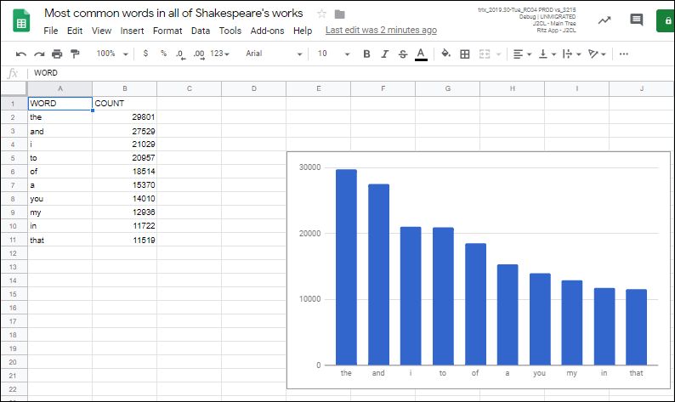

**Put the results data into a slide deck**

The final part of the lab involves creating a new Google Slides presentation, filling the title and subtitle on the title slide, then adding 2 new slides, one for each of the data cells and another for the chart.

1. Create slide deck: Start with the creation of a new slide deck, then add a title and subtitle to the default title slide we get with all new presentations. All of the work on the slide deck takes place in the createSlidePresentation() function, which you add to bq-sheets-slides.gs right after the createColumnChart()function code.

/**

* Create presentation with spreadsheet data & chart

* @param {Spreadsheet} Spreadsheet with results data

* @param {EmbeddedChart} Sheets chart to embed on slide

* @returns {Presentation} Slide deck with results

*/

function createSlidePresentation(spreadsheet, chart) {

// Create the new presentation.

var deck = SlidesApp.create(QUERY_NAME);

// Populate the title slide.

var [title, subtitle] = deck.getSlides()[0].getPageElements();

title.asShape().getText().setText(QUERY_NAME);

subtitle.asShape().getText().setText('via GCP and G Suite APIs:\n' +

'Google Apps Script, BigQuery, Sheets, Slides');

1. Add data table: The next step in createSlidePresentation() is to import the cell data from the Google Sheet into our new slide deck. Add this code snippet to the createSlidePresentation()function:

// Data range to copy is from cell A1 to B11

var START_CELL = 'A1'; // include header row

var END_CELL = 'B11';

// Add the table slide and insert an empty table on it of

// the dimensions of the data range; fails if Sheet empty.

var tableSlide = deck.appendSlide(SlidesApp.PredefinedLayout.BLANK);

var sheetValues = spreadsheet.getSheets()[0].getRange(

START_CELL + ':' + END_CELL).getValues();

var table = tableSlide.insertTable(sheetValues.length, sheetValues[0].length);

// Populate the table with spreadsheet data.

for (var i = 0; i < sheetValues.length; i++) {

for (var j = 0; j < sheetValues[0].length; j++) {

table.getCell(i, j).getText().setText(String(sheetValues[i][j]));

}

}

1. Import chart: The final step in createSlidePresentation() is to create one more slide, import the chart from our spreadsheet, and return the Presentation object. Add this final snippet to the function:

// Add a chart slide and insert the chart on it.

var chartSlide = deck.appendSlide(SlidesApp.PredefinedLayout.BLANK);

chartSlide.insertSheetsChart(chart);

// Return the presentation object for later use.

return deck;

}

1. Return chart: Now that our final function is complete, take another look at its signature. Yes, createSlidePresentation() requires both a spreadsheet and a chart object. We've already adjusted runQuery() to return the Spreadsheet object but now we need to make a similar change to createColumnChart() to return the chart (EmbeddedChart) object. Do that by going back in your application and add one last line at the end of createColumnChart():

// Return chart object for later use

return chart;

}

1. Update createBigQueryPresentation(): Since createColumnChart() returns the chart, you need to save that chart to a variable then pass *both* the spreadsheet and the chart to createSlidePresentation(). Since you log the URL of the newly-created spreadsheet, you can also log the URL of the new slide presentation. Replace this code block

/**

* Runs a BigQuery query, adds data and a chart in a Sheet.

*/

function createBigQueryPresentation() {

var spreadsheet = runQuery();

Logger.log('Results spreadsheet created: %s', spreadsheet.getUrl());

createColumnChart(spreadsheet);

}

With this:

/**

* Runs a BigQuery query, adds data and a chart in a Sheet,

* and adds the data and chart to a new slide presentation.

*/

function createBigQueryPresentation() {

var spreadsheet = runQuery();

Logger.log('Results spreadsheet created: %s', spreadsheet.getUrl());

var chart = createColumnChart(spreadsheet);

var deck = createSlidePresentation(spreadsheet, chart);

Logger.log('Results slide deck created: %s', deck.getUrl());

}

After all updates, your bq-sheets-slides.gs should now look like this, except for the PROJECT_ID.

bq-sheets-slides.gs - final version

// Filename for data results

var QUERY_NAME = "Most common words in all of Shakespeare's works";

// Replace this value with your Google Cloud API project ID

var PROJECT_ID = '<YOUR_PROJECT_ID>';

if (!PROJECT_ID) throw Error('Project ID is required in setup');

/**

* Runs a BigQuery query; puts results into Sheet. You must enable

* the BigQuery advanced service before you can run this code.

* @see http://developers.google.com/apps-script/advanced/bigquery#run_query

* @see http://github.com/gsuitedevs/apps-script-samples/blob/master/advanced/bigquery.gs

*

* @returns {Spreadsheet} Returns a spreadsheet with BigQuery results

* @see http://developers.google.com/apps-script/reference/spreadsheet/spreadsheet

*/

function runQuery() {

// Replace sample with your own BigQuery query.

var request = {

query:

'SELECT ' +

'LOWER(word) AS word, ' +

'SUM(word_count) AS count ' +

'FROM [bigquery-public-data:samples.shakespeare] ' +

'GROUP BY word ' +

'ORDER BY count ' +

'DESC LIMIT 10'

};

var queryResults = BigQuery.Jobs.query(request, PROJECT_ID);

var jobId = queryResults.jobReference.jobId;

// Wait for BQ job completion (with exponential backoff).

var sleepTimeMs = 500;

while (!queryResults.jobComplete) {

Utilities.sleep(sleepTimeMs);

sleepTimeMs *= 2;

queryResults = BigQuery.Jobs.getQueryResults(PROJECT_ID, jobId);

}

// Get all results from BigQuery.

var rows = queryResults.rows;

while (queryResults.pageToken) {

queryResults = BigQuery.Jobs.getQueryResults(PROJECT_ID, jobId, {

pageToken: queryResults.pageToken

});

rows = rows.concat(queryResults.rows);

}

// Return null if no data returned.

if (!rows) {

return Logger.log('No rows returned.');

}

// Create the new results spreadsheet.

var spreadsheet = SpreadsheetApp.create(QUERY_NAME);

var sheet = spreadsheet.getActiveSheet();

// Add headers to Sheet.

var headers = queryResults.schema.fields.map(function(field) {

return field.name.toUpperCase();

});

sheet.appendRow(headers);

// Append the results.

var data = new Array(rows.length);

for (var i = 0; i < rows.length; i++) {

var cols = rows[i].f;

data[i] = new Array(cols.length);

for (var j = 0; j < cols.length; j++) {

data[i][j] = cols[j].v;

}

}

// Start storing data in row 2, col 1

var START_ROW = 2; // skip header row

var START_COL = 1;

sheet.getRange(START_ROW, START_COL, rows.length, headers.length).setValues(data);

// Return the spreadsheet object for later use.

return spreadsheet;

}

/**

* Uses spreadsheet data to create columnar chart.

* @param {Spreadsheet} Spreadsheet containing results data

* @returns {EmbeddedChart} visualizing the results

* @see http://developers.google.com/apps-script/reference/spreadsheet/embedded-chart

*/

function createColumnChart(spreadsheet) {

// Retrieve the populated (first and only) Sheet.

var sheet = spreadsheet.getSheets()[0];

// Data range in Sheet is from cell A2 to B11

var START_CELL = 'A2'; // skip header row

var END_CELL = 'B11';

// Place chart on Sheet starting on cell E5.

var START_ROW = 5; // row 5

var START_COL = 5; // col E

var OFFSET = 0;

// Create & place chart on the Sheet using above params.

var chart = sheet.newChart()

.setChartType(Charts.ChartType.COLUMN)

.addRange(sheet.getRange(START_CELL + ':' + END_CELL))

.setPosition(START_ROW, START_COL, OFFSET, OFFSET)

.build();

sheet.insertChart(chart);

// Return the chart object for later use.

return chart;

}

/**

* Create presentation with spreadsheet data & chart

* @param {Spreadsheet} Spreadsheet with results data

* @param {EmbeddedChart} Sheets chart to embed on slide

* @returns {Presentation} Returns a slide deck with results

* @see http://developers.google.com/apps-script/reference/slides/presentation

*/

function createSlidePresentation(spreadsheet, chart) {

// Create the new presentation.

var deck = SlidesApp.create(QUERY_NAME);

// Populate the title slide.

var [title, subtitle] = deck.getSlides()[0].getPageElements();

title.asShape().getText().setText(QUERY_NAME);

subtitle.asShape().getText().setText('via GCP and G Suite APIs:\n' +

'Google Apps Script, BigQuery, Sheets, Slides');

// Data range to copy is from cell A1 to B11

var START_CELL = 'A1'; // include header row

var END_CELL = 'B11';

// Add the table slide and insert an empty table on it of

// the dimensions of the data range; fails if Sheet empty.

var tableSlide = deck.appendSlide(SlidesApp.PredefinedLayout.BLANK);

var sheetValues = spreadsheet.getSheets()[0].getRange(

START_CELL + ':' + END_CELL).getValues();

var table = tableSlide.insertTable(sheetValues.length, sheetValues[0].length);

// Populate the table with spreadsheet data.

for (var i = 0; i < sheetValues.length; i++) {

for (var j = 0; j < sheetValues[0].length; j++) {

table.getCell(i, j).getText().setText(String(sheetValues[i][j]));

}

}

// Add a chart slide and insert the chart on it.

var chartSlide = deck.appendSlide(SlidesApp.PredefinedLayout.BLANK);

chartSlide.insertSheetsChart(chart);

// Return the presentation object for later use.

return deck;

}

/**

* Runs a BigQuery query, adds data and a chart in a Sheet,

* and adds the data and chart to a new slide presentation.

*/

function createBigQueryPresentation() {

var spreadsheet = runQuery();

Logger.log('Results spreadsheet created: %s', spreadsheet.getUrl());

var chart = createColumnChart(spreadsheet);

var deck = createSlidePresentation(spreadsheet, chart);

Logger.log('Results slide deck created: %s', deck.getUrl());

}

1. Save and run createBigQueryPresentation() again. Before it executes, you'll be prompted for one more set of permissions to view and manage your Google Slides presentations.
2. Go to your My Drive and see that in addition to the Sheet that's created, you should also see a new Slides presentation with 3 slides (title, data table, data chart), as shown below:

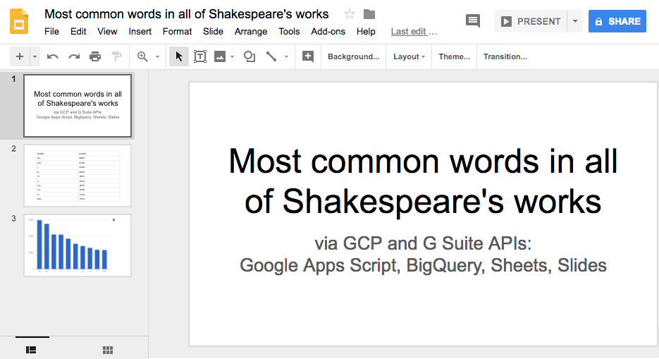

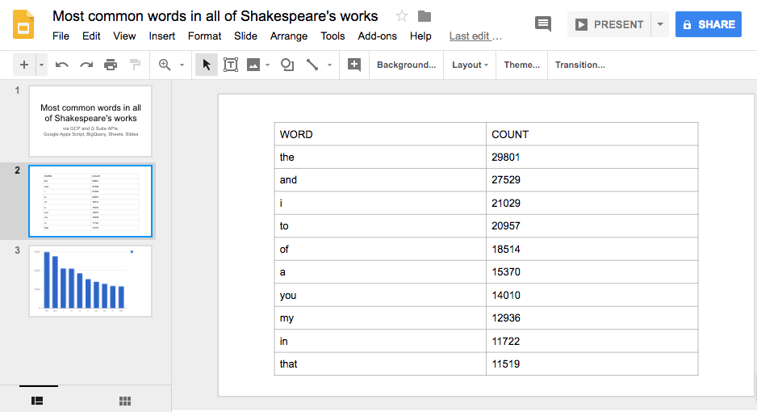

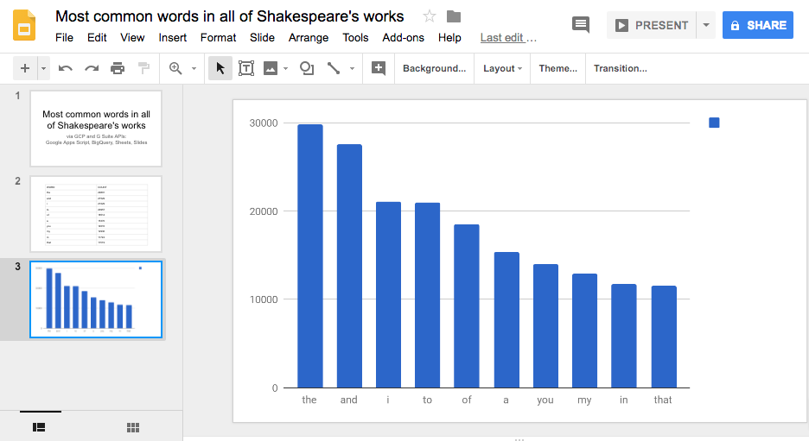

**Congratulations!**

You've now created an application that leverages both sides of Google Cloud by performing a BigQuery request that queries one of its public data sets, creates a new Google Sheet to store the results, add a chart based on the retrieved data, and finally create a Google Slides presentation featuring the results as well as chart in the spreadsheet.

That's what you did technically. Broadly speaking, you went from a big data analysis to something you can present to stakeholders, all in code, all automated. Now you can take this lab and customize it for your own projects.

 

Finish Your Quest

This self-paced lab is part of the Qwiklabs [G Suite: Integrations](https://google.qwiklabs.com/quests/51) and [BigQuery Basics for Data Analysts](https://google.qwiklabs.com/quests/69) Quests. A Quest is a series of related labs that form a learning path. Completing a Quest earns you a badge to recognize your achievement. You can make your badge (or badges) public and link to them in your online resume or social media account. Enroll in a Quest and get immediate completion credit if you've taken this lab. [See other available Qwiklabs Quests](https://google.qwiklabs.com/catalog).

Looking for a hands-on challenge lab to demonstrate your BigQuery skills and validate your knowledge? On completing this quest, finish this additional [challenge lab](https://google.qwiklabs.com/catalog_lab/2712) to receive an exclusive Google Cloud digital badge.

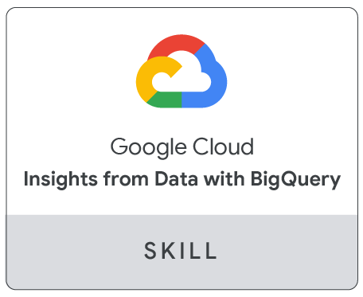

Learn more

The code featured in this lab is also available at its GitHub repo at [GitHub.com/googlecodelabs/bigquery-sheets-slides](http://github.com/googlecodelabs/bigquery-sheets-slides). The lab tries to stay in-sync with the repo. Below are additional resources to help you dig deeper into the material covered in this lab and explore other ways of accessing Google developer tools programmatically.

**Documentation**

* Google [Apps Script](http://developers.google.com/apps-script) documentation site
* Apps Script [Spreadsheet service](https://developers.google.com/apps-script/guides/sheets)
* Apps Script [Slides service](https://developers.google.com/apps-script/guides/slides)
* Apps Script [BigQuery advanced service](https://developers.google.com/apps-script/advanced/bigquery)

**Related and general videos**

* Another Google (Apps) secret - (Apps Script intro [video](http://goo.gl/1sXeuD))
* Accessing Google Maps from a spreadsheet - ( [video](http://goo.gl/oAzBN9))
* Others in Google Apps Script - [video library](https://developers.google.com/apps-script/guides/videos)
* Launchpad Online - [video series](http://goo.gl/kFMUa6)
* G Suite Dev Show - [video series](http://goo.gl/JpBQ40)

**Related and general news & updates**

* BigQuery integrates with Google Drive (2016: [link1](http://cloud.google.com/blog/big-data/2016/05/bigquery-integrates-with-google-drive), [link2](https://gsuiteupdates.googleblog.com/2016/05/google-bigquery-integrates-with-google.html))
* Google [Developers blog](http://developers.googleblog.com/)
* Google [Cloud Platform blog](http://cloudplatform.googleblog.com/)
* Google Cloud [Big Data & Machine Learning blog](http://cloud.google.com/blog/big-data)
* Google Developers [Twitter](https://twitter.com/GoogleDevs) (@GoogleDevs)
* G Suite [developers blog](http://gsuite-developers.googleblog.com/)
* G Suite developers [Twitter](https://twitter.com/GSuiteDevs) (@GSuiteDevs)
* G Suite [developers monthly newsletter](https://developers.google.com/google-apps/newsletters)

Manual Last August 05, 2020

Lab Last Tested August 05, 2020

Copyright 2020 Google LLC All rights reserved. Google and the Google logo are trademarks of Google LLC. All other company and product names may be trademarks of the respective companies with which they are associated.