**Overview**

[BigQuery](https://cloud.google.com/bigquery/) is Google's fully managed, NoOps, low cost analytics database. With BigQuery you can query terabytes and terabytes of data without having any infrastructure to manage, or needing a database administrator.

[BigQuery Machine Learning](https://cloud.google.com/bigquery/docs/bigqueryml-analyst-start) (BQML, product in beta) is a new feature in BigQuery where data analysts can create, train, evaluate, and predict with machine learning models with minimal coding.

In this lab, you will explore millions of New York City yellow taxi cab trips available in a BigQuery Public Dataset. You will then create a machine learning model inside of BigQuery to predict the fare of the cab ride given your model inputs. Lastly, you will evaluate the performance of your model and make predictions with it.

Objectives

In this lab, you will learn to perform the following tasks:

* Use BigQuery to find public datasets.
* Query and explore the public taxi cab dataset.
* Create a training and evaluation dataset to be used for batch prediction.
* Create a forecasting (linear regression) model in BQML.
* Evaluate the performance of your machine learning model.

What you'll need

* A Google Cloud Project
* A Browser, such as [Google Chrome](https://www.google.com/chrome/browser/desktop/) or [Mozilla Firefox](https://www.mozilla.org/firefox/).

**Set up your environment**

**Before you click the Start Lab button**

Read these instructions. Labs are timed and you cannot pause them. The timer, which starts when you click **Start Lab**, shows how long Google Cloud resources will be made available to you.

This Qwiklabs hands-on lab lets you do the lab activities yourself in a real cloud environment, not in a simulation or demo environment. It does so by giving you new, temporary credentials that you use to sign in and access Google Cloud for the duration of the lab.

**What you need**

To complete this lab, you need:

* Access to a standard internet browser (Chrome browser recommended).
* Time to complete the lab.

**Note:** If you already have your own personal Google Cloud account or project, do not use it for this lab.

**Note:** If you are using a Pixelbook, open an Incognito window to run this lab.

**How to start your lab and sign in to the Google Cloud Console**

1. Click the **Start Lab** button. If you need to pay for the lab, a pop-up opens for you to select your payment method. On the left is a panel populated with the temporary credentials that you must use for this lab.

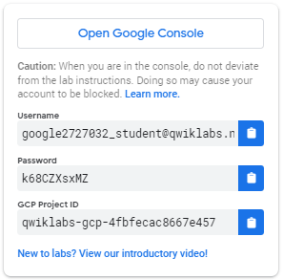

1. Copy the username, and then click **Open Google Console**. The lab spins up resources, and then opens another tab that shows the **Sign in** page.

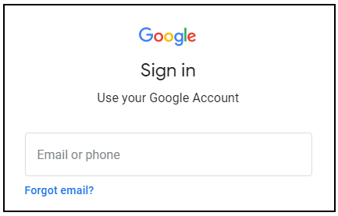

***Tip:*** Open the tabs in separate windows, side-by-side.

If you see the **Choose an account** page, click **Use Another Account**. 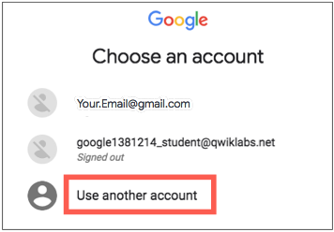

1. In the **Sign in** page, paste the username that you copied from the Connection Details panel. Then copy and paste the password.

***Important:*** You must use the credentials from the Connection Details panel. Do not use your Qwiklabs credentials. If you have your own Google Cloud account, do not use it for this lab (avoids incurring charges).

1. Click through the subsequent pages:
   * Accept the terms and conditions.
   * Do not add recovery options or two-factor authentication (because this is a temporary account).
   * Do not sign up for free trials.

After a few moments, the Cloud Console opens in this tab.

**Note:** You can view the menu with a list of Google Cloud Products and Services by clicking the **Navigation menu** at the top-left. 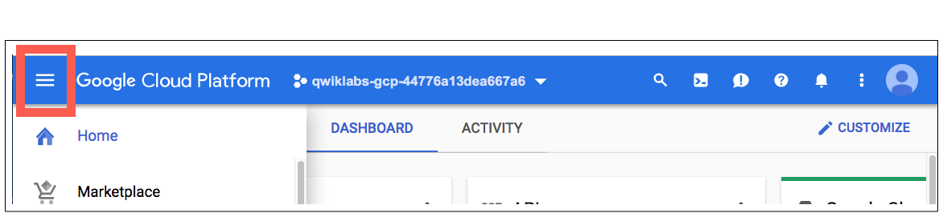

Open BigQuery Console

In the Google Cloud Console, select **Navigation menu** > **BigQuery**:

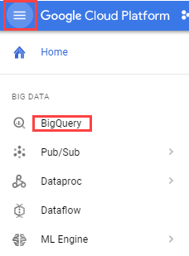

The **Welcome to BigQuery in the Cloud Console** message box opens. This message box provides a link to the quickstart guide and the release notes.

Click **Done**.

The BigQuery console opens.

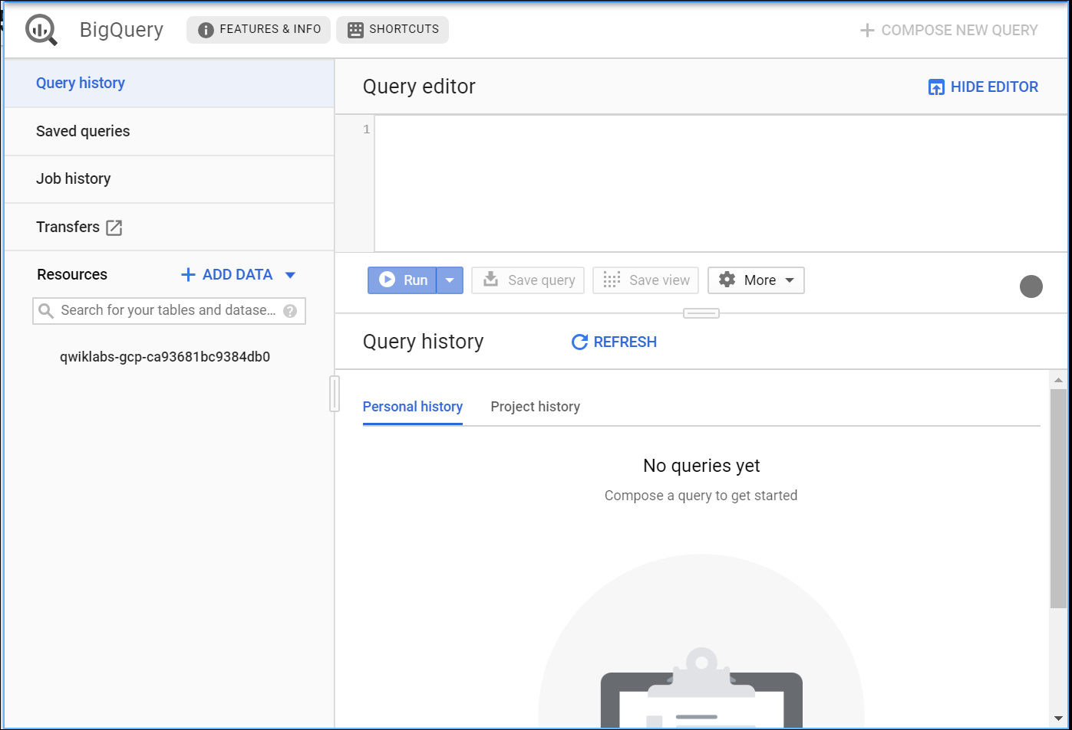

**Explore NYC taxi cab data**

**Question:** How many trips did Yellow taxis take each month in 2015?

Copy and paste the following SQL code into the Query Editor:

*#standardSQL*

SELECT

TIMESTAMP_TRUNC(pickup_datetime,

MONTH) month,

COUNT(*) trips

FROM

`bigquery-public-data.new_york.tlc_yellow_trips_2015`

GROUP BY

1

ORDER BY

1

Then click **Run**.

You should receive the following result:

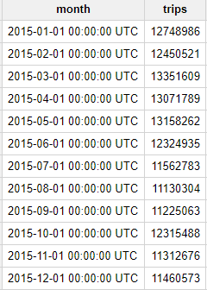

As we see, every month in 2015 had over 10 million NYC taxi trips—no small amount!

Test Completed Task

Click **Check my progress** to verify your performed task. If you have completed the task successfully, you will be granted with an assessment score.

Calculate trips taken by Yellow taxi in each month of 2015

Check my progress

**Question:** What was the average speed of Yellow taxi trips in 2015?

Replace the previous query with the following and then click **Run**:

*#standardSQL*

SELECT

EXTRACT(HOUR

FROM

pickup_datetime) hour,

ROUND(AVG(trip_distance / TIMESTAMP_DIFF(dropoff_datetime,

pickup_datetime,

SECOND))*3600, 1) speed

FROM

`bigquery-public-data.new_york.tlc_yellow_trips_2015`

WHERE

trip_distance > 0

AND fare_amount/trip_distance BETWEEN 2

AND 10

AND dropoff_datetime > pickup_datetime

GROUP BY

1

ORDER BY

1

You should receive the following result:

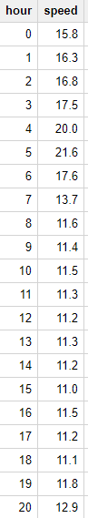

During the day, the average speed is around 11-12 MPH; but at 5:00 AM the average speed almost doubles to 21 MPH. Intuitively this makes sense since there is likely less traffic on the road at 5:00 AM.

Test Completed Task

Click **Check my progress** to verify your performed task. If you have completed the task successfully, you will be granted with an assessment score.

Calculate the average speed of Yellow taxi trips in 2015

Check my progress

**Identify an objective**

You will now create a machine learning model in BigQuery to predict the price of a cab ride in New York City given the historical dataset of trips and trip data. Predicting the fare before the ride could be very useful for trip planning for both the rider and the taxi agency.

**Select features and create your training dataset**

The New York City Yellow Cab dataset is a [public dataset](https://cloud.google.com/bigquery/public-data/nyc-tlc-trips) provided by the city and has been loaded into BigQuery for your exploration. Browse the complete list of fields [here](https://bigquery.cloud.google.com/table/nyc-tlc:yellow.trips) and then [preview the dataset](https://bigquery.cloud.google.com/table/nyc-tlc:yellow.trips?tab=preview) to find useful features that will help a machine learning model understand the relationship between data about historical cab rides and the price of the fare.

Your team decides to test whether these below fields are good inputs to your fare forecasting model:

* Tolls Amount
* Fare Amount
* Hour of Day
* Pick up address
* Drop off address
* Number of passengers

Replace the query with the following:

*#standardSQL*

WITH params AS (

SELECT

1 AS TRAIN,

2 AS EVAL

),

daynames AS

(SELECT ['Sun', 'Mon', 'Tues', 'Wed', 'Thurs', 'Fri', 'Sat'] AS daysofweek),

taxitrips AS (

SELECT

(tolls_amount + fare_amount) AS total_fare,

daysofweek[ORDINAL(EXTRACT(DAYOFWEEK FROM pickup_datetime))] AS dayofweek,

EXTRACT(HOUR FROM pickup_datetime) AS hourofday,

pickup_longitude AS pickuplon,

pickup_latitude AS pickuplat,

dropoff_longitude AS dropofflon,

dropoff_latitude AS dropofflat,

passenger_count AS passengers

FROM

`nyc-tlc.yellow.trips`, daynames, params

WHERE

trip_distance > 0 AND fare_amount > 0

AND MOD(ABS(FARM_FINGERPRINT(CAST(pickup_datetime AS STRING))),1000) = params.TRAIN

)

SELECT *

FROM taxitrips

Note a few things about the query:

1. The main part of the query is at the bottom (SELECT * from taxitrips).
2. taxitrips does the bulk of the extraction for the NYC dataset, with the SELECT containing your training features and label.
3. The WHERE removes data that you don't want to train on.
4. The WHERE also includes a sampling clause to pick up only 1/1000th of the data.
5. Define a variable called TRAIN so that you can quickly build an independent EVAL set.

Now that you have a better understanding of this query's purpose, click **Run**.

You should receive a similar result:

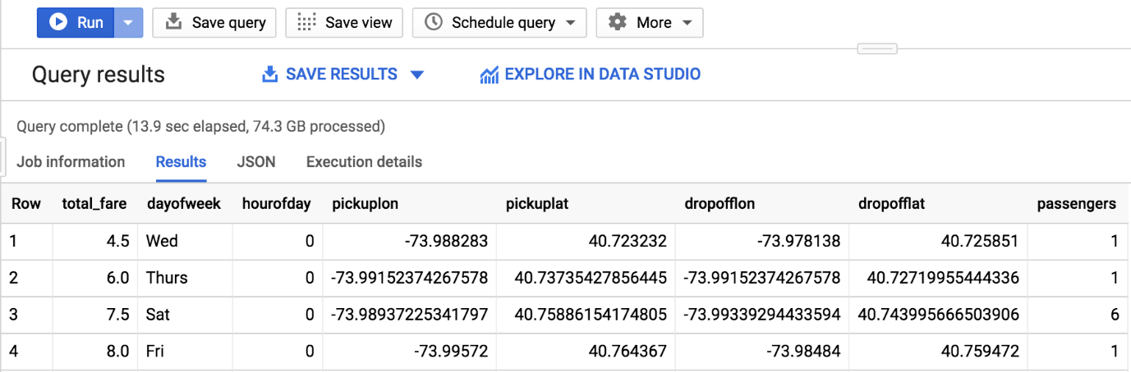

What is the label (correct answer)?

total_fare is the label (what you will be predicting). You created this field out of tolls_amount and fare_amount, so you could ignore customer tips as part of the model as they are discretionary.

Test Completed Task

Click **Check my progress** to verify your performed task. If you have completed the task successfully, you will be granted with an assessment score.

Test whether fields are good inputs to your fare forecasting model

Check my progress

**Create a BigQuery dataset to store models**

In this section, you will create a new BigQuery dataset which will store your ML models.

1. In the left-hand Resources panel, select your Qwiklabs Project ID.
2. Then on the right-hand side of the page, click **CREATE DATASET**.
3. In the Create Dataset dialog, enter in the following:

* For **Dataset ID**, type **taxi**.
* Leave the other values at their defaults.

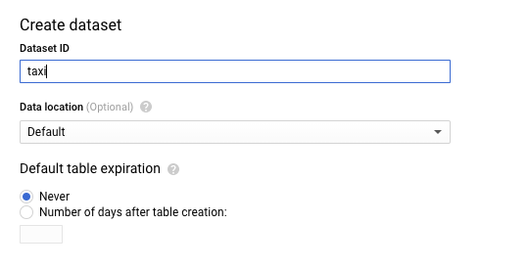

1. Then click **Create dataset**.

Test Completed Task

Click **Check my progress** to verify your performed task. If you have completed the task successfully, you will be granted with an assessment score.

Create a BigQuery dataset to store models

Check my progress

**Select a BQML model type and specify options**

Now that you have your initial features selected, you are now ready to create your first ML model in BigQuery.

There are several model types to choose from:

* **Forecasting** numeric values like next month's sales with Linear Regression (linear_reg).
* Binary or Multiclass **Classification** like spam or not spam email by using Logistic Regression (logistic_reg).
* k-Means **Clustering** for when you want unsupervised learning for exploration (kmeans).

**Note:** There are many additional model types used in Machine Learning (like Neural Networks and decision trees) and available using libraries like [TensorFlow](https://www.tensorflow.org/tutorials/). At this time, BQML supports the three listed above. Follow the [BQML roadmap](https://cloud.google.com/bigquery/docs/reference/standard-sql/bigqueryml-syntax-create) for more information.

Which model type should you choose for predicting taxi cab fare (numeric value)?

checkLinear Regression



Binary Classification



SQL



Multiclass Classification

Submit

Enter the following query to create a model and specify model options.

CREATE or REPLACE MODEL taxi.taxifare_model

OPTIONS

(model_type='linear_reg', labels=['total_fare']) AS

WITH params AS (

SELECT

1 AS TRAIN,

2 AS EVAL

),

daynames AS

(SELECT ['Sun', 'Mon', 'Tues', 'Wed', 'Thurs', 'Fri', 'Sat'] AS daysofweek),

taxitrips AS (

SELECT

(tolls_amount + fare_amount) AS total_fare,

daysofweek[ORDINAL(EXTRACT(DAYOFWEEK FROM pickup_datetime))] AS dayofweek,

EXTRACT(HOUR FROM pickup_datetime) AS hourofday,

pickup_longitude AS pickuplon,

pickup_latitude AS pickuplat,

dropoff_longitude AS dropofflon,

dropoff_latitude AS dropofflat,

passenger_count AS passengers

FROM

`nyc-tlc.yellow.trips`, daynames, params

WHERE

trip_distance > 0 AND fare_amount > 0

AND MOD(ABS(FARM_FINGERPRINT(CAST(pickup_datetime AS STRING))),1000) = params.TRAIN

)

SELECT *

FROM taxitrips

Next, click **Run** to train your model.

Wait for the model to train (5 - 10 minutes).

After your model is trained, you will see the message "This was a CREATE operation. Results will not be shown" which indicates that your model has been successfully trained.

Look inside your taxi dataset and confirm **taxifare_model** now appears:

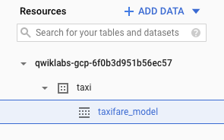

Next, you will evaluate the performance of the model against new unseen evaluation data.

Test Completed Task

Click **Check my progress** to verify your performed task. If you have completed the task successfully, you will be granted with an assessment score.

Create a taxifare model

Check my progress

**Evaluate classification model performance**

Select your performance criteria

For linear regression models you want to use a loss metric like [Root Mean Square Error (RMSE)](https://en.wikipedia.org/wiki/Root-mean-square_deviation). You want to keep training and improving the model until it has the lowest RMSE.

In BQML, mean_squared_error is a queryable field when evaluating your trained ML model. Add a SQRT() to get RMSE.

Now that training is complete, you can evaluate how well the model performs with this query using ML.EVALUATE. Copy and paste the following into the query editor and click **Run**:

*#standardSQL*

SELECT

SQRT(mean_squared_error) AS rmse

FROM

ML.EVALUATE(MODEL taxi.taxifare_model,

(

WITH params AS (

SELECT

1 AS TRAIN,

2 AS EVAL

),

daynames AS

(SELECT ['Sun', 'Mon', 'Tues', 'Wed', 'Thurs', 'Fri', 'Sat'] AS daysofweek),

taxitrips AS (

SELECT

(tolls_amount + fare_amount) AS total_fare,

daysofweek[ORDINAL(EXTRACT(DAYOFWEEK FROM pickup_datetime))] AS dayofweek,

EXTRACT(HOUR FROM pickup_datetime) AS hourofday,

pickup_longitude AS pickuplon,

pickup_latitude AS pickuplat,

dropoff_longitude AS dropofflon,

dropoff_latitude AS dropofflat,

passenger_count AS passengers

FROM

`nyc-tlc.yellow.trips`, daynames, params

WHERE

trip_distance > 0 AND fare_amount > 0

AND MOD(ABS(FARM_FINGERPRINT(CAST(pickup_datetime AS STRING))),1000) = params.EVAL

)

SELECT *

FROM taxitrips

))

You are now evaluating the model against a different set of taxi cab trips with your params.EVAL filter.

After the model runs, review your model results (your model RMSE value will vary slightly).

|  |  |
| --- | --- |
| **Row** | **rmse** |
| 1 | 9.477056435999074 |

After evaluating your model you get a **RMSE** of 9.47. Since we took the Root of the Mean Squared Error (RMSE) the 9.47 error can be evaluated in the same units as the total_fare so it's +-$9.47.

Knowing whether or not this loss metric is acceptable to productionalize your model is entirely dependent on your benchmark criteria, which is set before model training begins. Benchmarking is establishing a minimum level of model performance and accuracy that is acceptable.

Test Completed Task

Click **Check my progress** to verify your performed task. If you have completed the task successfully, you will be granted with an assessment score.

Evaluate the classification model performance

Check my progress

**Predict taxi fare amount**

Next you will write a query to use your new model to make predictions. Copy and paste the following into the Query editor and click **Run**:

*#standardSQL*

SELECT

*

FROM

ml.PREDICT(MODEL `taxi.taxifare_model`,

(

WITH params AS (

SELECT

1 AS TRAIN,

2 AS EVAL

),

daynames AS

(SELECT ['Sun', 'Mon', 'Tues', 'Wed', 'Thurs', 'Fri', 'Sat'] AS daysofweek),

taxitrips AS (

SELECT

(tolls_amount + fare_amount) AS total_fare,

daysofweek[ORDINAL(EXTRACT(DAYOFWEEK FROM pickup_datetime))] AS dayofweek,

EXTRACT(HOUR FROM pickup_datetime) AS hourofday,

pickup_longitude AS pickuplon,

pickup_latitude AS pickuplat,

dropoff_longitude AS dropofflon,

dropoff_latitude AS dropofflat,

passenger_count AS passengers

FROM

`nyc-tlc.yellow.trips`, daynames, params

WHERE

trip_distance > 0 AND fare_amount > 0

AND MOD(ABS(FARM_FINGERPRINT(CAST(pickup_datetime AS STRING))),1000) = params.EVAL

)

SELECT *

FROM taxitrips

));

Now you will see the model's predictions for taxi fares alongside the actual fares and other features for those rides. Your results should look similar to those below:

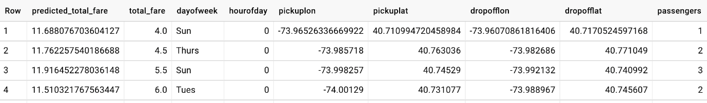

Test Completed Task

Click **Check my progress** to verify your performed task. If you have completed the task successfully, you will be granted with an assessment score.

Predict taxi fare amount

Check my progress

**Improving the model with Feature Engineering**

Building Machine Learning models is an iterative process. Once we have evaluated the performance of our initial model, we often go back and prune our features and rows to see if we can get an even better model.

Filtering the training dataset

Let's view the common statistics for taxi cab fares. Copy and paste the following into the Query editor and click **Run**:

SELECT

COUNT(fare_amount) AS num_fares,

MIN(fare_amount) AS low_fare,

MAX(fare_amount) AS high_fare,

AVG(fare_amount) AS avg_fare,

STDDEV(fare_amount) AS stddev

FROM

`nyc-tlc.yellow.trips`

*# 1,108,779,463 fares*

You should receive a similar output:

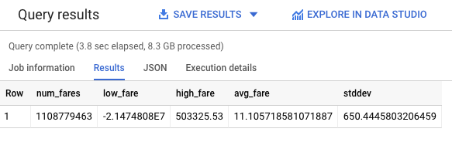

As you can see, there are some strange outliers in our dataset (negative fares or fares over $50,000). Let's apply some of our subject matter expertise to help the model avoid learning on strange outliers.

Let's limit the data to only fares between $$6 and $$200. Copy and paste the following into the Query editor and click **Run**:

SELECT

COUNT(fare_amount) AS num_fares,

MIN(fare_amount) AS low_fare,

MAX(fare_amount) AS high_fare,

AVG(fare_amount) AS avg_fare,

STDDEV(fare_amount) AS stddev

FROM

`nyc-tlc.yellow.trips`

WHERE trip_distance > 0 AND fare_amount BETWEEN 6 and 200

*# 843,834,902 fares*

You should receive a similar output:

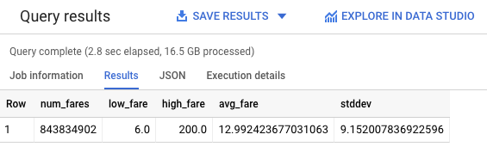

That's a little bit better. While you're at, let's limit the distance traveled so you're really focusing on New York City.

Copy and paste the following into the Query editor and click **Run**:

SELECT

COUNT(fare_amount) AS num_fares,

MIN(fare_amount) AS low_fare,

MAX(fare_amount) AS high_fare,

AVG(fare_amount) AS avg_fare,

STDDEV(fare_amount) AS stddev

FROM

`nyc-tlc.yellow.trips`

WHERE trip_distance > 0 AND fare_amount BETWEEN 6 and 200

AND pickup_longitude > -75 *#limiting of the distance the taxis travel out*

AND pickup_longitude < -73

AND dropoff_longitude > -75

AND dropoff_longitude < -73

AND pickup_latitude > 40

AND pickup_latitude < 42

AND dropoff_latitude > 40

AND dropoff_latitude < 42

*# 827,365,869 fares*

You should receive a similar output:

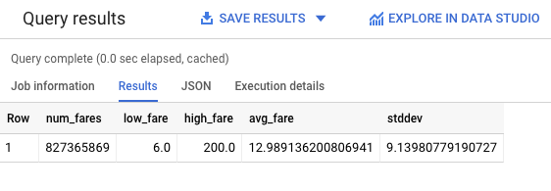

You still have a large training dataset of over 800 million rides for our new model to learn from. Let's re-train the model with these new constraints and see how well it performs.

Retraining the model

Let's call our new model taxi.taxifare_model_2 and retrain our linear regression model to predict total fare. You'll note that you've also added a few calculated features for the [Euclidean distance](https://en.wikipedia.org/wiki/Euclidean_distance) (straight line) between the pick up and drop off.

Copy and paste the following into the Query editor and click **Run**:

CREATE OR REPLACE MODEL taxi.taxifare_model_2

OPTIONS

(model_type='linear_reg', labels=['total_fare']) AS

WITH params AS (

SELECT

1 AS TRAIN,

2 AS EVAL

),

daynames AS

(SELECT ['Sun', 'Mon', 'Tues', 'Wed', 'Thurs', 'Fri', 'Sat'] AS daysofweek),

taxitrips AS (

SELECT

(tolls_amount + fare_amount) AS total_fare,

daysofweek[ORDINAL(EXTRACT(DAYOFWEEK FROM pickup_datetime))] AS dayofweek,

EXTRACT(HOUR FROM pickup_datetime) AS hourofday,

SQRT(POW((pickup_longitude - dropoff_longitude),2) + POW(( pickup_latitude - dropoff_latitude), 2)) as dist, *#Euclidean distance between pickup and drop off*

SQRT(POW((pickup_longitude - dropoff_longitude),2)) as longitude, *#Euclidean distance between pickup and drop off in longitude*

SQRT(POW((pickup_latitude - dropoff_latitude), 2)) as latitude, *#Euclidean distance between pickup and drop off in latitude*

passenger_count AS passengers

FROM

`nyc-tlc.yellow.trips`, daynames, params

WHERE trip_distance > 0 AND fare_amount BETWEEN 6 and 200

AND pickup_longitude > -75 *#limiting of the distance the taxis travel out*

AND pickup_longitude < -73

AND dropoff_longitude > -75

AND dropoff_longitude < -73

AND pickup_latitude > 40

AND pickup_latitude < 42

AND dropoff_latitude > 40

AND dropoff_latitude < 42

AND MOD(ABS(FARM_FINGERPRINT(CAST(pickup_datetime AS STRING))),1000) = params.TRAIN

)

SELECT *

FROM taxitrips

It may take a couple minutes to retrain the model. You can move onto the next step when you receive the following message in the Console:

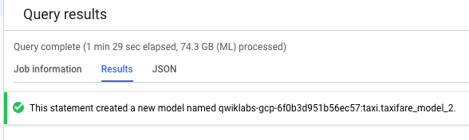

Evaluate the new model

Now that our linear regression model has been optimized, let's evaluate the dataset with it and see how it performs. Copy and paste the following into the Query editor and click **Run**:

SELECT

SQRT(mean_squared_error) AS rmse

FROM

ML.EVALUATE(MODEL taxi.taxifare_model_2,

(

WITH params AS (

SELECT

1 AS TRAIN,

2 AS EVAL

),

daynames AS

(SELECT ['Sun', 'Mon', 'Tues', 'Wed', 'Thurs', 'Fri', 'Sat'] AS daysofweek),

taxitrips AS (

SELECT

(tolls_amount + fare_amount) AS total_fare,

daysofweek[ORDINAL(EXTRACT(DAYOFWEEK FROM pickup_datetime))] AS dayofweek,

EXTRACT(HOUR FROM pickup_datetime) AS hourofday,

SQRT(POW((pickup_longitude - dropoff_longitude),2) + POW(( pickup_latitude - dropoff_latitude), 2)) as dist, *#Euclidean distance between pickup and drop off*

SQRT(POW((pickup_longitude - dropoff_longitude),2)) as longitude, *#Euclidean distance between pickup and drop off in longitude*

SQRT(POW((pickup_latitude - dropoff_latitude), 2)) as latitude, *#Euclidean distance between pickup and drop off in latitude*

passenger_count AS passengers

FROM

`nyc-tlc.yellow.trips`, daynames, params

WHERE trip_distance > 0 AND fare_amount BETWEEN 6 and 200

AND pickup_longitude > -75 *#limiting of the distance the taxis travel out*

AND pickup_longitude < -73

AND dropoff_longitude > -75

AND dropoff_longitude < -73

AND pickup_latitude > 40

AND pickup_latitude < 42

AND dropoff_latitude > 40

AND dropoff_latitude < 42

AND MOD(ABS(FARM_FINGERPRINT(CAST(pickup_datetime AS STRING))),1000) = params.EVAL

)

SELECT *

FROM taxitrips

))

You should receive a similar output:

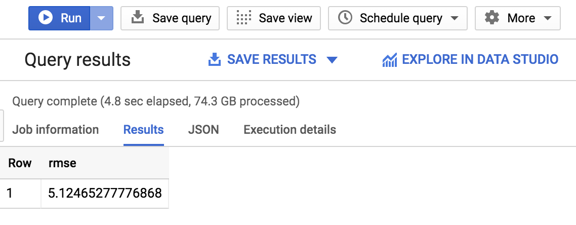

As you see, you've now gotten the RMSE down to: +-$$5.12 which is significantly better than +-$$9.47 for your first model.

Since RSME defines the standard deviation of prediction errors, we see that the retrained linear regression made our model a lot more accurate.

**Test your Understanding**

Below are multiple choice questions to reinforce your understanding of this lab's concepts. Answer them to the best of your abilities.

A lower RSME value usually indicates a more accurate BQML model.



False



True

Submit

**Other datasets to explore**

You can use this below link to bring in the **bigquery-public-data** project if you want to explore modeling on other datasets like forecasting fares for Chicago taxi trips:

<https://bigquery.cloud.google.com/table/bigquery-public-data::chicago_taxi_trips.taxi_trips>

**Congratulations!**

You've successfully built a ML model in BigQuery to forecast taxi cab fare for New York City cabs.

Finish your Quest

  

This self-paced lab is part of the Qwiklabs [Data Engineering](https://google.qwiklabs.com/quests/25) and [BigQuery for Machine Learning](https://google.qwiklabs.com/quests/71) Quests. A Quest is a series of related labs that form a learning path. Completing a Quest earns you a badge to recognize your achievement. You can make your badge (or badges) public and link to them in your online resume or social media account. Enroll in either Quest and get immediate completion credit if you've taken this lab. [See other available Qwiklabs Quests](https://google.qwiklabs.com/catalog).

Next steps/learn more

* To learn more about BiqQuery, see [BigQuery documentation](https://cloud.google.com/bigquery/docs/)
* To learn more about Machine Learning, see [AI Platform documentation](https://cloud.google.com/ml-engine/docs/).

Google Cloud Training & Certification

...helps you make the most of Google Cloud technologies. [Our classes](https://cloud.google.com/training/courses) include technical skills and best practices to help you get up to speed quickly and continue your learning journey. We offer fundamental to advanced level training, with on-demand, live, and virtual options to suit your busy schedule. [Certifications](https://cloud.google.com/certification/) help you validate and prove your skill and expertise in Google Cloud technologies.

Manual Last Updated September 10, 2020

Lab Last Tested September 10, 2020

Copyright 2020 Google LLC All rights reserved. Google and the Google logo are trademarks of Google LLC. All other company and product names may be trademarks of the respective companies with which they are associated.