**Overview**

Wouldn’t it be awesome to have an accurate estimate of how long it will take for tech support to resolve your issue? In this lab you will train a simple machine learning model for predicting helpdesk response time using BigQuery Machine Learning. You will then build a simple chatbot using Dialogflow, and learn how to integrate your trained BigQuery ML model with your helpdesk chatbot. The final solution will provide an estimate of response time to users at the moment a request is generated.

The exercises are ordered to reflect a common cloud developer experience:

1. Train a Model using BigQuery Machine Learning
2. Deploy a simple Dialogflow application
3. Use an inline code editor within Dialogflow for deploying a Node.js fulfillment script that integrates BigQuery
4. Test your chatbot

What you'll learn

* How to train a machine learning model using BigQuery ML
* How to evaluate and improve a machine learning model using BigQuery ML
* How to import intents & entities into a Dialogflow agent
* How to implement custom Node.js fulfillment scripts
* How to integrate BigQuery with Dialogflow

Prerequisites

* Basic concepts and constructs of Dialogflow. [Click here](https://dialogflow.com/docs/tutorial-build-an-agent) for an introductory Dialogflow tutorial that covers basic conversational design and fulfillment using a webhook.
* Basic SQL and Node.js (or any coding language) knowledge.

Solution Feedback/Lab Help

* For more information on this solution or feedback on this lab, please reach out to [gcct-ce-amer-specialists-ml@google.com](mailto:gcct-ce-amer-specialists-ml@google.com).

**Setup Lab**

**Before you click the Start Lab button**

Read these instructions. Labs are timed and you cannot pause them. The timer, which starts when you click **Start Lab**, shows how long Google Cloud resources will be made available to you.

This Qwiklabs hands-on lab lets you do the lab activities yourself in a real cloud environment, not in a simulation or demo environment. It does so by giving you new, temporary credentials that you use to sign in and access Google Cloud for the duration of the lab.

**What you need**

To complete this lab, you need:

* Access to a standard internet browser (Chrome browser recommended).
* Time to complete the lab.

**Note:** If you already have your own personal Google Cloud account or project, do not use it for this lab.

**Note:** If you are using a Pixelbook, open an Incognito window to run this lab.

**How to start your lab and sign in to the Google Cloud Console**

1. Click the **Start Lab** button. If you need to pay for the lab, a pop-up opens for you to select your payment method. On the left is a panel populated with the temporary credentials that you must use for this lab.

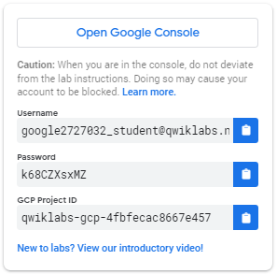

1. Copy the username, and then click **Open Google Console**. The lab spins up resources, and then opens another tab that shows the **Sign in** page.

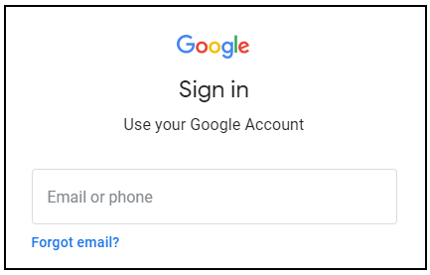

***Tip:*** Open the tabs in separate windows, side-by-side.

If you see the **Choose an account** page, click **Use Another Account**. 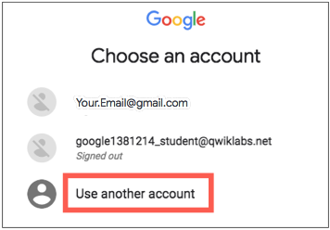

1. In the **Sign in** page, paste the username that you copied from the Connection Details panel. Then copy and paste the password.

***Important:*** You must use the credentials from the Connection Details panel. Do not use your Qwiklabs credentials. If you have your own Google Cloud account, do not use it for this lab (avoids incurring charges).

1. Click through the subsequent pages:
   * Accept the terms and conditions.
   * Do not add recovery options or two-factor authentication (because this is a temporary account).
   * Do not sign up for free trials.

After a few moments, the Cloud Console opens in this tab.

**Note:** You can view the menu with a list of Google Cloud Products and Services by clicking the **Navigation menu** at the top-left. 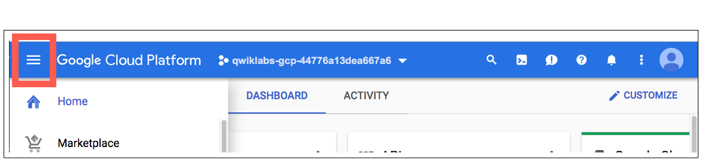

**Train a Model Using BigQuery Machine Learning**

Open BigQuery Console

In the Google Cloud Console, select **Navigation menu** > **BigQuery**:

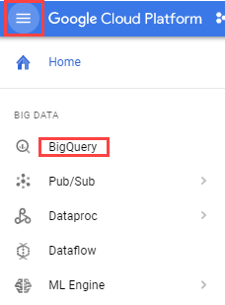

The **Welcome to BigQuery in the Cloud Console** message box opens. This message box provides a link to the quickstart guide and the release notes.

Click **Done**.

The BigQuery console opens.

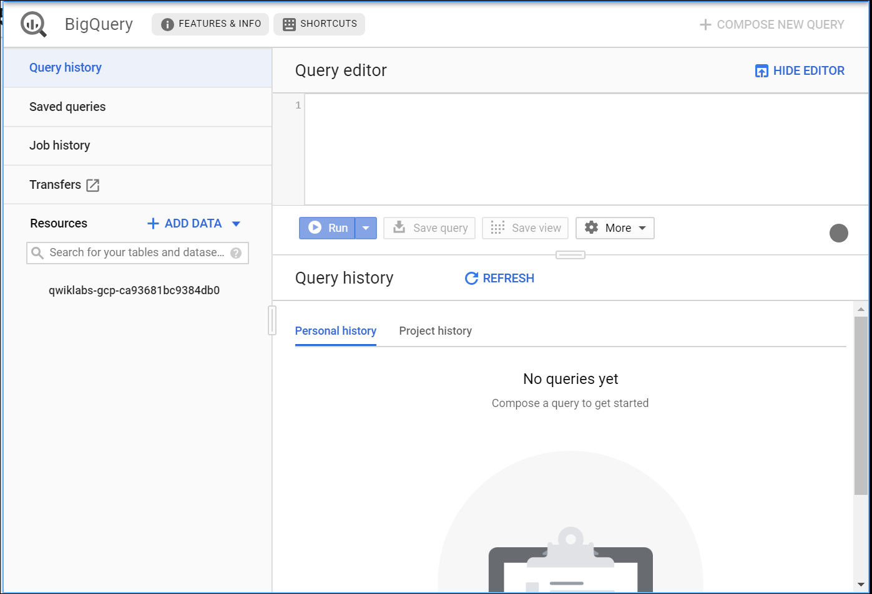

Click on your Project in the left menu, then click **CREATE DATASET**. For **Dataset ID**, type **helpdesk**.

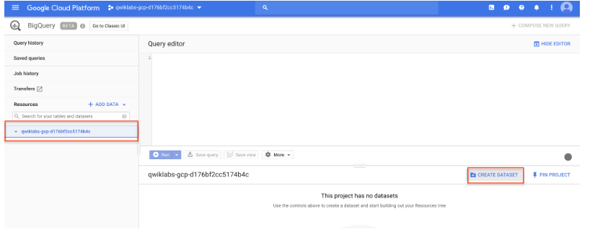

Leave **Default** selected as the location and click **Create dataset**.

**Test Completed Task**

To check your progress in this lab, click **Check my progress** below. A checkmark means you're on track.

Create a BigQuery dataset

Check my progress

In the left menu click the new **helpdesk** dataset you just created, then click **Create Table**.

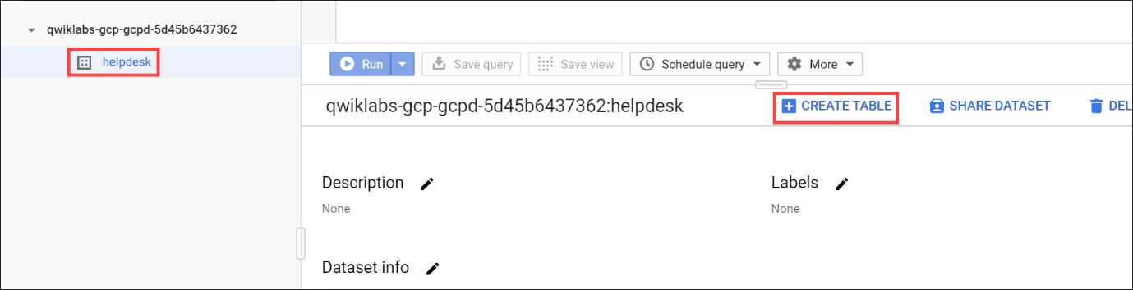

Use the following parameters to create a new table leaving the defaults for all other fields:

|  |  |
| --- | --- |
| **Properties** | **Values** |
| **Create table from** | Google Cloud Storage |
| **Select file from GCS bucket** | gs://solutions-public-assets/smartenup-helpdesk/ml/issues.csv |
| **File format** | CSV |
| **Table name** | issues |
| **Auto detect** | Check box for **Schema and input parameters** |
| **Advanced options > Header rows to skip** | 1 |

Click **Create Table**.

This will trigger a job that loads the source data into a new BigQuery table. It will take about 30 seconds for the job to complete, and you can view it by selecting **Job History** from the left.

**Test Completed Task**

To check your progress in this lab, click **Check my progress** below. A checkmark means you're on track.

Create a new table in BigQuery dataset

Check my progress

In Query editor add the following query:

SELECT * FROM `helpdesk.issues` LIMIT 1000

Click **Run** and examine the data.

In the next query, the data fields category and resolutiontime are used to build a machine learning model that predicts how long it will take to resolve an issue. The model type is a simple linear regression, and the trained model will be named **predict_eta_v0** in the helpdesk dataset.

Run this query, it takes about **1** minute to complete:

CREATE OR REPLACE MODEL `helpdesk.predict_eta_v0`

OPTIONS(model_type='linear_reg') AS

SELECT

category,

resolutiontime as label

FROM

`helpdesk.issues`

**Test Completed Task**

To check your progress in this lab, click **Check my progress** below. A checkmark means you're on track.

Build an ML model to predicts time taken to resolve an issue

Check my progress

Run the following query to evaluate the machine learning model you just created. The metrics generated by this query tell us how well the model is likely to perform.

WITH eval_table AS (

SELECT

category,

resolutiontime as label

FROM

helpdesk.issues

)

SELECT

*

FROM

ML.EVALUATE(MODEL helpdesk.predict_eta_v0,

TABLE eval_table)

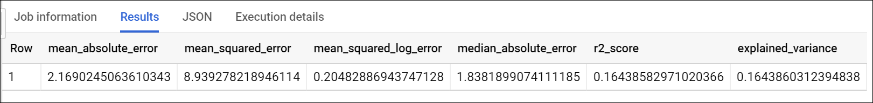

Using the evaluation metrics, we can see that the model doesn't perform very well. When the r2_score and explained_variance metrics are close to 0, our algorithm is having difficulty distinguishing the signal in our data from the noise. We are going to use a few more fields during training and see if there is an improvement: **seniority***,****experience****&****type****.* The final trained model will be named **predict_eta**. Run the query below:

CREATE OR REPLACE MODEL `helpdesk.predict_eta`

OPTIONS(model_type='linear_reg') AS

SELECT

seniority,

experience,

category,

type,

resolutiontime as label

FROM

`helpdesk.issues`

Now, run the following query to evaluate the updated machine learning model you just created.

WITH eval_table AS (

SELECT

seniority,

experience,

category,

type,

resolutiontime as label

FROM

helpdesk.issues

)

SELECT

*

FROM

ML.EVALUATE(MODEL helpdesk.predict_eta,

TABLE eval_table)

**Test Completed Task**

To check your progress in this lab, click **Check my progress** below. A checkmark means you're on track.

Run the query to evaluate the ML model

Check my progress

After adding the additional fields during training, we can see that our model has improved. When the metrics r2_score and explained_variance are close to 1, there is evidence to suggest that our model is capturing a strong linear relationship. We can also see that our *_error metrics are lower than before, which means our model will likely perform better.

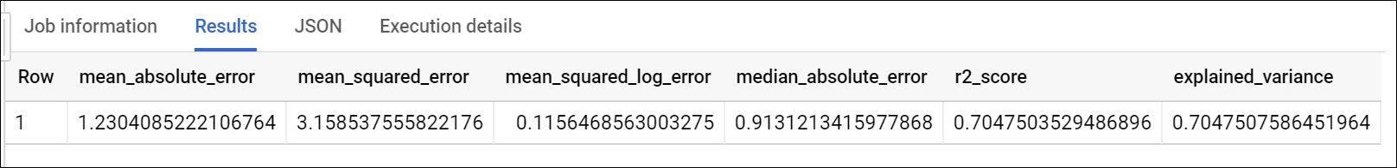

Now we can execute a query to get a prediction of resolution time for a given scenario:

WITH pred_table AS (

SELECT

5 as seniority,

'3-Advanced' as experience,

'Billing' as category,

'Request' as type

)

SELECT

*

FROM

ML.PREDICT(MODEL `helpdesk.predict_eta`,

TABLE pred_table)

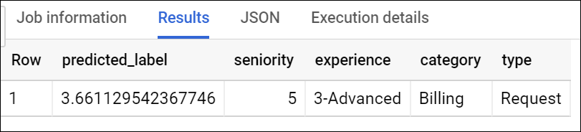

When seniority is **5**, experience is **3-Advanced**, category is **Billing**, and type is **Request**, our model is saying that the average response time is **3.74 days**.

**Create a Dialogflow Agent**

In a new browser tab, create an Agent at Dialogflow.

1. Click this [Dialogflow.com](http://dialogflow.cloud.google.com/) link.
2. Click **Sign-in with Google**, then use the credentials you logged into this lab with.
3. Check **Yes, I have read and accept the agreement**, and then **Accept** the agreement.
4. Click **Create Agent**.
5. Name your agent and select other properties such as language and time zone.
6. Set Google Project to your Qwiklabs ID.

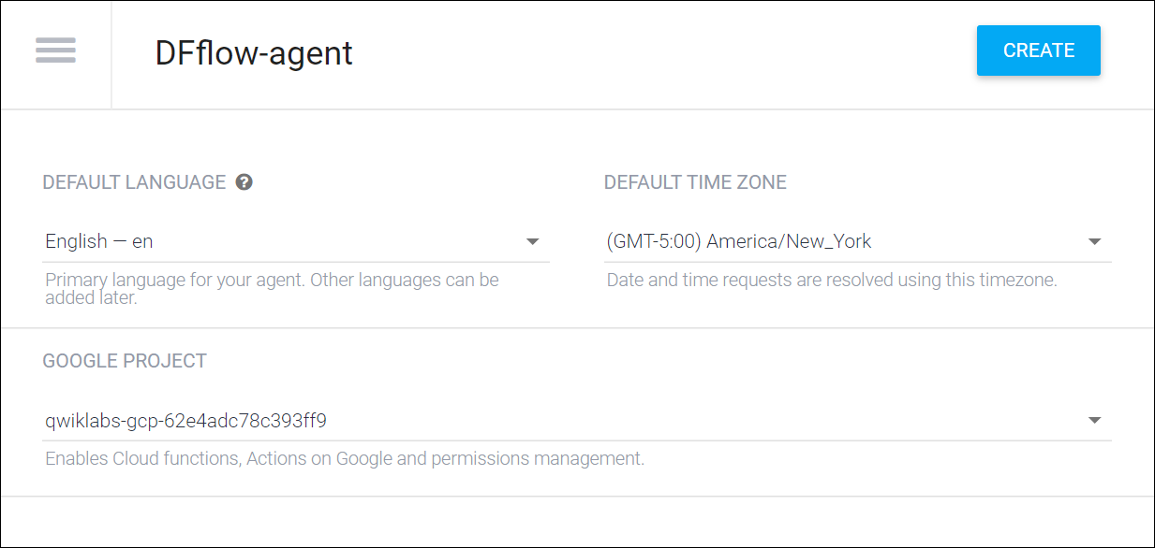

When you're ready, click **Create**.

**Test Completed Task**

To check your progress in this lab, click **Check my progress** below. A checkmark means you're on track.

Create a Dialogflow Agent

Check my progress

**Import Intents & Entities for a Simple Helpdesk Agent**

To save time, instead of configuring an agent from scratch, you are going to import the intents and entities for an existing helpdesk agent.

**Import an IT helpdesk agent**

* Download settings file from <https://github.com/googlecodelabs/cloud-dialogflow-bqml/raw/master/ml-helpdesk-agent.zip> and save it to your local computer.
* Still in the Diagflow console, click the hamburger icon in the top left to open the left panel.



* Click on the gear icon  next to your existing agent.

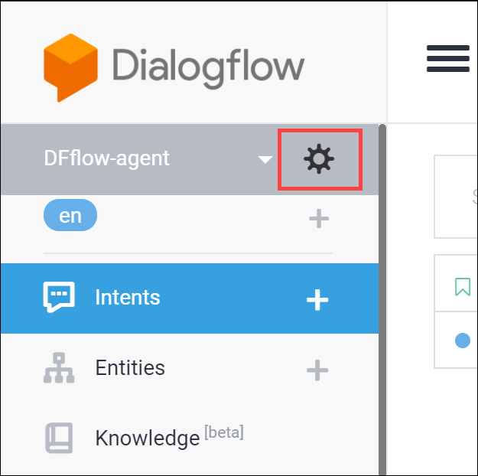

* Click on **Export and Import** tab from the list of settings.
* Select **Import from zip**.
* Select the ml-helpdesk-agent.zip file from your local computer.
* Type IMPORT in the given textbox and click **Import**.
* Click **Done**.

Once the import completes, use the left panel to navigate to **Intents**. Examine the intents that were imported. **Submit Ticket** is the main intent, which has the follow-up intents **Submit Ticket - Email** and **Submit Ticket - Issue Category**. **Submit Ticket - Email** is used to collect a user's email address and **Submit Ticket - Issue Category** is used to collect the issue description from the user and automatically infer a support category.

Use the left panel to navigate to **Entities** and look at the **@category** entity. This entity will be used to map a request description that the user provides to support category. The support category will be used for predicting response time.

**Test Completed Task**

To check your progress in this lab, click **Check my progress** below. A checkmark means you're on track.

Import an IT Helpdesk Agent

Check my progress

**Use the Inline Editor to create a fulfillment that integrates with BigQuery**

**Note:** The code doesn't store the ticket. It only sends a decorated message back to the user to demonstrate the possibilities.

Click on **Fulfillment** in the left panel and switch the **Inline Editor** toggle to **Enabled**.

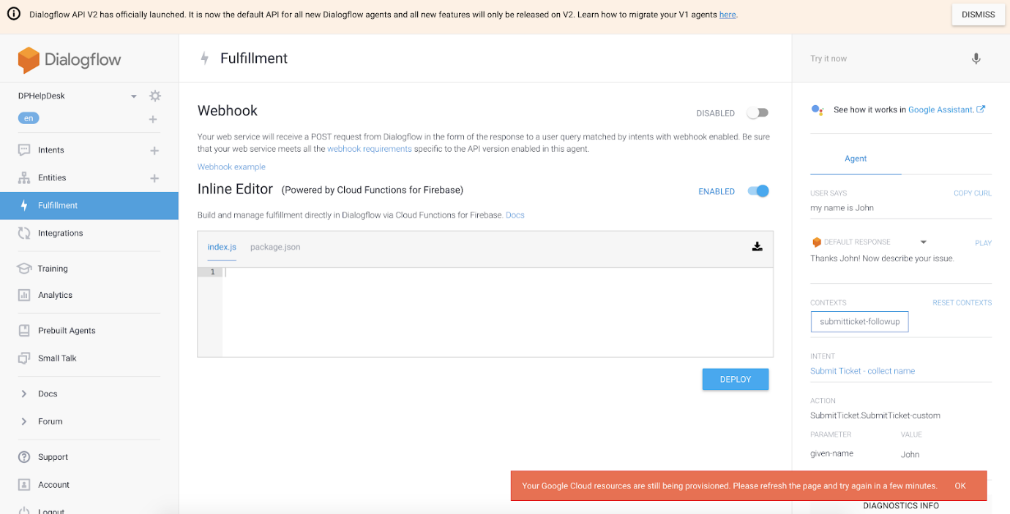

**Note:** You may get an error saying "Your Google Cloud resources are still being provisioned, please refresh the page and try again in a few minutes." If you do, just wait a short time and reload your page.

Copy the following code and paste it in the **index.js** tab, replacing the existing content:

*/\*\**

*\* Copyright 2017 Google Inc. All Rights Reserved.*

*\**

*\* Licensed under the Apache License, Version 2.0 (the "License");*

*\* you may not use this file except in compliance with the License.*

*\* You may obtain a copy of the License at*

*\**

*\* http://www.apache.org/licenses/LICENSE-2.0*

*\**

*\* Unless required by applicable law or agreed to in writing, software*

*\* distributed under the License is distributed on an "AS IS" BASIS,*

*\* WITHOUT WARRANTIES OR CONDITIONS OF ANY KIND, either express or implied.*

*\* See the License for the specific language governing permissions and*

*\* limitations under the License.*

*\*/*

"use strict";

const functions = require("firebase-functions");

const { WebhookClient } = require("dialogflow-fulfillment");

const { Card } = require("dialogflow-fulfillment");

const BIGQUERY = require("@google-cloud/bigquery");

const BIGQUERY_CLIENT = new BIGQUERY({

projectId: "your-project-id" *// ** CHANGE THIS \*\**

});

process.env.DEBUG = "dialogflow:debug";

exports.dialogflowFirebaseFulfillment = functions.https.onRequest(

(request, response) => {

const agent = new WebhookClient({ request, response });

console.log(

"Dialogflow Request headers: " + JSON.stringify(request.headers)

);

console.log("Dialogflow Request body: " + JSON.stringify(request.body));

function welcome(agent) {

agent.add(`Welcome to my agent!`);

}

function fallback(agent) {

agent.add(`I didn't understand`);

agent.add(`I'm sorry, can you try again?`);

}

function ticketCollection(agent) {

*// Capture Parameters from the Current Dialogflow Context*

console.log('Dialogflow Request headers: ' + JSON.stringify(request.headers));

console.log('Dialogflow Request body: ' + JSON.stringify(request.body));

const OUTPUT_CONTEXTS = request.body.queryResult.outputContexts;

const EMAIL = agent.getContext('submitticket-email-followup').parameters.email;

const ISSUE_CATEGORY = OUTPUT_CONTEXTS[OUTPUT_CONTEXTS.length - 1].parameters.category;

const ISSUE_TEXT = request.body.queryResult.queryText;

*// The SQL Query to Run*

const SQLQUERY = `WITH pred_table AS (SELECT 5 as seniority, "3-Advanced" as experience,

@category as category, "Request" as type)

SELECT cast(predicted_label as INT64) as predicted_label

FROM ML.PREDICT(MODEL helpdesk.predict_eta, TABLE pred_table)`;

const OPTIONS = {

query: SQLQUERY,

*// Location must match that of the dataset(s) referenced in the query.*

location: "US",

params: {

category: ISSUE_CATEGORY

}

};

return BIGQUERY_CLIENT.query(OPTIONS)

.then(results => {

*//Capture results from the Query*

console.log(JSON.stringify(results[0]));

const QUERY_RESULT = results[0];

const ETA_PREDICTION = QUERY_RESULT[0].predicted_label;

*//Format the Output Message*

agent.add( EMAIL + ", your ticket has been created. Someone will you contact shortly. " +

" The estimated response time is " + ETA_PREDICTION + " days."

);

agent.add(

new Card({

title:

"New " + ISSUE_CATEGORY +

" Request for " + EMAIL +

" (Estimated Response Time: " + ETA_PREDICTION +

" days)",

imageUrl:

"https://developers.google.com/assistant/assistant.png",

text: "Issue description: " + ISSUE_TEXT,

buttonText: "Go to Ticket Record",

buttonUrl: "https://assistant.google.com/"

})

);

agent.setContext({

name: "submitticket-collectname-followup",

lifespan: 2

});

})

.catch(err => {

console.error("ERROR:", err);

});

}

*// Run the proper function handler based on the matched Dialogflow intent name*

let intentMap = new Map();

intentMap.set("Default Welcome Intent", welcome);

intentMap.set("Default Fallback Intent", fallback);

intentMap.set("Submit Ticket - Issue Category", ticketCollection);

agent.handleRequest(intentMap);

}

);

While in this file update the BIGQUERY_CLIENT variable. Replace your-project-id with your Project ID:

Notice that your fulfillment script contains the **ML.PREDICT** function in Query statement. This is what is going to return a prediction of response time back to the client. Dialogflow will automatically categorize the ticket description and send the category to **BigQuery ML** for predicting issue response time.

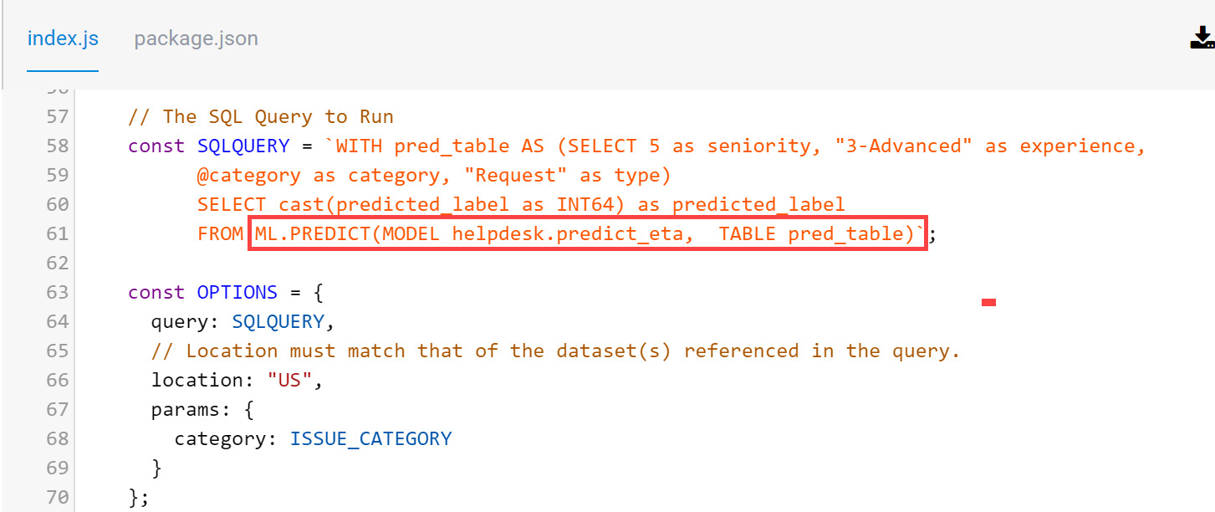

Copy the following code and paste it in the **package.json** tab, replacing the existing content:

{

"name": "dialogflowFirebaseFulfillment",

"description": "Dialogflow Fulfillment Library quick start sample",

"version": "0.0.1",

"private": true,

"license": "Apache Version 2.0",

"author": "Google Inc.",

"engines": {

"node": ">=6.0"

},

"scripts": {

"start": "firebase serve --only functions:dialogflowFirebaseFulfillment",

"deploy": "firebase deploy --only functions:dialogflowFirebaseFulfillment"

},

"dependencies": {

"firebase-admin": "^4.2.1",

"firebase-functions": "^0.5.7",

"dialogflow-fulfillment": "0.3.0-beta.3",

"@google-cloud/bigquery": "^1.3.0"

}

}

Click the **Deploy** button. Wait until you see a message that the deployment was successful. This may take a few minutes.

If the deployment fails, try refreshing and clicking Deploy one more time.

**Test Completed Task**

To check your progress in this lab, click **Check my progress** below. A checkmark means you're on track.

Create a Fulfillment that Integrates with BigQuery

Check my progress

**Enable webhook for fulfillment**

Next, go back to **Intents** in the left panel. Click the down arrow next to **Submit Ticket** to reveal its follow-up intents.

Click on the last follow-up intent **Submit Ticket - Issue Category** to open it for editing.

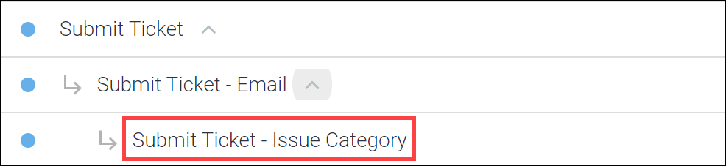

Scroll to the bottom, in the **Fulfillment** section, verify that **Enable webhook call for this intent** is turned on.

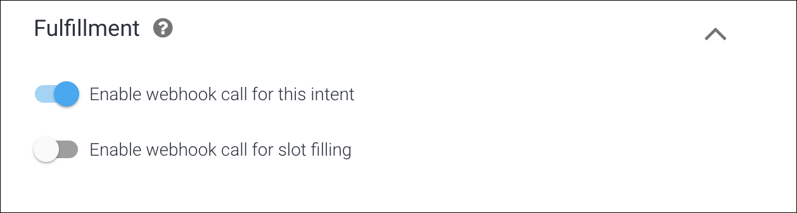

**Test your chatbot**

At this point, the Dialogflow should be set up.

Test it in the **Try it now** panel on the right by typing in the following conversation, one line at a time:

1. Hi
2. I would like to submit a ticket
3. My email is student@qwiklabs.net
4. I can't login

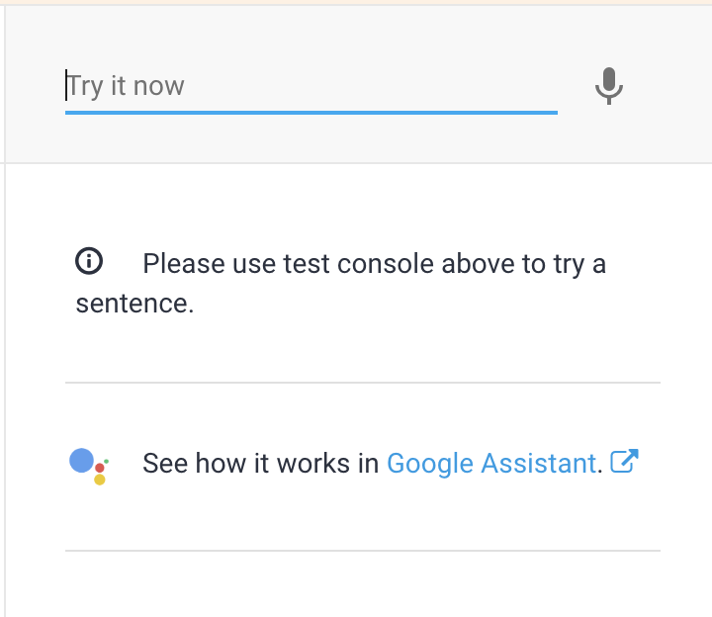

The output from #4 should look like:

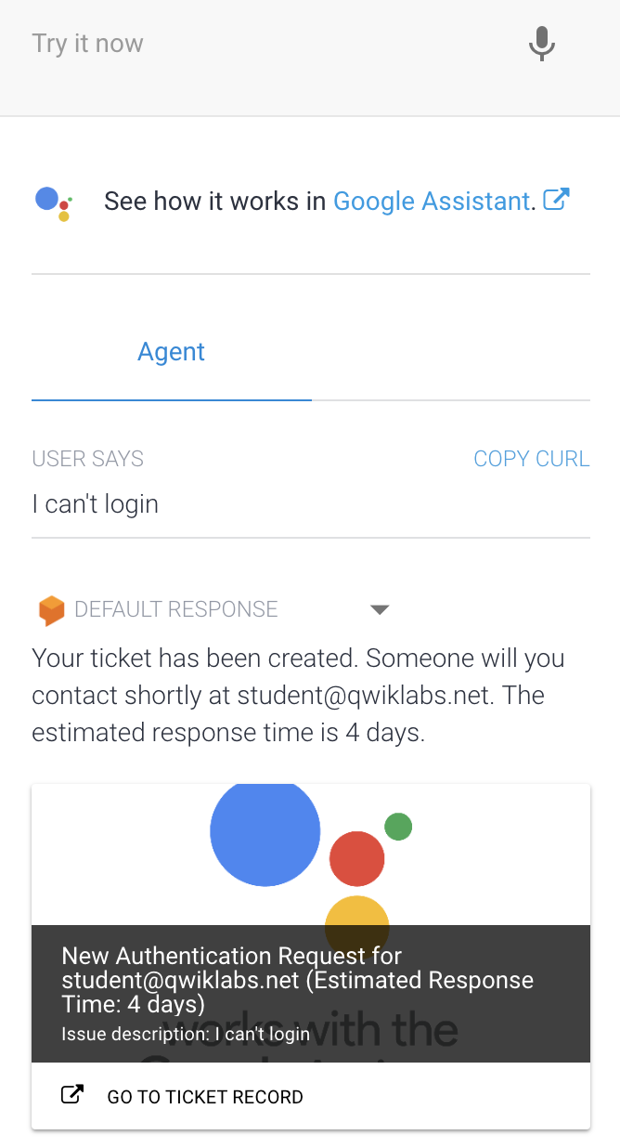

Notice that our fulfillment script is also leveraging the [Dialogflow Fulfillment Library](https://github.com/dialogflow/dialogflow-fulfillment-nodejs) to provide richer content to the end user on certain platforms.

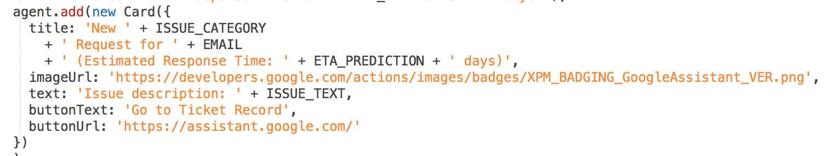

**Note:** If you don't see the expected output depicted above, go back to the Fulfillment section of the agent and redeploy the code you copied into the Inline Editor. Also verify that you updated the **projectId** specified in the code to match your project.

**Understanding the BigQuery integration**

Remember that your BigQuery ML model required other fields to return a prediction: **seniority** and **experience**. If this were a real world app, you could programmatically get the user's seniority & experience from a company database using the name or company ID they provide. For this example assume **5** as seniority and **3-Advanced** as experience.

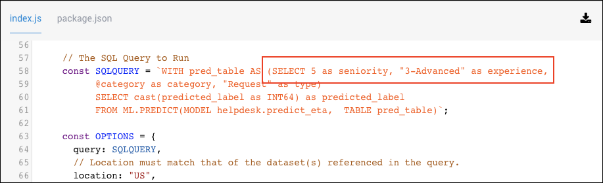

**Extra Credit:** Change the fulfillment script so that your response time prediction is based on a user with 2 as seniority instead of 5. Then retest the bot. How does this change the Estimated ETA?

To extend this example further, you could also collect the **seniority** and **experience** information from the chatbot user by leveraging the Slot Filling functionality in Dialogflow. [Click here](https://blog.dialogflow.com/post/use-slot-filling-in-fulfillment/) to learn more about Slot Filling in Dialogflow.

**Test using a one-click integration**

Dialogflow provides many types of integrations for your chatbot. Take a look now at a sample web user interface.

Click on **Integrations** in the Dialogflow left panel.

Enable the **Web Demo** integration by flipping the switch. 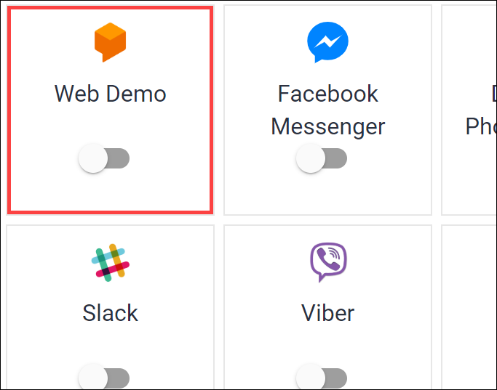

Click on the **URL** link to launch Web Demo: 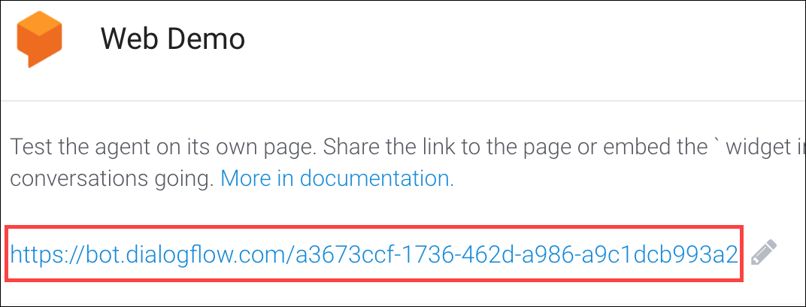

Start using the chat interface by typing in the Ask something... section! If you are using a Chrome browser, if you click the microphone icon and you can speak your questions to the chatbot. Start chatting with the chatbot using the following conversation:

* Type "Hi" and hit Enter. The chatbot should respond as before.
* Then enter/say "Submit ticket"
* Provide the name "My email is student@qwiklabs.net"
* Provide the ticket details of "My printer is broken"

**Congratulations!**

You built a custom machine learning model, and you're now a chatbot developer!



Finish your Quest

This self-paced lab is part of the Qwiklabs Quest [BigQuery for Machine Learning](https://google.qwiklabs.com/quests/71). A Quest is a series of related labs that form a learning path. Completing this Quest earns you the badge above, to recognize your achievement. You can make your badge (or badges) public and link to them in your online resume or social media account. Enroll in this Quest and get immediate completion credit if you've taken this lab. [See other available Qwiklabs Quests](https://google.qwiklabs.com/catalog).