**Overview**

**Blockchain**

A blockchain is a growing list of records, called blocks, which are linked using cryptography. Each block contains:

* a cryptographic hash of the previous block
* a timestamp
* transaction data (generally represented as a merkle tree root hash)

By design, a blockchain is resistant to modification of the data. It is "an open, distributed ledger that can record transactions between two parties efficiently and in a verifiable and permanent way". For use as a distributed ledger, a blockchain is typically managed by a peer-to-peer network collectively adhering to a protocol for inter-node communication and validating new blocks. Once recorded, the data in any given block cannot be altered retroactively without alteration of all subsequent blocks, which requires consensus of the network majority. Although blockchain records are not unalterable, blockchains may be considered secure by design and exemplify a distributed computing system with high Byzantine fault tolerance. Decentralized consensus has therefore been claimed with a blockchain.

**Hyperledger**

Hyperledger is an open source collaborative effort created to advance cross-industry blockchain technologies. It is a global collaboration, hosted by The Linux Foundation, and includes leaders in finance, banking, Internet of Things, supply chains, manufacturing, and technology.

**Hyperledger Composer**

Hyperledger Composer is an extensive open development toolset and framework to make developing blockchain applications easier.

Hyperledger Composer can be used to rapidly develop use cases and deploy a blockchain solution in weeks rather than months. Hyperledger Composer allows you to model your business network and integrate existing systems and data with your blockchain applications. It supports the existing [Hyperledger Fabric blockchain](https://hyperledger.org/) infrastructure and runtime, which supports pluggable blockchain consensus protocols to ensure that transactions are validated according to policy by the designated business network participants.

For an example of a business network in action; a realtor can quickly model their business network as such:

**Assets**: houses and listings

**Participants**: buyers and homeowners

**Transactions**: buying or selling houses, and creating and closing listings

In this lab, you will learn to use Hyperledger Composer to quickly model a business network containing assets, participants, and transactions related to them. Hyperledger Composer Playground provides a user interface for the configuration, deployment, and testing of a business network.

**What you'll learn**

* How to deploy Hyperledger Fabric and Composer solution from GCP Marketplace.
* How to deploy a new business network.
* How to use Hyperledger Composer Playground to configure and test the deployed business network by creating sample assets, participants, and transactions.

**To complete this lab**

* You do NOT need a G Suite Admin account. An account, project and associated resources are provided to you as part of this lab.
* If you already have your own G Suite Admin account, make sure you are signed out of the account. Do not use it for this lab.

**Setup and Requirements**

**Before you click the Start Lab button**

Read these instructions. Labs are timed and you cannot pause them. The timer, which starts when you click **Start Lab**, shows how long Google Cloud resources will be made available to you.

This Qwiklabs hands-on lab lets you do the lab activities yourself in a real cloud environment, not in a simulation or demo environment. It does so by giving you new, temporary credentials that you use to sign in and access Google Cloud for the duration of the lab.

**What you need**

To complete this lab, you need:

* Access to a standard internet browser (Chrome browser recommended).
* Time to complete the lab.

**Note:** If you already have your own personal Google Cloud account or project, do not use it for this lab.

**Note:** If you are using a Pixelbook, open an Incognito window to run this lab.

Your lab will take a few minutes to build an environment with the required resources. When you see the green Lab Running light you can begin your lab. Feel free to log into the Console while this is happening.

**How to start your lab and sign in to the Google Cloud Console**

1. Click the **Start Lab** button. If you need to pay for the lab, a pop-up opens for you to select your payment method. On the left is a panel populated with the temporary credentials that you must use for this lab.

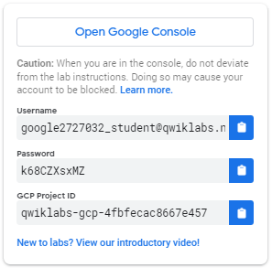

1. Copy the username, and then click **Open Google Console**. The lab spins up resources, and then opens another tab that shows the **Sign in** page.

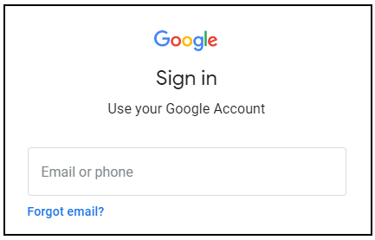

***Tip:*** Open the tabs in separate windows, side-by-side.

If you see the **Choose an account** page, click **Use Another Account**. 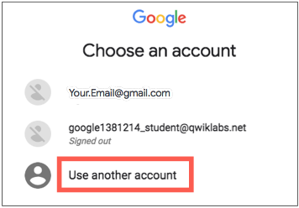

1. In the **Sign in** page, paste the username that you copied from the Connection Details panel. Then copy and paste the password.

***Important:*** You must use the credentials from the Connection Details panel. Do not use your Qwiklabs credentials. If you have your own Google Cloud account, do not use it for this lab (avoids incurring charges).

1. Click through the subsequent pages:
   * Accept the terms and conditions.
   * Do not add recovery options or two-factor authentication (because this is a temporary account).
   * Do not sign up for free trials.

After a few moments, the Cloud Console opens in this tab.

**Note:** You can view the menu with a list of Google Cloud Products and Services by clicking the **Navigation menu** at the top-left. 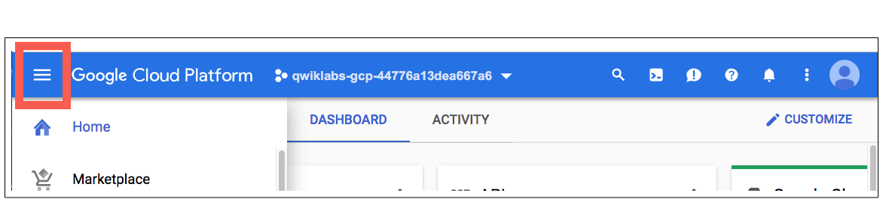

**Launch Hyperledger Fabric and Composer**

In this section, you will launch the Hyperledger Fabric and Composer solution available on GCP Marketplace.

1. From the **Navigation menu**, select **Marketplace**.
2. Type **Hyperledger** in the search box then select **Hyperledger Fabric and Composer**.
3. Click **LAUNCH ON COMPUTE ENGINE**.

You are now presented with the deployment properties setup.

1. For **Deployment name**, type hyperledger-fabric-and-composer.
2. Check the box to accept the Terms of Service.
3. Keep the rest of the settings at their defaults and click **Deploy**.

This solution will be deployed by **Deployment Manager** and you can watch the progress on the Deployment Manager screen, which is the screen you're on.

1. Once the solution is deployed, from the **Navigation menu**, select **Compute Engine**.

You should see a VM instance that was created as part of the deployment.

1. Click on the instance name to open the **VM instance details** page.
2. Click **EDIT** at the top.
3. Scroll down to **Network tags** and enter hyperledgerin the field.

This will allow you to configure specific firewall rules on instances which have been tagged with the Network tag - hyperledger. You will configure this in the next section.

1. Click **Save**.

Enable firewall access on the VM

To access Playground, you will need to enable port 8080 on the deployed VM. For security purposes, you will create a firewall rule that allows access to port 8080 only from your browser IP.

1. Open a new browser tab and navigate to [http://www.whatismyip.com](http://www.whatismyip.com/).
2. Copy the public IPv4 address.
3. In the Console, go to **Navigation menu** > **VPC network** > **Firewall rules**.
4. Click **CREATE FIREWALL RULE**.
5. Name for the firewall rule hyperleger-firewall-rule and add an optional description.
6. Under **Targets**, ensure that the **Specified target tags** option is selected.
7. For **Target tags**, enter the **Network tag** name that you created in the previous section, hyperledger.
8. Under **Source filter**, select **IP ranges**.
9. For **Source IP ranges**, enter your public IPv4 address with the mask /32. For example, if your public IPv4 address is 104.132.25.98, enter the range as 104.132.25.98/32.
10. Under **Protocols and ports**, select the **Specified protocols and ports** option.

a. Check the tcp checkbox b. Enter the port number in the tcp box as 8080

Note: This is the port number on which Hyperledger Composer will be listening by default.

1. Click **Create**. Wait for the firewall rule to be created before moving on.

**Deploy and access Hyperledger Composer Playground**

1. From the **Navigation menu**, select **Compute Engine**.
2. Click the **SSH** button for the Hyperledger VM.
3. Inside the SSH session, run the following command to run as root:
4. sudo su
5. Deploy Composer Playground by running:
6. composer-playground

This will deploy the Playground solution and run it on port 8080 by default.

1. Go back to the Console and copy the **External IP** of the Hyperledger VM.
2. Open a new browser tab and navigate to http://<ExternalIP>:8080 to access Hyperledger Composer Playground.
3. Click the **Let's Blockchain!** button to get started.

**Using Playground**

In this section, you will set up a business network, defining assets, participants and transactions, and testing the network by creating some participants, an asset, and submitting transactions to change the ownership of the asset from one to another.

**Create and connect to a new business network**

A business network has a couple of defining properties; a name, and an optional description. You can also choose to base a new business network on an existing template, or import your own template. This represents the different components of the business network:

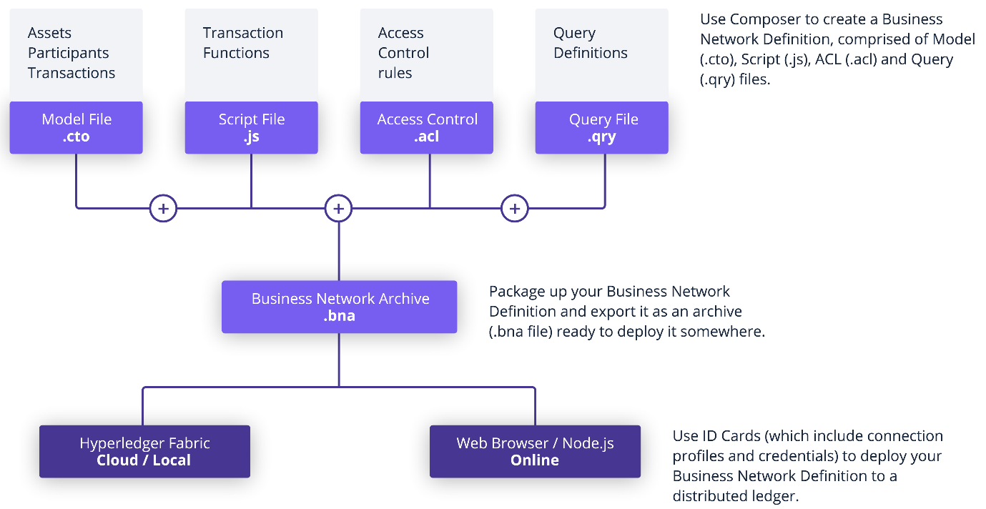

For typical solution architecture, refer to this [link](https://hyperledger.github.io/composer/latest/introduction/solution-architecture.html).

1. Click **Deploy a new business network** under the **Web Browser** heading to get started.

Note: Do not click the **Deploy a new business network** under the heading **Connection: hlfv1**.

1. In Basic Information, name the network tutorial-network and optionally add a description.
2. In Model Network Starter Template, select the **empty-business-network** card. You will be building a business network from scratch.
3. Keep the rest of the default settings and click **Deploy**.

You should see a new business network card called **admin** for the business network tutorial-network in your wallet. The wallet can contain business network cards to connect to multiple deployed business networks.

When connecting to an external blockchain, business network cards represent everything necessary to connect to a business network. They include connection details, authentication material, and metadata.

1. Now that the business network is deployed, click **Connect now** on tutorial-network.

**Add a model file**

You are now on the **Define** tab now. This is where you create and edit files that make up the business network definition.

Since you selected an empty business network template, you need to modify the default template files provided. The first step is to update the Model File. Model files define the assets, participants, transactions, and events in your business network.

1. Click **Model File** to view it.
2. Delete the existing lines of code in the Model File and replace it with this:

/**

* My commodity trading network

*/

namespace org.example.mynetwork

asset Commodity identified by tradingSymbol {

o String tradingSymbol

o String description

o String mainExchange

o Double quantity

--> Trader owner

}

participant Trader identified by tradeId {

o String tradeId

o String firstName

o String lastName

}

transaction Trade {

--> Commodity commodity

--> Trader newOwner

}

This domain model defines a single asset type Commodity and single participant type Trader and a single transaction type Trade that is used to modify the owner of a commodity.

**Add a transaction processor script file**

You can now define the transaction logic for the business network. Composer expresses the logic for a business network using JavaScript functions. These functions are automatically executed when a transaction is submitted for processing.

1. In the bottom left, click the **Add a file** link.
2. Click the **Script File** radio button, then **Add**.
3. Delete the lines of code in the script file and replace it with the following code:

/**

* Track the trade of a commodity from one trader to another

* @param {org.example.mynetwork.Trade} trade - the trade to be processed

* @transaction

*/

async function tradeCommodity(trade) {

trade.commodity.owner = trade.newOwner;

let assetRegistry = await getAssetRegistry('org.example.mynetwork.Commodity');

await assetRegistry.update(trade.commodity);

}

This function changes the owner property on a commodity based on the newOwner property on an incoming Trade transaction. It then persists the modified Commodity back into the asset registry, used to store Commodity instances.

Deploy the updated business network

Now that you have the model, script, and access control files, you can deploy and test your business network.

Click **Deploy changes** to upgrade the business network.

**Test the business network definition**

Next, test your business network by creating some participants (in this case Traders), creating an asset (a Commodity), and then using your Trade transaction to change the ownership of the Commodity.

Click the **Test** tab to get started.

**Create participants**

1. Ensure that you have the **Trader** tab selected on the left, and click **Create New Participant** in the upper right.

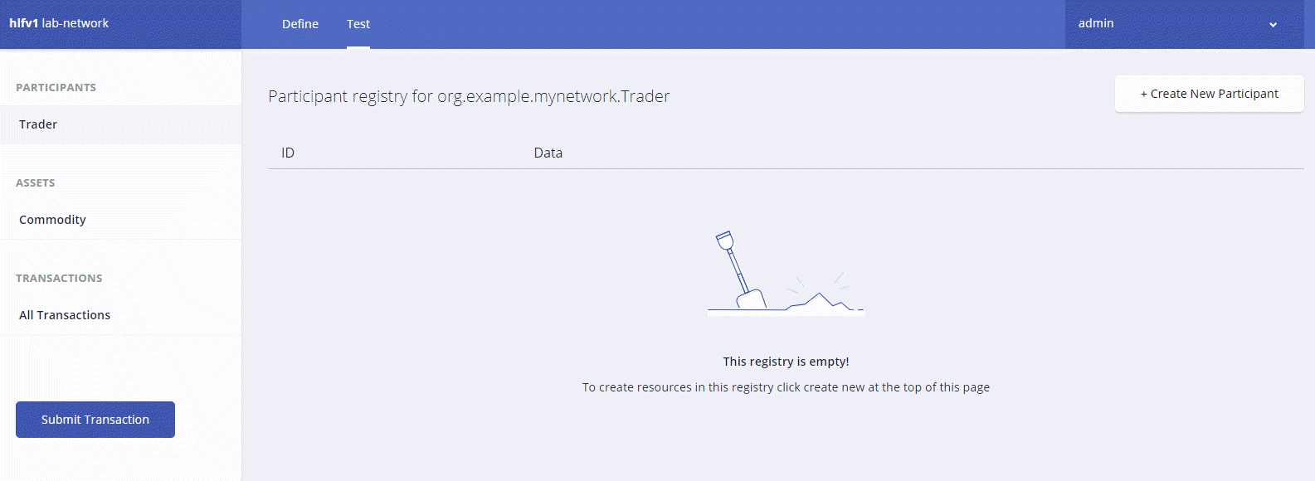

1. What you can see is the data structure of a Trader participant. We want some easily recognizable data, so delete the code that's there and paste the following:

{

"$class": "org.example.mynetwork.Trader",

"tradeId": "TRADER1",

"firstName": "Jenny",

"lastName": "Jones"

}

1. Click **Create New** to create the participant.
2. You should be able to see the new Trader participant you created. You'll need another Trader to test your Trade transaction though, so create another Trader, but this time, use the following data:

{

"$class": "org.example.mynetwork.Trader",

"tradeId": "TRADER2",

"firstName": "Amy",

"lastName": "Williams"

}

Make sure that both participants exist in the Trader view before moving on.

Create an asset

Now that you have two Trader participants, you need something for them to trade. Creating an asset is very similar to creating a participant. The Commodity you are creating will have an owner property indicating that it belongs to the Trader with the tradeId of TRADER1.

1. Click **Commodity** under Assets and click **Create New Asset**.
2. Delete the asset data and replace it with the following:

{

"$class": "org.example.mynetwork.Commodity",

"tradingSymbol": "ABC",

"description": "Test commodity",

"mainExchange": "Euronext",

"quantity": 72.297,

"owner": "resource:org.example.mynetwork.Trader#TRADER1"

}

1. After creating this asset, you should be able to see it in the Commodity page.

Transfer commodity between participants

With two Traders and a Commodity to trade between them you can test your Trade transaction. Transactions are the basis of all changes in a Hyperledger Composer business network.

1. Click the **Submit Transaction** button on the bottom left.
2. Ensure that the transaction type is Trade.
3. Replace the transaction data with the following, or just change the details:

{

"$class": "org.example.mynetwork.Trade",

"commodity": "resource:org.example.mynetwork.Commodity#ABC",

"newOwner": "resource:org.example.mynetwork.Trader#TRADER2"

}

1. Click **Submit**.
2. Check that the asset has changed ownership from TRADER1 to TRADER2 by expanding the data section for the asset. You should see that the owner is listed as: org.example.mynetwork.Trader#TRADER2.

To view the full transaction history of the business network, click **All Transactions** on the left.

You will get a list of each transaction as they were submitted. You can see that certain actions performed using the UI, like creating the Trader participants and the Commodity asset, are recorded as transactions even though they are not defined as transactions in the business network model. These transactions are known as **System Transactions** and are common to all business networks and defined in the Hyperledger Composer Runtime.

In this lab, you created a business network from scratch and defined a model file inside it. Alternatively, you could deploy one of the [sample networks](https://github.com/hyperledger/composer-sample-networks/tree/master/packages) available from Hyperledger.

Integrating with existing applications

Hyperledger Composer can be integrated with existing systems by using a Loopback API. Integrating existing systems allows you to pull data from existing business systems and convert it to assets or participants in a Composer business network. Refer to this [link](https://hyperledger.github.io/composer/latest/integrating/integrating-index) for more details.

**Congratulations!**

You have successfully created, deployed, and tested a business network using Hyperledger Composer Playground.

Next Steps / Learn More

* For more information on Hyperledger Composer, visit the [site](https://hyperledger.github.io/composer/latest/introduction/introduction.html).
* For more information on writing transaction processor functions, read the [documentation](https://hyperledger.github.io/composer/v0.19/reference/js_scripts.html).
* For more information on the modeling language, read the [documentation](https://hyperledger.github.io/composer/v0.19/reference/cto_language.html).

Google Cloud Training & Certification

...helps you make the most of Google Cloud technologies. [Our classes](https://cloud.google.com/training/courses) include technical skills and best practices to help you get up to speed quickly and continue your learning journey. We offer fundamental to advanced level training, with on-demand, live, and virtual options to suit your busy schedule. [Certifications](https://cloud.google.com/certification/) help you validate and prove your skill and expertise in Google Cloud technologies.

Manual Last Updated March 18, 2019

Lab Last Tested January 10, 2019

Copyright 2020 Google LLC All rights reserved. Google and the Google logo are trademarks of Google LLC. All other company and product names may be trademarks of the respective companies with which they are associated.