System Design:
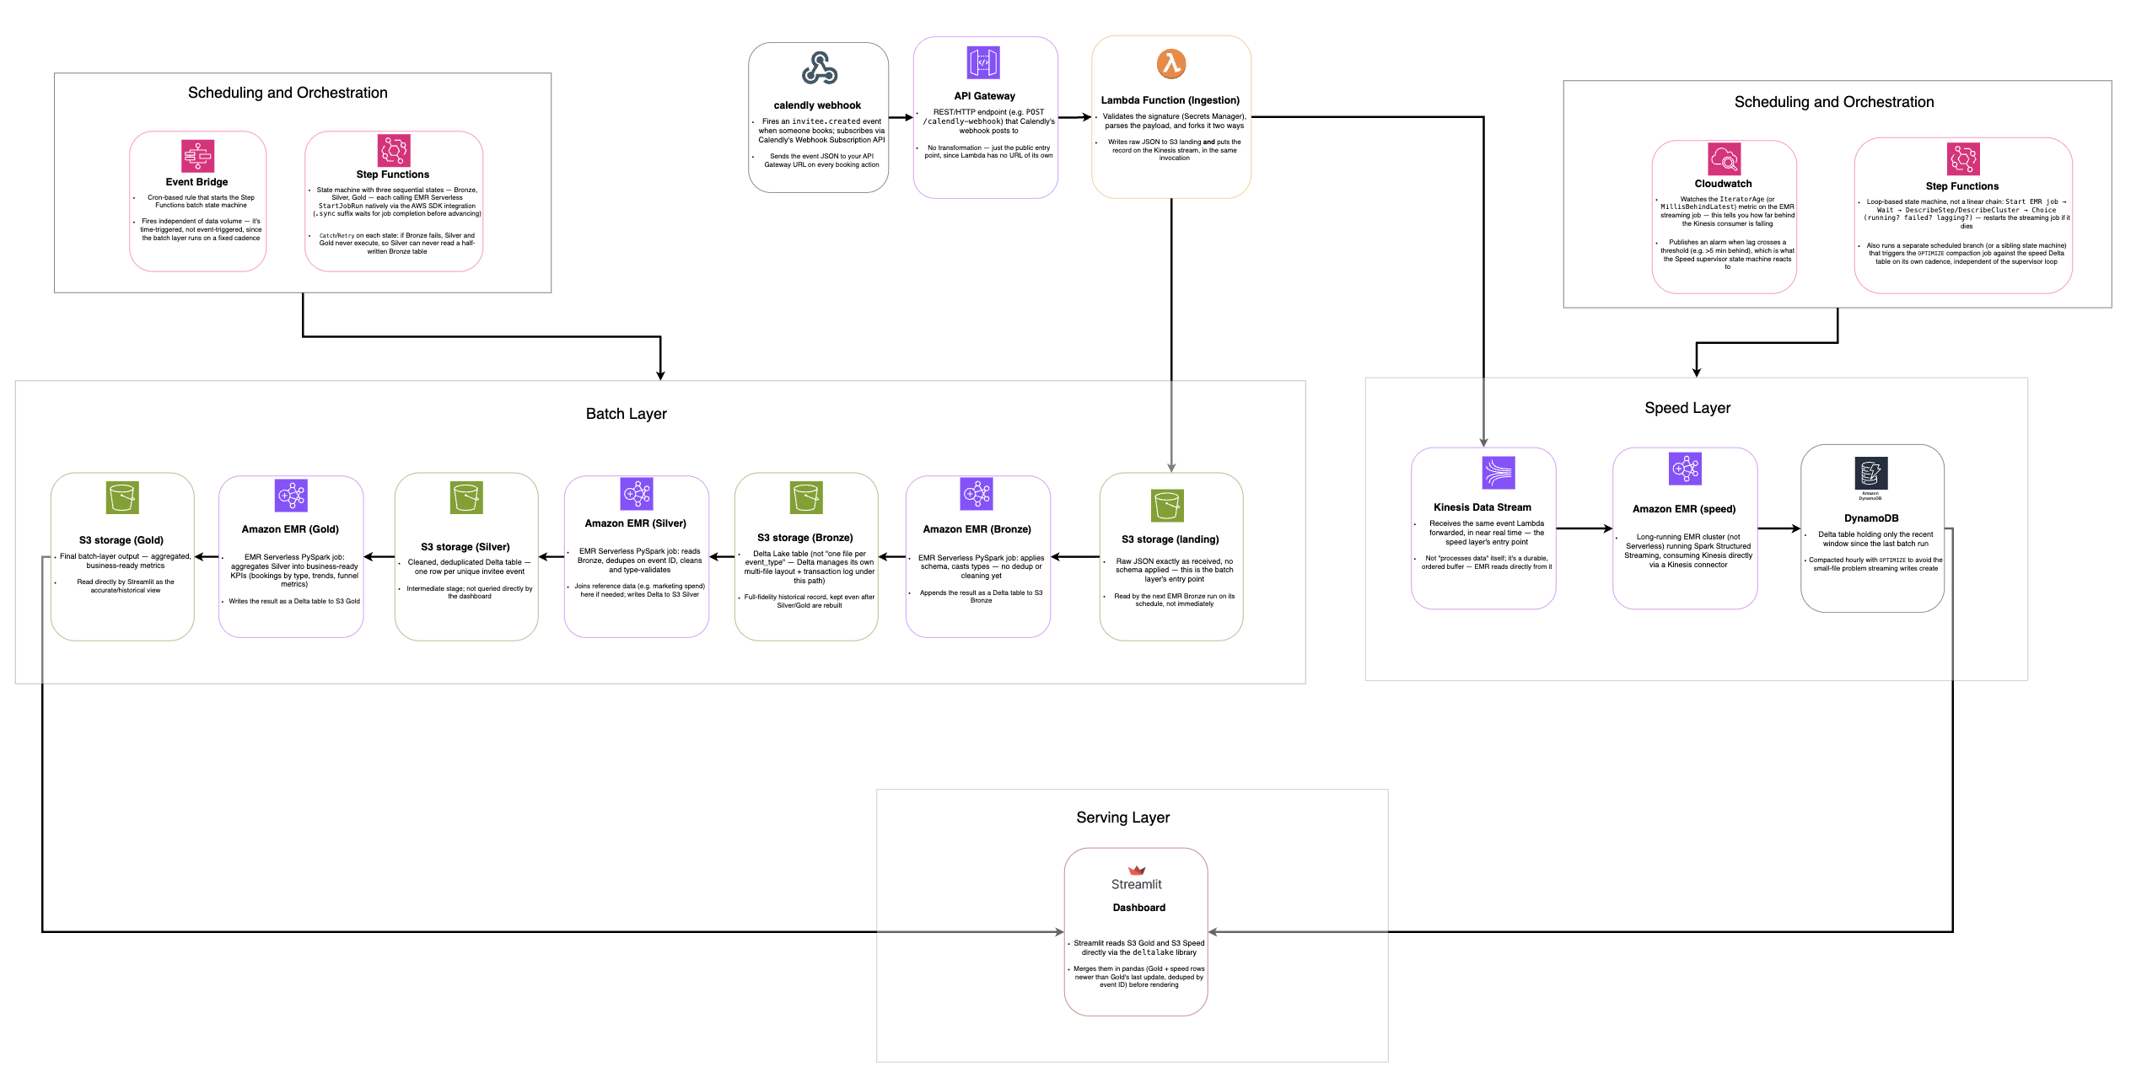
Data Modeling:
Silver Layer:
- silver_bookings

booking_id
booking_date
channel
start_time
end_time
host_email
host_name
utm_source

- silver_marketing_spend

date
channel
spend

Gold Layer:

- gold_bookings_by_source_daily

booking_date
utm_source
booking_count

- gold_cpb_by_channel

channel
total_bookings
total_spend
cost_per_booking

- gold_booking_time_distribution

day_of_week
booking_date
utm_source
booking_count

- gold_employee_meeting_load

host_email
week_start_date
meeting_count

