Cow And Bull Problem

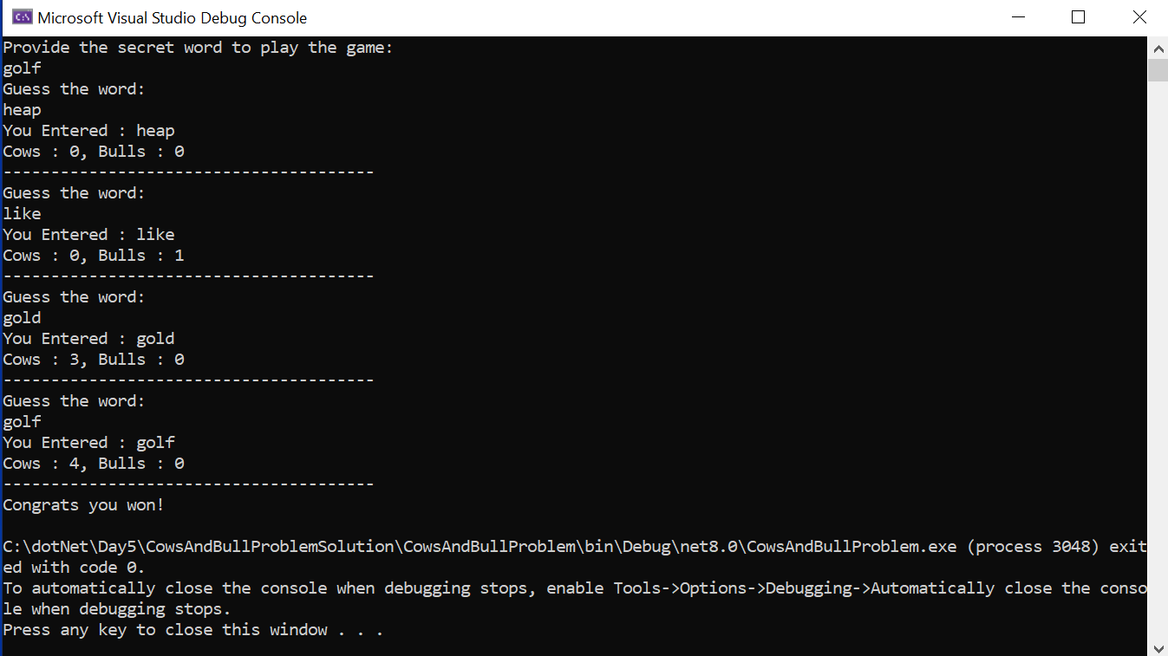

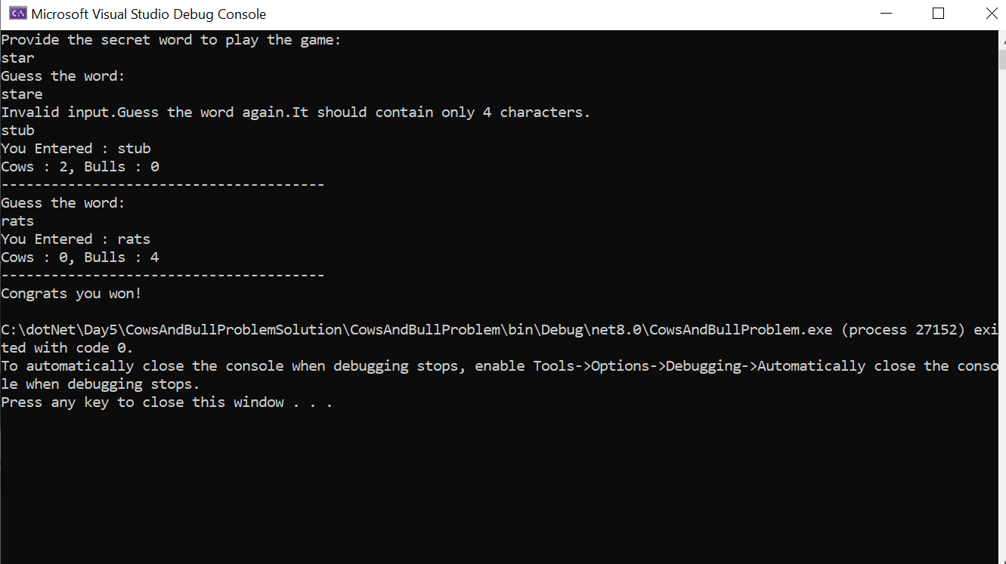

Leetcode Problem

public class Solution {

public string GetHint(string secret, string guess) {

int cows = 0, bulls =0;

int[] secretVal= new int[10];

int[] guessVal= new int[10];

for (int i = 0; i < guess.Length; i++)

{

if (guess[i] == secret[i])

{

bulls += 1;

}else{

secretVal[secret[i]-'0']++;

guessVal[guess[i]-'0']++;

}

}

for(int i=0;i<10;i++){

cows+= secretVal[i] < guessVal[i] ? secretVal[i] : guessVal[i];

}

string resStr = bulls+"A"+cows+"B";

return resStr;

}

}

