CUSTOMER
CHURN
PREDICTION
Customer churn prediction refers to the practice of using data analysis and predictive modeling techniques to forecast which customers are likely to stop using a product or service, often referred to as "churning" or "churned customers." Churn prediction is a valuable business strategy, especially for subscription-based services, telecom companies, e-commerce platforms, and other businesses that rely on customer retention and loyalty.
ABSTRACT
The project involves using IBM Cognos to predict customer churn and identify factors influencing customer retention. The goal is to help businesses reduce customer attrition by understanding the patterns and reasons behind customers leaving. This project includes defining analysis objectives, collecting customer data, designing relevant visualizations in IBM jCognos, and building a predictive model.
PROBLEM
DEFINITION
DESIGN
THINKING
ANALYSIS
OBJECTIVES
Define the specific objectives of predicting customer churn, such as identifying potential churners and understanding the key factors contributing to churn.
ANALYSI
S
OBJECTIV
ES
1.The primary objective of churn prediction is to identify customers who are at risk of churning. This can be done by developing a predictive model that assigns a churn probability score to each customer
2.Aim to detect potential churners as early as possible. Early detection allows for proactive measures to be taken, such as targeted marketing campaigns or personalized incentives, to retain these customers.
1
.Identify Potential
Churners
2
.Early Detection
3
.Reduce Churn
Rate
3.Set a specific target for reducing the churn rate. This objective could be framed as a percentage reduction in churn over a specified time period (e.g., reduce churn by 10% in the next quarter).
4.Segment the customer base based on churn probability and other relevant factors. This allows for tailored retention strategies for different customer groups. For example, high-value customers may receive different retention efforts compared to low-value customers.
5.Understand the key factors contributing to churn. Conduct feature importance analysis to identify which customer attributes, behaviors, or interactions with the company have the most significant impact on churn.
4
.Segmentation
5
.Feature Analysis
6
.Customer
Lifetime Value
(
CLV
)
6.Calculate CLV for each customer and analyze how it correlates with churn. The objective may be to increase the CLV of customers at risk of churning
7.Set performance benchmarks for your churn prediction model. This includes metrics such as accuracy, precision, recall, and F1-score. Aim to achieve a certain level of model accuracy in predicting churn.
8.The ultimate goal is to provide actionable insights to the business. Ensure that your churn prediction analysis translates into specific actions that can be taken to retain customers. These actions may include sending targeted offers, improving customer service, or enhancing product features.
7
.Model
Performance
8
.Actionable
Insights
9
.Monitoring and
Iteration
9.Implement a system for continuous monitoring of churn and model performance. Establish a process for regular model retraining and refinement to adapt to changing customer behaviors and market conditions.
10.Evaluate the cost of customer acquisition compared to the cost of retaining customers. The objective may be to reduce the cost of retention efforts while maximizing their effectiveness.
11.Integrate customer feedback into the churn prediction process. Identify the sentiment of customer feedback from potential churners and use it to refine retention strategies.
10
.Cost Reduction
11
.Customer
Feedback
Integration:
12
.Benchmarking
12.Compare your churn prediction and retention efforts with industry benchmarks or competitors to assess your performance and identify areas for improvement
Data
Collection
Determine the sources and methods for collecting customer data, including customer demographics, usage behavior, and historical interactions.
Data Collection

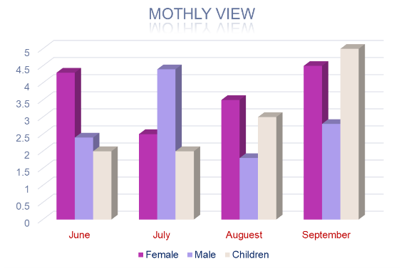

1.Use data mining techniques to extract valuable insights from large datasets. This can help identify patterns and factors that contribute to customer churn.
2.Implement predictive models like logistic regression, decision trees, or neural networks to analyze historical data and predict future churn based on customer behavior and demographics.
Methods for Collecting
Customer Data:
1
.Data Mining
2
.Machine Learning
Models
3
.Third
-
party Data
3.Consider using external data sources, such as market data or industry benchmarks, to enhance your analysis and gain a broader perspective on customer behavior.
Visualization
Strategy
Plan how to visualize the insights using IBM Cognos, showcasing factors affecting churn and retention rates for customer churn prediction project
Visualizatio
n
Strategy
1.Start by thoroughly understanding your dataset and the variables that may customer churn and retention. Identify key features and potential predictors.
2.Select appropriate visualization types for different types of data. For Example: Use line charts to visualize trends in churn and retention rates over Time. Create bar charts or pie charts to represent categorical variables like product usage, demographics, or subscription Type. Scatter plots can be useful to explore relationships between variables.
1
.Understand the
Data
2
.Choose the Right
Visualizations
3.Design a dashboard in IBM Cognos to bring all your visualizations together. A dashboard provides a unified view of insights.
Include a title, date, and description to provide context.
4.Display key churn and retention metrics prominently on the dashboard. This could include customer counts, churn rates, retention rates, and their trends.
3
.Create a
dashboard
4
.Churn and
Retention Metrics
5
.Color and
Formatting:
5.Choose a consistent color scheme and formatting style for your visualizations to make them visually appealing and easy to interpret.
Predictive
modeling

1.SVM - SVM or Support Vector Machine 2.Ridge Classifier 3.Random Forest 4.XG boost
Algorithms to predict customer churn prediction
SVM - SVM or Support Vector Machine is a supervised machine learning technique used for classification and regression. Finding a hyperplane in an N-dimensional space that classifies the data points is the goal of the SVM method. The number of features determines the hyperplane's size.
About the algorithms
Ridge Classifier - Ridge classification is a method used in machine learning to assess linear discriminant models. In order to prevent overfitting, this type of normalization limits model coefficients.
Random Forest - Random Forest is a
classification algorithm that uses multiple decision trees on smaller sets of the input dataset and averages the results to enhance the dataset's prediction accuracy.
XG Boost - Formally speaking, XGBoost may be described as a decision tree-based ensemble learning framework that uses Gradient Descent as the underlying objective function. It offers excellent flexibility and efficiently uses computation to produce the mandated results.
In conclusion, customer churn prediction plays a pivotal role in helping businesses retain their customers. By leveraging data-driven models and analytics, companies can identify potential churners and take proactive measures to retain them. This not only helps in maintaining revenue but also enhances customer satisfaction and loyalty.
Conclusion

