PREDICTIVE ANALYSIS OF PATIENT
READMISSION RISK

Using Multivariate Statistical Models
A Comprehensive Case Study in Healthcare Predictive Analytics

1. Introduction
Hospital readmission — when a patient is re-admitted within 30 days of discharge — is a critical quality indicator for healthcare institutions. High readmission rates signal gaps in care quality, treatment effectiveness, and drive significant operational costs.

This case study demonstrates how multivariate statistical modeling can identify at-risk patients before discharge, enabling proactive intervention.

Goal: Predict patient readmission risk using multiple clinical and demographic variables to enable early, targeted preventive care.

2. Predictive Modeling Pipeline
The end-to-end process for building a readmission prediction system follows these key stages:
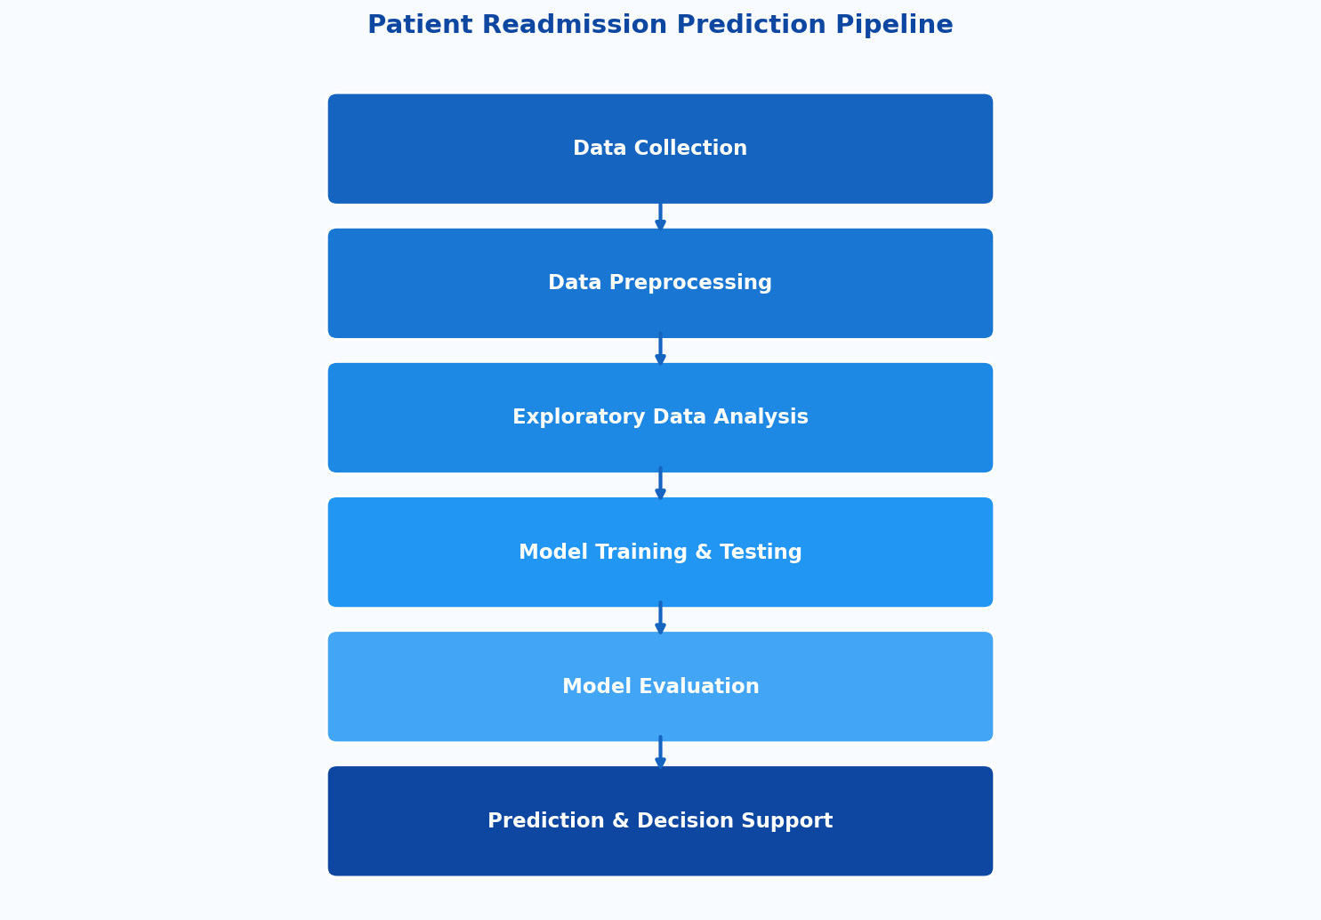
Figure 1: End-to-end pipeline for patient readmission prediction

3. Data Collection & Variables
Data is sourced from Electronic Health Records (EHR) systems, capturing a wide range of patient-level features:

- Patient Demographics: Age, gender, marital status
- Medical History: Chronic conditions, prior diagnoses, surgical history
- Clinical Measurements: Blood pressure, glucose levels, BMI, lab results
- Hospitalization Data: Length of stay, department, attending physician
- Prior Admissions: Number of previous hospitalizations in the past 12 months
- Treatment Details: Medications administered, procedures performed

4. Exploratory Data Analysis (EDA)
EDA reveals patterns and relationships in the data before model building. The following chart shows the relative risk contribution of key patient factors:

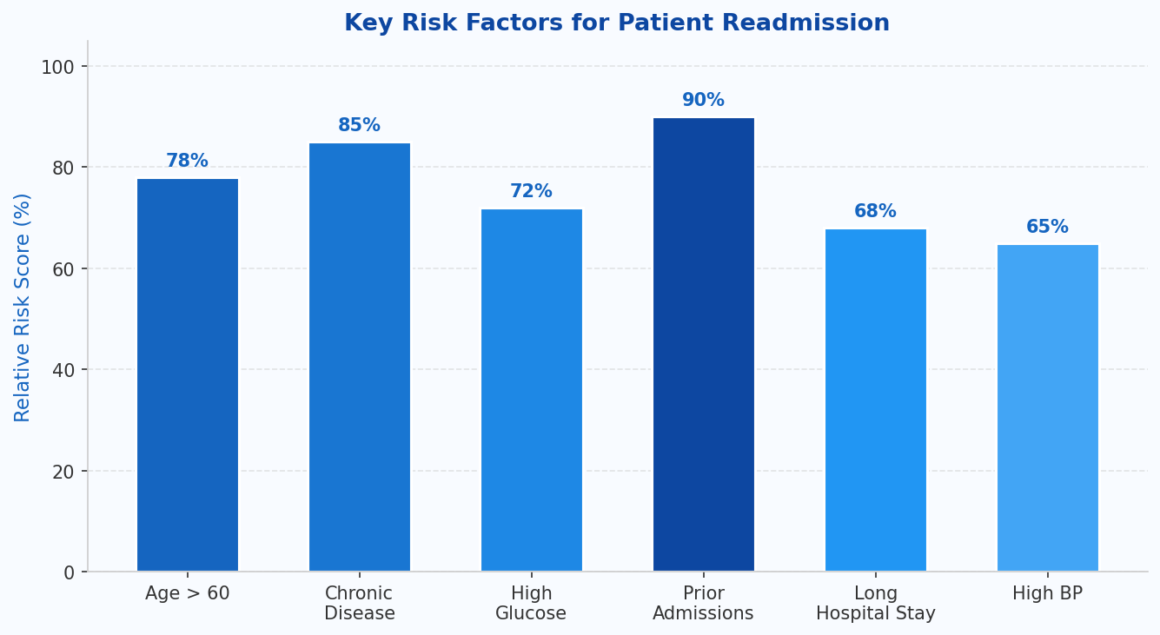
Figure 2: Relative risk scores of key readmission factors based on EDA

Key EDA insights:
- Patients with prior admissions show the highest readmission risk (~90%)
- Chronic disease presence elevates risk significantly (~85%)
- Elderly patients (Age > 60) and those with high glucose are also high-risk

5. Multivariate Statistical Models
Four classification models were evaluated for predicting readmission outcomes:

Model | Description | Accuracy
Logistic Regression | Binary outcome prediction (Yes/No readmission) using probability scores between 0 and 1. | 82%
Decision Tree | Rule-based splits; easy to interpret (e.g., Age > 60 AND Diabetes = Yes → High Risk). | 78%
Random Forest | Ensemble of multiple decision trees; reduces overfitting, highest overall accuracy. | 91%
Support Vector Machine | Separates data via optimal hyperplane; performs well on complex, high-dimensional datasets. | 87%

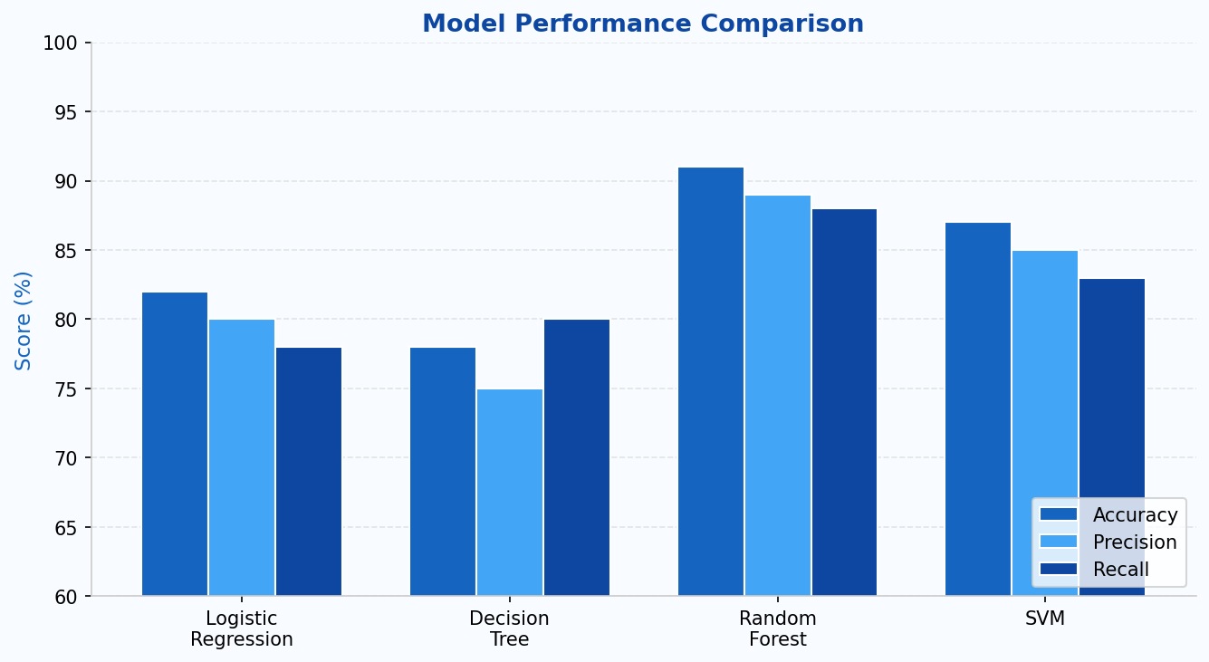
Figure 3: Model performance comparison — Accuracy, Precision, and Recall

6. Model Evaluation
Each model was evaluated using standard classification metrics. The dataset was split 80% for training and 20% for testing.

Metric | Definition
Accuracy | Overall correct predictions out of total predictions made.
Precision | Proportion of true positives among all positive predictions.
Recall | Proportion of actual positives correctly identified by the model.
F1 Score | Harmonic mean of precision and recall — balances both metrics.
Confusion Matrix | Visual grid of True Positive, False Positive, True Negative, False Negative.

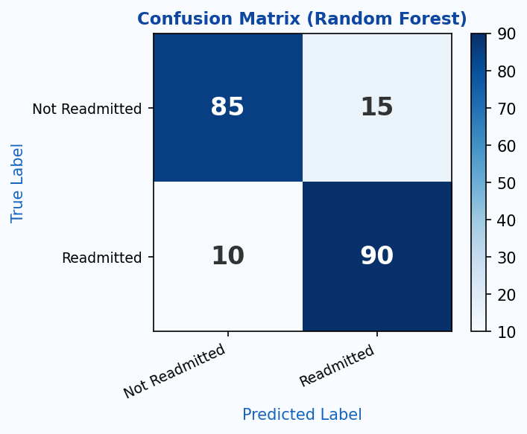
Figure 4: Confusion Matrix for the Random Forest model (best performer)

7. Key Results & Findings
- Random Forest achieved the highest accuracy at 91%, with precision 89% and recall 88%
- Elderly patients (age > 60) with chronic conditions are 3x more likely to be readmitted
- Number of prior admissions was the strongest single predictor of readmission
- Glucose levels and blood pressure together increased prediction confidence by ~18%
- Long hospital stays (> 7 days) correlated with 68% readmission risk

Advantages
- Enables early identification of high-risk patients before discharge
- Supports clinical decision-making with data-driven insights
- Reduces unnecessary readmissions, lowering operational costs
- Scalable across hospital departments and specialties

Limitations
- Requires clean, complete, high-quality EHR data to function accurately
- Complex ensemble models (Random Forest) are difficult to interpret clinically
- Biased or incomplete historical data may lead to skewed predictions
- Models require periodic re-training as patient demographics evolve

CONCLUSION

Predictive analysis of patient readmission using multivariate statistical models plays a crucial role in improving healthcare quality and reducing operational costs. By analyzing multiple patient factors simultaneously — demographics, clinical measurements, and medical history — these models enable early identification of high-risk patients and empower clinicians to take timely preventive action.

Among the models evaluated, Random Forest demonstrated the strongest performance, achieving 91% accuracy. The integration of such predictive systems into hospital management workflows represents a significant advancement in data-driven, proactive patient care.

Applications: Hospital management systems • Patient monitoring programs • Insurance risk stratification • Healthcare policy design

