RESEARCH METHODOLOGY ASSIGNMENT

Coding Agents in Enterprise SDLC
Guardrails, Review Load, and Real Productivity
on Private Repositories

Student Name | Puneetha
Programme | M.Tech - Artificial Intelligence, Machine Learning and Data Science
Institution | PES University
Project Type | Enterprise empirical software engineering capstone
Date | September 2026
Research focus: design and evidence-based, privacy-preserving evaluation of a governed agentic SDLC (A-SDLC) for coding agents in real enterprise development workflows

Assignment Deliverables
Item | Included content
Deliverable 1 | Abstract (approximately 25-30 lines) and literature-survey foundation
Deliverable 2 | Ten relevant peer-reviewed/indexed research articles in Harvard format
Deliverable 3 | High-level block diagram and proposed research methodology
Deliverable 4 | Plagiarism-report submission record
Deliverable 5 | Condensed abstract (approximately 15 lines)
Deliverable 6 | Ten SCI/Scopus-indexed journals relevant to the project

Project Overview
Coding agents can plan, generate, modify, test and explain software across multiple files. Their value in enterprise software development, however, cannot be established from code-completion speed alone. Private repositories contain legacy architecture, organisation-specific conventions, confidential intellectual property, security boundaries and complex review practices. The proposed capstone will measure whether coding agents improve end-to-end delivery while maintaining quality, security, privacy and reviewer trust.
The proposed solution is a governed Agentic Software Development Lifecycle (A-SDLC). An orchestrator agent decomposes each ticket and delegates the work to stage-specific sub-agents through Model Context Protocol (MCP) integrations, across an eight-step, two-phase ticket-to-merge pipeline. Humans retain authority over intent, architecture and merge, and agents are used only where they can raise velocity without bypassing policy.

Research Problem
Enterprises lack an evidence-based method to decide where coding agents should be permitted, which guardrails are necessary, and whether apparent developer speed translates into net team productivity. Existing evaluations frequently use public benchmarks, isolated programming exercises or self-reported perceptions. They rarely quantify the additional review effort, rework, CI failures, security findings and governance risk created when agents operate on private, evolving codebases. A further, largely unmeasured risk is that agents generate code faster than engineers can safely review it, moving the bottleneck from code production to review queues and defect leakage.

Primary Research Objective
To design, implement and empirically evaluate a governed, privacy-preserving agentic SDLC framework for coding agents in enterprise workflows, with simultaneous measurement of guardrail effectiveness, review load, software quality and net productivity on private repositories.

Research Questions
- RQ1: How does coding-agent assistance affect end-to-end delivery productivity across unaided, agent-assisted and agent-driven working modes, compared with a human-only baseline?
- RQ2: How does agent-generated or agent-modified code affect reviewer effort, review cycles, rework and merge latency?
- RQ3: Which technical and process guardrails most effectively prevent insecure, non-compliant or out-of-scope changes?
- RQ4: Do productivity effects vary by task type, repository maturity, codebase familiarity and developer experience?
- RQ5: What adoption thresholds provide a favourable balance among speed, quality, security, privacy and human oversight?

Deliverable 1: Abstract (25-30 Lines)
Coding agents based on large language models are rapidly entering software development, but their real value in enterprise software delivery remains uncertain. This research aims to design, implement and evaluate a governed Agentic Software Development Lifecycle (A-SDLC) for private enterprise repositories, and to determine whether specialised coding agents improve real delivery once guardrails, human review load and rework are fully accounted for. The work is needed because faster code generation does not necessarily mean faster or safer delivery. Most performance claims come from public benchmarks, isolated programming exercises or inline-completion trials, which do not represent the access controls, secrets management, dependency policies, protected branches and continuous integration (CI) pipelines of enterprise repositories. Agents may also produce changes faster than engineers can safely review them, shifting the bottleneck from implementation to review queues, testing, security remediation and defect leakage. Prior studies report useful gains from AI-assisted programming, and code-review research shows that review participation and rework materially affect quality, but these streams are rarely combined, and governance is usually left as an open problem. This study differs by implementing a closed ticket-to-merge loop on private repositories with an immutable audit trail, in which every change must pass CI, security policy and human review, so that the governance layer itself is implemented, tested and scored. An orchestrator agent delegates work to stage-specific sub-agents through Model Context Protocol (MCP) integrations across an eight-step, two-phase pipeline. Phase 1 (Analysis and Generation) covers requirements analysis, design, code generation and test-case creation, with a ReAct (reason-act-observe) loop driving iterative, test-driven edits. Phase 2 (Review and Closure) covers CI test execution, AI-assisted code review, central-repository validation and Definition-of-Done checks, with human approval gates retained for scope, design and merge. Guardrails cover path rules, secret scanning, least-privilege permissions, dependency controls, mandatory tests, step and budget limits, and audit logging. Matched bug-fix, feature and refactoring tasks will be compared across three working modes, unaided developer, agent-assisted and agent-driven, against a human-only baseline period. Evidence will be collected from Git history, pull requests, review comments, CI pipelines, security scans, issue trackers and short developer surveys, while proprietary source code and prompts remain inside the enterprise boundary. Measures will include task completion and merge rate, time to first pull request, lead time to merge, reviewer minutes, review cycles, retries, policy-block triggers, test pass rate, escaped defects and post-merge rework. Net engineering effort will be computed as unaided effort minus agent execution, human review, rework and failure-recovery time, and difference-in-differences and mixed-effects models will control for developer, repository and task variation. The expected outcome is a balanced scorecard showing whether faster initial patching is achieved without inflating review bottlenecks or residual defects, together with evidence on which guardrails reduce risk with the least workflow friction. Results will support an adoption matrix that tells engineering leaders where coding agents should be allowed, monitored or restricted, turning adoption from a perception-driven decision into an evidence-based engineering practice.

Keywords
Coding agents; agentic SDLC; enterprise SDLC; private repositories; developer productivity; modern code review; guardrails; ReAct; Model Context Protocol; human-in-the-loop; software quality; secure software development; empirical software engineering.

Literature Survey and Research Foundation

Theme 1: LLMs and AI-assisted software engineering
Research shows that code-oriented language models can support generation, repair, testing and comprehension, but performance varies by task, context and evaluation method. Hou et al. (2024) synthesised a broad LLM-for-software-engineering literature and highlighted evaluation, dataset and reproducibility gaps, while Gao et al. (2025) set out the open challenges that LLMs create for software engineering practice, including reliability, evaluation and integration into existing processes. Dakhel et al. (2023) found that GitHub Copilot can be useful but produces outputs requiring careful validation. These findings support treating the coding agent as a fallible collaborator rather than an autonomous trusted committer.

Theme 2: Agentic and repository-level workflows
Yao et al. (2023) introduced ReAct, which interleaves reasoning traces with tool actions and observations; this is the loop the proposed coding agent runs against Git, the build and the test suite. Jimenez et al. (2024) showed with SWE-bench that resolving real GitHub issues is much harder than isolated function synthesis, yet the benchmark still uses public repositories without enterprise access rules, human review or CI policy. Wang et al. (2024) surveyed LLM-based software testing and showed both the promise of generated tests and the risk of weak test oracles, which motivates mandatory test gates and traceability of tests to requirements.

Theme 3: Review load and software quality
Modern code review research demonstrates that review coverage, participation and process quality influence defect outcomes. McIntosh et al. (2016) associated weak review practices with poorer software quality, while Bosu et al. (2017) showed that code review is also a social coordination process. Coding agents may reduce authoring effort while increasing reviewer burden; therefore reviewer time, review cycles, requested changes and rework must be first-class outcomes.

Theme 4: Productivity as a multidimensional outcome
Developer productivity cannot be represented safely by lines of code or commit counts. Forsgren et al. (2021) proposed the SPACE framework, a multidimensional view spanning satisfaction, performance, activity, communication and efficiency. The proposed study will therefore report speed, quality, review load and developer experience together, compute net engineering effort rather than raw generation speed, and never use a single metric to rank individual developers.

Theme 5: Security, privacy and governance
AI-generated code can reproduce insecure patterns, introduce unsuitable dependencies or expose confidential context. Ozkaya (2023) argues that applying LLMs to software engineering tasks brings risks of incorrect output, data leakage and over-reliance that require deliberate engineering controls. Enterprise use also creates risks relating to data residency, prompt logging, repository permissions and licence provenance. The study therefore embeds policy-as-code controls, path rules, least-privilege access, secret scanning, software composition analysis, static analysis, test requirements, step and budget caps, audit logging and mandatory human approval into the experimental workflow.

Consolidated Research Gap
Existing research provides strong foundations for AI code generation, agentic tool use, modern code review and developer productivity, but these areas are commonly evaluated in isolation. Surveys map the gaps and reference architectures leave governance as an open problem, while benchmark and inline-assistant studies measure patch success, suggestion latency or acceptance rate rather than a reviewed, CI-green change. There is limited longitudinal evidence from private enterprise repositories that measures both the benefit created by a coding agent and the downstream human effort and risk it generates. This capstone addresses that gap through a governed, privacy-preserving, ticket-to-merge and multi-metric evaluation.

Literature Evidence Matrix
Study | Main contribution | Use in this capstone | Remaining gap
Dakhel et al. (2023) | Empirical assessment of GitHub Copilot as an AI pair programmer. | Direct evidence on usefulness and limitations of generated code. | Does not measure a controlled private-repository rollout with review-cost accounting.
Hou et al. (2024) | Systematic review of LLM applications across software engineering. | Provides taxonomy, evaluation approaches and open research gaps. | Broad review; not an enterprise intervention study.
Gao et al. (2025) | Identifies the current challenges of software engineering in the LLM era. | Frames reliability, evaluation and process-integration risks to be measured. | Agenda paper; no controlled enterprise evaluation.
Jimenez et al. (2024) | SWE-bench: resolution of real GitHub issues by language models. | Public benchmark baseline for repository-level agent capability. | Public repositories; no access policy, human review or CI governance.
Yao et al. (2023) | ReAct: interleaving reasoning traces with tool actions and observations. | Reasoning loop used by the coding agent (Step 3 of the pipeline). | Evaluated on general reasoning tasks, not governed software delivery.
Wang et al. (2024) | Survey of software testing with large language models. | Informs test-case generation (Step 4) and test-gate design. | Does not measure the review or rework cost of generated tests.
McIntosh et al. (2016) | Links modern code review practices with software quality. | Motivates review coverage and participation measures. | No AI-assisted development condition.
Bosu et al. (2017) | Examines process and social dynamics of code review. | Supports reviewer workload and collaboration measures. | Does not quantify agent-created review demand.
Forsgren et al. (2021) | Defines multidimensional developer productivity through SPACE. | Prevents reliance on simplistic activity metrics; basis for net-effort scorecard. | Conceptual framework rather than private-repository experiment.
Ozkaya (2023) | Opportunities, risks and implications of LLMs for software engineering tasks. | Motivates guardrails, human oversight and explicit risk measures. | Position paper; risks are not empirically quantified.

Proposed Objectives and Hypotheses

Specific Objectives
- Define a deployable guardrail architecture for coding agents working with private repositories.
- Measure end-to-end productivity before and after controlled coding-agent adoption.
- Quantify the review effort and rework associated with agent-assisted changes.
- Measure changes in software quality, security findings and policy compliance.
- Identify task, developer and repository conditions that explain beneficial or harmful outcomes.
- Produce an enterprise decision framework for safe adoption and continuous monitoring.

Testable Hypotheses
- H1: Agent assistance reduces median lead time for eligible low- and medium-complexity tasks.
- H2: Agent-assisted pull requests require more review comments or revision cycles unless contextual and policy guardrails are applied.
- H3: Guardrails reduce security and policy violations without removing the productivity benefit for eligible tasks.
- H4: Net productivity gains are larger for repetitive and well-specified tasks than for architecture-intensive tasks.
- H5: Codebase familiarity and developer experience moderate both productivity and review-load effects.

Data Availability and Governance
Source | Candidate fields | Privacy treatment
Git metadata | Commit timestamps, change size, files touched, reverts | Repository-local extraction; pseudonymous developer ID
Pull requests | Open/merge times, reviews, comments, cycles, requested changes | Comment text excluded or de-identified unless separately approved
CI/CD | Build duration, test result, deployment result, rollback | Pipeline metadata only
Quality/security | Static-analysis, secret, dependency and vulnerability findings | Finding category/severity; no proprietary code snippet
Issue tracker | Task type, complexity, start/end status, acceptance | Business-sensitive fields minimised
Developer survey | Trust, cognitive load, satisfaction, perceived usefulness | Voluntary; aggregated reporting; no individual ranking
Agent audit log | Stage, tool calls, retries, policy blocks, step/budget usage, human-gate decisions | Kept inside the enterprise boundary; prompt and code content excluded

Deliverable 2: Ten Relevant Research Articles
The following references use Harvard style. The list combines direct coding-agent and LLM-for-software-engineering research, the agent reasoning loop and benchmark used by the method, and established work on review quality, developer productivity and LLM risk. Two items (Jimenez et al., 2024; Yao et al., 2023) are widely cited, peer-reviewed ICLR conference papers rather than journal articles.
Bosu, A., Carver, J.C., Bird, C., Orbeck, J. and Chockley, C. (2017) 'Process aspects and social dynamics of contemporary code review: Insights from open source development and industrial practice at Microsoft', IEEE Transactions on Software Engineering, 43(1), pp. 56-75. https://doi.org/10.1109/TSE.2016.2576451.
Dakhel, A.M., Majdinasab, V., Nikanjam, A., Khomh, F., Desmarais, M.C. and Jiang, Z.M.J. (2023) 'GitHub Copilot AI pair programmer: Asset or liability?', Journal of Systems and Software, 203, 111734. https://doi.org/10.1016/j.jss.2023.111734.
Forsgren, N., Storey, M.-A., Maddila, C., Zimmermann, T., Houck, B. and Butler, J. (2021) 'The SPACE of developer productivity: There's more to it than you think', Queue, 19(1), pp. 20-48. https://doi.org/10.1145/3454122.3454124.
Gao, C., Hu, X., Gao, S., Xia, X. and Jin, Z. (2025) 'The current challenges of software engineering in the era of large language models', ACM Transactions on Software Engineering and Methodology, 34(5), Article 127, pp. 1-30. https://doi.org/10.1145/3712005.
Hou, X., Zhao, Y., Liu, Y., Yang, Z., Wang, K., Li, L., Luo, X., Lo, D., Grundy, J. and Wang, H. (2024) 'Large language models for software engineering: A systematic literature review', ACM Transactions on Software Engineering and Methodology, 33(8), Article 220, pp. 1-79. https://doi.org/10.1145/3695988.
Jimenez, C.E., Yang, J., Wettig, A., Yao, S., Pei, K., Press, O. and Narasimhan, K. (2024) 'SWE-bench: Can language models resolve real-world GitHub issues?', in Proceedings of the International Conference on Learning Representations (ICLR 2024). https://arxiv.org/abs/2310.06770.
McIntosh, S., Kamei, Y., Adams, B. and Hassan, A.E. (2016) 'An empirical study of the impact of modern code review practices on software quality', Empirical Software Engineering, 21, pp. 2146-2189. https://doi.org/10.1007/s10664-015-9366-8.
Ozkaya, I. (2023) 'Application of large language models to software engineering tasks: Opportunities, risks, and implications', IEEE Software, 40(3), pp. 4-8. https://doi.org/10.1109/MS.2023.3248401.
Wang, J., Huang, Y., Chen, C., Liu, Z., Wang, S. and Wang, Q. (2024) 'Software testing with large language models: Survey, landscape, and vision', IEEE Transactions on Software Engineering, 50(4), pp. 911-936. https://doi.org/10.1109/TSE.2024.3368208.
Yao, S., Zhao, J., Yu, D., Du, N., Shafran, I., Narasimhan, K. and Cao, Y. (2023) 'ReAct: Synergizing reasoning and acting in language models', in Proceedings of the International Conference on Learning Representations (ICLR 2023). https://arxiv.org/abs/2210.03629.

Deliverable 3: High-Level Methodology
The study uses a quasi-experimental, longitudinal mixed-method design built around a governed agentic delivery pipeline. A controlled rollout is preferred over a simple before/after comparison because repositories, task types and developer experience can strongly affect outcomes. Figure 1 shows the evaluation workflow and Figure 2 shows the pipeline being evaluated.
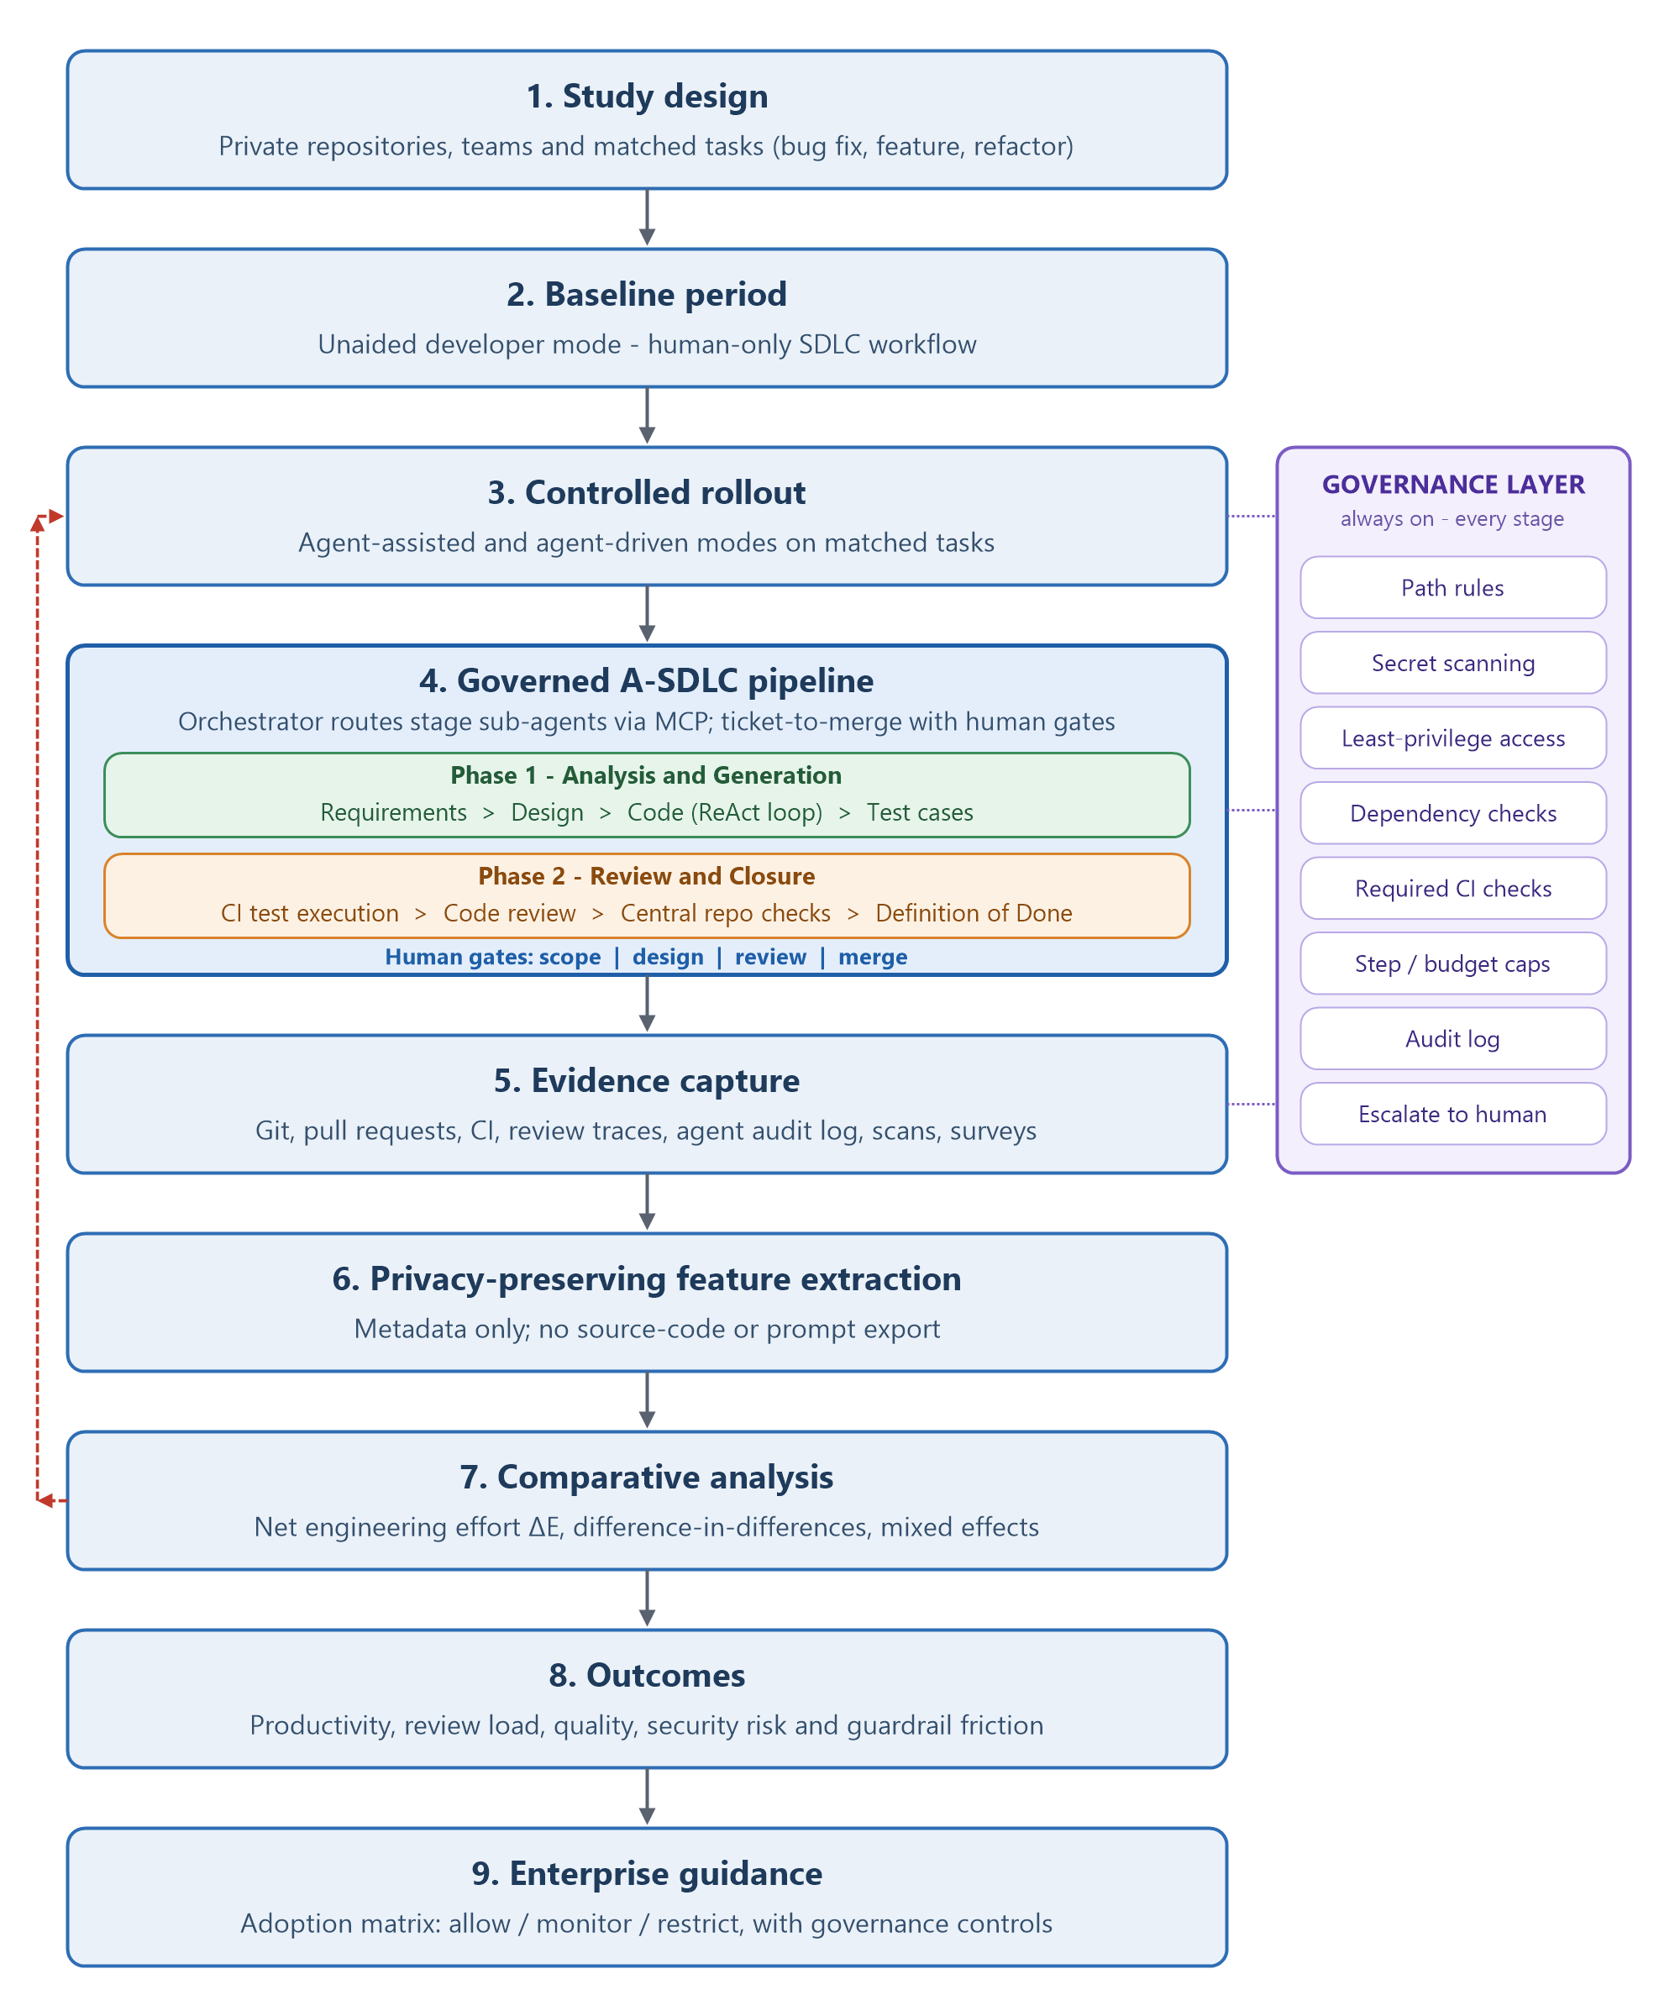
Figure 1. Proposed privacy-preserving evaluation workflow for the governed A-SDLC (dashed red line: analysis findings feed back into the rollout and guardrail settings)

Governed Agentic SDLC Pipeline
The intervention evaluated in the study is a governed A-SDLC pipeline (Figure 2). A ticket from Jira or GitHub Issues enters the pipeline; a human supervisor sets intent, constraints and the Definition of Done (DoD); and an orchestrator agent decomposes the goal and routes each stage to a specialised sub-agent through MCP integrations. Failures return to the stage that caused them, an always-on governance layer applies path rules, secret scanning, permissions, audit logging and step/budget caps, and every stage logs telemetry to a metrics store that feeds the net-productivity comparison.
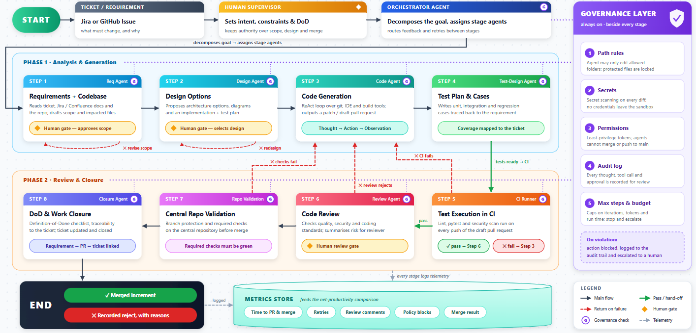
Figure 2. Governed agentic SDLC pipeline: eight steps in two phases with human gates and an always-on governance layer
The eight steps, the responsible agent and the gate or control applied at each step are summarised below.
Step | Agent and activity | Gate / control
1. Requirements and codebase (Phase 1) | Requirements agent reads the ticket, linked documents and repository; drafts scope and impacted files. | Human gate approves scope.
2. Design options (Phase 1) | Design agent proposes architecture options and an implementation and test plan. | Human gate selects the design.
3. Code generation (Phase 1) | Code agent runs a ReAct loop (thought, action, observation) over Git, IDE and build tools; outputs a patch or draft pull request. | Path rules, change-size limits, step/budget caps.
4. Test plan and cases (Phase 1) | Test-design agent writes unit, integration and regression tests traced to the requirement. | Coverage mapped to the ticket.
5. Test execution in CI (Phase 2) | CI runner executes lint, pytest and security scans on every push of the draft pull request. | Pass moves to Step 6; failure returns to Step 3.
6. Code review (Phase 2) | Review agent checks quality, security and coding standards and summarises risk for the human reviewer. | Human review gate; rejection returns to Step 3.
7. Central repository validation (Phase 2) | Branch protection and required checks run on the central repository before merge. | Required checks must be green.
8. DoD and work closure (Phase 2) | Closure agent completes the Definition-of-Done checklist and links requirement, pull request and ticket. | Merged increment, or rejection recorded with reasons.

Working Modes and Net Engineering Effort
Matched tasks (bug fixes, small features and refactoring) are assigned to three working modes: (i) unaided developer, the human-only baseline; (ii) agent-assisted, where the developer drives the work and uses agents for selected steps; and (iii) agent-driven, where the orchestrator runs the full pipeline and humans act only at the approval gates. Net engineering effort per task is defined as:
$$ΔE=E_{unaided}-\left(E_{agent}+E_{review}+E_{rework}+E_{recovery}\right)$$
The terms are, in order, the effort of the unaided baseline, agent execution and supervision time, human reviewer time, post-review and post-merge rework, and time spent recovering from failed runs or blocked actions. A positive value indicates a real gain. If review and rework outweigh coding-time savings, the study will report no net gain rather than advertise generation speed.

Experimental Design
- Select eligible repositories and task classes with approval from repository owners, security and legal stakeholders.
- Observe a baseline period using the existing human-only workflow and stable measurement definitions.
- Introduce the governed A-SDLC pipeline to a matched treatment group in agent-assisted and agent-driven modes, using a staggered rollout where feasible.
- Enforce identical CI quality gates in both conditions; apply additional agent-specific access and policy controls.
- Capture approved metadata automatically and collect short, voluntary developer/reviewer feedback.
- Compare outcomes using matched samples, difference-in-differences and mixed-effects regression.
- Conduct sensitivity analysis by excluding unusually large incidents, migrations and emergency work.
- Report aggregated outcomes and derive an adoption decision matrix by task risk and evidence strength.

Guardrail Layers
Layer | Controls
Identity and access | Least privilege, repository allow-list, branch restrictions, short-lived credentials.
Context boundary | Path rules (only allowed folders editable; protected files locked), approved context only, secret redaction, no unauthorised source-code or prompt retention.
Change boundary | Maximum change size, protected paths, dependency and infrastructure-change approvals, step and budget caps (iterations, tokens, run time) with escalation to a human.
Quality gates | Formatting, lint, tests, coverage threshold, static analysis and build verification.
Security and compliance | Secret scanning, SAST, dependency/licence checks and policy-as-code.
Human oversight | Human gates for scope, design and code review; mandatory owner approval, clear AI-assistance label and no autonomous production merge.
Auditability | Every agent action, tool call and approval logged to an audit trail; blocked actions escalated to a human; agent/version/configuration record and reproducible evaluation metadata.

Core Measures and Operational Definitions
Measure | Definition
Net delivery lead time | Task in progress to accepted merge/deployment; compare median and distribution.
Active engineering time | Time actively spent implementing, testing and revising; self-report or IDE telemetry only with consent.
Review load | Reviewer minutes, review cycles, comments, requested changes and time to approval.
Rework | Post-review changes and post-merge corrective work attributable to the original task.
Quality | CI failures, test pass rate, escaped defects, rollbacks and maintainability findings.
Security/compliance | Secret, vulnerability, dependency, licence and policy violations by severity.
Developer experience | Trust, satisfaction, perceived usefulness and cognitive load from short validated scales.
Guardrail friction | Blocked valid actions, policy-block triggers, retries, override requests and time added by controls.
Delivery outcomes | Task completion rate, merge success rate, time to first pull request and time to merge.
Net engineering effort | Unaided effort minus agent execution, human review, rework and failure-recovery time (see equation above).

Analysis Plan
Descriptive statistics will report median, interquartile range and full distributions rather than averages alone. Difference-in-differences will estimate the treatment effect when suitable control and treatment groups exist. Mixed-effects regression will model repeated observations while treating developer and repository as random effects and controlling for task type, task complexity, change size and codebase familiarity. Effect sizes and 95% confidence intervals will accompany significance tests. Qualitative survey responses will be coded thematically and used to interpret the quantitative results. Outcomes will be compared across the three working modes, net engineering effort will be reported per task type, and the frequency with which each guardrail fires will be recorded so that security claims remain empirical.

Ethics and Privacy
- Do not export proprietary source code, prompts containing confidential content or secrets.
- Pseudonymise developer identifiers and report team-level aggregates.
- Do not use metrics for individual performance evaluation.
- Obtain informed consent for surveys and any optional IDE activity telemetry.
- Use documented retention periods, access controls and deletion procedures.
- Record model, agent and guardrail versions to support reproducibility without exposing code.

Deliverable 4: Plagiarism Report Record
A genuine similarity percentage must come from the university-approved plagiarism system or another authorised service after the document is finalised. No similarity score has been invented for this submission draft.
The abstract in Deliverable 1 should be checked on the university-approved service (for example Turnitin through the LMS). If no institutional service is available, a free checker such as Duplichecker, Quetext (limited free scan) or SmallSEOTools can be used by pasting the abstract text and exporting the result as a PDF (for example BAC_RM_Plagiarism_Abstract.pdf) to attach behind this page. Short overlaps on standard phrases such as 'software development life cycle' or 'pull request' are normal.

Document checked | Coding Agents in Enterprise SDLC - Research Assignment
Tool/service
Date checked
Overall similarity
Exclusions used | Bibliography / quoted text / small matches (circle as applicable)
Report attachment | Attach the exported similarity report behind this page

Pre-submission Check
- Run the final DOCX or PDF through the approved similarity checker.
- Review every highlighted passage; rewrite only where wording is unintentionally close.
- Do not alter correct technical names, paper titles or properly formatted references merely to lower a score.
- Export the complete report and replace the blank fields above with the actual result.
- Follow the university threshold and supervisor guidance; no universal acceptable percentage is assumed.

Declaration
The abstract in Deliverable 1 is the author's own writing for this assignment, based on the literature survey and the capstone framing. Sources are cited in Deliverable 2, and no other team's abstract has been copied.

Deliverable 5: Condensed Abstract
Coding agents can accelerate code creation, but their enterprise value cannot be judged from generated lines of code or task speed alone. This research designs and evaluates a governed agentic SDLC for private repositories, measuring real productivity after guardrails, human review and rework are included. An orchestrator routes specialised sub-agents through an eight-step pipeline split into generation (requirements, design, code, tests) and closure (CI execution, review, central-repository checks, Definition of Done), and the coding loop is ReAct over Git, tests and CI. Humans retain intent, architecture and merge authority. Guardrails cover paths, secrets, permissions, dependencies, required checks, budgets and audit logging. Unaided, agent-assisted and agent-driven modes will be compared on matched tasks against a human-only baseline, using approved metadata from issues, pull requests, CI, scans and voluntary surveys without exporting proprietary code. Key outcomes include completion and merge rate, time to first pull request and to merge, reviewer effort, review cycles, retries, policy blocks, test pass rate, escaped defects and net engineering effort versus the unaided baseline. Difference-in-differences and mixed-effects models will control for task, developer and repository variation. Expected outputs are a balanced productivity scorecard, evidence on review-cost transfer and guardrail friction, and an adoption matrix showing where coding agents may be allowed, monitored or restricted. If review and rework outweigh coding-time savings, the study will report no net gain.

Deliverable 6: Relevant SCI/Scopus-Indexed Journals
Indexing and quartile status can change by year. The latest Scopus Sources and Web of Science Master Journal List should be checked immediately before selecting a submission venue.
Journal | Fit with the capstone | Publisher
ACM Transactions on Software Engineering and Methodology | LLMs for SE, empirical methods, testing, maintenance and developer tools; publishes several core citations (Hou et al., 2024; Gao et al., 2025) | ACM
IEEE Transactions on Software Engineering | High-rigor empirical software engineering, quality, productivity and AI for SE, including LLM-based testing (Wang et al., 2024) | IEEE
Empirical Software Engineering | Repository mining, controlled/field studies, review load, human factors and industrial case studies | Springer Nature
Journal of Systems and Software | AI-assisted development, systems-level SDLC and tooling evaluations, software processes and industrial studies | Elsevier
Information and Software Technology | Software methods, tools, evaluation, evidence-based practice and automation in the life cycle | Elsevier
Automated Software Engineering | Program synthesis, repair, testing, agents and development automation | Springer Nature
Journal of Software: Evolution and Process | Maintenance, evolution, process improvement, rework and Definition-of-Done practice | Wiley
Software Quality Journal | Quality assurance, review, testing, metrics and secure development | Springer Nature
IEEE Software | Industry-facing evidence on LLM risk, adoption, governance and developer experience (e.g., Ozkaya, 2023) | IEEE
ACM Transactions on Privacy and Security | Privacy, security controls, governance and policy enforcement for agent workflows | ACM

Expected Research Contributions
- A working, governed ticket-to-merge A-SDLC pipeline with human gates, an always-on governance layer and a complete audit trail.
- A reusable and privacy-preserving measurement model for coding agents on private repositories.
- A quantitative account of whether implementation-time savings are offset by review, rework or remediation.
- Evidence linking specific guardrails to reductions in security and policy risk.
- A task-risk adoption matrix and monitoring scorecard for enterprise engineering leaders.
- A reproducible research protocol that avoids exposing proprietary source code or ranking individual developers.

Proposed Implementation Stack
Area | Proposed tools/approach
Agent pipeline | Orchestrator and stage sub-agents on a hosted LLM; ReAct coding loop; MCP integrations to GitHub, Jira and CI; standard workstation plus cloud CI runners
Data extraction | Python; GitHub and Jira APIs; GitHub Actions / CI APIs; agent audit-log export
Storage | Access-controlled PostgreSQL or approved analytics store; de-identified metadata schema
Analysis | Python, pandas, scipy/statsmodels, Jupyter; R optional for mixed-effects validation
Quality/security | Ruff, pytest, Bandit, secret scanning and dependency analysis, alongside existing enterprise linters, test frameworks and SAST
Dashboards | Grafana, Power BI or approved BI platform for aggregate scorecards
Reproducibility | Versioned metric definitions, analysis code, synthetic sample dataset and experiment manifest

Indicative Timeline
Period | Activity
Weeks 1-4 | Final literature review, stakeholder approvals, metric definitions and ethics/privacy review
Weeks 5-8 | Instrumentation, data model, A-SDLC pipeline and guardrail implementation, and pilot validation
Weeks 9-14 | Baseline observation and data-quality checks
Weeks 15-22 | Controlled rollout in agent-assisted and agent-driven modes, with continuous evidence capture
Weeks 23-26 | Statistical analysis, qualitative coding and sensitivity checks
Weeks 27-30 | Adoption framework, dissertation writing, review and final presentation

Final Submission Checklist
- Confirm student name, SRN/register number, guide name and course details on the cover page.
- Validate the ten references against the university library databases and retain DOI links.
- Run and attach the authorised plagiarism/similarity report.
- Confirm ethics, security, legal and repository-owner approval before collecting enterprise data.
- Replace expected outcomes with actual results only after completing the experiment and analysis.

