RESEARCH METHODOLOGY ASSIGNMENT

Coding Agents in Enterprise SDLC
Guardrails, Review Load, and Real Productivity
on Private Repositories

Student Name | Praveenkumar
Programme | M.Tech - Artificial Intelligence, Machine Learning and Data Science
Institution | PES University
Project Type | Enterprise empirical software engineering capstone
Date | September 2026
Research focus: evidence-based and privacy-preserving evaluation of coding agents in real enterprise development workflows

Assignment Deliverables
Item | Included content
Deliverable 1 | Abstract (approximately 25-30 lines) and literature-survey foundation
Deliverable 2 | Ten relevant peer-reviewed/indexed research articles in Harvard format
Deliverable 3 | High-level block diagram and proposed research methodology
Deliverable 4 | Plagiarism-report submission record
Deliverable 5 | Condensed abstract (approximately 15 lines)
Deliverable 6 | Ten SCI/Scopus-indexed journals relevant to the project

Project Overview
Coding agents can plan, generate, modify, test and explain software across multiple files. Their value in enterprise software development, however, cannot be established from code-completion speed alone. Private repositories contain legacy architecture, organisation-specific conventions, confidential intellectual property, security boundaries and complex review practices. The proposed capstone will measure whether coding agents improve end-to-end delivery while maintaining quality, security, privacy and reviewer trust.

Research Problem
Enterprises lack an evidence-based method to decide where coding agents should be permitted, which guardrails are necessary, and whether apparent developer speed translates into net team productivity. Existing evaluations frequently use public benchmarks, isolated programming exercises or self-reported perceptions. They rarely quantify the additional review effort, rework, CI failures, security findings and governance risk created when agents operate on private, evolving codebases.

Primary Research Objective
To design and empirically evaluate a privacy-preserving governance and measurement framework for coding agents in enterprise SDLC workflows, with simultaneous measurement of guardrail effectiveness, review load, software quality and real productivity on private repositories.

Research Questions
- RQ1: How does coding-agent assistance affect end-to-end delivery productivity compared with a human-only baseline?
- RQ2: How does agent-generated or agent-modified code affect reviewer effort, review cycles, rework and merge latency?
- RQ3: Which technical and process guardrails most effectively prevent insecure, non-compliant or out-of-scope changes?
- RQ4: Do productivity effects vary by task type, repository maturity, codebase familiarity and developer experience?
- RQ5: What adoption thresholds provide a favourable balance among speed, quality, security, privacy and human oversight?

Deliverable 1: Abstract (25-30 Lines)
Coding agents based on large language models are rapidly entering software development, but their real value in enterprise software delivery remains uncertain. This research aims to develop and evaluate a privacy-preserving framework for measuring coding-agent impact across the software development life cycle using private repositories. The study will examine three connected dimensions: effectiveness of guardrails, change in human review load, and net productivity after accounting for quality and rework. This research is needed because faster code generation does not necessarily mean faster or safer software delivery. Enterprise repositories contain confidential code, legacy dependencies, internal standards and access restrictions that public coding benchmarks do not represent. Agent-generated changes may also shift effort from implementation to code review, testing, security remediation and architectural correction. Therefore, measurements based only on accepted suggestions, lines of code or task completion time can overstate business value. Prior studies report useful gains from AI-assisted programming, but much of the evidence comes from controlled tasks, public repositories, surveys or short-term tool usage. Research on modern code review separately shows that review latency, reviewer participation and rework materially affect software quality and delivery performance. A gap remains in combining these streams to evaluate coding agents as part of an enterprise socio-technical system. The proposed work differs by studying end-to-end outcomes on private repositories without exporting proprietary source code. A quasi-experimental longitudinal design will compare a baseline human-only period with a controlled agent-assisted period across matched repositories, developers and task categories. The coding agent will operate under configurable guardrails covering repository access, allowed files, dependency changes, secret detection, secure coding rules, mandatory tests and human approval. Evidence will be collected from Git history, pull requests, review comments, CI pipelines, static analysis, security scans, issue trackers and short developer surveys. Source code and prompts containing proprietary content will remain within the enterprise boundary; only approved metadata and derived measures will be analysed. Productivity measures will include lead time for changes, active engineering time, deployment throughput and successful task completion. Review-load measures will include time to first review, reviewer minutes, number of review cycles, comment density and requested-change rate. Quality and risk measures will include escaped defects, rollback rate, CI failure rate, security findings, policy violations and post-merge rework. Difference-in-differences and mixed-effects models will be used to estimate agent impact while controlling for developer, repository and task-level variation. Qualitative feedback will be analysed to explain trust, cognitive load and conditions under which developers accept or reject agent output. The expected outcome is a balanced scorecard that prevents local speed improvements from being mistaken for net productivity. The study is also expected to identify which guardrails reduce risk with the least workflow friction. Results will support an enterprise adoption matrix for low-, medium- and high-risk development tasks. The final framework will help engineering leaders decide where coding agents should be allowed, monitored or restricted. It will also provide reproducible definitions and measurement procedures for future studies of agentic software engineering. Overall, the capstone seeks to convert coding-agent adoption from a perception-driven decision into an evidence-based engineering practice.

Keywords
Coding agents; enterprise SDLC; private repositories; developer productivity; modern code review; guardrails; software quality; secure software development; empirical software engineering.

Literature Survey and Research Foundation

Theme 1: LLMs and AI-assisted software engineering
Research shows that code-oriented language models can support generation, repair, testing and comprehension, but performance varies by task, context and evaluation method. Dakhel et al. (2023) found that GitHub Copilot can be useful but produces outputs requiring careful validation. Hou et al. (2024) synthesised a broad LLM-for-software-engineering literature and highlighted evaluation, dataset and reproducibility gaps. These findings support treating the coding agent as a fallible collaborator rather than an autonomous trusted committer.

Theme 2: Review load and software quality
Modern code review research demonstrates that review coverage, participation and process quality influence defect outcomes. McIntosh et al. (2016) associated weak review practices with poorer software quality, while Bosu et al. (2017) showed that code review is also a social coordination process. Coding agents may reduce authoring effort while increasing reviewer burden; therefore reviewer time, review cycles, requested changes and rework must be first-class outcomes.

Theme 3: Productivity as a multidimensional outcome
Developer productivity cannot be represented safely by lines of code or commit counts. Meyer et al. (2017) connected perceived productivity with work activities and interruptions, while Forsgren et al. (2021) proposed a multidimensional view spanning satisfaction, performance, activity, communication and efficiency. The proposed study will consequently report speed, quality, review load and developer experience together, with no single metric used as a performance ranking of individuals.

Theme 4: Security, privacy and governance
AI-generated code can reproduce insecure patterns, introduce unsuitable dependencies or expose confidential context. Enterprise use also creates risks relating to data residency, prompt logging, repository permissions and licence provenance. The study therefore embeds policy-as-code controls, least-privilege access, secret scanning, software composition analysis, static analysis, test requirements and mandatory human approval into the experimental workflow.

Consolidated Research Gap
Existing research provides strong foundations for AI code generation, modern code review and developer productivity, but these areas are commonly evaluated in isolation. There is limited longitudinal evidence from private enterprise repositories that measures both the benefit created by a coding agent and the downstream human effort and risk it generates. This capstone addresses that gap through a privacy-preserving, end-to-end and multi-metric evaluation.

Literature Evidence Matrix
Study | Main contribution | Use in this capstone | Remaining gap
Dakhel et al. (2023) | Empirical assessment of GitHub Copilot as an AI pair programmer. | Direct evidence on usefulness and limitations of generated code. | Does not measure a controlled private-repository rollout with review-cost accounting.
Hou et al. (2024) | Systematic review of LLM applications across software engineering. | Provides taxonomy, evaluation approaches and open research gaps. | Broad review; not an enterprise intervention study.
Wang et al. (2023) | Systematic review of machine/deep learning in software engineering. | Supports structured task and evaluation taxonomy. | Predates much agentic, repository-level workflow evidence.
Allamanis et al. (2018) | Survey of machine learning for source code. | Explains representation, prediction and generation foundations. | Does not address modern LLM agents or enterprise governance.
McIntosh et al. (2016) | Links modern code review practices with software quality. | Motivates review coverage and participation measures. | No AI-assisted development condition.
Bosu et al. (2017) | Examines process and social dynamics of code review. | Supports reviewer workload and collaboration measures. | Does not quantify agent-created review demand.
Meyer et al. (2017) | Studies developer activities, task switching and perceived productivity. | Guides developer-level experience and interruption measures. | Not designed for coding-agent interventions.
Forsgren et al. (2021) | Defines multidimensional developer productivity through SPACE. | Prevents reliance on simplistic activity metrics. | Conceptual framework rather than private-repository experiment.
Le Goues et al. (2019) | Reviews automated program repair techniques and evaluation. | Provides quality and validation lessons for machine-generated changes. | Program repair is narrower than end-to-end coding agents.
Kalliamvakou et al. (2016) | Documents limitations and perils of mining GitHub data. | Informs careful repository sampling and metric interpretation. | Public GitHub focus; enterprise private repositories differ.

Proposed Objectives and Hypotheses

Specific Objectives
- Define a deployable guardrail architecture for coding agents working with private repositories.
- Measure end-to-end productivity before and after controlled coding-agent adoption.
- Quantify the review effort and rework associated with agent-assisted changes.
- Measure changes in software quality, security findings and policy compliance.
- Identify task, developer and repository conditions that explain beneficial or harmful outcomes.
- Produce an enterprise decision framework for safe adoption and continuous monitoring.

Testable Hypotheses
- H1: Agent assistance reduces median lead time for eligible low- and medium-complexity tasks.
- H2: Agent-assisted pull requests require more review comments or revision cycles unless contextual and policy guardrails are applied.
- H3: Guardrails reduce security and policy violations without removing the productivity benefit for eligible tasks.
- H4: Net productivity gains are larger for repetitive and well-specified tasks than for architecture-intensive tasks.
- H5: Codebase familiarity and developer experience moderate both productivity and review-load effects.

Data Availability and Governance
Source | Candidate fields | Privacy treatment
Git metadata | Commit timestamps, change size, files touched, reverts | Repository-local extraction; pseudonymous developer ID
Pull requests | Open/merge times, reviews, comments, cycles, requested changes | Comment text excluded or de-identified unless separately approved
CI/CD | Build duration, test result, deployment result, rollback | Pipeline metadata only
Quality/security | Static-analysis, secret, dependency and vulnerability findings | Finding category/severity; no proprietary code snippet
Issue tracker | Task type, complexity, start/end status, acceptance | Business-sensitive fields minimised
Developer survey | Trust, cognitive load, satisfaction, perceived usefulness | Voluntary; aggregated reporting; no individual ranking

Deliverable 2: Ten Relevant Research Articles
The following references use Harvard style. The list combines direct coding-agent research with established work on review quality, developer productivity, automated change generation and repository-mining validity.
Allamanis, M., Barr, E.T., Devanbu, P. and Sutton, C. (2018) 'A survey of machine learning for big code and naturalness', ACM Computing Surveys, 51(4), Article 81, pp. 1-37. https://doi.org/10.1145/3212695.
Bosu, A., Carver, J.C., Bird, C., Orbeck, J. and Chockley, C. (2017) 'Process aspects and social dynamics of contemporary code review: Insights from open source development and industrial practice at Microsoft', IEEE Transactions on Software Engineering, 43(1), pp. 56-75. https://doi.org/10.1109/TSE.2016.2576451.
Dakhel, A.M., Majdinasab, V., Nikanjam, A., Khomh, F., Desmarais, M.C. and Jiang, Z.M.J. (2023) 'GitHub Copilot AI pair programmer: Asset or liability?', Journal of Systems and Software, 203, 111734. https://doi.org/10.1016/j.jss.2023.111734.
Forsgren, N., Storey, M.-A., Maddila, C., Zimmermann, T., Houck, B. and Butler, J. (2021) 'The SPACE of developer productivity: There's more to it than you think', Queue, 19(1), pp. 20-48. https://doi.org/10.1145/3454122.3454124.
Hou, X., Zhao, Y., Liu, Y., Yang, Z., Wang, K., Li, L., Luo, X., Lo, D., Grundy, J. and Wang, H. (2024) 'Large language models for software engineering: A systematic literature review', ACM Transactions on Software Engineering and Methodology, 33(8), Article 220, pp. 1-79. https://doi.org/10.1145/3695988.
Kalliamvakou, E., Gousios, G., Blincoe, K., Singer, L., German, D.M. and Damian, D. (2016) 'An in-depth study of the promises and perils of mining GitHub', Empirical Software Engineering, 21, pp. 2035-2071. https://doi.org/10.1007/s10664-015-9393-5.
Le Goues, C., Pradel, M. and Roychoudhury, A. (2019) 'Automated program repair', Communications of the ACM, 62(12), pp. 56-65. https://doi.org/10.1145/3318162.
McIntosh, S., Kamei, Y., Adams, B. and Hassan, A.E. (2016) 'An empirical study of the impact of modern code review practices on software quality', Empirical Software Engineering, 21, pp. 2146-2189. https://doi.org/10.1007/s10664-015-9366-8.
Meyer, A.N., Fritz, T., Murphy, G.C. and Zimmermann, T. (2017) 'The work life of developers: Activities, switches and perceived productivity', IEEE Transactions on Software Engineering, 43(12), pp. 1178-1193. https://doi.org/10.1109/TSE.2017.2656886.
Wang, S., Huang, L., Gao, A., Ge, J., Zhang, T., Feng, H., Satyarthi, I., Li, M., Zhang, H. and Ng, V. (2023) 'Machine/deep learning for software engineering: A systematic literature review', IEEE Transactions on Software Engineering, 49(3), pp. 1188-1231. https://doi.org/10.1109/TSE.2022.3173346.

Deliverable 3: High-Level Methodology
The study uses a quasi-experimental, longitudinal mixed-method design. A controlled rollout is preferred over a simple before/after comparison because repositories, task types and developer experience can strongly affect outcomes.
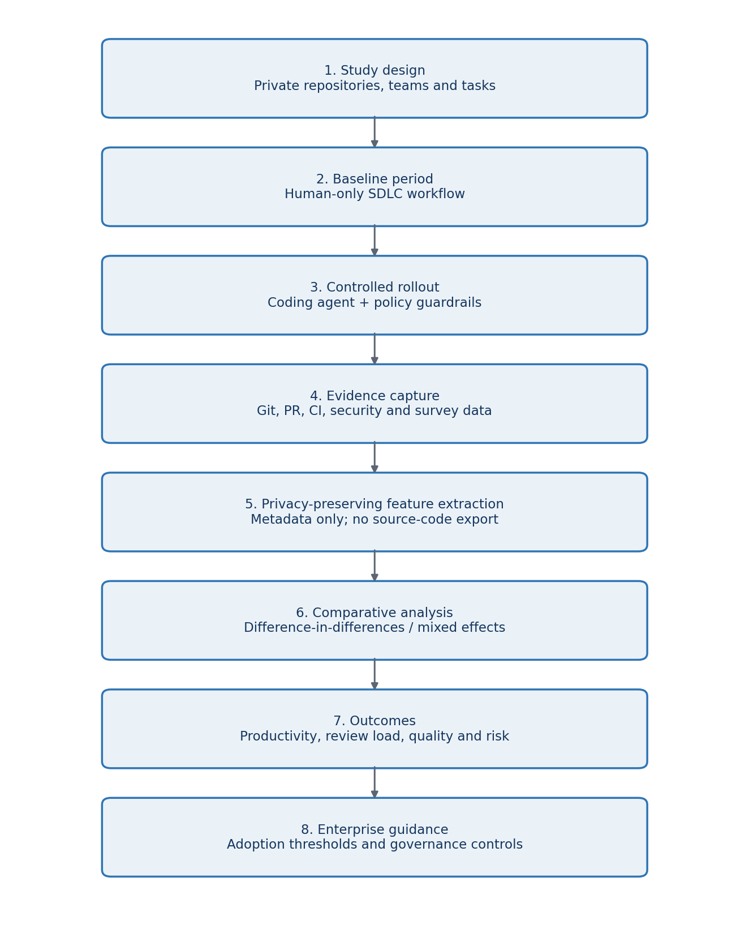
Figure 1. Proposed privacy-preserving evaluation workflow

Experimental Design
- Select eligible repositories and task classes with approval from repository owners, security and legal stakeholders.
- Observe a baseline period using the existing human-only workflow and stable measurement definitions.
- Introduce the coding agent to a matched treatment group, using a staggered rollout where feasible.
- Enforce identical CI quality gates in both conditions; apply additional agent-specific access and policy controls.
- Capture approved metadata automatically and collect short, voluntary developer/reviewer feedback.
- Compare outcomes using matched samples, difference-in-differences and mixed-effects regression.
- Conduct sensitivity analysis by excluding unusually large incidents, migrations and emergency work.
- Report aggregated outcomes and derive an adoption decision matrix by task risk and evidence strength.

Guardrail Layers
Layer | Controls
Identity and access | Least privilege, repository allow-list, branch restrictions, short-lived credentials.
Context boundary | Approved files only, secret redaction, no unauthorised source-code or prompt retention.
Change boundary | Maximum change size, protected paths, dependency and infrastructure-change approvals.
Quality gates | Formatting, lint, tests, coverage threshold, static analysis and build verification.
Security and compliance | Secret scanning, SAST, dependency/licence checks and policy-as-code.
Human oversight | Mandatory owner review, clear AI-assistance label and no autonomous production merge.
Auditability | Agent/version/configuration record, tool-call audit trail and reproducible evaluation metadata.

Core Measures and Operational Definitions
Measure | Definition
Net delivery lead time | Task in progress to accepted merge/deployment; compare median and distribution.
Active engineering time | Time actively spent implementing, testing and revising; self-report or IDE telemetry only with consent.
Review load | Reviewer minutes, review cycles, comments, requested changes and time to approval.
Rework | Post-review changes and post-merge corrective work attributable to the original task.
Quality | CI failures, escaped defects, rollbacks, test outcomes and maintainability findings.
Security/compliance | Secret, vulnerability, dependency, licence and policy violations by severity.
Developer experience | Trust, satisfaction, perceived usefulness and cognitive load from short validated scales.
Guardrail friction | Blocked valid actions, override requests and time added by controls.

Analysis Plan
Descriptive statistics will report median, interquartile range and full distributions rather than averages alone. Difference-in-differences will estimate the treatment effect when suitable control and treatment groups exist. Mixed-effects regression will model repeated observations while treating developer and repository as random effects and controlling for task type, task complexity, change size and codebase familiarity. Effect sizes and 95% confidence intervals will accompany significance tests. Qualitative survey responses will be coded thematically and used to interpret the quantitative results.

Ethics and Privacy
- Do not export proprietary source code, prompts containing confidential content or secrets.
- Pseudonymise developer identifiers and report team-level aggregates.
- Do not use metrics for individual performance evaluation.
- Obtain informed consent for surveys and any optional IDE activity telemetry.
- Use documented retention periods, access controls and deletion procedures.
- Record model, agent and guardrail versions to support reproducibility without exposing code.

Deliverable 4: Plagiarism Report Record
A genuine similarity percentage must come from the university-approved plagiarism system or another authorised service after the document is finalised. No similarity score has been invented for this submission draft.
Document checked | Coding Agents in Enterprise SDLC - Research Assignment
Tool/service
Date checked
Overall similarity
Exclusions used | Bibliography / quoted text / small matches (circle as applicable)
Report attachment | Attach the exported similarity report behind this page

Pre-submission Check
- Run the final DOCX or PDF through the approved similarity checker.
- Review every highlighted passage; rewrite only where wording is unintentionally close.
- Do not alter correct technical names, paper titles or properly formatted references merely to lower a score.
- Export the complete report and replace the blank fields above with the actual result.
- Follow the university threshold and supervisor guidance; no universal acceptable percentage is assumed.

Deliverable 5: Condensed Abstract
Coding agents can accelerate code creation, but their real enterprise value cannot be judged from generated lines of code or task speed alone. This research proposes a privacy-preserving framework to evaluate coding agents across private enterprise repositories. It will jointly measure guardrail effectiveness, human review load, software quality, security risk and net delivery productivity. A longitudinal quasi-experimental design will compare a human-only baseline with a controlled agent-assisted rollout across matched repositories and task types. The agent will operate under least-privilege access, repository and file boundaries, secret scanning, dependency controls, mandatory tests and human approval. Approved metadata will be collected from Git, pull requests, CI/CD, quality scans, issue trackers and voluntary surveys without exporting proprietary source code. Key outcomes will include lead time, active engineering time, reviewer effort, review cycles, rework, CI failures, escaped defects and policy violations. Difference-in-differences and mixed-effects models will control for task, developer and repository variation. The study will also examine how task complexity, codebase familiarity and developer experience moderate the results. Expected outputs include a balanced productivity scorecard, evidence on review-cost transfer, and estimates of guardrail effectiveness and friction. The final adoption matrix will identify where coding agents may be allowed, monitored or restricted. The research will help enterprises move from perception-based adoption to measurable, secure and accountable agent-assisted software engineering.

Deliverable 6: Relevant SCI/Scopus-Indexed Journals
Indexing and quartile status can change by year. The latest Scopus Sources and Web of Science Master Journal List should be checked immediately before selecting a submission venue.
Journal | Fit with the capstone | Publisher
ACM Transactions on Software Engineering and Methodology | LLMs for SE, empirical methods, testing, maintenance and developer tools | ACM
IEEE Transactions on Software Engineering | High-rigor empirical software engineering, quality, productivity and AI for SE | IEEE
Empirical Software Engineering | Repository mining, controlled/field studies, review practices and human factors | Springer Nature
Journal of Systems and Software | AI-assisted development, software processes, quality and industrial studies | Elsevier
Information and Software Technology | Software methods, tools, evaluation and evidence-based practice | Elsevier
Automated Software Engineering | Program synthesis, repair, testing, agents and development automation | Springer Nature
Journal of Software: Evolution and Process | Maintenance, evolution, process improvement and industrial evidence | Wiley
Software Quality Journal | Quality assurance, review, testing, metrics and secure development | Springer Nature
IEEE Software | Industry-facing evidence, practice, governance and developer experience | IEEE
ACM Transactions on Privacy and Security | Privacy, security controls, governance and policy enforcement for agent workflows | ACM

Expected Research Contributions
- A reusable and privacy-preserving measurement model for coding agents on private repositories.
- A quantitative account of whether implementation-time savings are offset by review, rework or remediation.
- Evidence linking specific guardrails to reductions in security and policy risk.
- A task-risk adoption matrix and monitoring scorecard for enterprise engineering leaders.
- A reproducible research protocol that avoids exposing proprietary source code or ranking individual developers.

Proposed Implementation Stack
Area | Proposed tools/approach
Data extraction | Python; Git provider APIs; CI/CD APIs; issue-tracker API
Storage | Access-controlled PostgreSQL or approved analytics store; de-identified metadata schema
Analysis | Python, pandas, scipy/statsmodels, Jupyter; R optional for mixed-effects validation
Quality/security | Existing enterprise linters, test frameworks, SAST, secret scanning and dependency analysis
Dashboards | Grafana, Power BI or approved BI platform for aggregate scorecards
Reproducibility | Versioned metric definitions, analysis code, synthetic sample dataset and experiment manifest

Indicative Timeline
Period | Activity
Weeks 1-4 | Final literature review, stakeholder approvals, metric definitions and ethics/privacy review
Weeks 5-8 | Instrumentation, data model, guardrail implementation and pilot validation
Weeks 9-14 | Baseline observation and data-quality checks
Weeks 15-22 | Controlled agent rollout and continuous evidence capture
Weeks 23-26 | Statistical analysis, qualitative coding and sensitivity checks
Weeks 27-30 | Adoption framework, dissertation writing, review and final presentation

Final Submission Checklist
- Confirm student name, SRN/register number, guide name and course details on the cover page.
- Validate the ten references against the university library databases and retain DOI links.
- Run and attach the authorised plagiarism/similarity report.
- Confirm ethics, security, legal and repository-owner approval before collecting enterprise data.
- Replace expected outcomes with actual results only after completing the experiment and analysis.

