Synapse Competition

Competition is a common motif in biology & neuroscience. In this post I describe and analyse using a competition to control synapse formation. This competition fixes failure modes in state of the art neural systems.

Written by David McDougall, 2019

# Hebbian Learning and Thresholds

Synapses in the cortex use Hebbian Learning. Neurons in the cortex use a constant activation threshold to discriminates between cells which recognize their inputs and cells which do not. Naive models of the cortex incorporated just these two features and observed that Hebbian learning has two characteristic failure modes.

* If the threshold is too high then cells never activate. Inactive cells do not learn, and so they never form additional synapses with which they might overcome the activation threshold. These cells are stuck-off.
* If the threshold is too low then cells activate, learn and form new synapses, which makes them more likely to activate. This can lead to lead to run away activity, where all cells activate at the same time, or a cell activates in response to everything. These cells are stuck-on.

Inhibitory cells in the cortex facilitate a competition between neurons. The competition augments the activation threshold be raising it such that only a small fraction of the strongest neurons activate. The competition can raise the threshold as high or low as it needs to, allowing it to scale to any number of neurons with any number of inputs. Models which include a competition do not suffer from the same characteristic failures of the naive models. In general, hebbian learning works better with a competition than with only a constant threshold.

There is a component of HTM models which uses hebbian learning with only a constant threshold: synapses. The permanence value of a synapse is controlled by hebbian learning. A simple constant threshold discriminates between potentially and actually connected synapses. Synapses suffer from failure modes which are characteristic of hebbian learning combined with only a constant threshold.

# Methods of Analysis

I trained a Spatial Pooler * to recognize the handwritten digits 0-9 in the MNIST dataset. All experiments scored between 95% and 96% accuracy, and changes in accuracy as a result of these experiments were insignificant.

I measured the number of connected synapses on each segment. This experiment seeks to control this number. Segments have at most 73 potentially connected synapses, meaning that regardless of any experimental modifications the maximum number of connected synapses is 73.

I measured the activation frequencies of each neuron. Activation frequencies are reported in graphs as a fraction between 0 and 1. The Spatial Pooler enforces a sparsity of 1% cell activations, which means that the average activation frequency across all cells in the Spatial Pooler will also be 1%.

I calculated the binary entropy of the activations, which is a measure of how much information the cells are transmitting. The entropy is reported as a percent of the theoretical maximum entropy of the system with the sparsity held constant. Higher entropy is better.

* Cui Y, Ahmad S and Hawkins J (2017) The HTM Spatial Pooler — A Neocortical Algorithm for Online Sparse Distributed Coding. Front. Comput. Neurosci. 11:111. doi:10.3389/fncom.2017.00111

# Run Away Hebbian Learning

In this section I demonstrate the failures which are characteristic of Hebbian learning combined with a constant threshold.

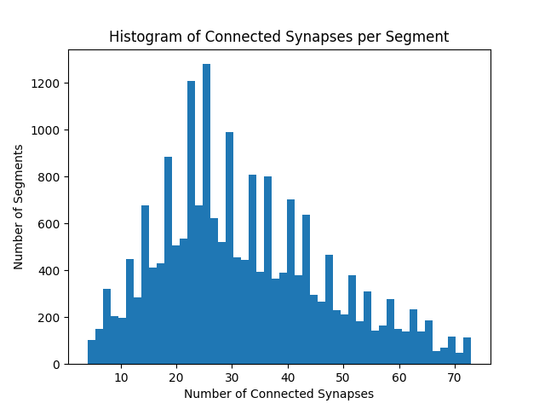Figure 1: Histogram of the number of connected synapses per segment, in a Spatial Pooler with no constraints on the number of connected synapses per segment. Notice that some segments have very few synapses (4) and that some segments have connected every potential synapse (73).

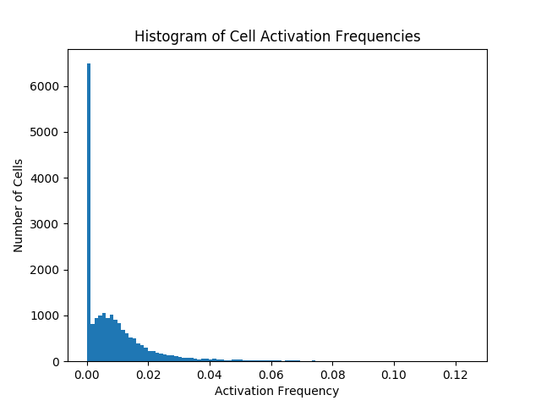Figure 2: Histogram of cell activation frequencies, in a Spatial Pooler with no constraints on the number of connected synapses per segment. There are cells in almost every bin in this image, although many of them are invisible because there are too few cells in the bin to render on this low resolution image.

Notice that a significant number of segments are underutilized / stuck-off, having close to zero activations. A small minority of segments are overutilized / stuck-on, activating significantly more often than the average activation frequency of 1%.

# Model of Synapse Competition

I modified a Spatial Pooler such that the number of connected synapses on each proximal segment is constrained. I introduce two new global parameters: minimumSynapsesPerSegment and maximumSynapsesPerSegment. Whenever a segment has too few or too many connected synapses the permanence values of all synapses on the segment are changed uniformly such that the segment has a valid number of connected synapses. The permanence change is calculated to be the smallest possible change which achieves the desired effect.

# Results

I implemented the model of synapse competition and I hope to eventually contribute it to the community fork of Nupic. I experimented with several different parameter sets, shown here:

|  |  |  |  |  |
| --- | --- | --- | --- | --- |
| Minimum Connected Synapses Per Segment | 0 (No Limit) | 15 | 20 | 30 |
| Maximum Connected Synapses Per Segment | 73 (No Limit) | 50 | 40 | 35 |
| Maximum Cell Activation Frequency | 12 % | 9.3 % | 6.8 % | 3.1 % |
| Binary Entropy | 87 % | 91 % | 94 % | 96 % |

Figure 3: Data table of results. Notice that as the constraints of the synapse competition are tightened, the entropy increases.

# 

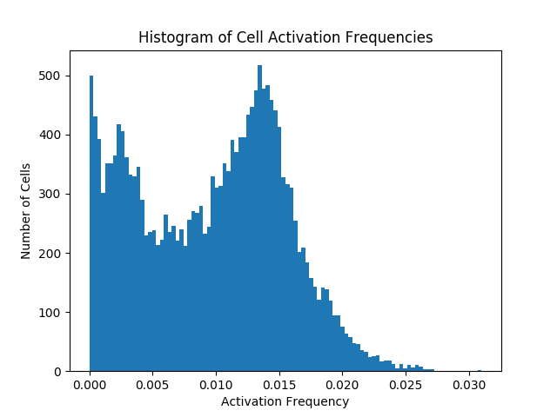

Figure 4: Histogram of cell activation frequencies, in a Spatial Pooler with the constraint that the number of connected synapses per segment is between 30 and 35. Notice that significantly fewer cells are underutilized and that no cells are overutilized.

# Effect of Synapse Competition on Permanences

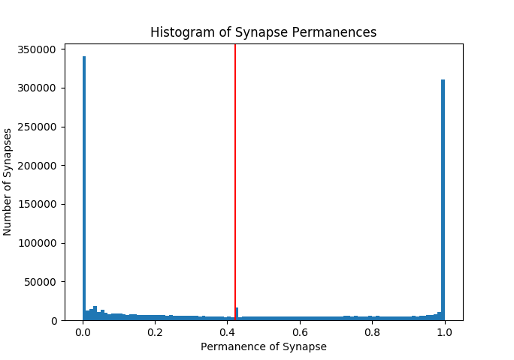Figure 5: Histogram of synapse permanence values, in a Spatial Pooler with the constraint that the number of connected synapses per segment is between 30 and 35. The red line indicates the connected threshold for synapses. All synapses to the right of the red line are connected. All synapses to the left of the red line are disconnected.

The permanence values of approximately 50% of the synapses have saturated to either 0 or 1. This is a normal aspect of the Spatial Pooler learning process, and will not be discussed further.

Notice the small bump which coincides with the connected threshold. This bump exists on both sides of the threshold. This bump is only present when the number of connected synapses per segment is constrained (evidence not shown). This bump is caused by synapses which lost their competition and are trying to cross the threshold, but which are being held back by the new competition rules. These synapses could be either trying to connect or disconnect, and in both cases they're unable to.

# Mathematical Analysis

In this section I demonstrate the perils of having too many synapses. I used Monte Carlo methods to measure the false positive error rates as a function of the number of connected synapses.

This analysis models dendritic segments as coincidence detectors. A simple threshold determines if a segment receives enough input to activate. I generate segments with random connectivity and measure the probability that the segments respond to a random inputs.

|  |  |
| --- | --- |
| Size of Potential Pool | 2,000 cells |
| Number of Active Inputs | 100 cells, (5 % sparsity) |
| Threshold of Detection | 50 cells, (50 % of the active inputs) |

Figure 6: Table of parameters used by this analysis. These values are typical of a proximal dendritic segment. These are not the values used by the Spatial Pooler used to solve the MNIST dataset used by the rest of this article.

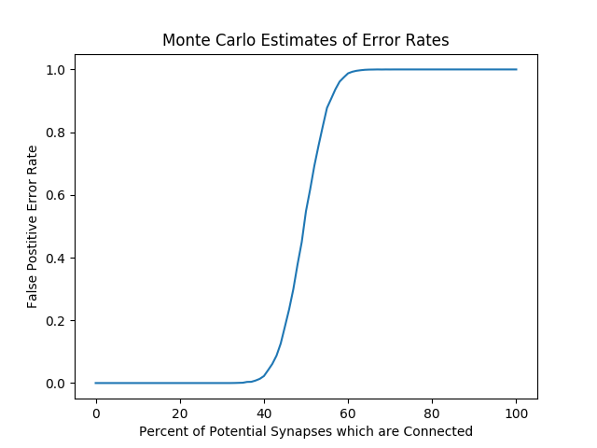

Figure 7: Clearly, too many synapses causes a total breakdown of dendritic segment function.

# Comparison with other methods of Boosting

Boosting is a general term for methods which aim to control and normalize the activation frequencies of neurons. Here is a table of relevant findings, followed by a more detailed analysis of each method.

|  |  |  |
| --- | --- | --- |
| Method of Boosting | Maximum Cell Activation Frequency | Binary Entropy |
| No Boosting | 71 % | 51 % |
| Synapse Competition | 67 % | 55 % |
| Exponential Boosting | 6 % | 87 % |
| Logarithmic Boosting | 12 % | 87 % |
| Synapse Competition and Logarithmic Boosting | 3 % | 96 % |

All methods which use an exponential moving average to track the activation frequency, use a time scale of 1402.

## 

## No Boosting

For this experiment I disabled boosting to observe the extent and severity of the issues which boosting seeks to fix. This scored 93.88 % accuracy, making it the only experiment which scored less than 95 % accuracy.

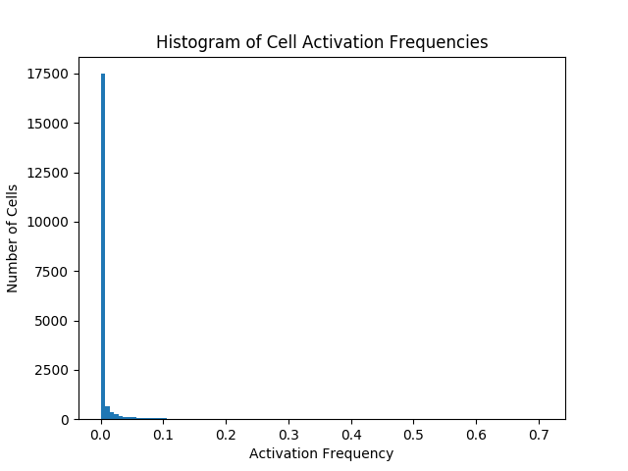

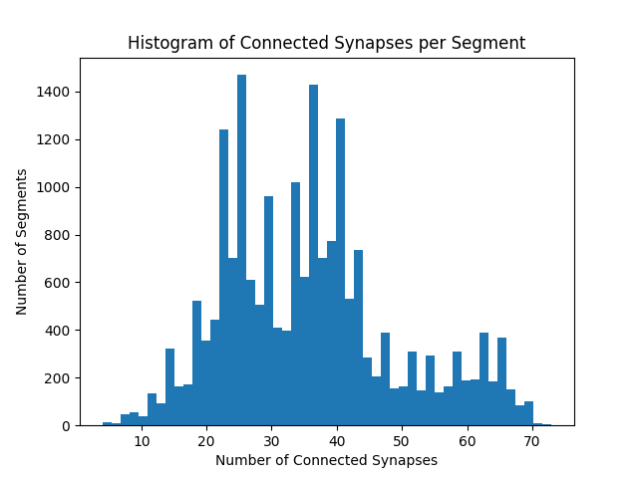

## Synapse Competition without Boosting

For this experiment I disabled boosting but enabled the synapse competition, enforcing between 30 and 35 connected synapses per segment. The results show that synapse competition is not a replacement for boosting.

Without boosting the activation frequencies of the cells tend towards the extremes, although it does score above 95% accuracy and it does perform marginally better than with neither boosting nor synapse competition.

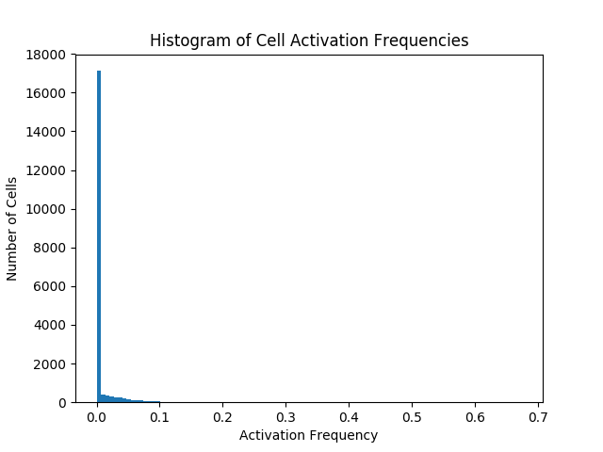

## Exponential Boosting

For this experiment I used boosting without a synapse competition. Numenta came up with this boosting function, and it is currently the default for Nupic.

boost-factor = e ^ (boost-strength * (target-sparsity - activation-frequency))

boost-strength = 25.

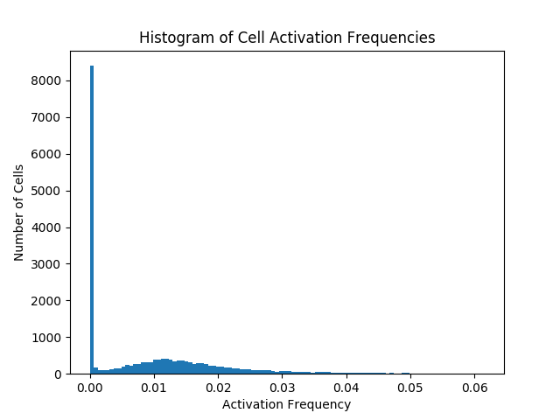

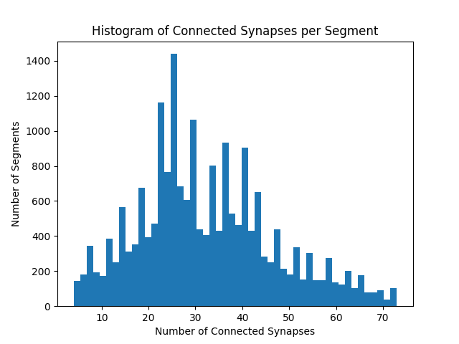

## Logarithmic boosting

For this experiment I used boosting without a synapse competition. I came up with this boosting function.

boost-factor = log(activation-frequency) / log(target-sparsity)

This function has a zero-crossing at cell activation frequency of 100% and an asymptote to infinity at activation frequency of 0%. These properties give it stronger theoretical guarantees than the exponential boosting function. It also has no parameters, which makes it easier to use.

See figure 1 for histogram of connected synapses per segment.

See figure 2 for histogram of cell activation frequencies.

## Synapse Competition and Logarithmic boosting

For this experiment I used both logarithmic boosting as well as the synapse competition. This is what the results section of this article uses.

See figure 4 for histogram of cell activation frequencies.

Boosting is unable to control the number of connected synapses. The synapse competition can control this. The fact that the synapse competition improves the performance of the boosting function is evidence of the underlying failures and that they are now fixed.