QsoTrainer © by HB9FVK

<sk><sk> Reset

<ka><ka> Chasermode

<qrl?> Activatormode

<as><as> Trainingsmode keying

<bt><bt> Callsign Training

<ve><ve> CW Abbreviation Training

<ar><ar> single character Training.

The second double combination of you give stops this mode, “ar” increses the number of charatcers to Test.

A qso follows these rules. More details on Github.

Activator: CQ [SOTA] DE XY2ABC [XY/KB023] K

Chaser : XY2DEF

Activator: XY2DEF GD 559 559 BK

Chaser : RR GD 559 559 [REF XY/KB045] 73 TU BK

Activator: 73 TU EE

Chaser : XY2GHJ

Double click the Black Know (Encoder) for a Menu, select WPM, Fansworht, SOTA mode or paddle Polarity. 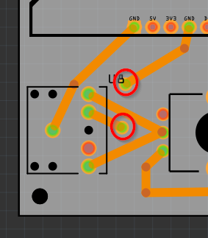The Silver Knob (Volume) to adjust the Volume. You ay add a small Loudspeaker 1W 8Ohm to the Board.

<https://www.aliexpress.com/w/wholesale-Loudspeaker-1W-8ohm.html?spm=a2g0o.productlist.search.0>

To see what you are keying, connect a Serial Terminal or use a Tablet and connect to WifiAp = qsoTrainer no Password, us a Telneclient to listen to 192.168.4.22:8088, i use ConnectBot for Android.

<https://github.com/pavian57/qsoTrainer>