**Blood Bank Management System**

Prepared by:

Group Leader : V. JudsonSam

Group Members: J. Ashwini

Bhavya V Kumar

P. Kanimozhi

I. Shivani

Y. Phanindra

**Abstract**

Blood Bank Management System (BBMS) is a browser based system that is designed to store, process, retrieve and analyse information concerned with the administrative and inventory management within a blood bank. This project aims at maintaining all the information pertaining to blood donors, different blood groups available in each blood bank and help them manage in a better way. Aim is to provide transparency in this field, make the process of obtaining blood from a blood bank hassle free and corruption free and make the system of blood bank management effective. Our client is not interested in blood stocking instead we are stocking blood donors information. The donors who are interested in donating blood has to register in the database. There is no storage of blood so no complications in the project.

**1. INTRODUCTION**

The population of the world is multiplying with each coming year and so are the diseases and health issues. With an increase in the population there is an increase in the need of blood. The growing population of the world results in a lot of potential blood donors. But in spite of this not more than 10% of the total world population participate in blood donation. With the growing population and the advancement in medical science the demand for blood has also increased.

Due to the lack of communication between the blood donors and blood recipients, most of the patients in need of blood do not get the blood on time and hence lost their lives. There is dire need of synchronisation between the blood donors and hospitals and blood banks. Improper communication synchronisation between blood banks and hospitals leads to waste of blood available. These problems can dealt with by automatic the existing manual blood bank management system. A high-end efficient, highly available system has to be developed to bridge the gap between the donors and recipients and to reduce the efforts required to search for the blood donors.

1.1 Existing System

Existing system of blood bank management is done manually. All the details including his blood group, medical reports, contact number and other personal details are collected from the donor and it is documented. All these paper works are stored for future reference. If an emergency arrives the administrator has to search for the appropriate donor from this huge collection of data.

1.2 Problem Definition

Entering the details about the blood groups, members, addresses etc and tracking the database is complicated when the details are maintained manually. This makes the maintenance of scheduled erroneous.

1.3 Why we need a new system

The existing system has the following disadvantages.

1. It is very time consuming.
2. It consumes a lot of manpower to better results.
3. lack of data security.
4. It takes a lot of time for the retrieval of data.
5. The percentage of accuracy is less.

To overcome all these limitations we propose a new system of blood bank management.

**2. SYSTEM REQUIREMENTS**

All computer software needs certain hardware components or other software resources to be present on a computer. These prerequisites are known as system requirements and often used as the guide line as opposed to an absolute rule.

2.1 Software Specifications

Operating System : Windows 8+

Frontend : HTML, CSS, Javascript.

Backend: Core Java.

2.2 Hardware Specification  
Processor : i3 Processor  
RAM : 8GB  
ROM : 250GB

**3.UML DIAGRAMS**

3.1 Usecase Diagram

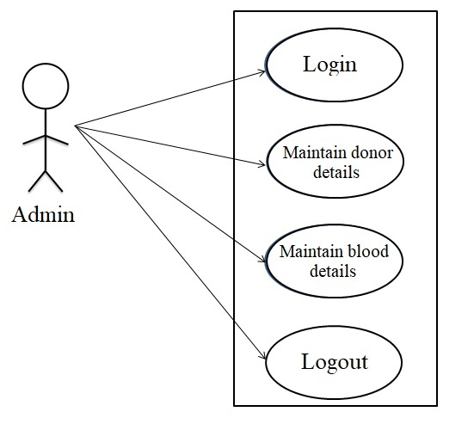

3.2 Activity Diagram

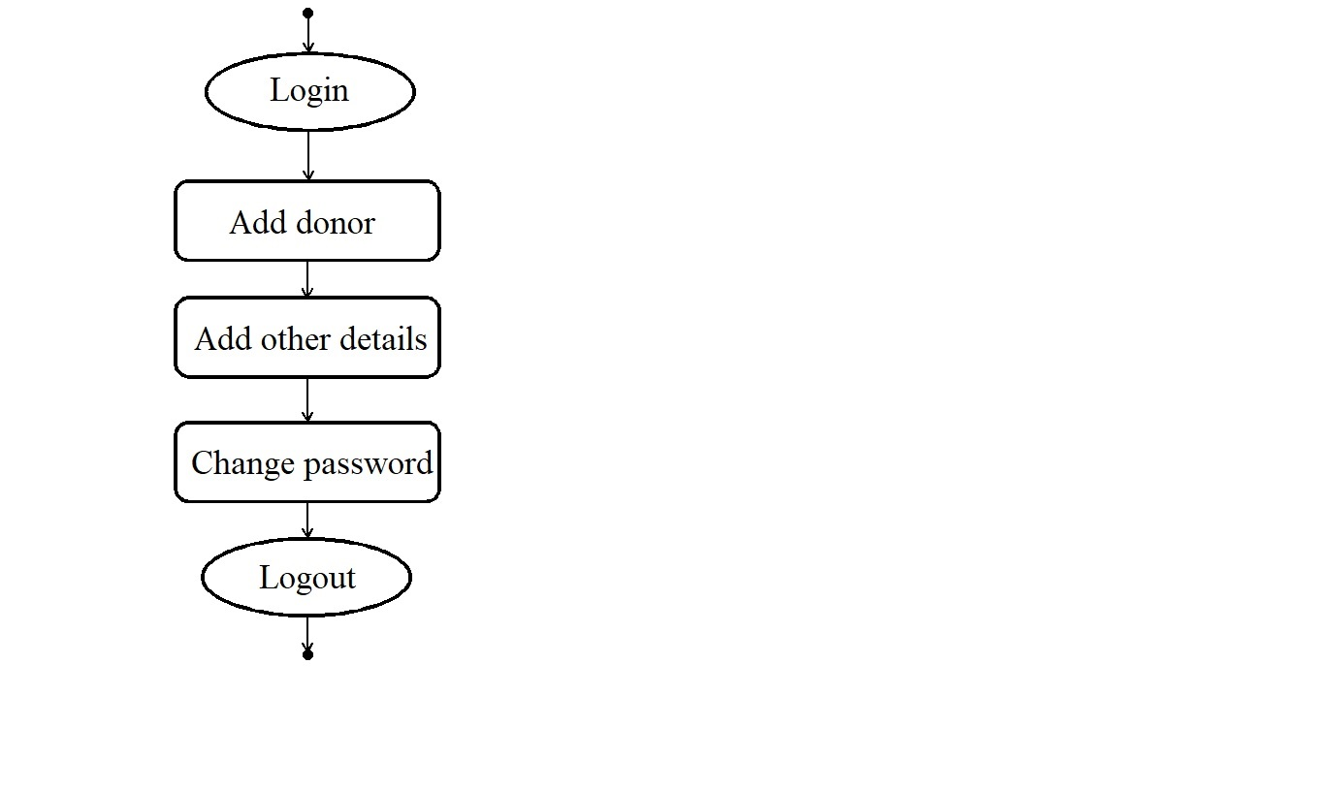

3.3 Sequence Diagram

