**Document vs Window Objects**

**Window Object**

Window object represents the browser window or tab, it is the global object in client side Javascript. it represents the browser window which acts as the top level of DOM. window object is supported and compatible with browsers and it includes Javascript objects, functions and variables as members.

Window object is also responsible for browser interaction methods and managing properties related to frames. Some examples of these managing window objects are **Location, History, Navigator, Frames, Screen, and XMLHttpReques**t.

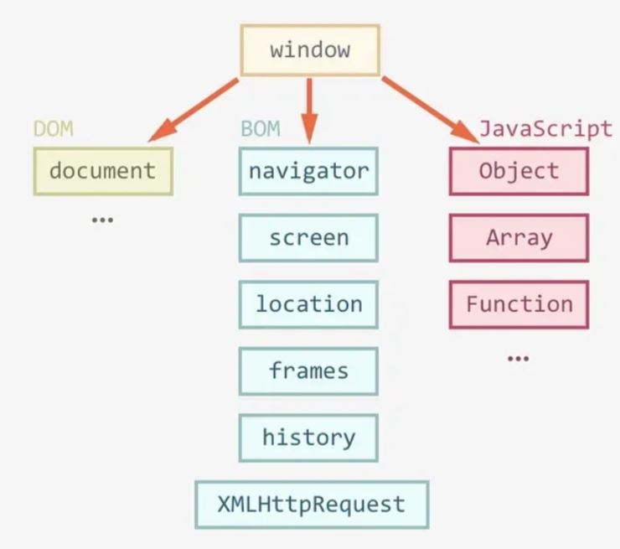

Window Object

Example of properties:

1. **window.origin;**
2. **window.innerHeight;**
3. **window.innerWidth;**

Examples of methods:

1. **window.open();**
2. **window.close();**
3. **window.moveTo();**

**Document Object**

Document object is the HTML document which is in the browser window and acts as an interface for the web page’s. DOM is contained within the window object as it is generated by the web page when it is being loaded.

It acts as a platform-neutral interface that allows for dynamic access and updating of document contents, structure, and style by using javascript programs and scripts. It has its own logical tree in the document, which allows for changes in structure, style and content.

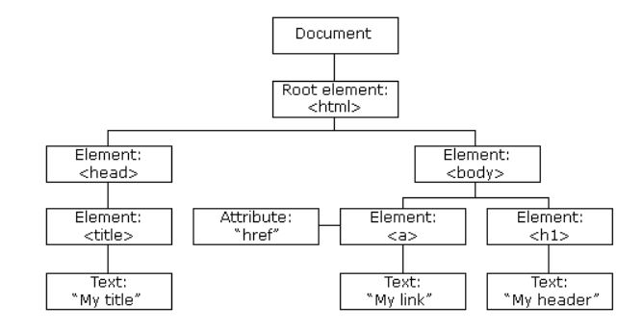

Document Object Model

Some methods that allows for manipulating DOM are:

1. **getElementById();**
2. **createElement();**
3. **innerHTML;**

Example of properties:

1. **element.innerHTML = new html content;**
2. **element.attribute = new value;**

Example of Methods:

1. **document.createElement(element);**
2. **document.removeChild(element);**

Some differences between DOM and Window object

| Document Object Model | Window Object |
| --- | --- |
| represents any HTML document or web page that is loaded in the browser. | represents a browser window or frame that displays the contents of the webpage. |
| Loaded inside the window | The first object loaded in the browser |
| Object of the window property | Object of the browser |
| All the tags, elements with attributes in HTML are part of the document. | Global objects, functions, and variables of JavaScript are members of the window object. |
| Properties of document objects such as title, body, cookies, etc can also be accessed by a window like this window. document.title | Properties of the window object cannot be accessed by the document object. |
| Can be accessed by the window (window.document;) | Can only be accessed by the window  (window.propertyname;) |

Using document object and window object, it allows developer to create a functional web page.