# Linux System Monitoring Report

**Author**: Pavithra Mohan
**Date**: 12/11/2024

## Introduction

System monitoring is essential for ensuring that services are reliable, available, and secure. This document outlines key monitoring metrics for a Linux system and provides command examples to gather each metric. Screenshots are included to showcase command outputs, and this report serves as a reference for monitoring any Linux-based system.

## 1. CPU Usage

**Description**: Monitoring CPU usage helps detect any processes that may be overloading the system.

**Commands**:
- `top` - Provides a dynamic view of running processes and CPU usage.
- `htop` - An interactive, visual version of `top`.
- `mpstat` - Displays CPU usage statistics in a more detailed format.

**Example Command and Output**:
```@serverside: top
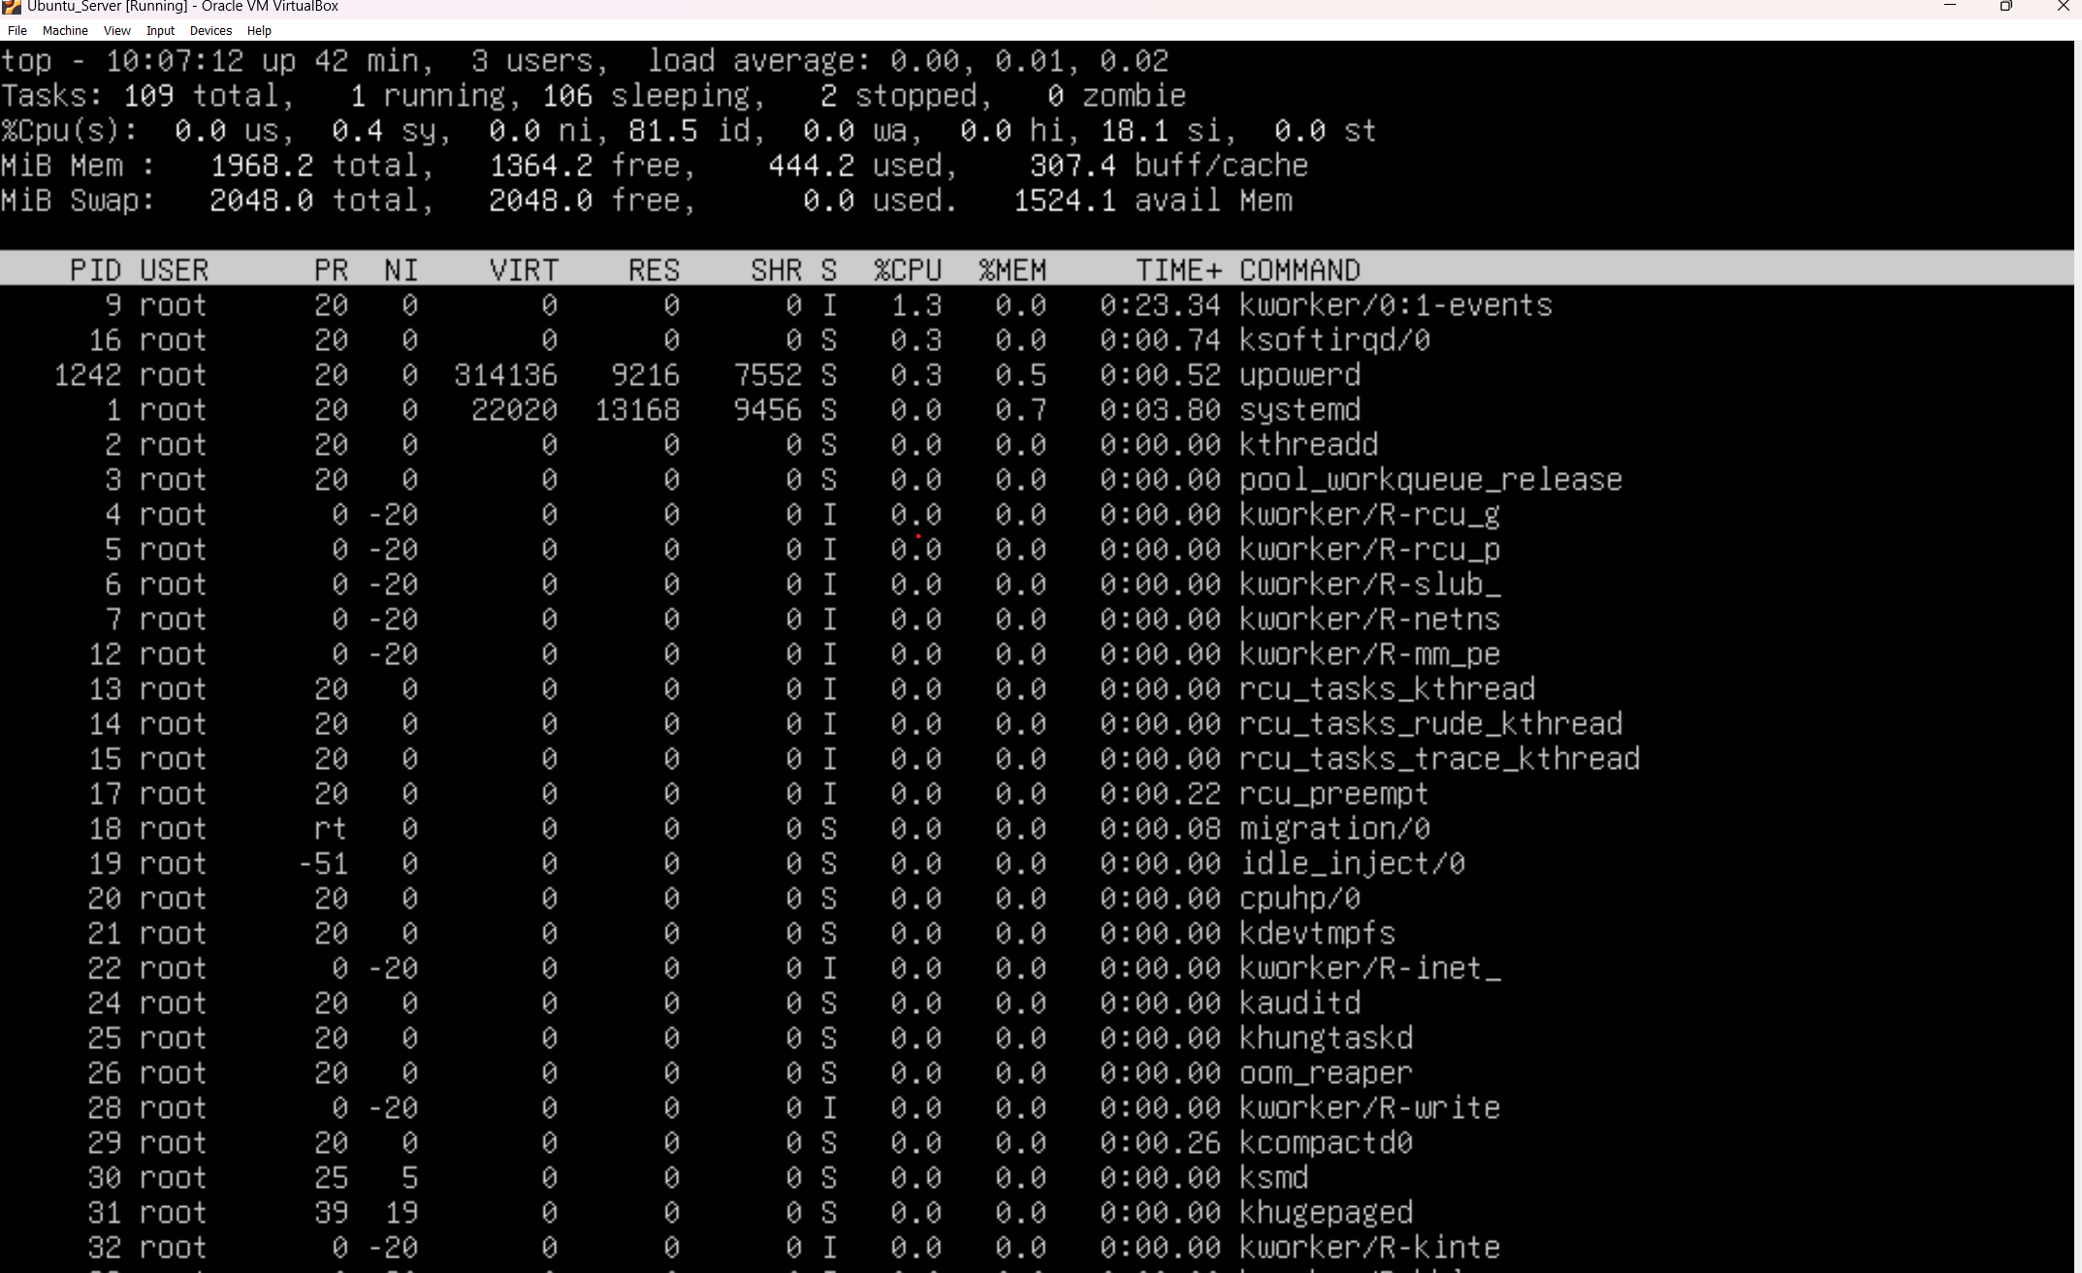

```@serverside: htop
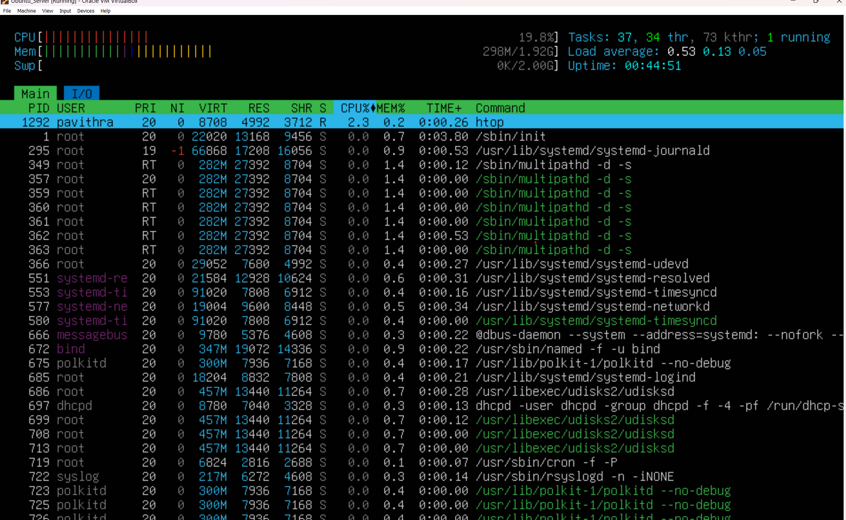
```@serverside: mpstat

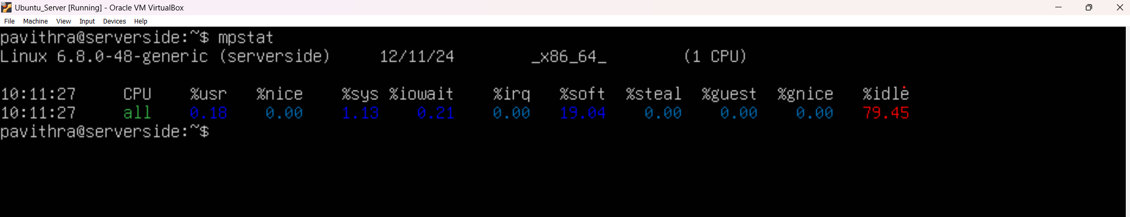

## 2. Memory Usage

**Description**: Checking memory usage helps identify processes that consume high amounts of RAM, which can slow down or crash the system.

**Commands**:
- `free -h` - Shows available, used, and free memory.
- `top` or `htop` - Displays memory usage by each process.
- `vmstat` - Provides memory, CPU, and I/O statistics.

**Example Command and Output**:
```@serverside:free-h
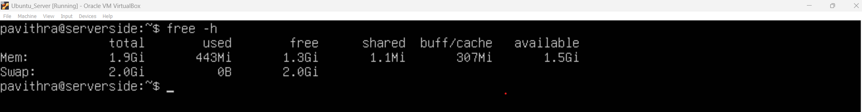
```
```@serverside:vmstat
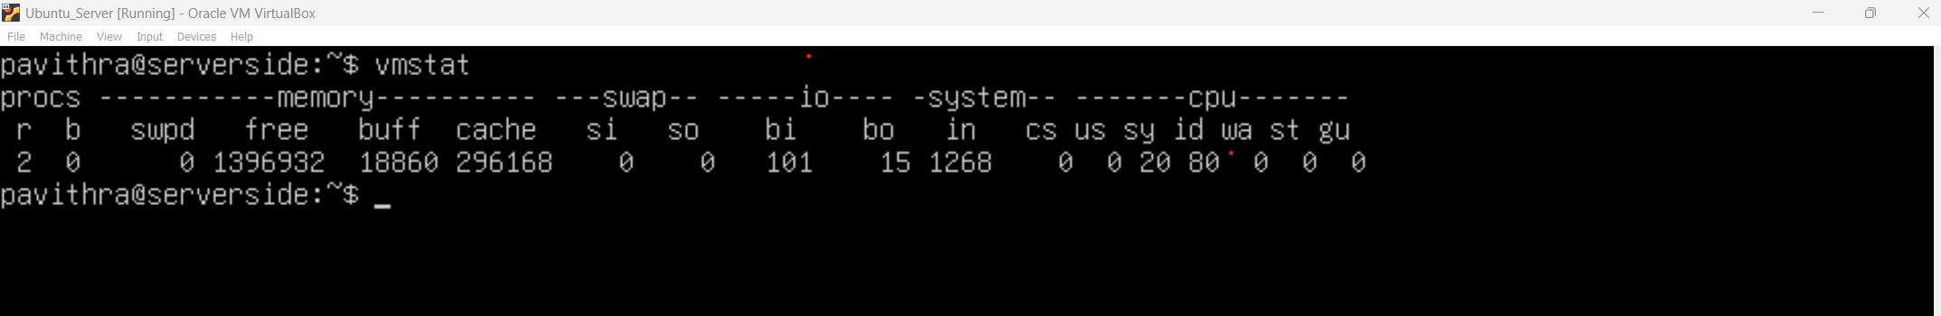

## 3. Disk Usage

**Description**: Monitoring disk usage prevents storage from filling up, which could hinder system performance.

**Commands**:
- `df -h` - Displays disk usage of all mounted filesystems.
- `du -h [directory]` - Shows disk usage by directories and files.

**Example Command and Output**:
```@serverside: df-h
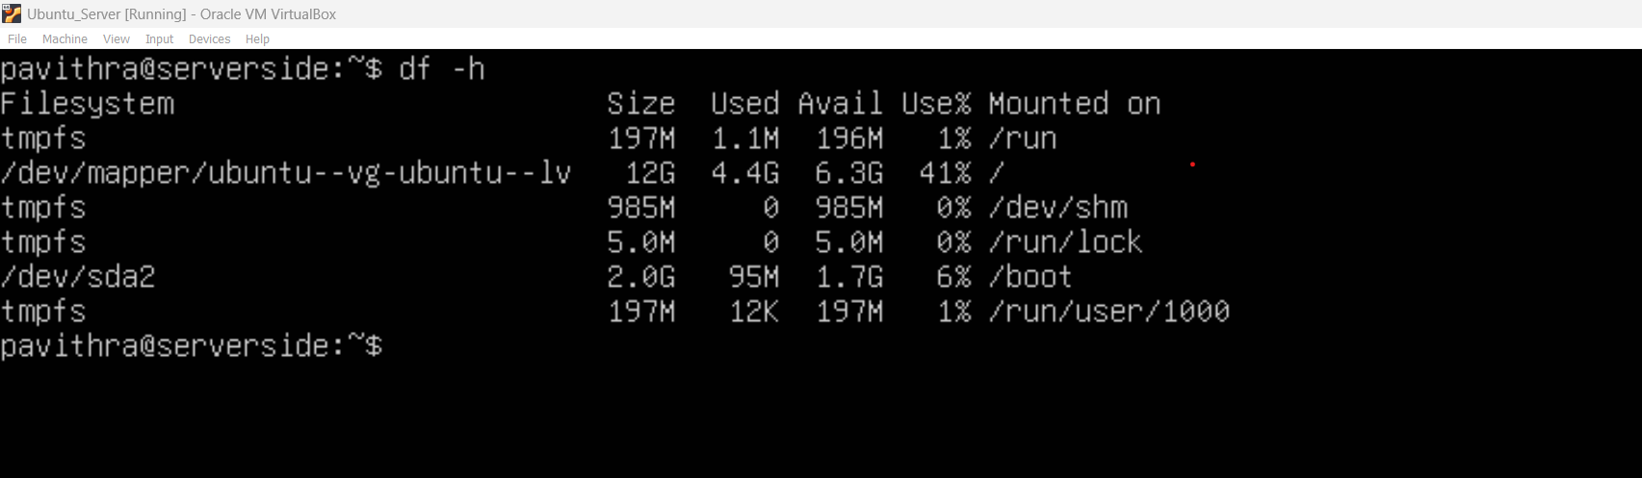

```@serverside:du -h
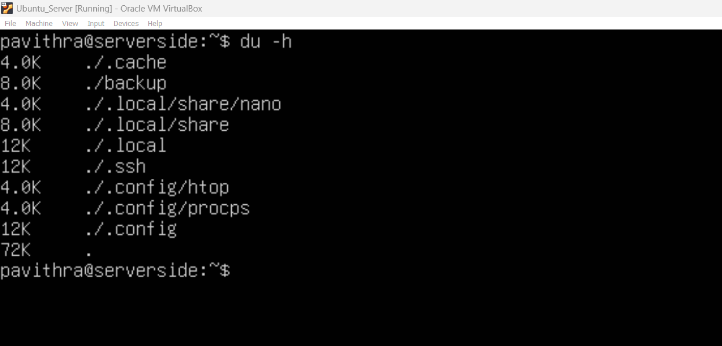

## 4. Log Files

**Description**: Logs provide insights into system events, errors, and user activity, which are vital for troubleshooting and security checks.

**Common Log Locations**:
- `/var/log/syslog` - General system messages.
- `/var/log/auth.log` - Authentication logs.
- `/var/log/dmesg` - Kernel ring buffer logs.

**Commands**:
- `cat /var/log/syslog`
- `journalctl` - For systems using `systemd`.

**Example Command and Output**:
```bash
Sudo cat /var/log/syslog | tail -n 20
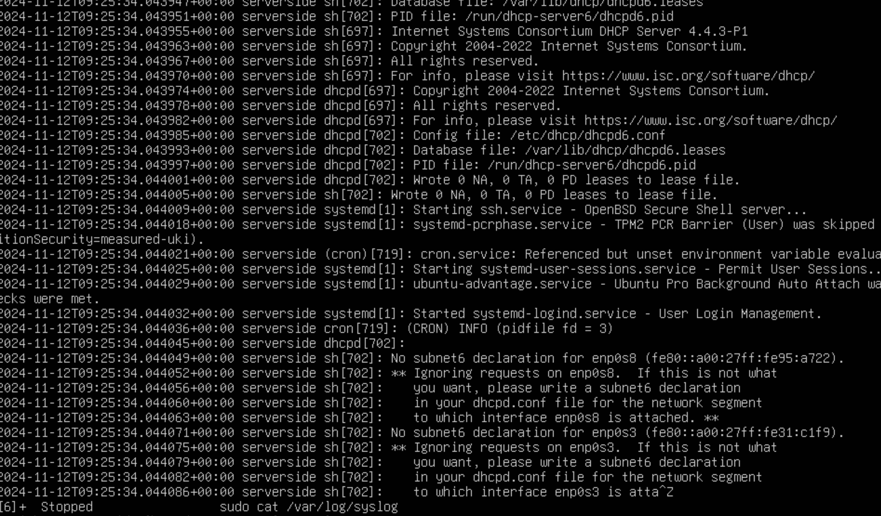
```sudo cat/var/log/auth.log
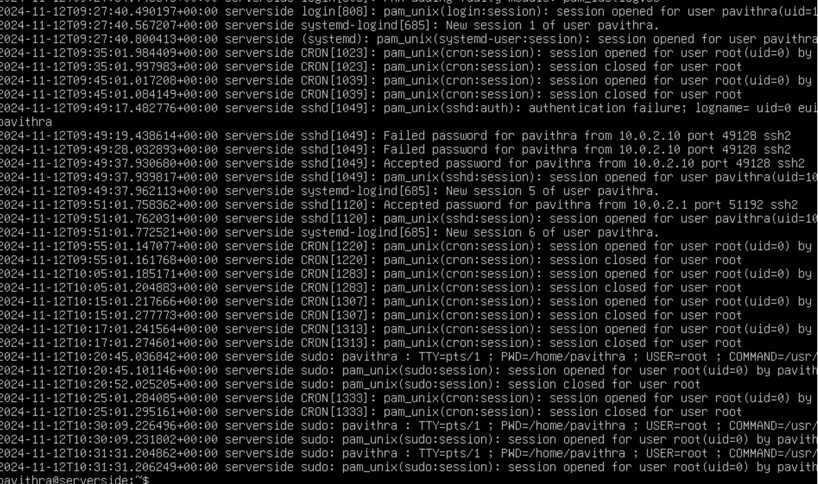
```journalctl

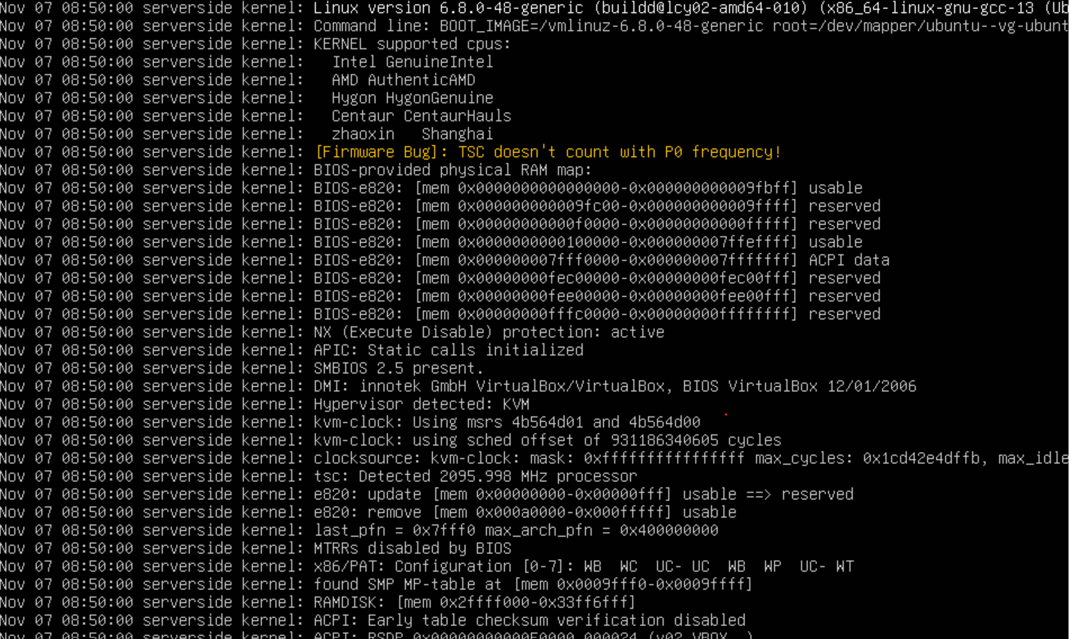
## 5. User Activity

**Description**: Tracking user activity helps ensure system security by logging user sessions and actions.

**Commands**:
- `last` - Shows a list of last logged-in users.
- `lastlog` - Displays information on the last login of all users.
- `w` - Displays who is logged on and what they are doing.

**Example Command and Output**:
```@serverside:last
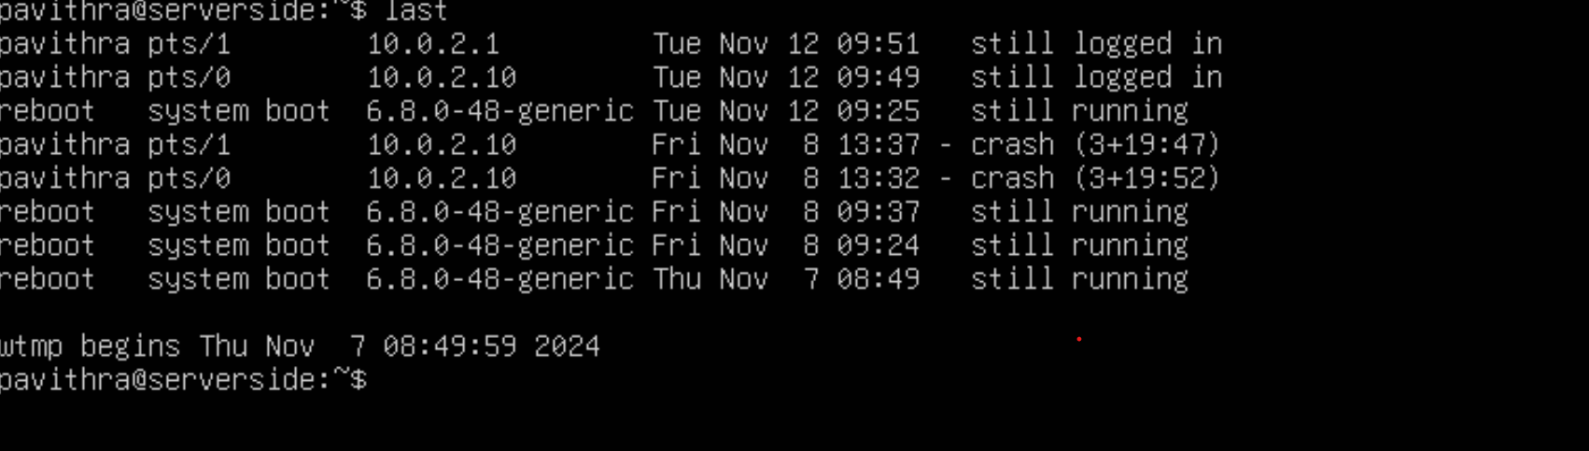
```@serverside:lastlog
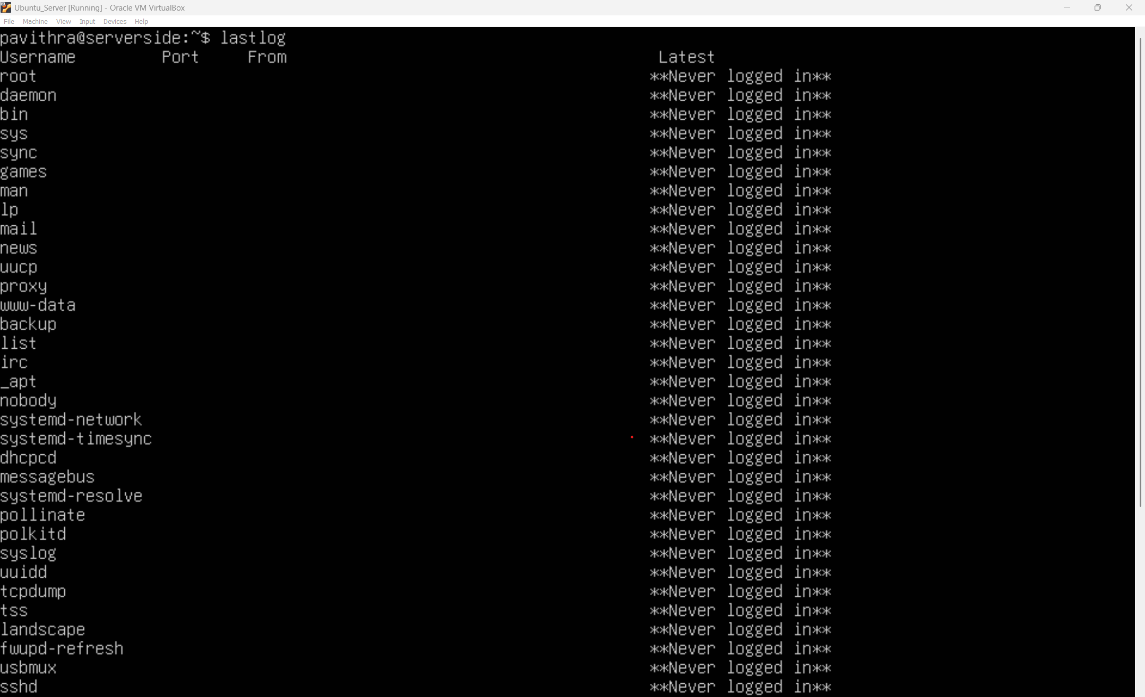

---@serverside:w
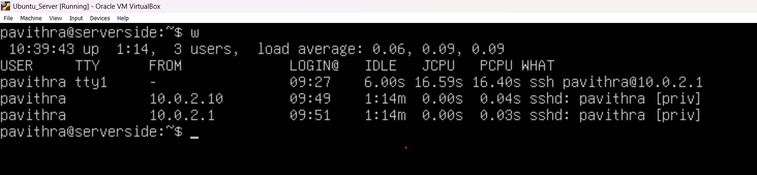

## 6. Uptime and Load Average

**Description**: The uptime and load average provide a quick snapshot of the system’s stability and workload over time.

**Commands**:
- `uptime` - Shows how long the system has been running and load averages.
- `cat /proc/loadavg` - Displays load averages directly.

**Example Command and Output**:
```@serverside:uptime
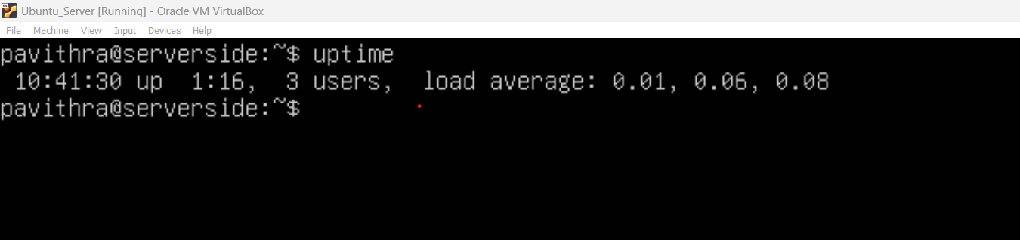
```@serverside: sudo cat /proc/loadavg
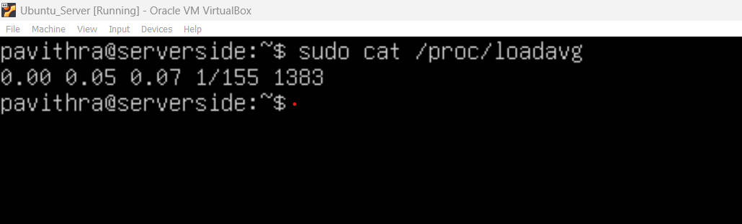
---

## 7. Network Traffic

**Description**: Monitoring network traffic helps identify unusual or excessive bandwidth usage, which could indicate a security issue or heavy network load.

**Commands**:
- `netstat` - Displays network connections, routing tables, etc.
- `iftop` - A real-time console network bandwidth usage tool.
- `ss` - Another network monitoring tool, similar to `netstat`.

**Example Command and Output**:
```@serverside: ss
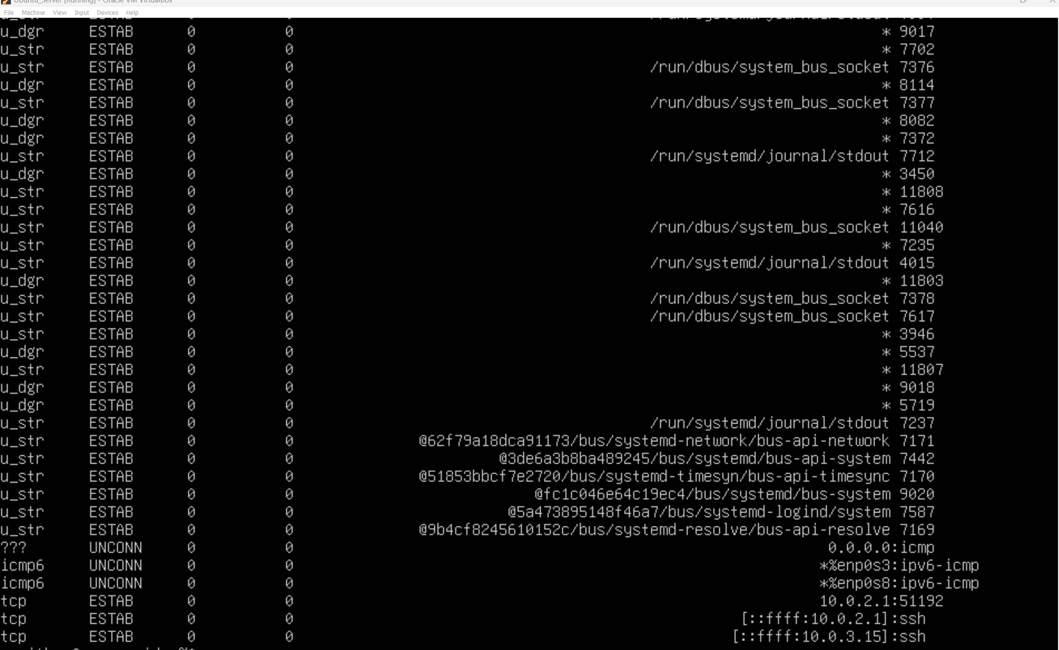

---

## 8. Service Health

**Description**: Ensuring that services are running as expected is crucial for system reliability and performance.

**Commands**:
- `systemctl status [service_name]` - Checks the status of a service.
- `service [service_name] status` - Alternative to `systemctl` for checking service status.

**Example Command and Output**:
```@serverside:systemctl status ssh
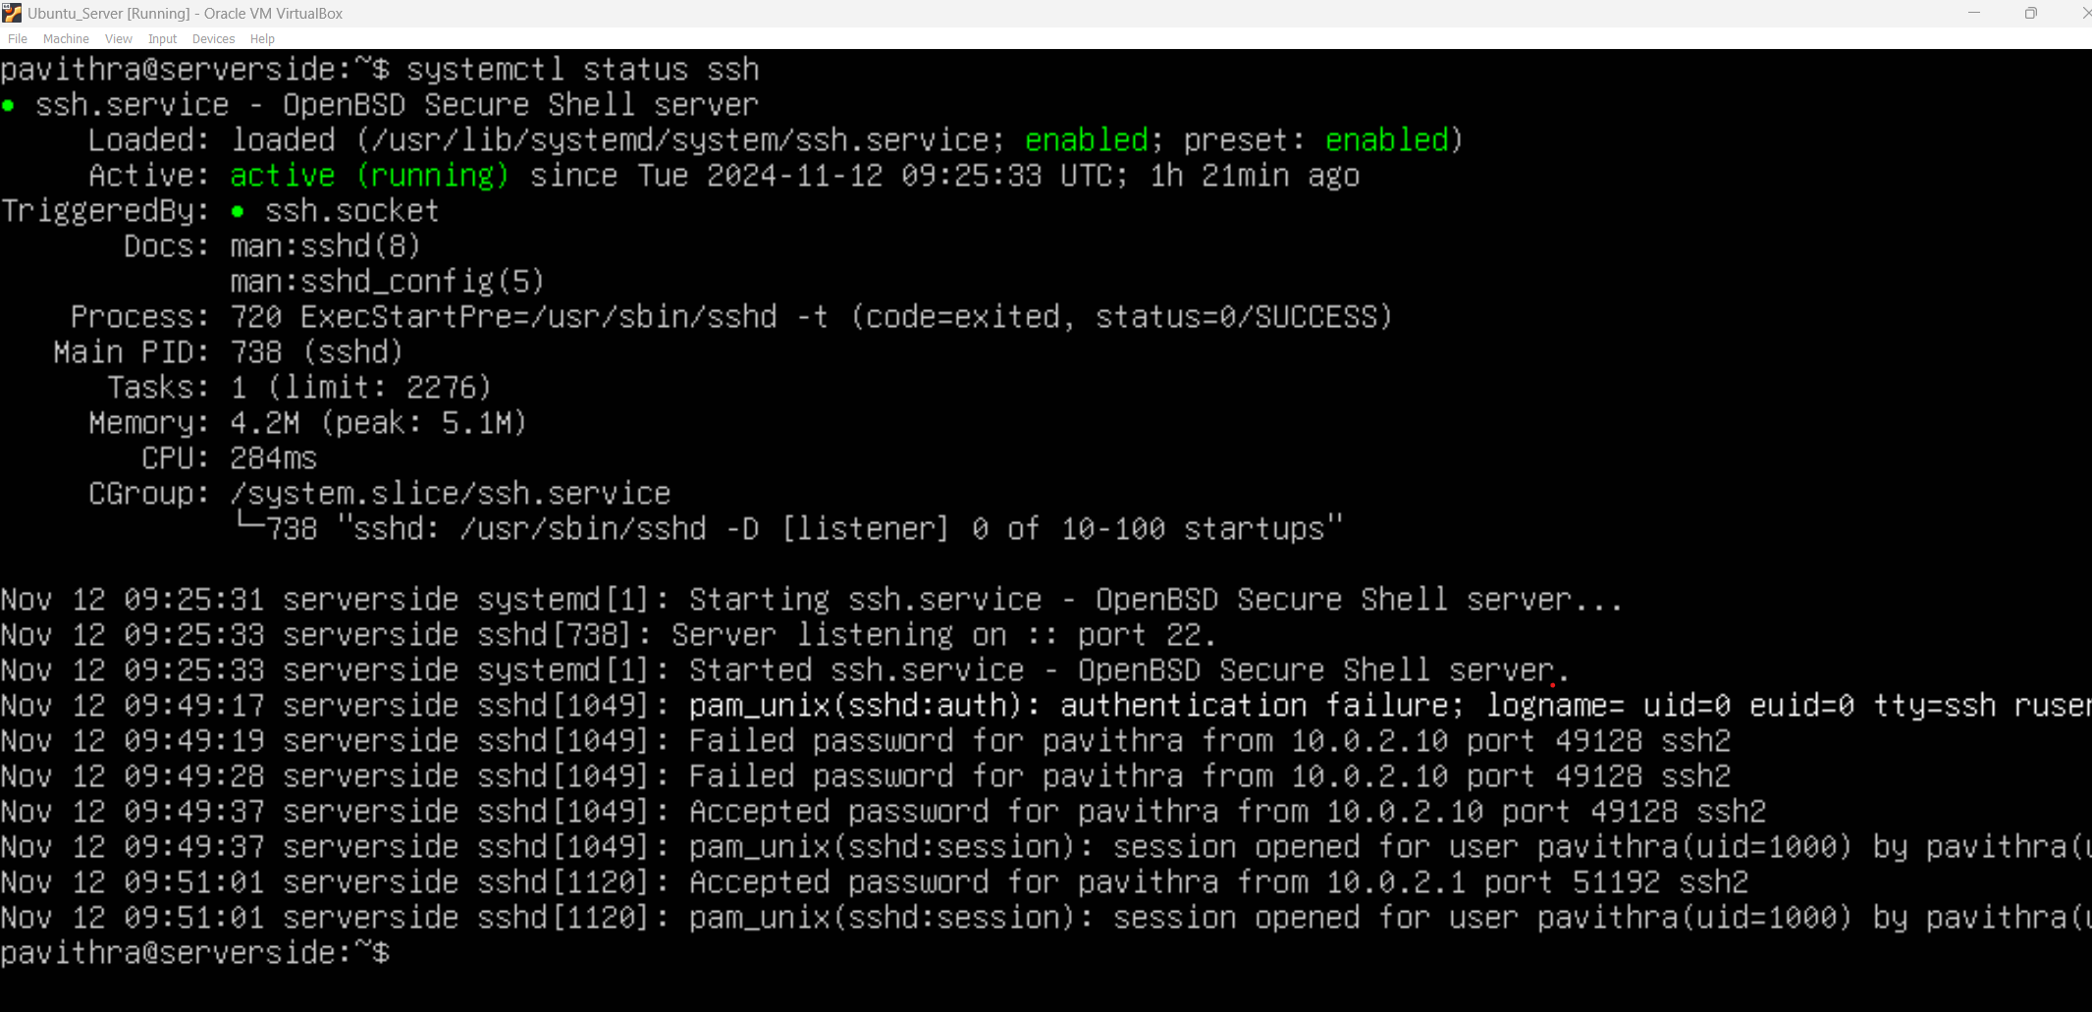
```@serverside:sudo systemctl status isc-dhcp-server
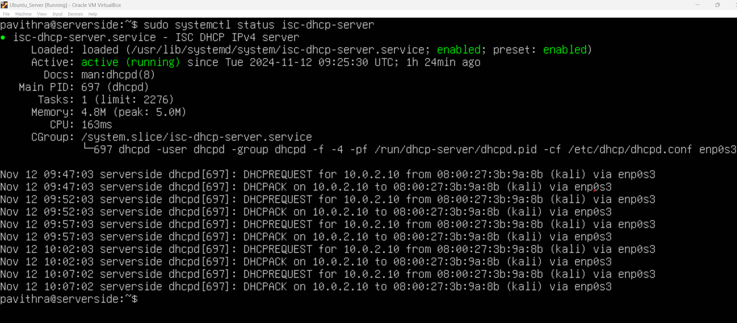
```@serverside:sudo systemctl status bind9
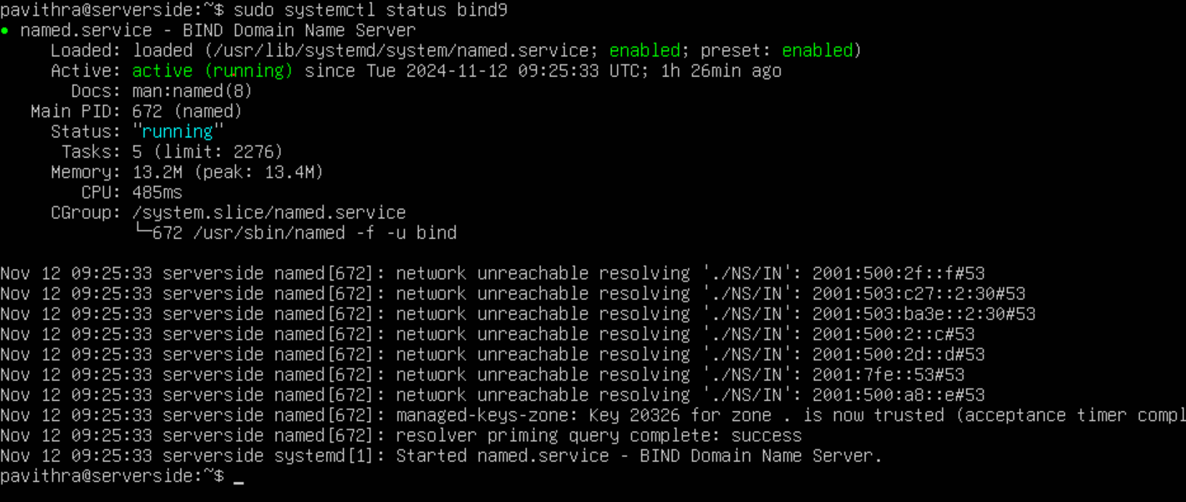

---@serverside:sudo systemctl status nginx
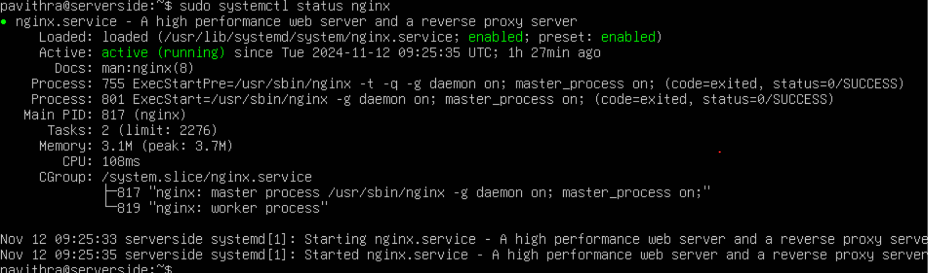

## Conclusion

Monitoring a Linux system involves keeping track of various performance metrics and log files. By regularly checking CPU, memory, disk usage, and network traffic, administrators can ensure that the system remains reliable and secure. Logs and user activity help track access and troubleshoot issues. Regular monitoring and timely action are essential for maintaining optimal system health.

---

