PERFICIENT — GLOBAL AI FIRST ACADEMY  AI Certifications — Capstone Case Study  Option 04 — Case Study Capstone · Global AI-First Academy | 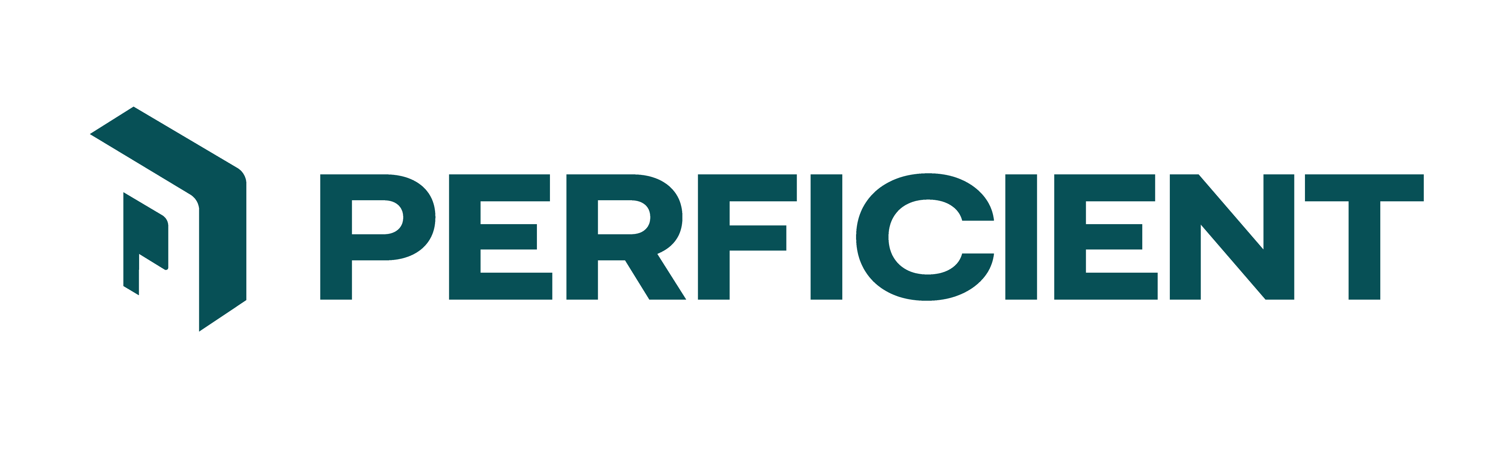
Case ID  L2_Case04_Warehouse_Ops_MCP_Toolkit | Level & Option  L2 — Agentic SDLC · Option 04 | Industry / Domain  Logistics
Warehouse Ops MCP Toolkit: designing tools an agent can use well
SCENARIO
Kestrel's warehouse ops staff work across three sites on forklift terminals, wearing gloves, switching between three systems to answer a single question. They have written down what they want an assistant to do for them. What they have written is a wish-list from people who know their job and do not design APIs - which is exactly what a requirements document usually is.
YOUR MISSION
Build the toolkit an agent can actually use well. That is not the same as building what Ops asked for. Several of the tools they described should not exist in the shape they described them, and working out which - then designing the interface properly and defending the changes - is the substance of this case. You will also write your interface design before you build it, in a sequence your git history has to show.
WHAT'S IN THE SANDBOX
- data/tool_specification.md — What Ops asked for, in their words, including the things they mentioned in passing and the things they did not think about at all. Read it as a requirements document, not a design.
- data/stock_snapshot.csv — 16 SKUs across three sites. Read this before designing your lookup interface; the shape of the data constrains what a usable lookup can promise.
- data/dock_schedule.jsonl — Dock slots for one day across the three sites, some booked.
- starter/PROCESS.md — The required build sequence. Read this first; it is graded.
WHAT YOUR SOLUTION MUST DO
- Follow the four-commit sequence in starter/PROCESS.md: 01-spec containing spec.md and no source files, then 02-plan, 03-tasks, 04-implement. For this case spec.md must contain the actual tool interface design - names, parameters and their types, the description the model will see, and your error shape - decided before any code exists.
- Design the tools rather than transcribing the wish-list. Where Ops described one tool that does two different things, or a tool that cannot keep the promise it makes given the data, change it and record why in spec.md.
- Constrain inputs with schemas. Where a parameter has a closed set of valid values, the schema should say so rather than accepting prose and validating it afterwards.
- Make state-changing tools distinguishable from read-only tools in the interface itself, and require confirmation before anything that is not reversible. Decide which of the requested operations those are; Ops did not.
- Return errors the model can act on - what failed, why, and what a corrected call would look like. Ops told you what they think of ERR_4001.
- Scope every tool to the caller's assigned site, enforced in the toolkit. Accepting a site parameter and trusting it does not satisfy the requirement Ops described from experience.
- Register the server in a real agent host and demonstrate an agent selecting tools at runtime, including a case where it has to ask a clarifying question rather than guess.
- Write a pytest-asyncio suite covering tool invocation, schema rejection, site scoping, the confirmation path, and error shape.
WHAT A STRONG SUBMISSION DEMONSTRATES
A strong submission shows an engineer who read the data before designing the interface, and who was willing to tell Ops that two of the things they asked for should be four. The weakest submissions are competent implementations of a bad specification - they work, they pass their own tests, and an agent using them makes confident mistakes.
SUGGESTED TECH STACK & GETTING STARTED
Suggested stack: Python 3.11, the MCP Python SDK, pydantic for parameter schemas, pytest-asyncio for the harness. Any agent host you can register a server with - Claude Code, VS Code, or equivalent - for the runtime selection demo. Stub the warehouse systems over the provided data files; the point is the interface, not the backend.
- Read starter/PROCESS.md, then data/tool_specification.md, then the two data files.
- Before designing anything, ask what a lookup tool can honestly promise given what is in stock_snapshot.csv. Look at the descriptions closely.
- Write spec.md with your tool list and full signatures. Commit as 01-spec with no code present.
- Commit plan.md and tasks.md, then implement.
- Register the server and drive it with an agent, using questions phrased the way Ops would phrase them rather than the way you would.
WHAT TO SUBMIT
- The git repository, or git log --stat covering all four required commits with timestamps.
- spec.md, plan.md, tasks.md as committed.
- Working MCP server, plus its registration config and a transcript of an agent selecting tools at runtime.
- Your list of changes from the requested design, each with its reasoning.
- Passing pytest-asyncio output covering schema rejection, site scoping, confirmation and error shape.
- REFLECTION.md, and a declared-effort statement.
A NOTE FROM THE CHIEF LEARNING OFFICER
The reason this case gives you a wish-list rather than a specification is that a wish-list is what you will get. Ops are not wrong about what they need; they are simply not in a position to know that 'let me search by name' is a promise the data cannot keep.
So look at the stock file properly before you design the lookup. Then tell me what you changed and why. An engineer who implements the request faithfully and ships something that confidently returns the wrong pallet wrap has done worse than one who pushed back.
Dr. KNS Acharya, Chief Learning Officer · Dr. Prithvi Sekhar Pagala, AI Technologies Pillar Lead
Global AI-First Academy | Perficient

