Exp.No: 07 Pavipraja.P

231701037

**Create a multimedia application that integrates images, sound, and video in a simple user interface.**

**Aim:**

To develop a simple **multimedia application** using Python that can:

* Display an image
* Play an audio file
* Play a video file

using appropriate Python libraries.

**Procedure:**

1. Import necessary Python libraries (PIL, IPython.display, matplotlib, etc.).
2. Upload multimedia files (image, audio, video) into the working directory.
3. Write Python code to:
   * Load and display an image.
   * Load and play an audio file.
   * Load and play a video file.
4. Execute the program.
5. Observe the output:
   * The selected image is displayed.
   * The audio file plays.
   * The video file plays within the output area.

**Code:**

from IPython.display import Audio, Video, display

from PIL import Image

import matplotlib.pyplot as plt

import os

from google.colab import files

print("Please upload your media files (image, audio, video)...")

uploaded = files.upload() # Choose: sample_image.jpg, sample_audio.mp3, sample_video.mp4

print("\nUploaded Files:")

for filename in uploaded.keys():

print(" -", filename)

print("\nDisplaying Image:")

image_file = 'sample_image.jpg' # Change filename if needed

if os.path.exists(image_file):

img = Image.open(image_file)

plt.imshow(img)

plt.axis('off')

plt.show()

else:

print("Image file not found. Check the name.")

print("\nPlaying Audio:")

audio_file = 'sample_audio.mp3' # Change filename if needed

if os.path.exists(audio_file):

display(Audio(audio_file))

else:

print("Audio file not found. Check the name.")

print("\n Playing Video:")

video_file = 'sample_video.mp4' # Change filename if needed

if os.path.exists(video_file):

display(Video(video_file, width=400))

else:

print(" Video file not found. Check the name.")

**Output:**

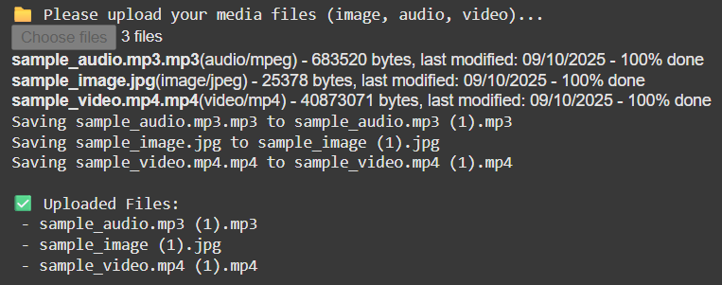

Displayed image :



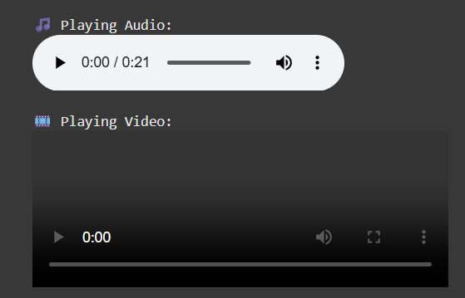

**Result:**

The Python multimedia application was successfully developed and executed.  
It was able to:

* Display the uploaded image,
* Play the given audio file, and
* Play the selected video file  
  within the same Colab notebook environment.