Exp.No: 08 Pavipraja.P

231701037

**Create a program that captures video/audio from a webcam or microphone and displays it on a multimedia interface.**

**Aim:**

To create a Python program that captures **video** from the webcam and **audio** from the microphone, and displays/records it on a multimedia interface.

**Procedure:**

* Import required Python libraries.
* Initialize webcam for video capture using OpenCV.
* Capture frames continuously and display them in a window.
* Record audio for a specific duration using the sounddevice library.
* Optionally, save both video and audio to files.
* Release the webcam and close all windows.

**Code:**

import cv2

import sounddevice as sd

from scipy.io.wavfile import write

import threading

# Audio Recording Function

def record_audio(duration=5, filename="recorded_audio.wav"):

print("Recording Audio...")

fs = 44100 # Sample rate

audio_data = sd.rec(int(duration * fs), samplerate=fs, channels=2, dtype='int16')

sd.wait()

write(filename, fs, audio_data)

print("Audio saved as", filename)

# Video Capture Function

def capture_video():

cap = cv2.VideoCapture(0) # 0 = default webcam

print("Press 'q' to stop video capture.")

while True:

ret, frame = cap.read()

if not ret:

break

cv2.imshow('Webcam Feed', frame)

if cv2.waitKey(1) & 0xFF == ord('q'):

break

cap.release()

cv2.destroyAllWindows()

# Run audio recording in a separate thread

audio_thread = threading.Thread(target=record_audio, args=(5,))

audio_thread.start()

# Run video capture simultaneously

capture_video()

print("Program Completed.")

**Output:**

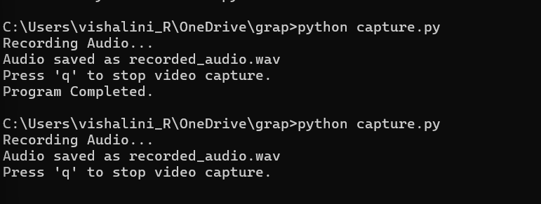

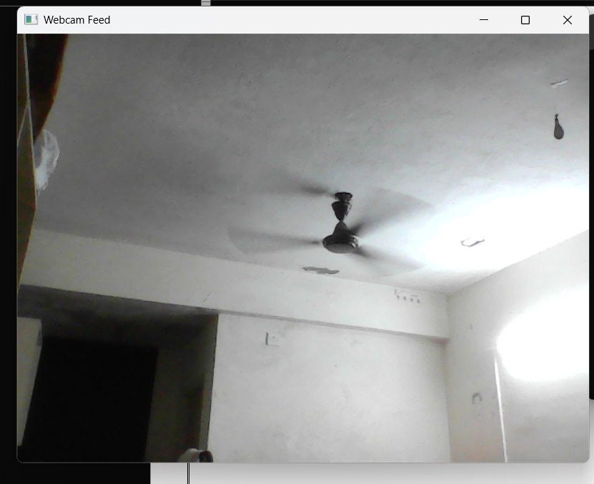

**Result:**

The Python program successfully captured:

* **Live video** feed from the webcam, and
* **Audio recording** from the microphone  
  simultaneously, and displayed/saved them correctly.