**DAY 10**

1**. Write  a function to Calculate the total stock value for a given category:**

**(Stock value=ROUND(SUM(unit_price * units_in_stock)::DECIMAL, 2)**

**Return data type is DECIMAL(10,2)**

SELECT * FROM categories

SELECT * FROM products

CREATE OR REPLACE FUNCTION total_stockvalue(p_category_id INT)

RETURNS DECIMAL(10,2)

LANGUAGE plpgsql

AS $$

DECLARE

v_stockvalue DECIMAL(10,2);

BEGIN

IF NOT EXISTS (SELECT 1 FROM products WHERE category_id = p_category_id) THEN

RAISE EXCEPTION 'Category id % does not exist',p_category_id;

RETURN 0;

END IF;

SELECT

COALESCE(ROUND(SUM(unit_price * units_in_stock)::DECIMAL,2),0)

INTO v_stockvalue

FROM products p

WHERE p.category_id = p_category_id;

RETURN v_stockvalue;

END;

$$;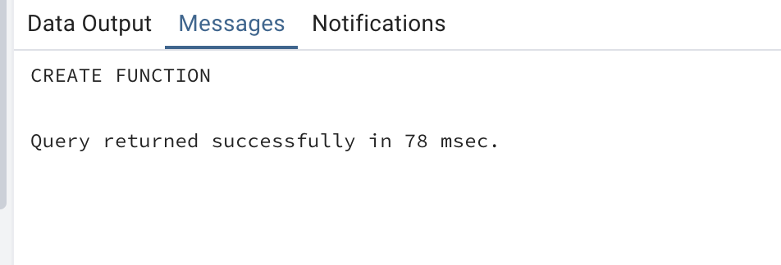

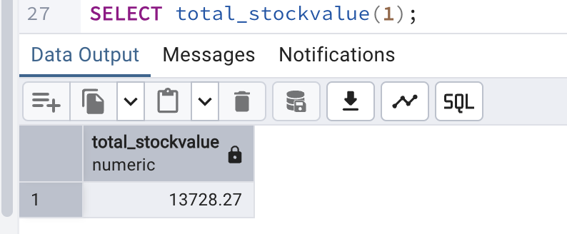

**2. Try writing a cursor query which I executed in the training.**

CREATE OR REPLACE PROCEDURE update_prices_with_cursor()

LANGUAGE plpgsql

AS $$

DECLARE

product_cursor CURSOR FOR

SELECT product_id,product_name,unit_price,units_in_stock

FROM products

WHERE discontinued = 0;

product_record RECORD;

v_new_price DECIMAL(10,2);

BEGIN

OPEN product_cursor;

LOOP

FETCH product_cursor INTO product_record;

EXIT WHEN NOT FOUND;

IF product_record.units_in_stock < 10 THEN

v_new_price := product_record.unit_price * 1.1;

ELSE

v_new_price := product_record.unit_price * 0.95;

END IF;

UPDATE products

SET unit_price = ROUND(v_new_price,2)

WHERE product_id = product_record.product_id;

RAISE NOTICE 'Updated % price from % to %',product_record.product_name,

product_record.unit_price,v_new_price;

END LOOP;

CLOSE product_cursor;

END;

$$;